Virginia Railway Express (VRE) Virginia
Bicycle Lockers at VRE Stations

Project Summary
The project will install bicycle lockers at eight Virginia Railway Express (VRE) Stations throughout Northern Virginia.

Project Cost
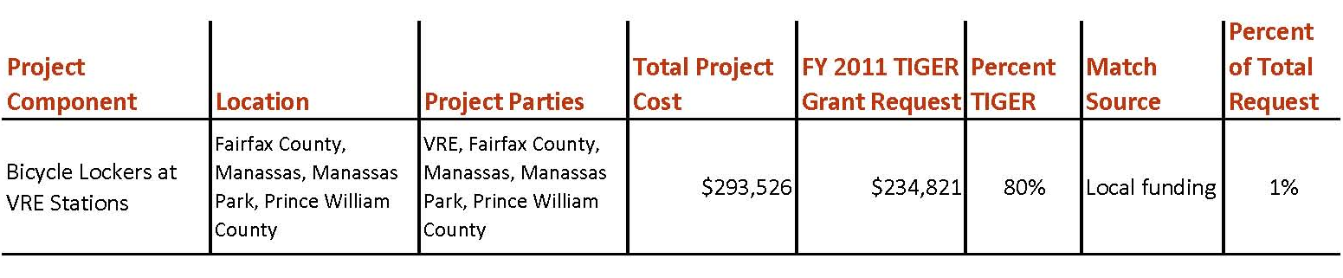

Project Location
The project is located in Northern Virginia at eight stations on two lines of the VRE commuter train service. The project will add bicycle lockers to three stations in Fairfax County, three stations in Prince William County, and two stations each in the City of Manassas and City of Manassas Park. The project locations include existing, under-utilized and emerging housing centers. The Manassas station is located within the City of Manassas Old Town historic district, an established, mixed-use area, while the Rolling Rd. and Franconia-Springfield stations are located adjacent to established residential areas. The Broad Run, Manassas Park, Lorton and Rippon stations are located in emerging housing centers where housing has been constructed in recent years or is planned for areas adjacent to the VRE station. The areas adjacent to the Manassas Park and Lorton stations also include retail/commercial uses in addition to residential uses. The Woodbridge station is part of Prince William County’s North Woodbridge redevelopment area, planned for housing, office, and retail uses.

Project Planning
VRE works closely with member jurisdictions to provide station amenities (e.g., sidewalks/trails, bicycle facilities, kiss-and-ride, station parking,) that give riders a variety of transportation choices for accessing VRE service. VRE currently provides bike racks at most stations as well as allowing bikes on board the last three AM/PM peak trains and mid-day/reverse-flow trains. There have been increased requests from VRE riders, either directly to VRE or through the local jurisdictions where VRE stations are located, to add bicycle lockers to VRE stations to provide additional options for riders accessing VRE via bicycle.

Project Details
The project will install bicycle lockers at the following VRE Stations:
- Broad Run/Airport (Prince William County) – 4 lockers, 8 bike capacity
- Manassas – 4 lockers, 8 bike capacity
- Manassas Park – 4 lockers, 8 bike capacity
- Rolling Road (Fairfax County) – 5 lockers, 10 bike capacity
- Lorton (Fairfax County) – 4 lockers, 8 bike capacity
- Franconia-Springfield (Fairfax County) – 6 lockers, 12 bike capacity
- Woodbridge (Prince William County) – 4 lockers, 8 bike capacity
- Rippon (Prince William County) – 4 lockers, 8 bike capacity

Project Schedule
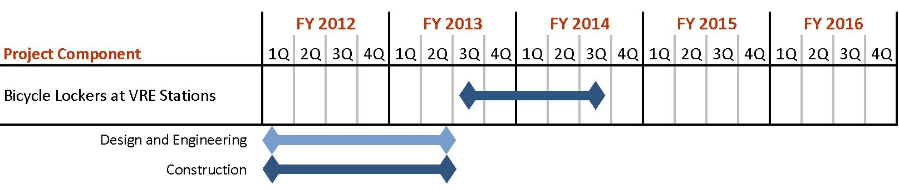

Additional Documentation

