Arlington County Virginia
Army Navy Drive Multimodal Access Improvement Project

Project Summary
The project re-conceives 3,300’ of Army Navy Drive, providing a wider, safer sidewalk, a physically-separated two-way cycle track, and safer street cross section that will support a future streetcar. The project adds ten bikeshare stations along Columbia Pike to complement the established Capital Bikeshare activities in the core project area. Collectively, the improvements will enhance multimodal access to three major activity centers.

Project Cost
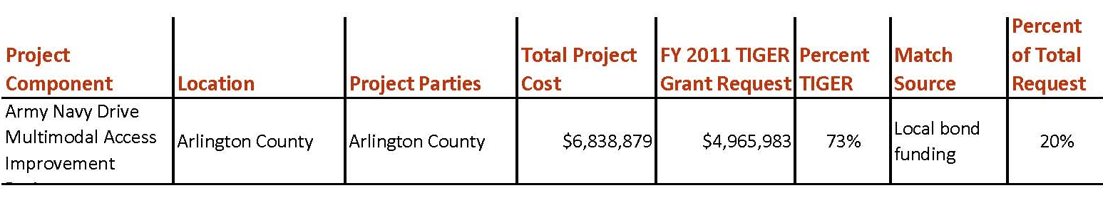
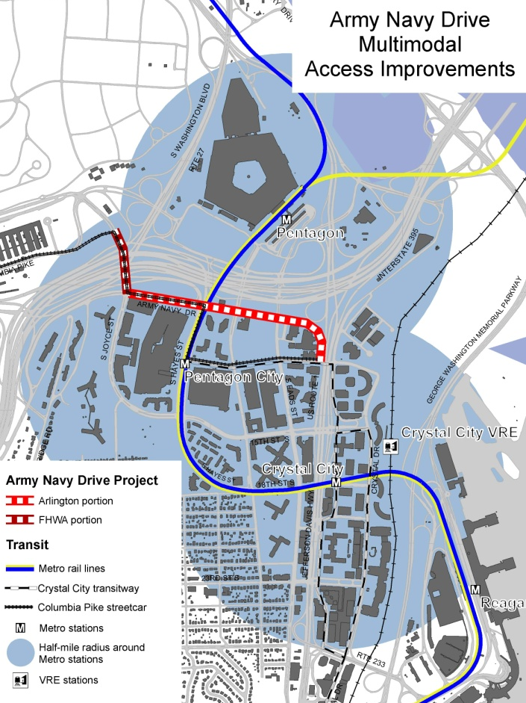

Project Location
The project is located in Arlington County, Virginia, within one-half mile of three Metrorail stations: Pentagon, Pentagon City, and Crystal City. In addition, it is located within one half mile of the Crystal City VRE station. The bikeshare locations are along Columbia Pike, the terminus of which is within one half mile of the Pentagon and Pentagon City Metrorail stations; Columbia Pike will be reconfigured to accommodate a streetcar within the next decade.

Project Planning
This project originated as a need to improve bicycle and pedestrian access and connectivity in the vicinity of the Pentagon Reservation, immediately north of Army Navy Drive. Arlington County is committed to revitalizing Pentagon City and Crystal City, and as such target investments that yield the greatest good, not only from a transportation perspective, but also in terms of overall quality of life. This project is one of Arlington’s priorities, as it will make it easier and safer for residents, workers and visitors to access major activity centers within the County and the region. The project grows out of Arlington’s Master Transportation Plan process, and also fully supports the Federal Highway Administration’s 14th Street Bridge Corridor EIS, which aims to improve conditions for pedestrian and bicycle access to river crossings as part of a long list of mitigation efforts to reduce the environmental effects of transportation in the region.

Guided by the Pentagon City Phased Development Site Plan, the Pentagon City area is developing a rich mix of office, retail, and residential uses to create a high-density, transit-oriented mixed use community. In 2010, the County adopted a long-range sector plan for Crystal City. The planning initiative was in response to BRAC recommendations, which called for the relocation of 17,000 jobs from Arlington to nearby military bases. As a result of the loss of employment, 4.2 million square feet of office space will be vacated. The approved Crystal City sector plan anticipates an increase in overall density of 61 percent by 2050, with an increased proportion of residential uses.

The project is also located within close proximity to major County capital projects, which further underscore the critical importance of the project area including: 1) construction of the new Long Bridge Park, a new state of the art aquatic, health and fitness facility and park located at the north end of Crystal City, scheduled to open in September 2011; 2) renewal of South Hayes Street in the heart of Pentagon City, scheduled for construction in 2012; 3) a major planning effort to establish fixed-rail transit along Columbia Pike; located just NW of the Project,, with stations in Pentagon City and Crystal City; and 4) the initial launch site of Arlington’s Capital Bikeshare system in September 2010.

Project Details
This project proposes building the region’s first separated two-way cycle track. While this type of facility is common in other parts of the world, especially in northern Europe, and has some precedent in North America; particularly in Montreal, this would be the first purpose-built cycle track in the Metropolitan Washington, DC area, and the first in the Commonwealth of Virginia. By narrowing the very wide existing street cross section of Army Navy Drive, space will be created for greatly improved conditions for pedestrians along an improved sidewalk, and a new alignment will be created for a dedicated bicycle facility. This will be done without negatively affecting motor vehicle operations, and while assuring a good fit for the anticipated fixed-rail streetcar line in the corridor. The anticipated cycle track facility proposed for Army Navy Drive is difficult to implement under existing modal funding in part because it is costly to build in prime urban settings, and in part because there are few precedents in this country for this type of bicycle accommodation.

Crystal City and Pentagon City launched Arlington’s Capital Bikeshare program in 2010. That bicycle transit system continues to grow and meet the needs for short term cycle trips. Arlington County will provide the necessary planning and design costs as an in-kind match. Arlington County will own the bikes and equipment for the ten bikeshare facilities, but they will be operated by Capital Bikeshare through our existing contract.

The project is currently at 30% design, with an estimated budget of $5.5 Million. A companion project to provide new bicycle and pedestrian facilities along South Joyce Street, immediately adjacent to Army Navy Drive, is scheduled for construction in 2012 (see attached map). It will be funded (at a cost of $1.5 Million) and will be built by FHWA and VDOT.

Project Schedule
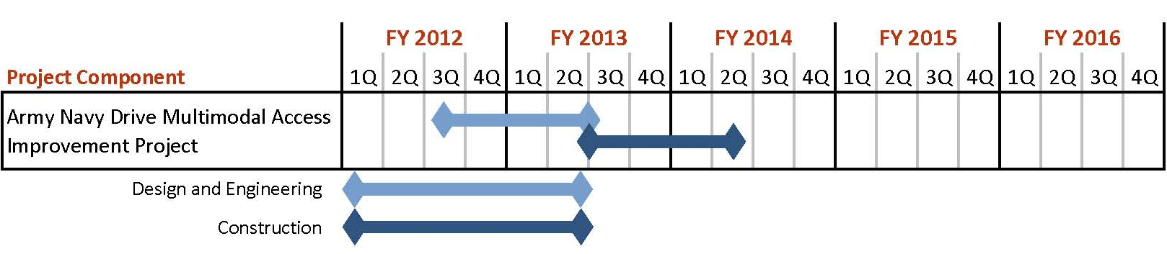

Additional Documentation
The Federal Highway Administration’s 14th Street Bridge Corridor EIS

