Table of Contents
Project Overview 1
Project Need and Regional Challenges 3
Proposed Project 5
District of Columbia 5
1. Fort Totten / 1st Place-Galloway Road Access Improvement Project 5
State of Maryland 5
2. Forest Glen Metrorail Access Project 5
3. Pedestrian Safety Measures for the New Carrollton Metrorail Station 6
4. Twinbrook Metrorail Station: Pedestrian Safety Improvements 6
5. West Hyattsville Metrorail Station Access Improvements 6
Commonwealth of Virginia 7
6. Army Navy Drive Multimodal Access Improvement Project 7
7. Bicycle Lockers at Virginia Railway Express (VRE) Stations 7
Project Parties 9
Grant Funds and Sources/Uses of Project Funds 10
Selection Criteria 12
Primary Selection Criteria I: Long-Term Outcomes 12
Primary Selection Criteria II: Job Creation & Near-Term Economic Activity 18
Secondary Selection Criteria I: Innovation 18
Secondary Selection Criteria II: Partnership 19
Benefit-Cost Analysis 19
Project Readiness and NEPA 23
Federal Wage Rate Certification 24
Material Changes to the Pre-Application 24

Project Overview

Regional Context
The Washington metropolitan area encompasses the District of Columbia and the surrounding jurisdictions in Northern Virginia and Suburban Maryland. The region is home to more than 5 million residents and nearly 3.5 million jobs, making it the ninth largest metropolitan area in the nation, according to 2008 census population estimates. As the seat of the national government, the District of Columbia alone receives 22 million visitors annually. Transportation planning at the regional level is coordinated by the National Capital Region Transportation Planning Board (TPB). The TPB is composed of representatives of the transportation agencies of the State of Maryland, the Commonwealth of Virginia, and the District of Columbia, local governments, the Washington Metropolitan Area Transit Authority (WMATA), the Maryland and Virginia General Assemblies, and members from the Metropolitan Washington Airports Authority (MWAA) and federal agencies. Established in 1965, the TPB is the federally-designated Metropolitan Planning Organization (MPO) that directs the comprehensive regional transportation planning process under the authority of the Federal-Aid Highway Act of 1962, as amended.

Project Summary
The application consists of seven multimodal capital improvement projects that will enhance non-motorized access to the region’s rail system (see map on following page). The project focuses on pedestrian, bicycle, and streetscape improvements to 16 rail station areas that are well-served by transit but currently underutilized for housing and employment. These locations include both suburban activity centers and potential housing and job centers on the eastern side of the region. In many cases, these places are reverse commute destinations. Together, these improvements enhance the ability of existing infrastructure to positively impact the accessibility, safety, and economic opportunity of these untapped regional assets.

The TPB’s scenario planning has demonstrated that the region can realize significant benefits by increasing job and housing growth near rail stations. The TPB Vision, a policy document that outlines eight broad goals to guide the region’s transportation investments into the 21st century, describes, and the scenarios evaluate, a region with an accessible and interconnected transportation system that enhances the quality of life, provides additional economic resilience and supports a growing economy throughout the entire area. Through strategic access improvements to the existing transit infrastructure, demand pressures on the transportation system would be alleviated by using trains in reverse-commute directions that are currently operating under capacity, or by selling the same seat twice in peak commute directions (where one group of commuters alights at a mixed-use suburban location and another group boards). More broadly, promoting development near rail station areas would reduce distances between housing and employment, which would reduce vehicle-miles traveled (VMT) and congestion.

Each project in the package supports multiple livability principles that enhance the effectiveness of the region’s rail system. The projects address the safety of rail system users, streetscaping and capacity improvements to the built environment, and basic pedestrian infrastructure for typically underserved areas of the region. Each project contributes to the vitality of the rail station area, and together the package represents a multimodal investment in transportation improvements that would otherwise remain unfunded.

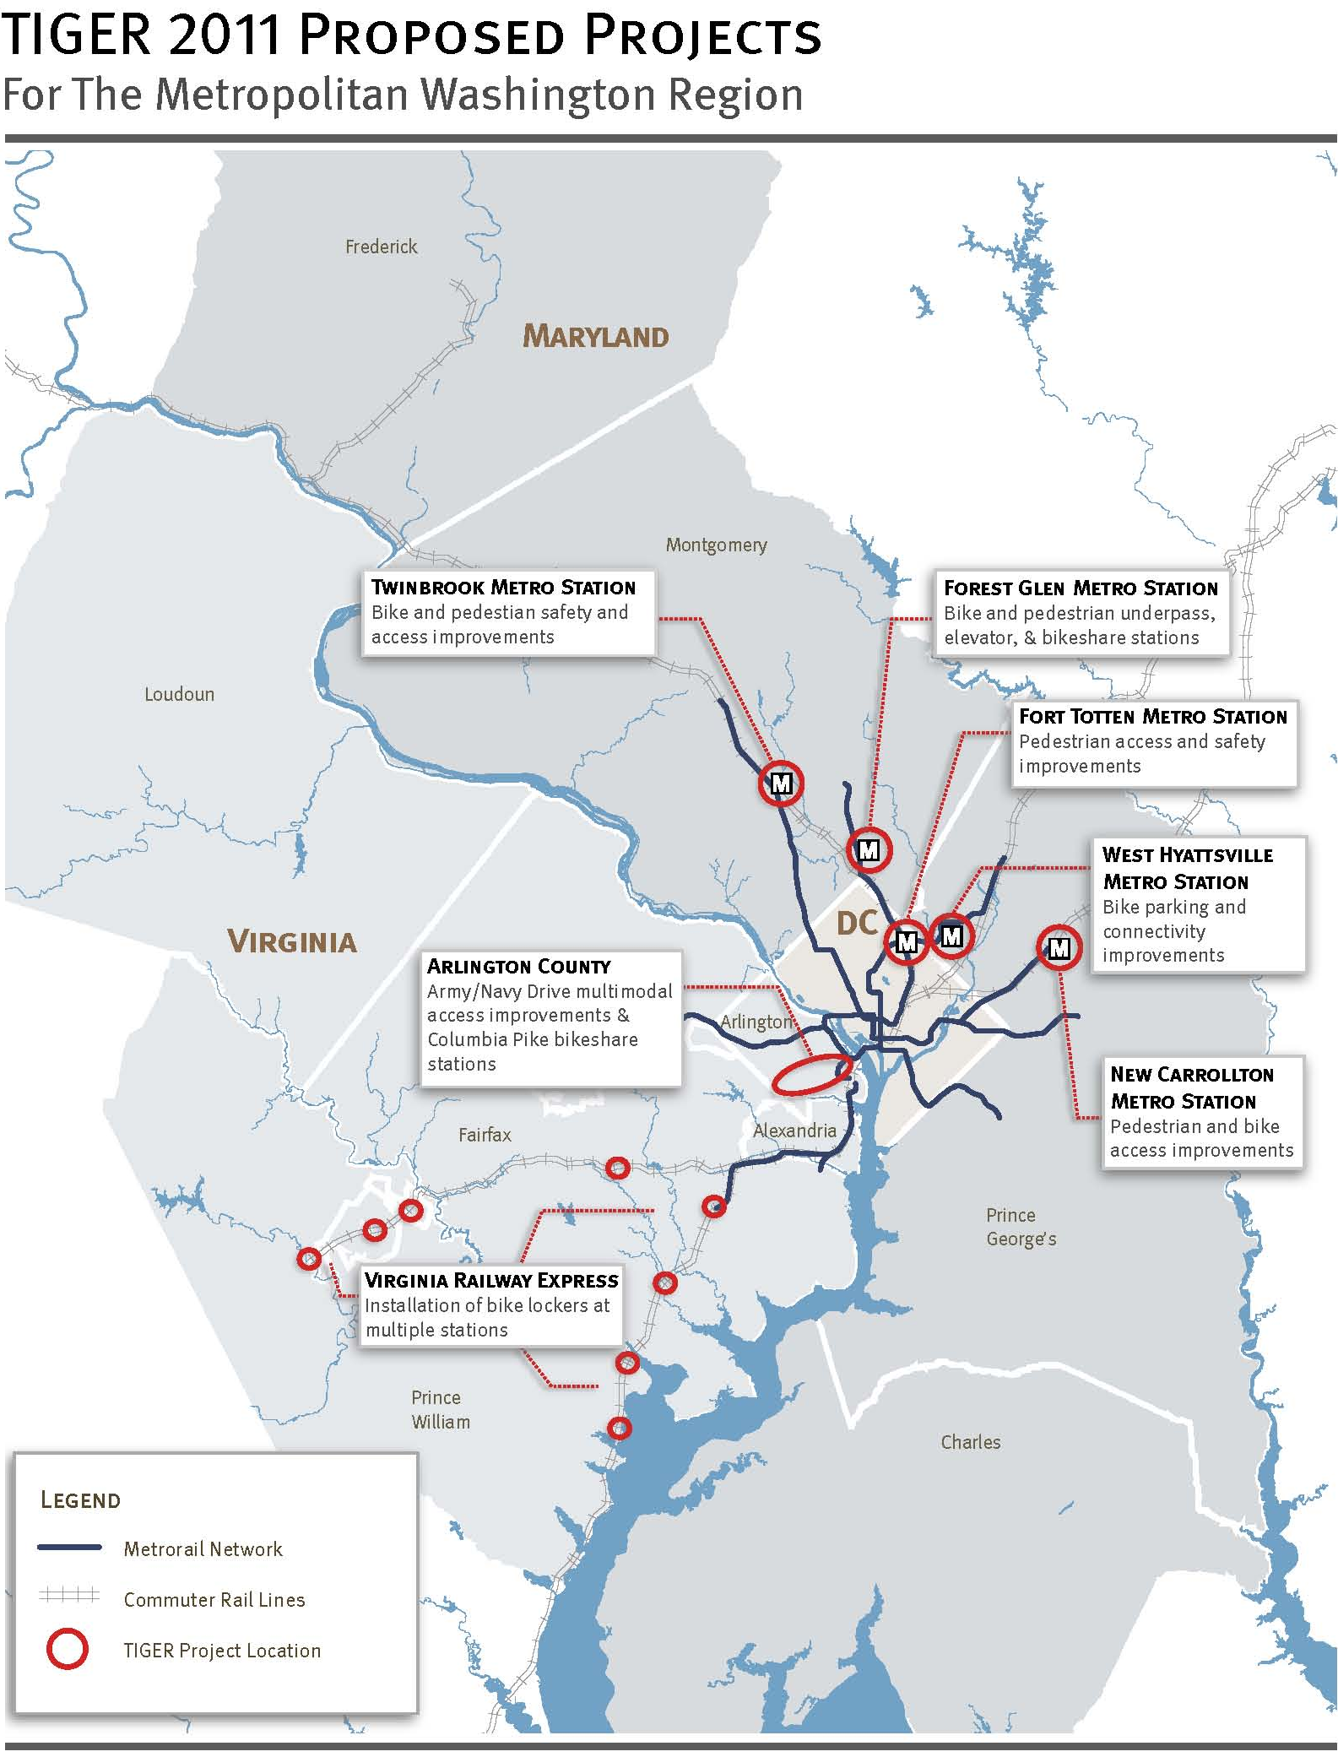

Project Need and Regional Challenges
The TPB’s application package highlights the need for the coordinated implementation of a transportation system that recognizes all modes and facilitates a balanced approach to economic development. Innovative, sustainable improvements to the transportation network are increasingly needed as the existing surface transportation system continues to come under strain, economic inequity increasingly limits access and opportunity, and regional and global environmental problems worsen. The Washington region seeks to leverage federal funds to implement small-scale, high-impact multimodal transportation improvements that increase safety and enhance access to the regional transit network.

Balance growth and development across the region
The National Capital Region has many successful examples of mixed use, transit-oriented development. The region’s robust economy is due in large part to the presence of the federal government, international community, and companies and organizations that do business with our government. The myriad pieces of these thriving developments have come together over time through a mix of local land use and funding decisions, developer contributions, and infrastructure improvements designed and funded on a regional level. Prosperity has not occurred equally throughout the region. According to scenario analysis conducted by the TPB in 2006, there is significant disparity in job growth between the eastern and western portions of the region, what has become known as the “east/west divide.” The study shows that job growth in the western portion region between 1990 and 2000 increased by 20 percent, while job growth in the eastern portion of the region increased only one percent during the same time period.

This phenomenon has caused several trends to develop. First, there is an imbalance of employment distribution related to a relatively balanced housing distribution across the region. This creates a rush hour situation where there is a general trend to commute west during the morning rush hour and the opposite trend in traffic moving east during the afternoon period. Second, the economies of the individual jurisdictions suffer because of this trend, causing friction at the regional and state levels due to the ability to attract high-quality employers. Third, housing costs have increased disproportionately in the western portion of the region; people want to live where they work to reduce commute time, but those locations are simply unaffordable for many workers in the region.

Future development initiatives and transportation options should encourage the development of locations well-served by transit, but currently underutilized for housing and employment. Small-scale improvements can serve as a catalyst for development around the region’s transit stations with untapped potential. In many cases there is often a missing link between the station and job and housing destinations that can be bridged by adding infrastructure.

Maximize efficiency of existing transportation infrastructure
The National Capital Region has an extensive highway network and the second largest public transit system in the country. Congestion and crowding on the region’s roadways and transit system is increasing and meeting the travel demands of a growing population and workforce brings difficult challenges. Congestion on the road network will continue to increase with an expected rise in VMT of 20 percent, impacting both private automobiles and bus transit. Funding constraints for all surface modes translates into an inability to keep up with rapidly rising demand.

While the region has and continues to benefit from a world-class transit system, this system faces considerable capacity challenges that endanger the future prosperity of the region. Over the next 20 years, transit work trips are forecast to increase by 35 percent as the region adds nearly 1.2 million people and almost 1 million jobs. According to projections, Metrorail ridership during the morning peak will grow from approximately 250,000 to over 350,000 by 2040. This means that 100,000 new riders will need to access Metrorail stations by some means. This increase in ridership inevitably will create even more crowding on the Metrorail system on some of the more heavily traveled corridors and at the busiest stations. Since the ability of the transit system to expand its capacity is limited by funding constraints, more creative measures must be taken to most effectively capitalize on the existing system.

In addition to identifying the east/west divide, the TPB scenario analysis identified land-use and transportation decisions that would help to alleviate pressure on the existing transportation infrastructure. These options included moving jobs and housing closer together by providing more housing options near existing employment centers or diverting job growth to locations with a high concentration of residential development. The scenario analysis also showed that increasing the region’s housing stock would decrease the number of longer distance commutes into the region. Finally, the study showed that concentrating job and housing growth in transit-oriented developments around the region’s rail stations would maximize the utility of the existing transportation system.

The projects in the grant application would provide strategic infrastructure to better integrate rail stations with surrounding communities. Integration will provide employees with viable housing and transportation options, including the possibility of taking transit and then traveling “the last mile” to a final destination by walking, biking, or riding a local circulator bus. The area’s highway and transit system will continue to play an important role in the region; however, coping with the increase in roadway traffic and transit constraints will require thinking differently about the way we plan, fund, and build our future transportation system.

Fund projects that support complete communities
Although the National Capital Region has many successful examples of mixed use, transit-oriented development, some areas of the region have been more successful than other in bringing about change which results in sustainable, complete communities. Combined, these projects provide for a greater range of mobility for all users of the transportation network, providing citizens with modal choice when considering daily trips.

The types of multimodal projects proposed in this application often slip through the cracks in the traditional federal modal funding programs. Projects that include multiple components across travel modes typically require creative funding options, and much of that funding is only available at the state and local levels. Specifically related to the TPB’s proposed project package, there is no federal funding source for rail station enhancements to existing stations. Similarly, projects that exhibit benefits such as safety improvements often compete for very small amounts of funding at the state level, even if the benefits show a likely reduction in auto-related deaths.

At a time when flexible local funding is scarce, it is all the more important to showcase how federal funding can be used to leverage limited local resources and provide for enhancements to the safety and options for all users of the transportation network.

Proposed Project
The TPB has partnered with five jurisdictions and Virginia Railway Express (VRE) to develop a package of seven projects that, together, enhance the region’s interconnected, multimodal transportation system and, sustainably and affordably, provide better access to 16 rail stations in the region. The goal of each project is to improve access to a rail station, as appropriate for each station area. Each project is the result of a comprehensive planning process. Some projects were initiated by community members or planners at the local level. Several projects are the products of regional studies, including WMATA’s “Metrorail Bicycle & Pedestrian Access Improvements Study,” completed in October 2010, and the TPB’s Transportation/Land-Use Connections (TLC) Technical Assistance Program. The products developed through the TLC Program served as the inspiration for this regional TIGER grant application concept. Many of the planning efforts completed under the TLC Program recommend capital improvements, such as pedestrian facilities or multimodal concepts for intersections or streets that further the ability of all modes to function well in a dense, multimodal area and help activity centers work well as vibrant, mixed-use places. Jurisdictions often struggle to identify funding to implement multimodal TLC projects even though these types of projects greatly enhance active transportation and sustainable communities.

The TPB’s application package highlights the need for the coordinated implementation of a transportation system that recognizes all modes and facilitates a balanced approach to economic development. The projects in this application will allow businesses to better integrate with surrounding communities and will provide employees with viable housing and transportation options, including the possibility to take transit and then travel “the last mile” on foot, by bike or by local circulator. The transportation projects in this application all focus on the common goal of providing complementary, non-motorized transportation infrastructure that will encourage the development of housing and job centers in locations well-served by transit but currently underutilized for housing and employment.

District of Columbia

1. Fort Totten / 1st Place-Galloway Road Access Improvement Project
The project will redesign 1st Place NE and Galloway Street NE in the District of Columbia to improve circulation and make the infrastructure around the Fort Totten Metrorail station safe and accessible for all modes. This project was initiated by the District Department of Transportation to improve access and circulation for the confluence of pedestrians, bicyclists, buses, and vehicles at the Fort Totten Metrorail station. The final study report recommends pedestrian improvements that include building missing sidewalk linkages, expanding some sidewalks to accommodate bicyclists, relocating crosswalks to safe locations, adding secure bike parking, and improving lighting. There are several significant changes coming to the area, including a planned intersection reconfiguration at Riggs Road NE and South Dakota Avenue NE, as well as several major real estate developments in various stages of planning and construction in the immediate vicinity that will significantly increase residential and commercial densities. These and other projects underscore the need to provide safe and efficient multimodal traffic circulation in the project study area.

State of Maryland

2. Forest Glen Metrorail Access Project
The project will construct a grade-separated pedestrian / cyclist crossing at the intersection of Georgia Avenue (MD 97) and Forest Glen Road in Montgomery County, Maryland. The crossing will create a safer linkage from the Forest Glen Metrorail station to Holy Cross Hospital. In order to increase access for users of all abilities, the project will also construct one elevator to connect the street level directly to the Metrorail station mezzanine. Finally, the project will establish Capital Bikeshare stations at the Forest Glen Metrorail station, Holy Cross Hospital and the surrounding area. The intersection of Georgia Avenue and Forest Glen Road is one of the most congested intersections located adjacent to a Metrorail station in the National Capital Region and presents challenges for pedestrians and cyclists to safely cross Georgia Avenue. The community has been lobbying several years for a grade-separated crossing that would eliminate conflicts with automobiles and significantly improve access to the Metrorail station. The project is coordinated with local development and the Maryland State Highway Administration’s MD 97/Montgomery Hills study, and would support further reverse commuting via Metrorail.

3. Pedestrian Safety Measures for the New Carrollton Metrorail Station
The project includes a subset of pedestrian safety measures recommended in a 2010 TLC Study. The project includes sidewalk and crossing improvements, as well as signal timing changes. The improvements will greatly enhance the pedestrian and bicycle access in the New Carrollton Metrorail station area in Prince George’s County, Maryland. The improvements will also serve to provide adequate infrastructure to support transit oriented development (TOD). New Carrollton is the top TOD priority for Prince George’s County. WMATA and the State of Maryland are in the process of selecting a firm to develop the north and south parcels of the WMATA station area site. The multimodal improvements implemented through this effort will provide for vital, accessible connections to a vibrant transit oriented development that engages all sectors.

4. Twinbrook Metrorail Station: Pedestrian Safety Improvements
The project will construct safety improvements along four specific corridors within one half mile radius of the Twinbrook Metrorail station in the City of Rockville, Maryland. The improvements identified in this area include refurbished high-visibility crosswalks, median extensions, curb extensions, and other related enhancements at approximately 26 intersections within the project area. These improvements were generated from a 2011 TLC Study that provided recommendations for improving the pedestrian walkways leading to the Twinbrook station. Private-sector redevelopment around the Twinbrook Metrorail station, a State of Maryland-designated TOD area, is adding more residential, retail, and office units. One such development, Twinbrook Station, has been designated a Smart Growth project by the Washington Smart Growth Alliance, received the International Charter Award for Excellence from the Congress for the New Urbanism, and was the first project in the Washington, DC, area to be awarded Stage 2 Leadership in Energy and Environmental Design (LEED) for Neighborhood Development Gold-level certification for its plan.

5. West Hyattsville Metrorail Station Access Improvements
The project will implement bicycle and pedestrian improvements around the West Hyattsville Metrorail station in Prince George’s County, Maryland. The bicycle and pedestrian measures were developed from the WMATA “Metrorail Bicycle & Pedestrian Access Improvements Study.” The project will construct sidewalks along Jamestown Road to improve access to the station, providing direct access to the station for several apartment complexes and residential communities. The project will also create a full service bicycle station at the Metrorail station. The project will help provide connectivity surrounding the West Hyattsville Metrorail Station, increasing mobility and active transportation options for underserved residents living around the station. The project will also increase the ability for people to access employment opportunities around the station.

Commonwealth of Virginia

6. Army Navy Drive Multimodal Access Improvement Project
The project re-conceives 3,300 feet of Army Navy Drive in Arlington County, Virginia, providing a wider, safer sidewalk, a physically-separated two-way cycle track, and safer street cross section that will support a future streetcar. Collectively, the capital improvements will enhance multimodal access to three major activity centers. The project is located within one-half mile of three Metrorail stations, Pentagon, Pentagon City, and Crystal City, and within one-half mile of the Crystal City VRE station. The project grows out of Arlington’s Master Transportation Plan process, and also fully supports the Federal Highway Administration’s 14th Street Bridge Corridor Environmental Impact Statement, which aims to improve conditions for pedestrian and bicycle access to river crossings as part of a long list of mitigation efforts to reduce the environmental effects of transportation in the region. The project is also in close proximity to major County capital projects. Ten new Capital Bikeshare stations will be added along Columbia Pike as part of this project. This project proposes building the region’s first separated two-way cycle track. While this type of facility is common in other parts of the world, this would be the first purpose-built cycle track both in Metropolitan Washington and the Commonwealth of Virginia.

7. Bicycle Lockers at Virginia Railway Express (VRE) Stations
The project will add bicycle lockers to VRE commuter rail stations in Fairfax and Prince William Counties, and the Cities of Manassas and Manassas Park. The project improves multimodal access opportunities to VRE by providing additional bicycle facilities at eight VRE stations, introducing 35 bicycle lockers to the system. The Franconia-Springfield station is co-located with Metrorail and several stations are served by local bus routes. VRE works closely with member jurisdictions to provide station amenities (e.g., sidewalks/trails, bicycle facilities, kiss-and-ride, station parking) that give riders a variety of transportation choices for accessing VRE service. Prince William County, Manassas, and Manassas Park are outer jurisdictions of the National Capital Region and are rarely included in discussions of transit access and multimodal transportation. The prospect of improving access to commuter rail stations provides a unique opportunity to not only facilitate bicycle and pedestrian access to the stations, but also encourage behavioral shifts towards active transportation.

TPB’s proposal has been developed to support the regional goal of creating sustainable, multimodal linkages between existing and planned employment opportunities and housing. Each project in the TPB’s application package complements this goal by providing pedestrian, bicycle, and other non-motorized connections at rail station areas, tapping into a an extensive regional asset. These series of projects will benefit the National Capital Region by [insert BCA language]. The TPB has strong relationships with each project agency and will streamline project management to ensure prompt implementation of the project components.

Together, these projects can serve as a regional and national example for how to infuse rail station areas with the capacity to not only entice employment growth but also serve existing jobs and housing with better access and greater mode choice. The projects demonstrate key safety, livability, and sustainability principles at very small, moderate, and large scales and provide a set of templates for other areas struggling with regional balance of housing and employment and maximizing capacity of their existing transportation infrastructure.

The following table provides summary information about each project component. More detailed information on each project may be found in Appendix X.
Table 1: Project Component Details
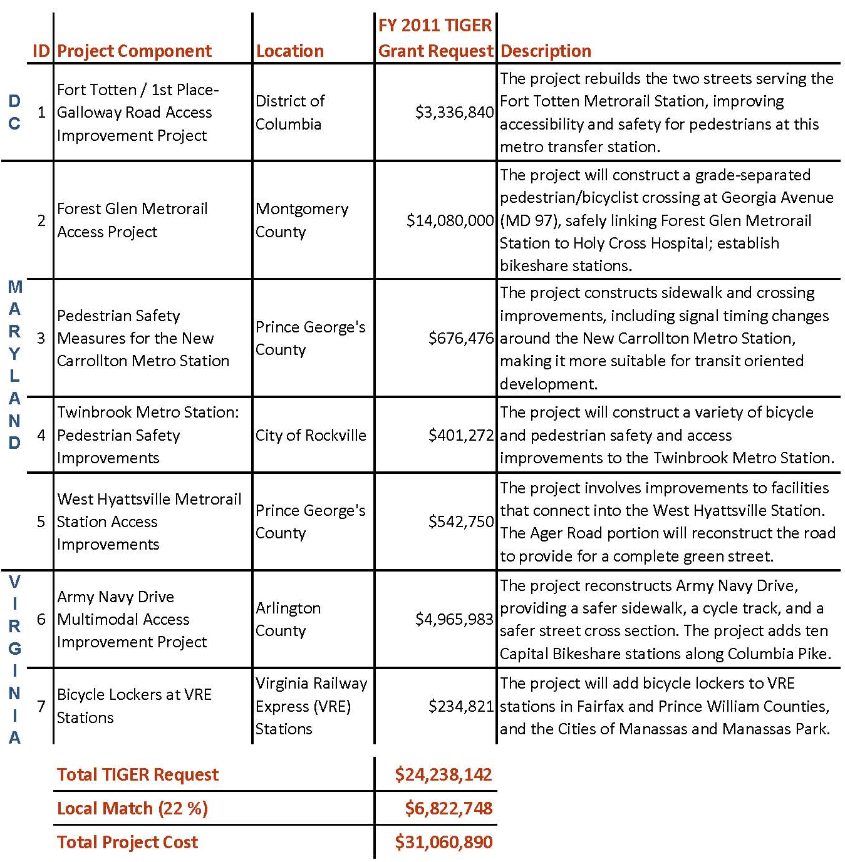

Project Parties
This project application is the result of many months of regional collaboration and cooperation among numerous local, state, and transit partners who have multimodal project concepts that do not naturally fall into existing funding structures. Upon reviewing the TPB FY 2011 TIGER application concept, project partners came forward with individual projects that each met the TPB’s application criteria in unique and innovative ways. Together, the projects represent the diversity of the region in form, application, and design. All partners and potential future partners have registered their support for this regional project, which is documented in numerous letters of support. Please see Appendix X, Letters of Support from Project Owners and Other Partners, or http://www.mwcog.org/transportation/TIGER2011 (Select “Project Support Letters”). On July 20, 2011, the TPB endorsed the TPB TIGER project application concept described in the “Project Overview” section of this application. Underpinning these letters and endorsement are TPB Resolution R3-2012 and an action to endorse the application package that were unanimously approved on July 21, 2011 and October 19, 2011, respectively. All project parties are identified with each component in Table 2, Project Cost Information.

Lead Applicant
As the MPO for the Washington Metropolitan Area, the TPB is an eligible applicant for this grant. The Metropolitan Washington Council of Governments (COG), which is a non-profit organization selected by the TPB to be its administrative agent, will be the lead applicant for this grant. Since 2007, COG has administered the Federal Transit Administration’s (FTA) Job Access and Reverse Commute (JARC) and New Freedom transit programs for the TPB when it became the FTA-designated recipient for grants under these programs. COG is also currently administering the region’s TIGER I grant award. COG will administer the grant program proposed in this application in a similar manner on behalf of TPB.

Project Owners
COG is joined by other parties as project owners, which are composed of local governments and transit agencies located and operating in the Washington metropolitan region. These include:

The District of Columbia
District of Columbia Department of Transportation (DDOT)

The State of Maryland
Montgomery County
Prince George’s County
City of Rockville

The Commonwealth of Virginia
Arlington County
Virginia Railway Express (VRE)

Project owners will be the recipients of grant funds and will be responsible for administering these funds and implementing the projects in accordance with the grant provisions. Project owners have registered their support for this application, understand the obligation this role confers upon them, and will cooperate at all levels in carrying out the activities to be supported by the FY 2011 TIGER Discretionary Grant. Table 2 identifies project owners for each of the project components.

Grant Administration
COG will be the lead applicant and responsible for managing the grant on behalf of TPB to ensure that the entire project is delivered as scheduled. To accomplish this, COG will execute a grant agreement with the Cognizant Modal Administration. To manage and integrate the project components into an effective system and deliver the entire project as timely and effectively as possible, COG will issue a request for qualifications (RFQ) for a management team promptly upon notice that the project grant will be awarded. Within 90 days, COG will hire a team of qualified consultants with appropriate staff and skills to coordinate, manage, and administer the implementation and integration of the project components, as well as to prepare all required documentation on the project grant implementation, project benefits, and financial reports. General project management expenses are included in the total project cost. It is anticipated that each public agency denoted as project owners above will execute specific grant agreements as first-tier sub-awardees with the Cognizant Modal Administration.

Grant Funds and Sources/Uses of Project Funds
Table 2 provides a listing of all components that collectively form the proposed project. The table includes the financial information including the amount of grant funding requested, total project costs, percentage of project costs that would be paid for with FY 2011 TIGER Discretionary Grant funds for each component, match sources, and percentage shares for each component of the total project. The total FY 2011 TIGER request for the project is $24,238,142, which is 78 percent of the total project cost of $31,060,890. This project is located in two states (Virginia and Maryland) and the District of Columbia, with percentage shares of the total project at 21 percent, 65 percent, and 14 percent respectively. The project is comprised of components in nine local jurisdictions, each of which supported the application with at least a 20 percent funding match. Match sources are mostly from local capital budgets, but also come from local transportation demand management funds. Match commitments have been documented in support letters from project partners, which are provided in Appendix X.

This application includes a series of multimodal transportation improvements that would collectively enhance access to the regional rail system. Each component provides unique pedestrian, bicycle, and/or streetscape enhancements to a rail station area and may stand alone from the rest of the application; however, the full benefits provided by the project package work together to improve the regional infrastructure and connect multiple modes of transportation.

Table 2: Project Cost Information
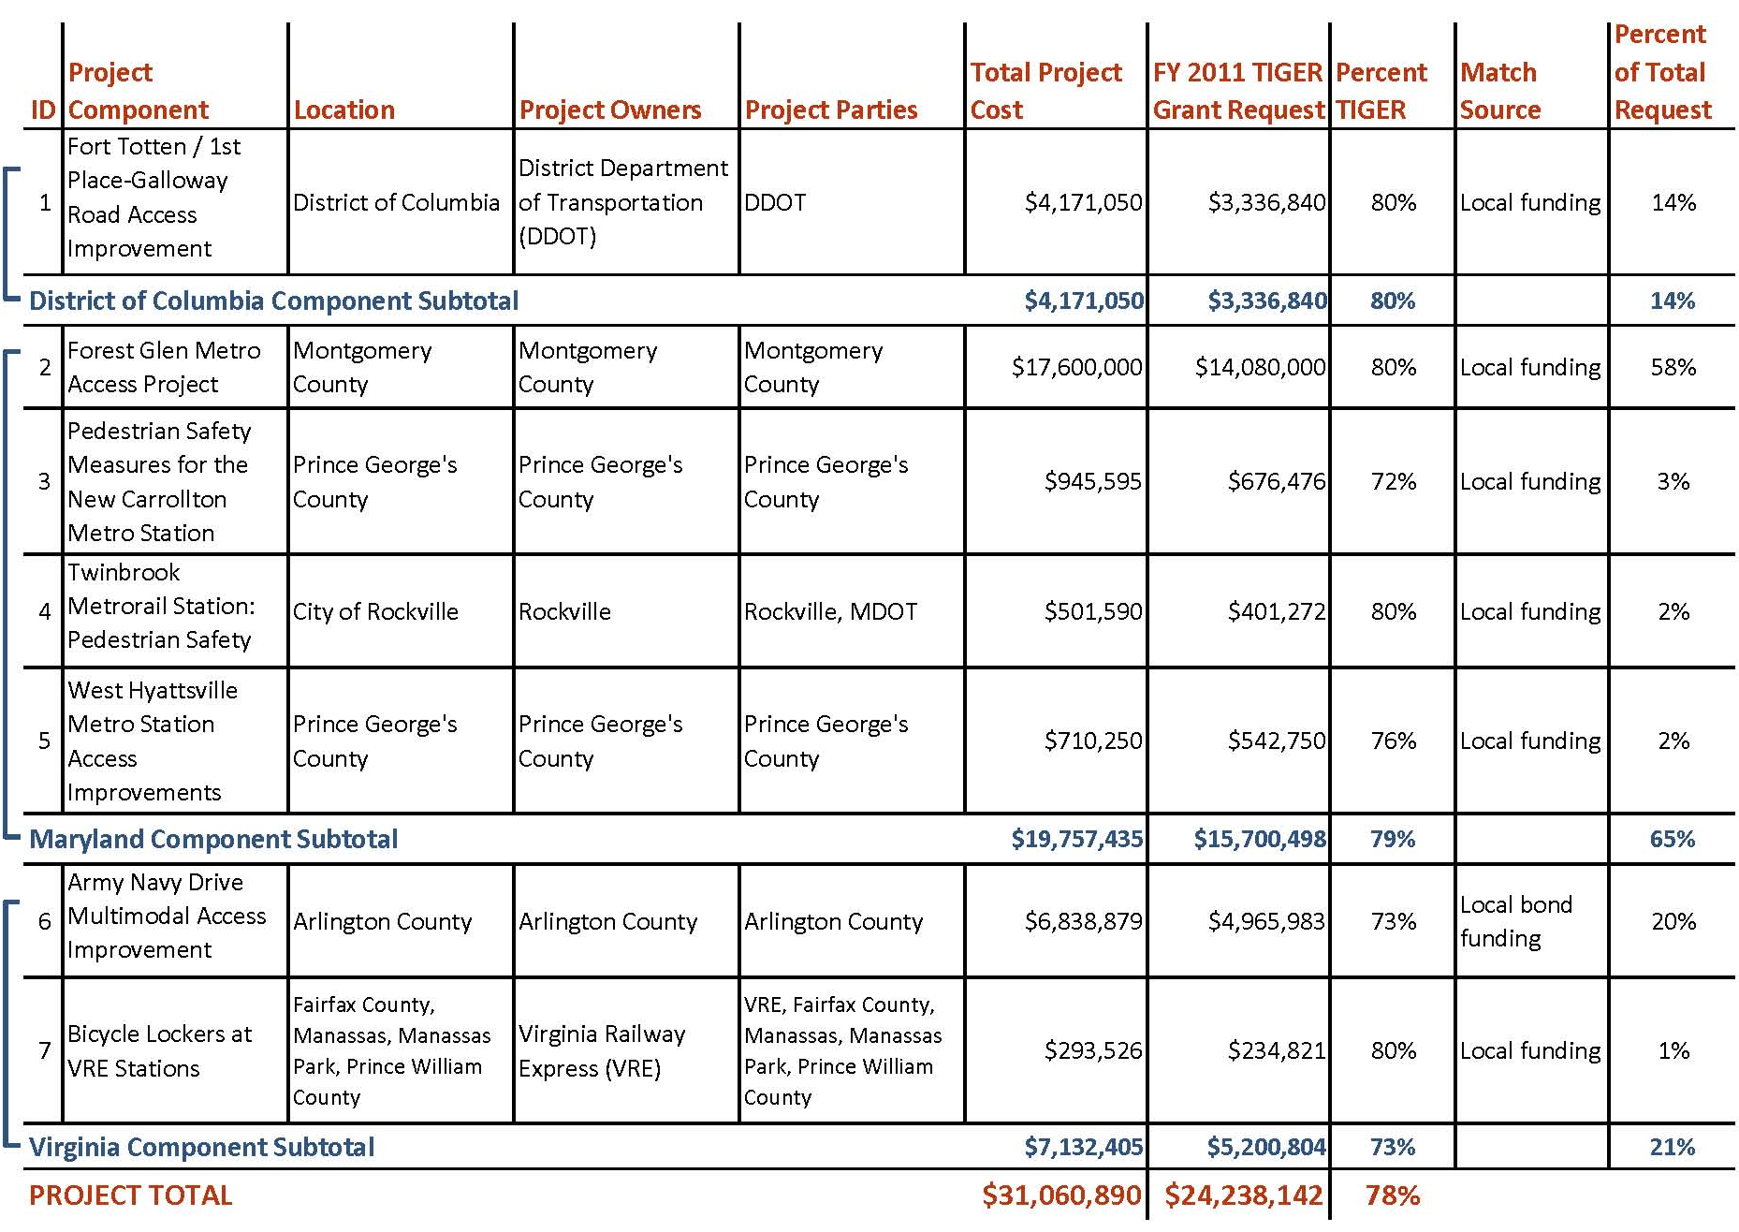

Selection Criteria
The project is a result of regional cooperation and reflects region-wide support. All 21 jurisdictions in the National Capital Region support the TPB’s application concept of enhancing non-motorized access to the region’s rail system through investments in our existing infrastructure. These jurisdictions have a history of working together to envision a prosperous and livable future. Through the TPB’s planning process, regional leaders have developed policy principles, land use and transportation scenarios, and most recently voluntary regional agreements to achieve regional goals and targets. Currently, the TPB is embarking on a regional priority planning exercise that will yield a list of unfunded, regional priorities that would have a high impact on the region’s transportation infrastructure.

The partnerships and projects in the TPB’s application package demonstrate that, together, focused enhancements to the region’s interconnected, multimodal transportation system provide better access to the region’s existing transportation infrastructure. The following is a specific discussion of how the TPB’s project will not only provide a step toward broader long-term outcomes, but will also achieve a multitude of long-term benefits resulting from small, strategic investments.

Primary Selection Criteria I: Long-Term Outcomes
The National Capital Region has fared better in this economic recession than some regions around the country. The region is host to the federal government, which not only provides a stable workforce, but also attracts companies that have business with the government. As a result, the region’s population in 2010 was 5.3 million and it is forecast to increase by 30 percent to 6.9 million by 2040. The region contained 3.3 million jobs in 2010 and it is forecast to add another 1 million jobs by 2040, a 39 percent increase.

The current transportation system is severely overburdened and can barely accommodate current demand, let alone a 30 percent population increase over the next 30 years. According to the Texas Transportation Institute’s 2011 Urban Mobility Report, the National Capital Region ranks first in the county in annual delay per peak auto commuter. The report also reveals that 84 percent of peak VMT are in congested conditions.

Significant improvements to the region’s transportation infrastructure are unrealistic under the current financial forecast. Therefore, it is imperative that strategic, cost-effective solutions be implemented to ease the burden on the system. The seven projects included in this package each enhance access to the region’s rail infrastructure through a variety of small-scale, value-added measures. Each improvement will provide users of the region’s rail system with better overall access to jobs and housing in the region.

State of Good Repair
The goal of each project in the TPB’s project package is to improve access to the region’s rail network, thus reducing dependence on motorized vehicles and providing connectivity and independent mobility. In order to reduce strain on rail system capacity, many of the station areas in the package would provide for reverse commute opportunities, thus maximizing existing excess capacity in the system. Additionally, the projects provide infrastructure to support non-motorized transportation options, contributing to intermodal station areas that provide sustainable options for residents and workers.

Reduce operating and maintenance costs
The repair and replacement of sidewalk infrastructure at the Fort Totten Metrorail station will reduce current upkeep costs for dilapidated and deficient infrastructure. Adding pedestrian infrastructure around the West Hyattsville Metrorail station will provide better access for users of the rail system who currently drive to the station from the surrounding neighborhoods. The reduced reliance on the road network will enhance the longevity of that system.

Enhance existing transportation infrastructure
Several projects will enhance portions of roadway by adhering to “complete streets” principles and create corridors that will improve use of the roadways for all modes (Arlington, Fort Totten, New Carrollton, Twinbrook, West Hyattsville). These improvements will complement the existing road infrastructure with high-quality accommodations for pedestrians, bicyclists, transit users, and persons with disabilities. Through these complete streets improvements, each project component will serve to improve access to the region’s rail stations, thus more effectively utilizing the extensive rail network in the National Capital Region.

The 20 Capital Bikeshare stations (Arlington and Forest Glen) proposed in this package will have relatively little detrimental impact on existing streets. Bike sharing will relieve pressure on many existing transportation systems and promote the most efficient use of the region’s assets in terms of person throughput. First, new bicycle trips will replace short auto trips, reducing VMT. Second, they will replace short transit trips, relieving pressure on congested transit lines, including the Orange Line in Arlington and the Red Line in Montgomery County. Third, they will increase access to transit, enabling longer transit trips, many of which are likely to be shifted from private automobile.

Improving the performance of the overall transportation system
Small, strategic improvements to the region’s non-motorized transportation infrastructure can have a positive impact on the road network and potentially reduce the anticipated usage of the road system, thus improving the quality and functionality of the region’s multimodal transportation system. Between 2010 and 2020, roads in the National Capital Region will be used more heavily, with VMT increasing by 22 percent. The number of new lane miles created is only expected to increase by 11 percent, leading to an increase of 38 percent in lane miles of congestion for the morning rush hour period. Capital improvements that provide for alternatives to automobile use provide for greater user flexibility and improved performance of the multimodal transportation system.

Currently, 30 percent of transit users drive and park at Metrorail stations in the morning peak, many alone, some with others. Given the cost of structured parking and the desire for WMATA to use land at its stations for joint development, there is a need to think strategically about how customers will access the system in the future. The reduction of short auto trips to Metrorail stations will reduce congestion around the stations. Building on the findings from the Metrorail Bicycle and Pedestrian Access Improvements Study, WMATA’s Bicycle and Pedestrian Capital Improvement Project Summary will identify the unmet bike and pedestrian access needs at all 86 Metrorail stations. It will create a comprehensive list of projects to improve the safety, capacity, and convenience of bike and pedestrians facilities at or adjacent to Metrorail stations.

The projects will enhance the ability of residents who live within one mile of the stations to walk to the stations by creating safer, more efficient non-auto access. The grade-separated crossing at the Forest Glen Metrorail station will provide better non-motorized access to the Metrorail station for residents in the area. Of the drivers who park at the Forest Glen and Fort Totten Metrorail stations, over one-third live within a one mile radius of the station, according to a current WMATA survey on parking trends at the region’s rail stations. The figure for the West Hyattsville Metrorail station is even greater; roughly one-half of those who drive and park at the station live within one mile of the station.

Economic Competitiveness
The National Capital Region has many successful examples of mixed use, transit-oriented development. Future development initiatives and transportation options should encourage the development of locations well-served by transit, but currently underutilized for housing and employment.

Address the east/west divide and jobs and housing imbalance
Several of the projects will provide bicycle and pedestrian capital improvements around rail station areas that are currently underutilized for both jobs and housing. The goal of the projects is to provide strategically placed infrastructure in locations ripe for economic development and traditionally underserved. These improvements will serve to provide infrastructure and connections around rail station areas that may serve to attract developers and businesses to underutilized rail stations. By balancing economic activity more evenly across the region, the demand on the road network related to the east/west divide should be alleviated.

West Hyattsville is located in Prince George’s County, in the eastern portion of the region. The improvements around the West Hyattsville Metrorail station will provide access to the non-motorzied transportation network for traditionally underserved communities, while providing better infrastructure for potential employment. The improvements proposed surrounding the New Carrollton Metrorail station will provide access for residents to the Metrorail and MARC commuter rail stations, as well as access for employees using these modes to the burgeoning employment center around the New Carrollton stations. The Fort Totten Metrorail station is situated in an area of the District that is underserved by high-quality multimodal transit options. The improvements will provide better access to the station for the surrounding community, as well as better access from the station to jobs in the area, which would provide for a reverse commute or the opportunity to “sell the same seat twice.”

Increase multimodal access to jobs
In addition to the east/west divide, the National Capital Region also exhibits traditional commuting congestion of workers traveling from outer areas to reach jobs in the central core. This is due in large part to the presence and location of the federal government and complementary businesses. This dynamic is an asset to the region in that is provides for stable employment; however, it creates gridlock during the AM and PM peak periods. By improving rail station access at strategic stations, workers who live near these stations may choose alternative modes to access the station if they typically use rail to commute, or may choose to switch to rail commuting altogether, alleviating some congestion on the road network. Conversely, workers who are employed near these stations may choose to commute by rail if they can rely on safe, efficient walkways from transit to work.

The area around the Twinbrook Metrorail station is experiencing growth and development, positioning it as an attractive reverse commute destination for employment. The improvements proposed for this area will improve pedestrian connections within one-half mile of the Metrorail station. While Arlington has a national reputation for leveraging the rail system successfully, the Pentagon City area has recently suffered a setback due to the Base Realignment and Closure (BRAC) actions taken by the Department of Defense. This area of the county will lose 20,000 jobs. This area is well-served by transit on two of the rail system’s less congested lines. The reconfiguration of Army Navy Drive into a complete street supports other efforts the county is undertaking to revitalize this area and attract new employers to a transit-rich, multimodal environment, creating a more efficient local transportation network to serve residents and workers.

Retailers benefit from increased pedestrian and bicycle traffic
Walking and bicycling can increase exposure to storefronts and retail businesses in main street shopping destinations. A study in Toronto, Ontario found that people who biked and walked to a main commercial area of the city spent more money in the area per month than people who drove there to shop. Tourists from around the globe visit the National Capital Region each year. Increasing accessibility to multiple modes of transportation not only provides more options for tourists to experience the region without impact to the road network, but also benefits the local economy by creating opportunities for tourists to make their way beyond the immediate station environment and explore and spend money in local businesses.

Livability
One of the goals of many jurisdictions in the National Capital Region is to create neighborhoods where residents can live, work, and play. The goal of the TPB’s application package is to foster complete communities across the region, linked with a multimodal transportation network.

The scope of impact for the project is regional
The project components represent a diversity of project needs and environment scales that exist throughout the region. The project reaches 16 rail stations and adds 20 bikeshare stations to a regional system, creating more intermodal connections throughout the region. While small in scale compared to the overall need for these types of multimodal capital improvements, this application package provides a framework around which jurisdictions can build momentum for multimodal projects that are difficult to fund, and a template for discrete improvements that can be completed as precious resources become available. The projects implement access improvements that allow users to reach more of the region without using an automobile. Components of the projects, such as bike-sharing contribute to an existing, vibrant system that is continuously being expanded and improved.

The 20 bikeshare stations (Arlington and Forest Glen) proposed in this package will add capacity to the Capital Bikeshare network in the Washington Region. According to Capital Bikeshare, the bikeshare system welcomed its one millionth trip on its first anniversary. Capital Bikeshare currently averages about 4,000 trips per day. Users of the bike-sharing system will operate their bicycles on existing roadways and paths, utilizing the existing infrastructure and network of bicycle facilities and streets, as well as the new cycle track proposed on Army Navy Drive. As of October 2011, there are 110 stations and roughly 1,100 bicycle in the Capital Bikeshare system. Through a grant received by the Montgomery County Department of Transportation under FTA’s JARC Program, Capital Bikeshare will be brought to Twinbrook, expanding the reach of the regional bikeshare system. Annual membership and usage fees will be waived for low-income workers who meet program guidelines. The improvements made through this grant effort will facilitate access to and use of the bikeshare system. Additionally, the ability of commuters to stow bicycles in bike lockers at VRE Stations at the beginning of their journey to work will potentially attract these commuters to use the bikeshare system upon reaching the core of the region.

Create Complete Communities
Jurisdictions in the region often struggle with the goal of creating complete communities when faced with the task of converting auto-oriented, single-use environments into multimodal, mixed-use communities. Small, strategically located capital improvements on public property can help to encourage developers to build and employers to locate in these communities. By focusing these improvements around underutilized rail stations, the jurisdictions can truly create a multimodal environment where residents and workers can live, work and play without having to rely on an automobile. Several of the projects provide multimodal infrastructure in locations where residents are typically underserved or have few high-quality options for travel. Some locations in the eastern part of the region struggle with attracting employment opportunities, leaving low-income residents with long commutes to jobs in the western portion of the region. Creating options for residents and workers allows them the flexibility to determine the most cost-effective and time efficient mode of transportation.

The New Carrollton Metrorail station is an intermodal hub located in Prince Geroge’s County in the eastern portion of the region. New Carrollton is served by Amtrak, MARC commuter rail, Metrorail, and bus services, however pedestrian and bicycle access to the station is both difficult and dangerous. The County has named the station as its number one transit-oriented development priority. The improvements funded through this grant would help provide access to the station for existing residential and employment facilities, as well as complement the development already underway around the station. The bike lockers installed at VRE stations will serve to provide for high-quality facilities for bicycles in a traditionally auto-oriented environment.

Improve transportation options for millions of residents in need
The region suffers from a current lack of housing and transportation affordability. According to the Center for Neighborhood Technology’s online Housing and Transportation Affordability Index, virtually the entire region is marked by housing and transportation costs that are more than 45 percent of area median income. This need for affordable options is also highlighted by the dependency of the region’s residents upon non-automobile travel modes. Around 12 percent of the residents of the Baltimore-Washington region are without an automobile, and in the District this number jumps to 37 percent. Creating better active transportation connections around rail stations in the National Capital Region will provide more options and connectivity for persons not owning an automobile.

Congestion savings across all modes
Each of these improvements will facilitate the use of multimodal transportation options and enhance the non-motorized transportation network. These projects will lead to reduced motorized vehicle congestion for the region, saving all users time and money.

The grade-separated pedestrian and cyclist crossing of Georgia Avenue will create an additional access point to the Forest Glen Metrorail station, improving access to Holy Cross Hospital and saving pedestrians time by creating a streamlined pathway to points east of Georgia Avenue. Montgomery County has studied possible changes to the signal timing to allow more time for pedestrians to cross these roads, however, this would result in greater delays in automobile traffic on the already highly congested roadway. This improvement will also facilitate automobile throughput on Georgia Avenue, which has one of the highest traffic volumes in the State of Maryland for an arterial roadway. The intersection of Forest Glen Road and Georgia Avenue was designated as Montgomery County’s most congested intersection during peak hours by the Maryland National Capital Park and Planning Commission. The cycle track planned for Army Navy Drive in Arlington will provide high-quality bicycle access to the Pentagon, Pentagon City, and Crystal City (and their respective Metrorail stations). This improvement, coupled with the bikeshare stations along adjacent Columbia Pike, will provide time savings for bicyclists on an efficient facility.

Environmental Sustainability
Each improvement in this package enhances non-motorized access to rail stations in the National Capital Region. These projects will provide current and future residents with infrastructure that allows them to move about the region without relying on an automobile.

Increase passenger fuel efficiency and reduce air pollution
The net impact of these improvements will reduce dependency on single-occupant automobiles by enhancing non-auto access to transit, making jobs and housing more accessible through non-motorized modes. This will give motorists the option to use an alternative mode to make a commute previously completed in an automobile. By taking motorists off the roads, congestion will be reduced for those who must rely on an automobile for moving about the region, creating a more efficient transportation system. The reduction of single-occupant vehicles will also have positive effects on other environmental resources. For example, less VMT means less polluted runoff in the region’s waterways and groundwater. As a result of the grade-separated pedestrian crossing at the Forest Glen Metrorail station, motorists on Georgia Avenue will experience less congestion at the Forest Glen Road intersection. The cars will not stop as frequently, reducing emissions resulting from idling.

Improve service without building resource-intensive new infrastructure
A major environmental benefit of the TPB’s project package is that some elements seek to improve service and increase transit capacity without building extensive infrastructure. This eliminates the need to take more land for travel lanes or build and/or operate new transit lines to extend the current reach of transit. By investing in small-scale, strategic multimodal improvements, the region can capitalize on the existing transportation network by providing better access to the rail system. Each project contributes to this goal: the Arlington and Forest Glen projects add bikeshare facilities to a regional network; the West Hyattsville and VRE Stations projects add bicycles amenities to rail stations; Fort Totten, New Carrollton, and Twinbrook enhance pedestrian connections to rail stations.

Safety
The improvements proposed in the TPB’s application package enhance safety for all modes in the National Capital Region. In some cases this may mean removing barriers for certain modes to achieve access, such as creating sidewalks where none exist or providing bicycle infrastructure to highlight the presence of bicycles in the roadway. In other cases, this may means keeping modes separated to reduce conflicts in highly congested areas and save lives, including separate facilities for bicycles or grade-separated crossings to enhance non-motorized connections.

Accommodate all modes safely
The goal of complete streets is to provide for transportation infrastructure that accommodates all modes safely and efficiently. Several of the projects highlight the commitment to create transportation facilities that accommodate all modes, with equivalent attention to the needs of each mode. Access to the West Hyattsville Metrorail station and New Carrollton Metrorail station is significantly impeded by the lack of any sidewalk infrastructure along several corridors. By connecting the pedestrian infrastructure, access to transit will be enhanced for those currently using informal paths and may also encourage use of the transit system by persons deterred by the current lack of safe passage. The reconfiguration of Army Navy Drive in Arlington will provide for an environment that accounts for the safety of all modes with complete streets enhancements to the roadway, providing safer access for pedestrian and bicyclists. According to Arlington county Traffic Counts from 2005, over 22,000 pedestrians traverse the intersection at Army Navy Drive at Hayes Street each weekday and almost 19,000 pedestrians use the same intersection on each weekend day. Army Navy Drive will also include a dedicated cycle track to expedite the throughput of bicyclists in an area used extensively by all modes. This will provide bicyclists with a safe, efficient, parallel route to motorists.

Reduce automobile and non-motorized modal conflict
The Forest Glen grade-separated crossing will reduce the significant number, rate and consequences of the crashes, injuries and fatalities of pedestrians and drivers at the intersection of heavily traveled Georgia Avenue and Forest Glen Road. There is currently no significant pedestrian refuge in the middle of the road where people can wait for the next signal phase. According to the BCA, the grade-separated improvement will prevent at least one crash-related death and sixteen vehicle-pedestrian crashes, making access to the station safer for patrons and employees of Holy Cross Hospital and the community. Additionally, the Forest Glen Metrorail Station will be more accessible to users of mobility devices, providing a safe passage to the Holy Cross Hospital for users who might otherwise seek another mode of transportation.

Primary Selection Criteria II: Job Creation & Near-Term Economic Activity
Investment of grant funds in the project and its components will result in economic benefits to the region and nation, including both jobs and increases in economic activity. Economic activity itself will generate induced jobs, which are not jobs that directly result from the infused spending; rather, they result from the increases in economic activity that results from these overall increases.

A factor of 1 new job per $92,000 of government spending was used to estimate the number of new jobs. Of this, 64 percent of the new jobs were direct and indirect jobs, while 36 percent was induced jobs. This is based on the May 2009 memorandum, Estimates of Job Creation from the American Recovery and Reinvestment Act of 2009, issued by The Executive Office of the President, Council of Economic Advisors. The total number of new jobs estimated to occur as a result of implementation of the entire project is 411. Of these, 263 are direct/indirect jobs, and 148 are induced jobs. These jobs result exclusively from the capital investment in the proposed projects. In addition to these jobs, some components will yield long-term jobs required to either operate the program or facilities, as well as jobs that may result from increased economic activity prompted by the components.

Secondary Selection Criteria I: Innovation
The projects included in the application package will introduce several innovative transportation techniques to the National Capital Region. Innovations include a two-way cycle track, extensive bicycle treatments to traditionally auto-oriented locations, and the implementation of green streets techniques.

Dedicated, two-way cycle track
Part of the TPB’s project package includes building the region’s first separated two-way cycle track in Arlington. This type of facility is common in other parts of the world, especially in northern Europe, and this would be the first purpose-built cycle track in the Metropolitan Washington, DC area, and the first in the Commonwealth of Virginia. By narrowing the wide existing street cross section of Army Navy Drive, space will be created for greatly improved conditions for pedestrians along an improved sidewalk, and a new alignment will be created for a dedicated bicycle facility. This will be done without negatively affecting motor vehicle operations, and while assuring a good fit for the anticipated fixed-rail streetcar line in the corridor. The anticipated cycle track facility proposed for Army Navy Drive is difficult to implement under existing modal funding in part because it is costly to build in prime urban settings, and in part because there are few precedents in this country for this type of bicycle accommodation. Together with international best practices as embodied in reference standards such as the Dutch Design Manual for Bicycle Traffic, the County is confident it can build a safe, convenient, and exemplary urban bicycle facility.

Enhanced Bicycle Facilities
Several projects in the TPB’s application provide bicycle facilities in areas that are heavily auto-dependent. The addition of bike lockers to eight VRE Stations in Fairfax and Prince William counties and the cities of Manassas and Manassas Park will provide users with high-quality bicycle facilities in suburban locations around commuter rail, creating incentive for VRE customers to commute to the rail station by bicycle. Additionally, the application includes the addition of bikeshare facilities around the Forest Glen Metrorail station, providing an alternative to the automobile for this auto-dependent area.

Secondary Selection Criteria II: Partnership
The TPB has partnered with five jurisdictions and Virginia Railway Express (VRE) to develop a package of seven projects that, together, enhance the region’s interconnected, multimodal transportation system and, sustainably and affordably, provide better access to 16 rail stations in the region. The goal of each project is to improve access to a rail station, as appropriate for each station area. Each project is the result of a comprehensive planning process.

TPB staff developed this project proposal over four months of regional coordination, cooperation, planning and consensus building. Staff consistently met with state and jurisdictional agencies to refine the proposal and discuss the merits of the individual projects. Decision-makers from throughout the region have stated that this application concept is integral to creating livable communities and ensuring the transportation infrastructure if used to its capacity.

Additionally, several of the components of the project were developed through public processes that engaged many stakeholders. The Forest Glen Metro Access Project was developed through a collaborative process and has the unanimous support of the surrounding communities, businesses, and Holy Cross Hospital. The New Carrollton Metrorail station improvements and the Twinbrook Metrorail station improvements were each the result of a regional planning grant received by Prince George’s County and the City of Rockville under the TPB’s TLC program, a process which included significant stakeholder input. The improvements recommended around the Fort Totten Metrorail station were developed through a comprehensive public process.

Benefit-Cost Analysis
The benefits and costs of the multimodal accessibility project were evaluated and are presented in this section. The following table provides a summary of this analysis, which shows that the benefits of the proposal outweigh the costs over the 20 year performance period. At a 7 percent discount rate, the benefit-cost ratio of the project is X.XX, with a X percent rate of return. The analysis summary is followed by a description of benefits not quantified in the analysis and a description of the methodology and limitations of the data available. The benefit-cost analysis, including a full description of input data, methodologies and data limitations are included in Appendix X and Appendix X, available for download from http://www.mwcog.org/transportation/TIGER2011.

Table 3: Benefit Cost Analysis Summary
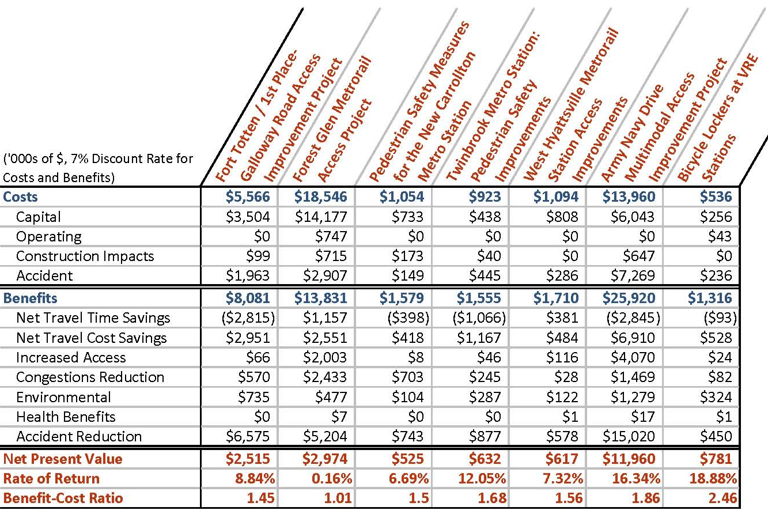

Additional, Unquantified Benefits

There are several qualitative benefits of the proposal that were not captured in the BCA. Many of these benefits are discussed throughout the primary and secondary criteria discussions; however, a few are noted here.

The procurement of twenty Capital Bikeshare stations (Arlington and Forest Glen) further extends the system throughout the region. While the stations to be added by this project are a relatively small extension of the system, there will be further network effects as users have greater access to the system across the region, increasing its visibility and utility. The spread of bicycle infrastructure, including bike sharing, bike lanes, bike lockers, and complementary accessibility improvements will act as a marketing tool to attract more people to consider a bicycle for a utilitarian trip.

Improvements in station infrastructure, lighting, and quality of service appurtenances are anticipated to improve personal security and safety for rail travelers, improving the attractiveness of utilizing transit. Theft and property vandalism are an issue at rail stations; improved lighting and appurtenances will deter such minor crimes. Improved sidewalks and lighting will also reduce safety hazards such as slips and falls. Sufficient data is lacking to make a quantitative assessment of these security and safety benefits, aside from the increases in transit use anticipated.

Finally, economic development benefits from the increased productivity of proximate businesses and residences with persons making use of the project components will take place. Typically such a change is quantified by estimating a modest increase in property value (approximately one percent) within a quarter mile around rail stations. However, recent fluctuations in property value, particularly for the several parcels that are currently under-developed (New Carrollton, Fort Totten) or are experiencing significant transition (Arlington) make use of the current values unrealistic in projections of actual or future value.

Input data and methodological standards used
The foundation of the analysis is based around several basic assumptions regarding users and mode shifts. Current and forecast user data was developed from Metrorail and regional travel demand models. Mode shares were calculated from the surveys conducted of Metrorail users and VRE users, and forecast based on station typology changes and typical bicycle infrastructure use rates. Major assumptions regarding accident rates, mode shares, and trip characteristics, such as average trip lengths, were taken from the COG Household Travel Survey (HHTS) 2007/2008.

The major costs in the benefit-cost analysis model are capital costs, construction impacts, travel time costs, and increased accidents. Capital costs include final design and engineering, utility relocation, and project construction. Construction of projects across active roadways has a temporary negative impact on road users. Travel time costs increase for many users switching mode, as travel times associated with walking or biking to a rail station and then making use of transit are typically longer than driving times. The increase in travel time costs is offset by the larger increase in travel cost savings due to reduced automobile and fuel use. Accident costs reflect the possible increase in accidents from adding more cyclists to the road, both from bicycle accessibility improvements and the bikesharing stations installed.

The major benefits in the benefit-cost analysis model are user travel cost savings, increased accessibility, reduced automobile use, congestion reduction, emissions reduction, improved public health, and accident reduction. Benefits apply to existing users, and new users are expected to use the system, both from mode shifts and as new trips not previously taken. User travel cost savings are a determination of the change in the direct user fees paid by travelers based on mode shifts, which for this project are shifts to pedestrian and bicycle trips from automobile, bus transit, and personal bike (for bikeshare). Increased access benefits were determined for trips that previously were not possible or worth the time or cost by calculating the consumer surplus between the user and time travel costs of the mode used versus automobile use. Accident reductions were determined based on the extent of new grade or barrier separation provided for bicyclists and pedestrians, along with a factor for improved street crossings.

Benefits were also assumed from reducing VMT, such as congestion reduction, emissions reductions, and accident reduction. VMT reductions were assumed to come from trips shifted from auto to transit, bicycle, and pedestrian. Lastly, benefits were assumed from increasing the number of people meeting the CDC’s recommended daily physical activity, defraying public health care costs.

A more detailed methodology is available in Appendix X.

Data Limitations
The primary limitations of the data are the lack of specificity and the need to average different assumptions into one regionally representative figure. Improvements in safety are based on general practice; however actual improvements in safety will depend on unique characteristics at each location as well as user perceptions and actions.

Project Readiness and NEPA
Each of the projects in the TPB’s application package requires final design and engineering prior to construction readiness. Most of the projects will have completed final design and engineering by the end of FY 2012. Construction is projects to be completed for five of the project components by the end of FY 2014. Construction of the most complex project elements, the grade-separated crossing of Georgia Avenue at the Forest Glen Metrorail Station and the reconstruction of Ager Road in conjunction with the West Hyattsville Metro Station improvements, will be completed by the end of FY 2016 and FY 2015, respectively.

Table 4: Project Schedule
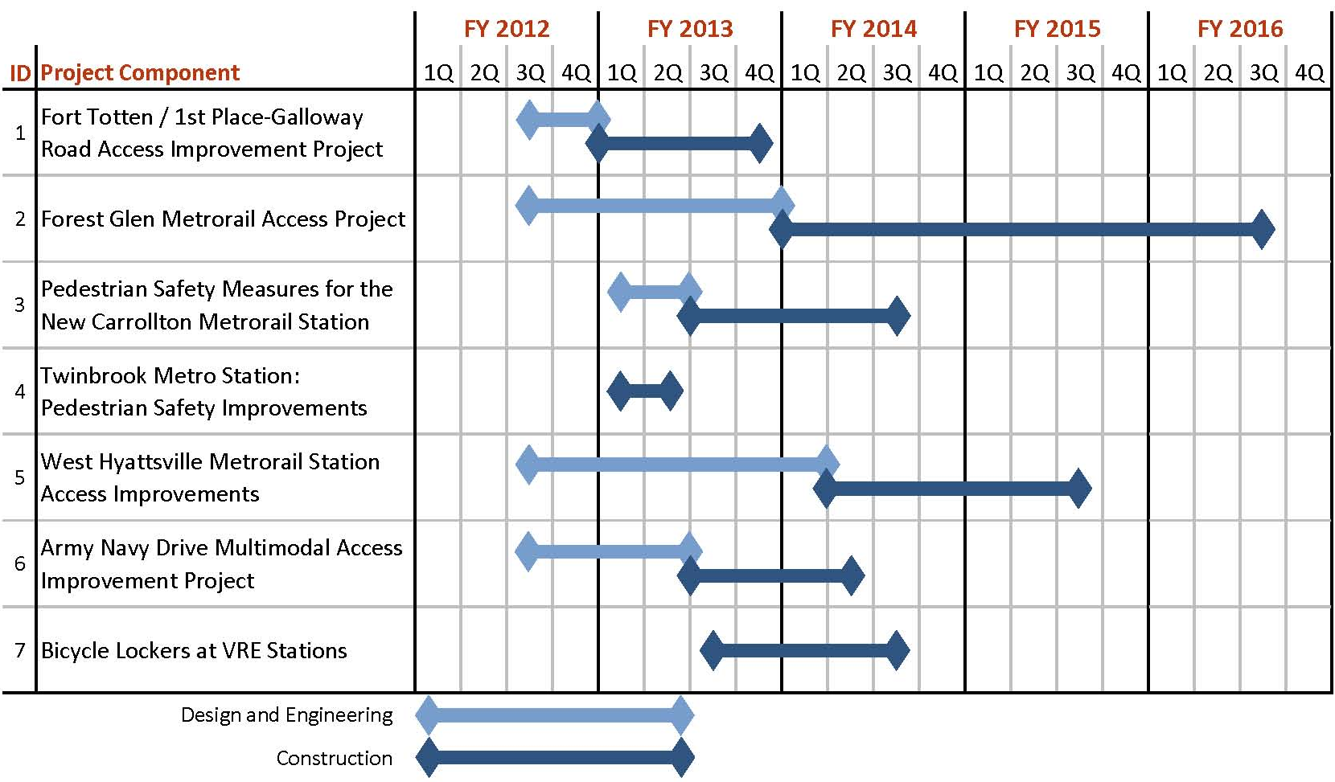

National Environmental Policy Act Requirement
Components of the proposed project may be subject to the provisions of the National Environmental Policy Act of 1969, as amended (hereafter NEPA). A feasibility report for the Forest Glen Metrorail Station Access Project is currently underway. Potential impacts to community, property, and natural, cultural and socio-economic resources are anticipated to be minor and it is expected that a Categorical Exclusion (CE) will be completed and approved by the Spring of 2012.The project to install bike lockers at VRE stations qualifies as a CE under 23 CFR §771.117, c.3, and does not require any further NEPA approvals by FTA. For all other components in the proposed project, NEPA analysis has not been completed, but it is anticipated that they will meet the criteria standards for a CE. These projects do not entail construction or other surface disturbing activities or they are confined to existing rights-of-way. For all project components, the appropriate level of NEPA analysis will be completed in time for project implementation and completion, in accordance with the project schedule provided in the previous section.

Environmentally-Related Federal, State and Local Actions
As part of project implementation, all project applicants and owners will comply with all applicable Federal, State, and local permitting requirements. Permits required for both the construction and operation of these proposed projects will be obtained. As is the case with all capital improvement projects implemented by any of the parties identified in this application, all applicable Federal, State, and local permits will be identified and obtained in accordance with standard construction management procedures carried by the applicants. All coordination necessary has begun or will be undertaken, such as coordination with WMATA on capital improvements at Metrorail stations.

Federal Wage Rate Certification
As the signatory to this application, the Metropolitan Washington Council of Governments certifies it will, in its role as administrative agent for the TPB and lead applicant for this TIGER grant application comply with all wage rate requirements and other applicable provisions of the United States Code, Subchapter IV of Chapter 31 of Title 40.

Material Changes to the Pre-Application
None as of October 13, 2011.

U.S. Bureau of the Census, Metropolitan and Micropolitan Statistical Area Estimates: April 1, 2000 to July 1, 2008, accessed from http://www.census.gov/popest/metro/CBSA-est2008-annual.html, accessed August 20, 2009.
Washington Metropolitan Area Transit Authority, Metrorail Bicycle & Pedestrian Access Improvements Study, October 2010: http://planitmetro.com/wp-content/uploads/2010/12/Metrorail-Bicycle-Pedestrian-Access-Improvements-Study-_Final.pdf.
District Department of Transportation, 1st Place and Galloway St, NE Transportation Access Study and Improvement Plan Final Report & Conceptual Design, August 2011: http://tooledesign.com/forttotten/project.html
MWCOG/Prince George’s County, New Carrollton Interim Pedestrian Safety Improvements, June 2010: http://www.mwcog.org/transportation/activities/tlc/pdf/NewCarrolltonPedSafety.pdf
MWCOG/City of Rockville, Safer Walkways to Transit, Final Report and Conceptual Plan. May 2011: http://www.mwcog.org/transportation/activities/tlc/pdf/Rockville-TOD.pdf
WMATA, Metrorail Bicycle & Pedestrian Access Improvements Study.
Texas Transportation Institute, 2011 Urban Mobility Report, September 27, 2011: http://mobility.tamu.edu/ums/.
Clean Air Partnership, “Bike Lanes, On-Street Parking and Business: A study of Bloor Street in Toronto’s Annex Neighborhood,” February 2009: http://www.cleanairpartnership.org/pdf/bike-lanes-parking.pdf
Capital Bikeshare, Capital Bikeshare Hit One Million Rides on First Anniversary, Press Release, September 20, 2011: http://capitalbikeshare.com/news/?p=1002
CNT Housing and Transportation Affordability Index http://htaindex.cnt.org/mapping_tool. php?region=Washington--Baltimore,%20DC--MD--VA--WV
Washington Post, “Stuck at a Crossroads is Par for the Course”, Thursday June 1, 2006
DDOT, 1st Place and Galloway St, NE Transportation Access Study and Improvement Plan Final Report & Conceptual Design.

