Bicycle Beltway/National Capital Trail Summary Report
DRAFT 9/20/2016
Item #6

Background
In January 2014 a TPB member suggested that the Bicycle & Pedestrian Subcommittee develop a Vision for a circumferential bicycle route around the core of the Washington Region.
The Atlanta “Beltline” Trail was the apparent model for this proposed circumferential route. The Atlanta Beltline is a trail, currently under development, that circles Atlanta’s core urban neighborhoods on a disused railway right of way. The sections completed thus far have provided a non-motorized link between urban neighborhoods formerly cut off from each other by highways and rail lines, stimulating new trail-oriented development.
The Vision
In response to the TPB’s suggestion, the Subcommittee formed a “Bicycle Beltway” working group, consisting of Three State DOT representatives, a WABA representative, and a couple of citizens. The working group developed a Vision Statement for a Bicycle Beltway, and identified an inner route. The Bicycle Beltway was to be circumferential loop shared-use path connecting the region’s radial shared-use paths. The Bicycle Beltway would:
- Connect major attractions, Activity Centers, and Transit Stations
- Attract both visitors and residents
- Be useable by persons of all ages and abilities
  - Principally off-street, with high-quality on-street connections and crossings
  - Avoid steps and steep grades
- Include clear and consistent wayfinding
- Provide good connections to surrounding communities
- Be an all weather facility
- Be achievable or “within reach” financially and politically
  - Short-term: 5 years
  - Long-term: 30 years
- Use existing Right of Way and existing facilities wherever possible
  - Fill the gaps between
- Be maintained in a State of Good Repair

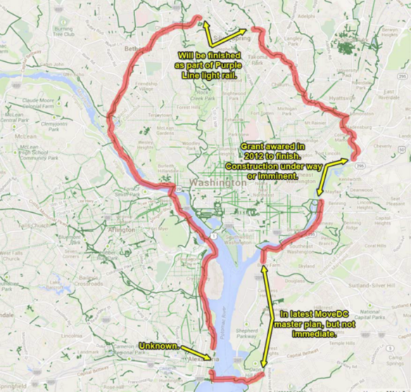
The Inner Loop
An inner loop was quickly identified, following the Mt. Vernon Trail, the Capitol Crescent Trail, the planned Purple Line trail, the Sligo Creek Parkway, the Anacostia Trail, the planned South Capitol Street Trail, and the Woodrow Wilson bridge. A connector on the South Capitol Street Bridge to the SW Waterfront Trail and the 14th Street Bridge created two connecting loops. Since much of the route was already complete or in agency plans with identified right of way, the inner loop was judged capable of being built within five years.
The Vision statement and the proposed inner route were presented to the Bicycle and Pedestrian Subcommittee in July 2015.
The Outer Loop
In addition to the inner loop route, VDOT and MDOT representatives requested an outer loop that would cross the Potomac at the American Legion Bridge and the Woodrow Wilson Bridge. However, work on an Outer Loop stalled, due to lack of a clear right of way or planned trails, as well as staff turnover, particularly in Maryland.
At the same time, other planning efforts were underway to identify regional trail routes, including the Prince George’s County Trails Master Plan (draft released May 2016), the National Parks Service Paved Trails Study (August 2016), and the Regional Trails Coalition, an effort organize by the Washington Area Bicyclist Association, and funded by REI, to develop a regional Trails Plan. This last group included most of the members of the Bicycle Beltway working group. Subcommittee members suggested working with the National Park Service and the Regional Trails Coalition to identify an outer loop.

National Park Service Endorses the Bicycle Beltway

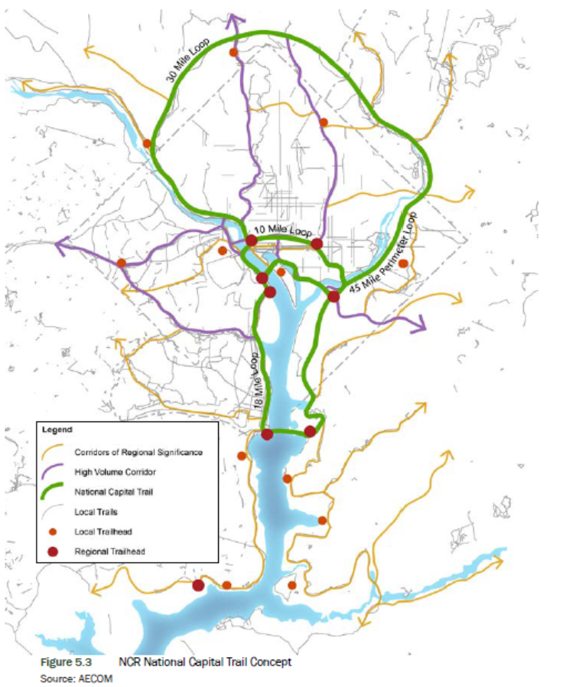
National Park Service adopted the Bicycle Beltway inner loop as part of its Paved Trails Plan, rebranding it the “National Capital Trail”. The National Park Service route, shown in green below, added a short-cut from the Anacostia River Trail through the Capitol and the north side of the mall. The NPS also re-routed the Potomac River crossing from the Key Bridge to the Memorial Bridge, avoiding a difficult on-street connection in Georgetown. Otherwise the routing is unchanged.
The National Capital Trail comprises four connected loops: a 30 mile northern loop, a 10 mile central loop around the monuments and the stadium, an 18 mile southern loop connecting to National Harbor and Old Town Alexandria, and a 45 mile perimeter loop.
“The NCT idea is compelling because it is simple, understandable, and refrains from trying to be overly ambitious or inclusive of all trails in the NCR or broader region.”

The National Capital Trail forms a hub that unites a radial network of trails. These “Corridors of Regional Significance” connect centers of population and employment to NPS parks, local trails and on-street facilities.

Implementation of the National Capital Trail will require support from multiple parties including the NPS, Arlington County, Montgomery County, Prince George’s County, the District of Columbia, and the City of Alexandria.

National Capital Trail Projects
While much of the National Capital Trail already exists, there are gaps that need to be filled, existing trail segments that need to be widened and upgraded, and access to surrounding neighborhoods added.
The table below list the major projects needed to complete the national capital trail, by jurisdiction.
Name | Jurisdiction | Gap | Plan | Project ID
Anacostia Riverwalk Trail | DC | Connect to Prince George’s County Anacostia River Trail | MoveDC, NPS Paved Trails
Georgetown Waterfront Connector | DC | Connect Capitol Crescent Trail to Rock Creek Trail | MoveDC, NPS Paved Trails | C1.1
Capitol to Virginia Avenue SE Trail | DC | Connect US Capitol to Virginia Avenue SE | MoveDC
Extend 15th Street NW Protected Bike Lane | DC | Connect existing protected bike lane to 14th Street Bridge | MoveDC, NPS Paved Trail | P1.2
Key Bridge Connection to Capital Crescent Trail | DC | Provide direct connection from Key Bridge to the Capitol Crescent Trail | NPS Paved Trails, MoveDC | C5.4
Pedestrian and Bicycle Access at Lincoln Memorial Circle | DC | Develop a set of recommendations to improve visitor safety and reduce conflicts for motorists, pedestrians, and cyclists  at Lincoln Memorial Circle. | NPS Paved Trails | N2.2, N2.3
South Capitol Street Trail | DC | Connect Anacostia Riverwalk Trail south to Prince George’s County | MoveDC, NPS Paved Trails
South Capitol Street Trail Connector | DC | Develop on-street trail connector from Shepherd Parkway along Blue Plains Drive SW - D.C. Village Lane to Oxon Hill Farm Trail | NPS Paved Trails
Virginia Avenue SE Protected Bike Lane | DC | Connect to 11th Street Bridge & Anacostia Riverwalk Trail | MoveDC
Whitney Memorial Bridge Pedestrian & Bicycle Access | DC | Connect Anacostia Riverwalk Trail to East Capitol Street | MoveDC, NPS Paved Trails Plan | E5.3
Capital Crescent Trail | Montgomery County | Connect Capitol Crescent Trail to Silver Spring Transit Center | Montgomery County Trails Plan, Purple Line | CIP Project 501316
Silver Spring Green Trail | Montgomery County | Connect Silver Spring Transit Center to the Sligo Creek Trail | Montgomery County Trails Plan, Purple Line | CIP Project 509975
Oxon Cove Hiker-Biker Trail Connector | DC, Prince George’s | Provides an off-street connection  between the NPS Oxon Hill Farm property and the proposed South Capitol Street Trail currently under development by the DDOT. | NPS Paved Trails | E1.1
Oxon Hill Farm Trail Connector | Prince George’s County | Develop on-street facility from Oxon Hill Farm Trail across I-495 to Oxon Hill Road and Harborview Avenue (in Prince George's Co.); improve signage and crossings. | NPS Paved Trails, Prince George’s County Trails Plan | E1.8

Next Steps

The Bicycle and Pedestrian Subcommittee was briefed at the July 2016 meeting, and recommended that the the National Capital Trail should be accepted as the Bicycle Beltway. The affected agencies will have an opportunity to comment on the projects needed to complete the National Capital Trail, and offer additions to the list if needed. The TPB Technical Committee will be briefed on the proposed National Capital Trail.
Work on a regional trails plan will continue in cooperation with the Regional Trails Coalition.

