Item #3

Car Free Day 2018
Washington, DC Region

Event Report

May 8, 2019
Draft Report

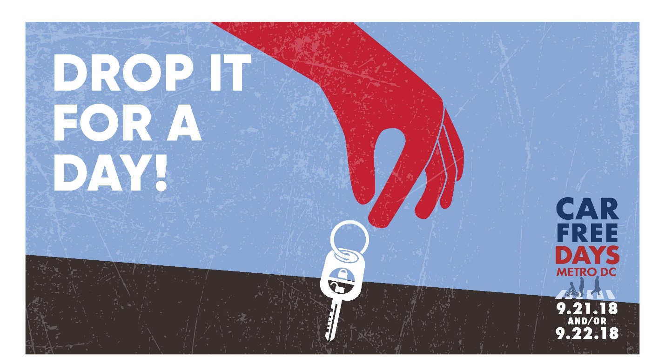



Metropolitan Washington Council of Governments
National Capital Region Transportation Planning Board
Commuter Connections Program

Background
Car Free Day is an internationally recognized event which started in Europe in 2000 as a day for residents to leave their cars at home, and instead get around by cleaner and more sustainable methods of travel for both commute and non-commute purposes. Travel modes include public transportation, bicycling, and walking. In the Washington, DC region Car Free Day began in 2008 and is coordinated by Commuter Connections and its network of regional partners. Car Free Day in the National Capital region also includes the option to participate by traveling “car lite” by way of carpool or vanpool. In 2018, the event was referred as Car Free Days due to spanning over a two-day period on Friday and Saturday, September 21-22. The total number of pledges for Car Free Day 2018 reached nearly 2,800.

Three main objectives of the Car Free Day marketing campaign were to:

- Use the event as an opportunity to promote alternative modes of transportation for both commute and non-commute trips.
- Encourage commuters and the general public to take the online pledge to use car free or car-lite travel methods during one or both days.
- Measure and report impacts.

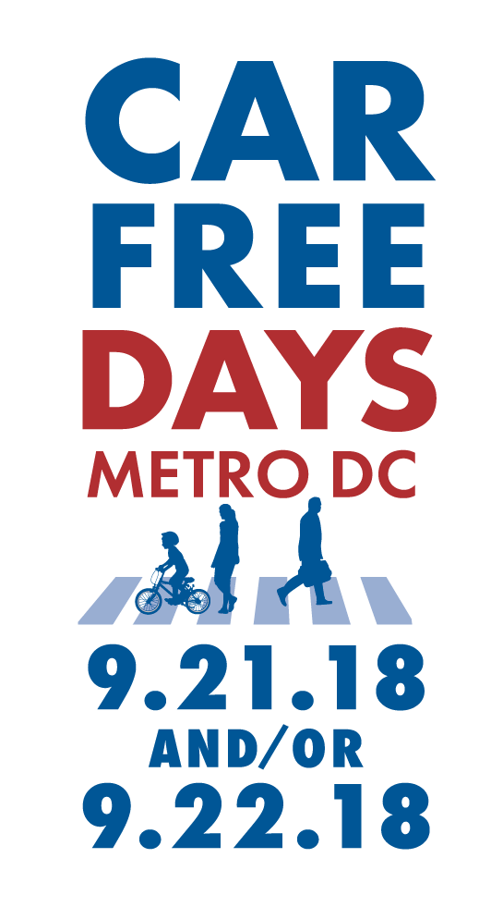

Proclamation Signing
The Car Free Day 2018 proclamation signing took place on July 18, 2018 at the National Capital Region Transportation Planning Board (TPB) meeting at the Metropolitan Washington Council of Governments. Some jurisdictions also approved local Car Free Day proclamations of their own.

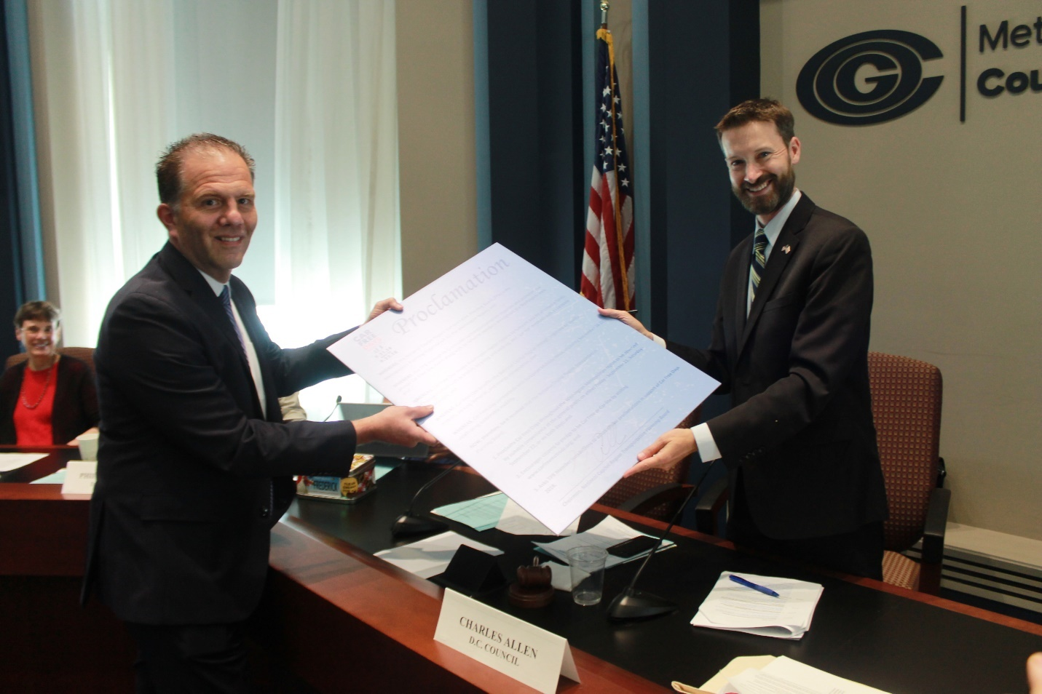

COG Director Transportation Operations, Nicholas Ramfos holds the 2018 Car Free Day proclamation as TPB Chairperson and District of Columbia Councilmember Charles Allen declares September 21-22, 2018 as Car Free Days throughout the Washington, DC region.

Regional Proclamation

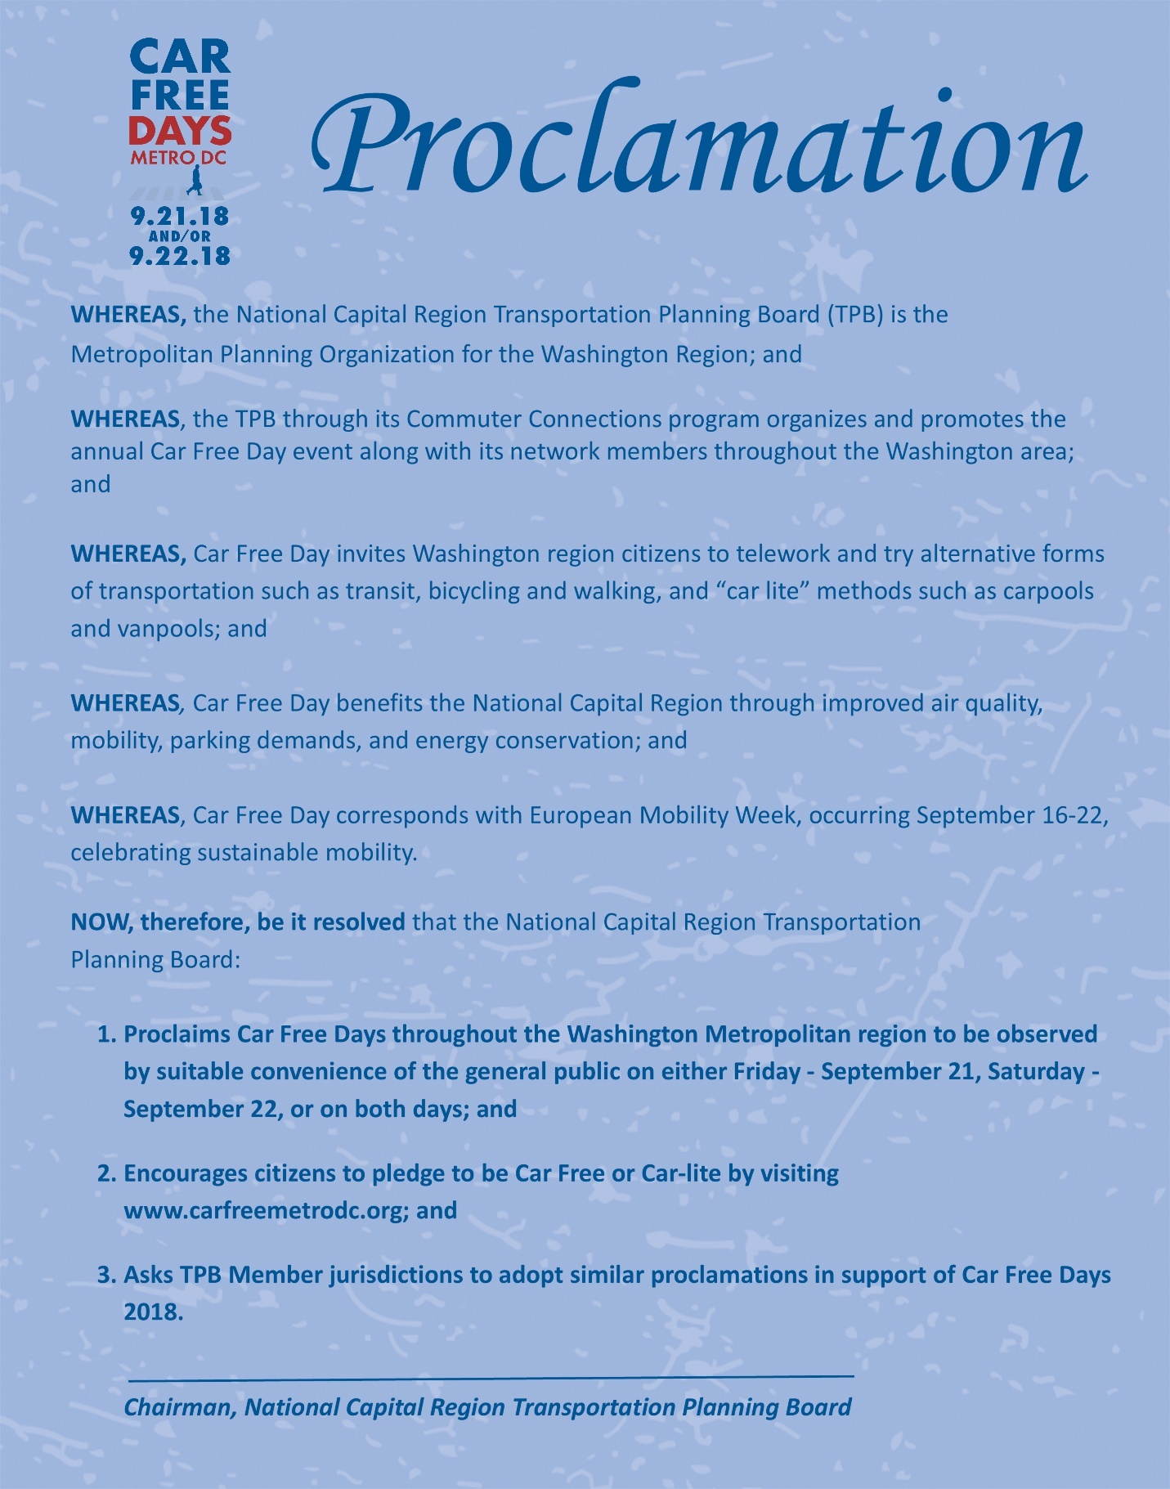
City of Frederick Proclamation

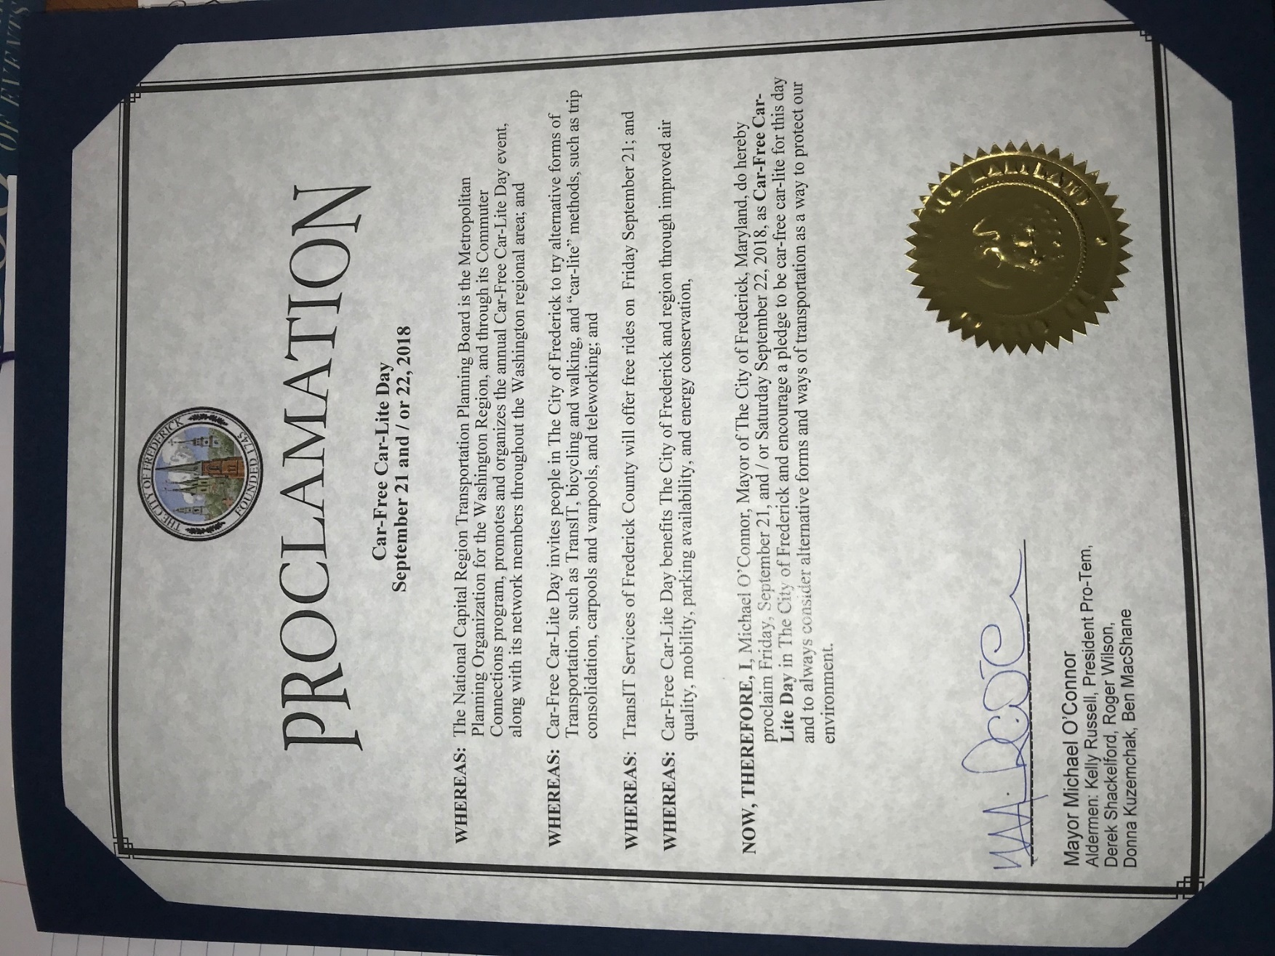
Poster
The 2018 poster was a revival of a previous year’s theme for Car Free Day and was refreshed with Committee feedback. Messaging encourages drivers to “Drop it For a Day” and take the free online pledge to use transportation alternatives on September 21 and/or 22. A PDF version of the poster was also made available on the web site for download.

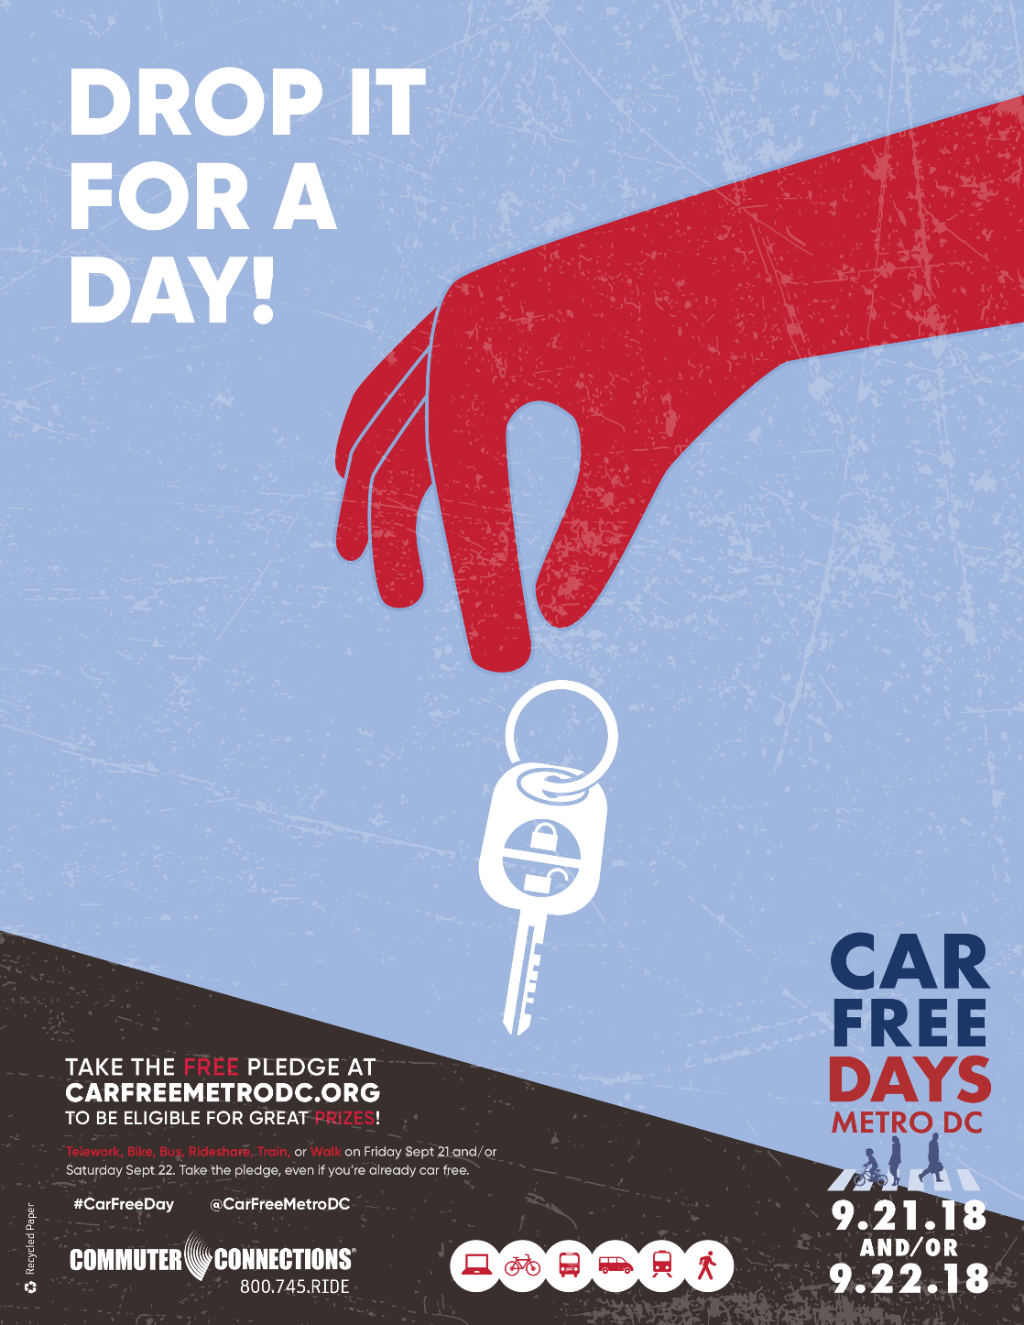

Employer Mailing
A total of 16,500 posters were printed, 5,500 of which were mailed to employers throughout the region, along with a cover letter. In addition, an email blast was sent to 45,000 email addresses comprised of those who took the Car Free Day pledge over the previous three years, Commuter Connections opt-in accounts, Committee Members, employers, and Federal Telework Coordinators.

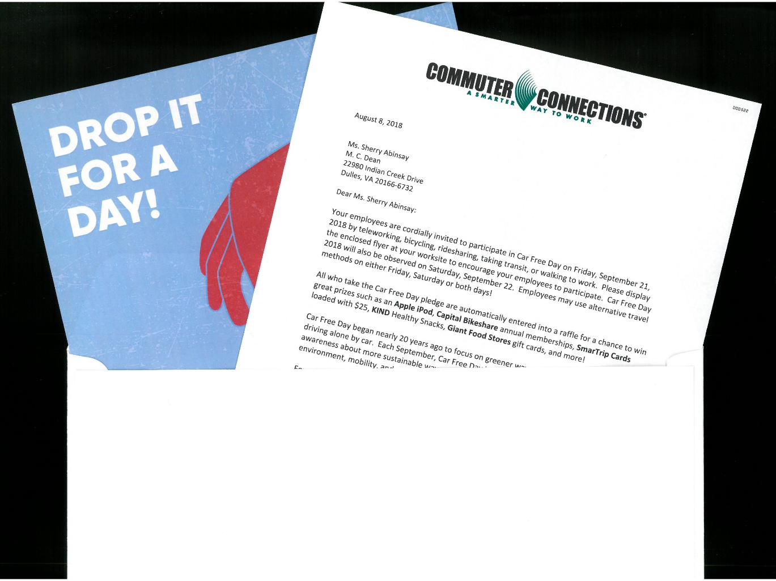

Employer’s Promotion
Inter-American Development Bank poster promoting Car Free Day.

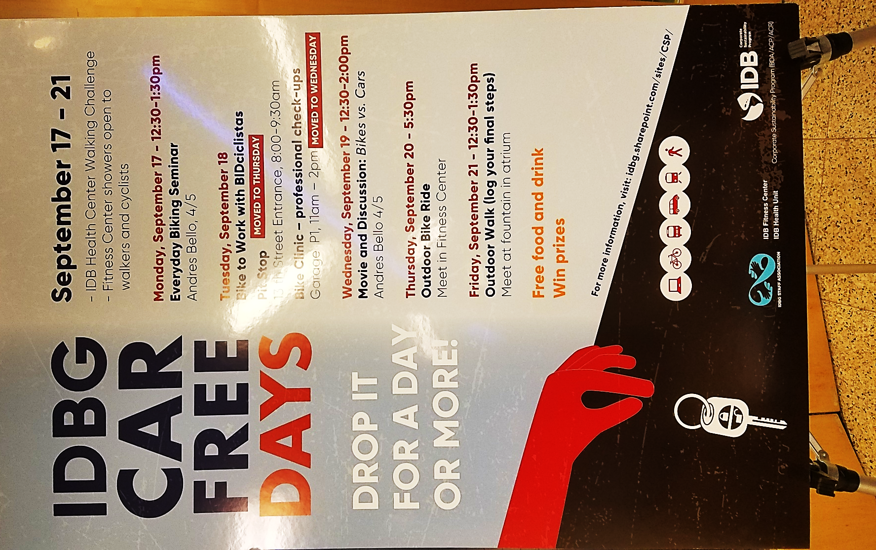
Sponsor Donated Prizes
Each participant who pledged to go car free or car-lite was entered into a raffle for a chance to win the following sponsor-donated prizes. Sponsors were recognized on the event web site, social media, and a press release.

- Capital Bikeshare annual memberships, courtesy goDCgo
- Samsung Galaxy Tab A 32GB Wi-Fi , courtesy Tri-County Council for Southern Maryland
- KIND Healthy Snacks gift bag, courtesy KIND
- SmarTrip cards with $25 in fare, courtesy Washington Metropolitan Area Transit Authority
- Annual membership and T-shirt, courtesy East Coast Greenway Alliance
- Grocery Store gift cards of $25 value, courtesy Giant Food
- Round trip tickets, courtesy VRE
- Annual memberships, courtesy Washington Area Bicyclist Association
- Washington at Home Book – an illustrated history of neighborhoods in DC, courtesy Cultural Tourism DC.

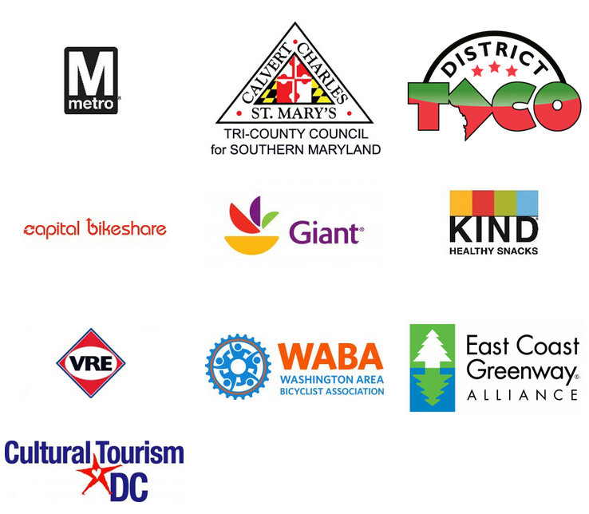

District Taco Special Offer
District Taco provided all who took the Car Free Day Pledge with a promo code for $3 OFF online orders of $10 or more. The promotion was valid through October 22, 2018 at all DC, Maryland, and Virginia locations.

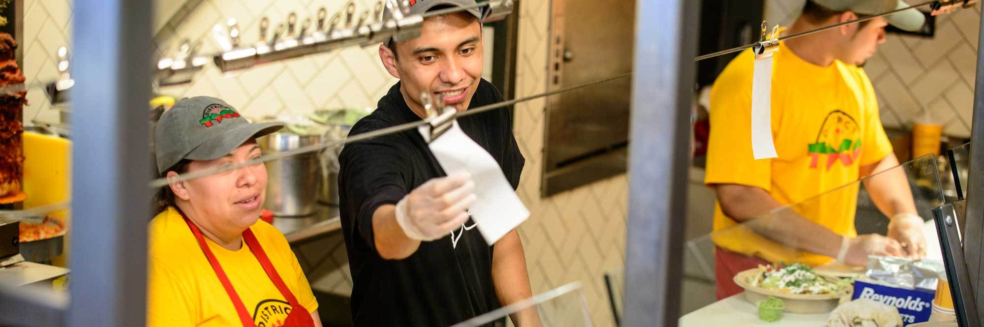

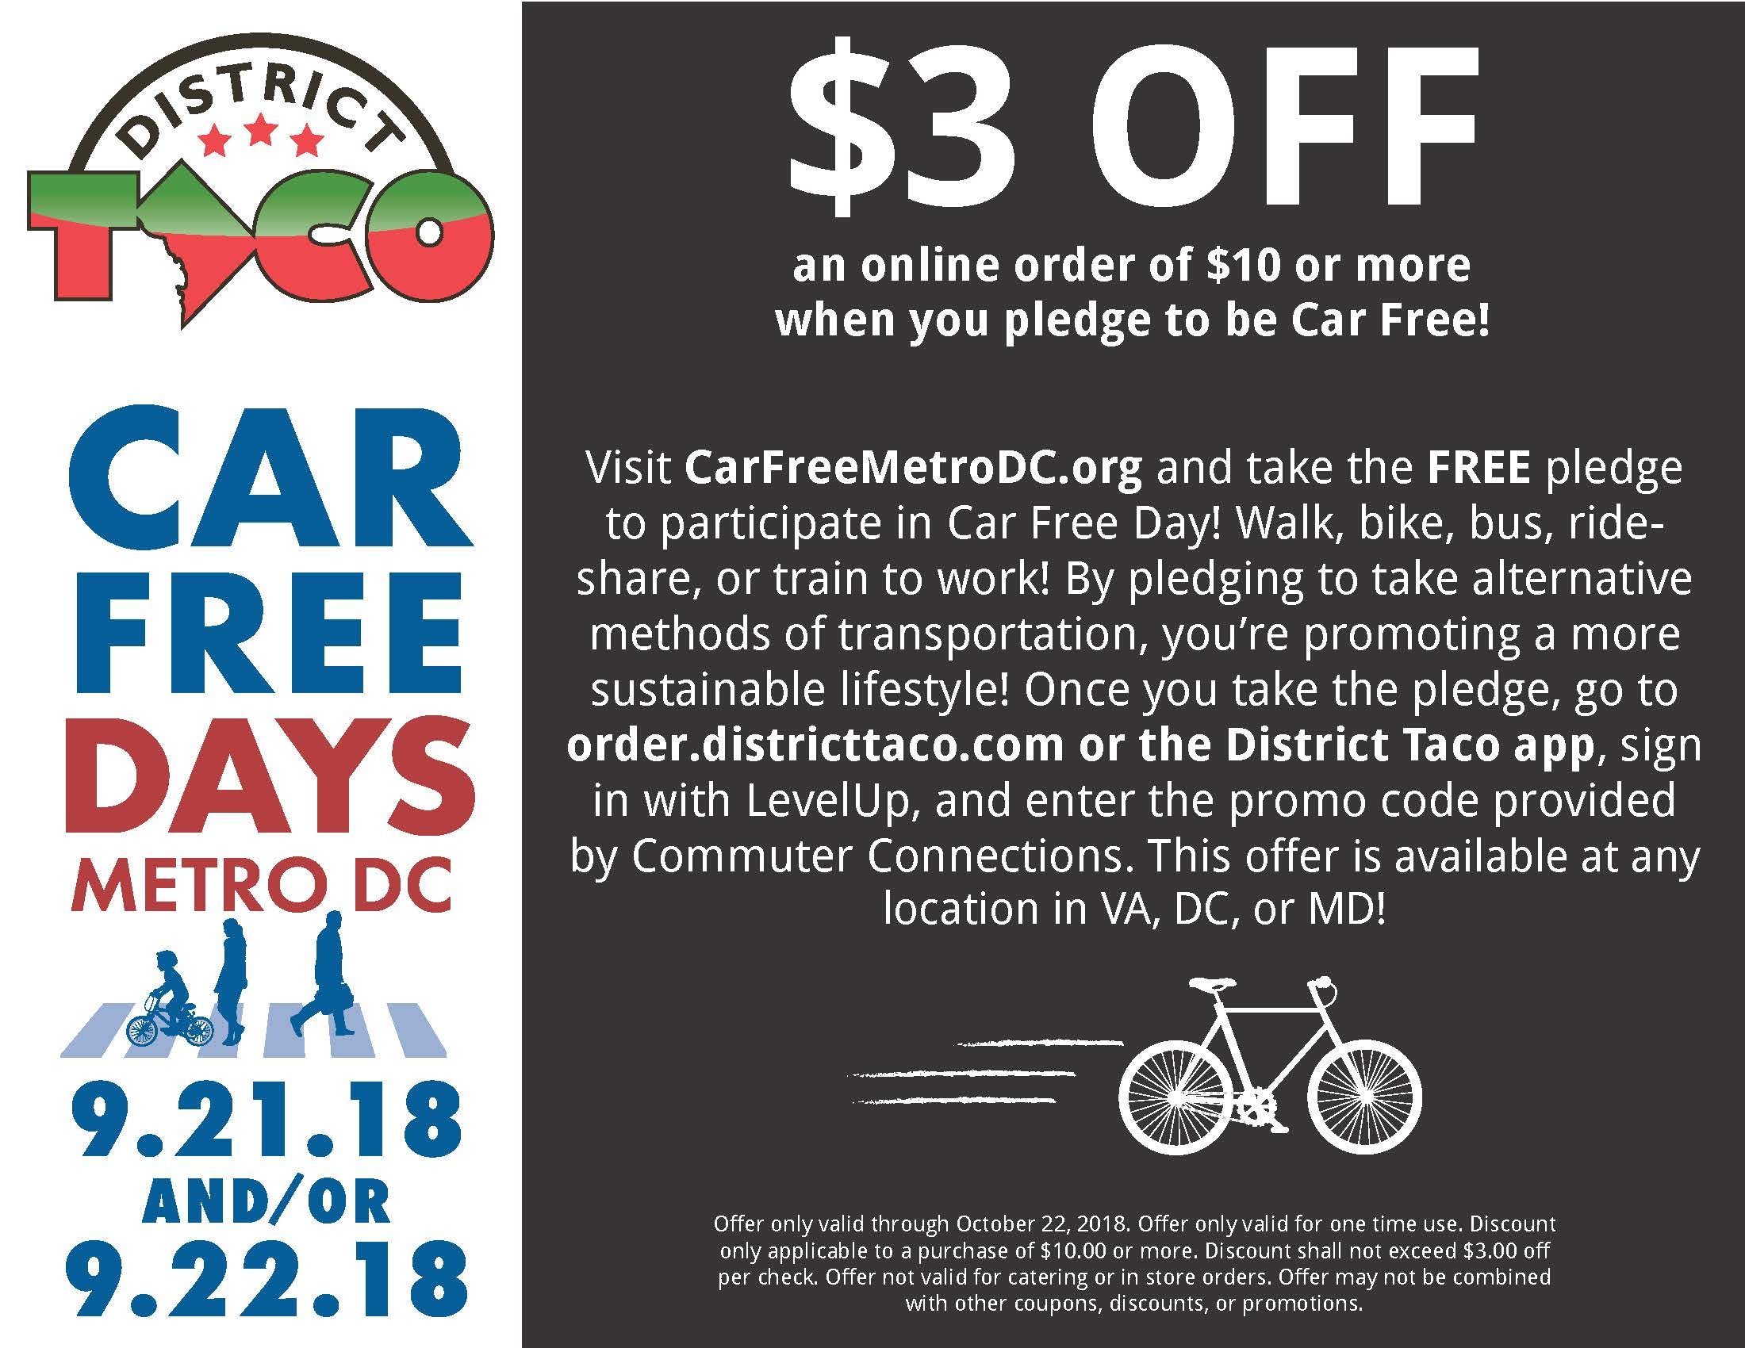

Media Objectives
The Car Free Days campaign raised public awareness and promoted use of more sustainable modes of transportation. Car Free Days challenged drivers to leave their cars home and go car free or car-lite on September 21 and/or 22.

Radio, text messaging, blogs, posters, bus signage, bus shelters, banner ads on radio station websites, social media, and an earned media effort were used to bring attention to the Car Free Day event and drive the public to www.carfreemetrodc.org to take the pledge.

Target market:
Drivers of Single Occupant Vehicles

Geographic Targeting
Washington D.C. DMA

Car Free Days Budget MWCOG Gross
Cost Dollars
Radio $ 23,364.00 $27,487.00
Pandora $ 12,236.00 $14,071.00
Social Media $ 6,000.00 $ 6,000.00
Key Influencer (blogs) $ 3,000.00 $ 3,529.00
Text Messaging $ 400.00 $ 471.00
Total Budget $45,000.00 $51,558.00

Radio
Radio comprised of half the media budget and informed the public about Car Free Days. Stations included WIAD (94.7 Fresh), WTOP (103.5 WTOP News), and WJFK (103.5 The Fan). Stations also provided pre-recorded DJ endorsements inviting listeners to participate from a personal level.



Social Media Sites
Social Media was used to keep fans up to date on activities prior to and after the event, and to spread the word through shares. The Car Free Day Facebook site is “liked” by over 4,300 users.

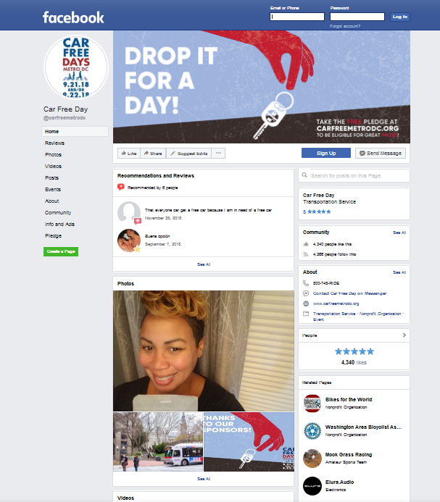



Car Free Day Twitter has 702 followers.

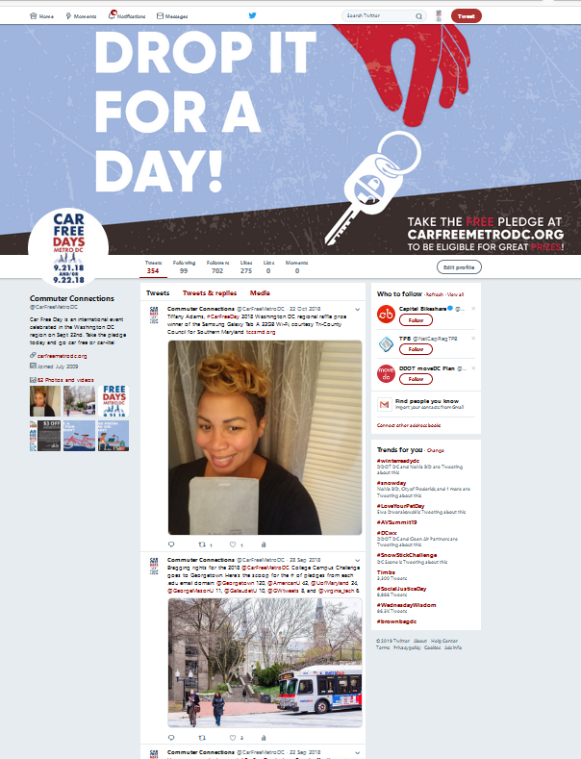
Paid Social Media
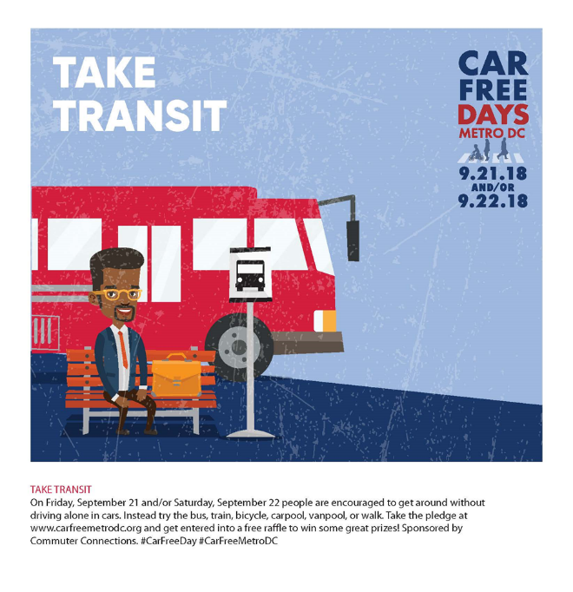
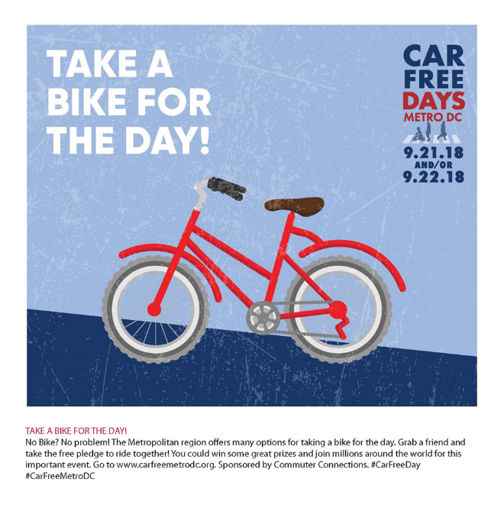
Boosted Facebook posts were placed in September 2018; a different one every several days.

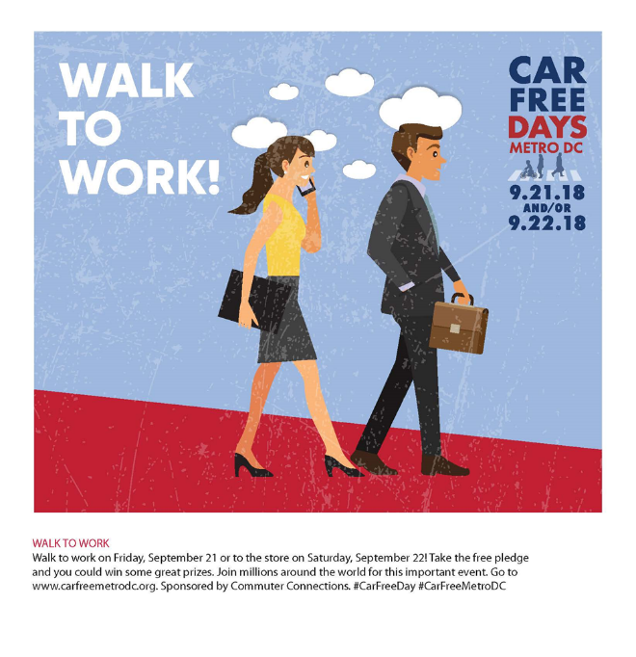
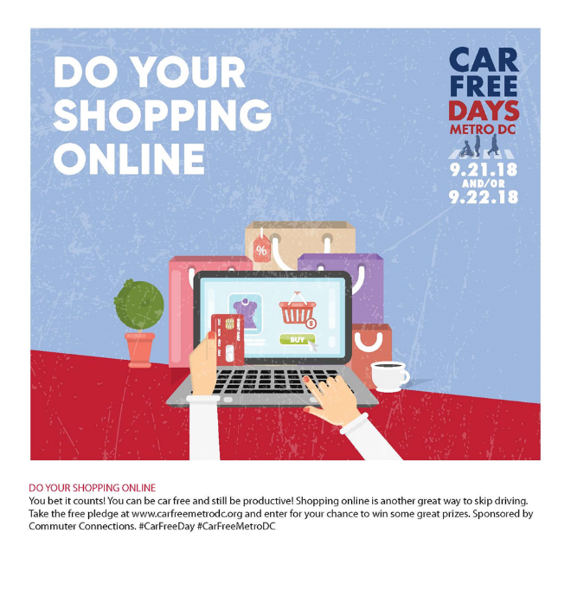
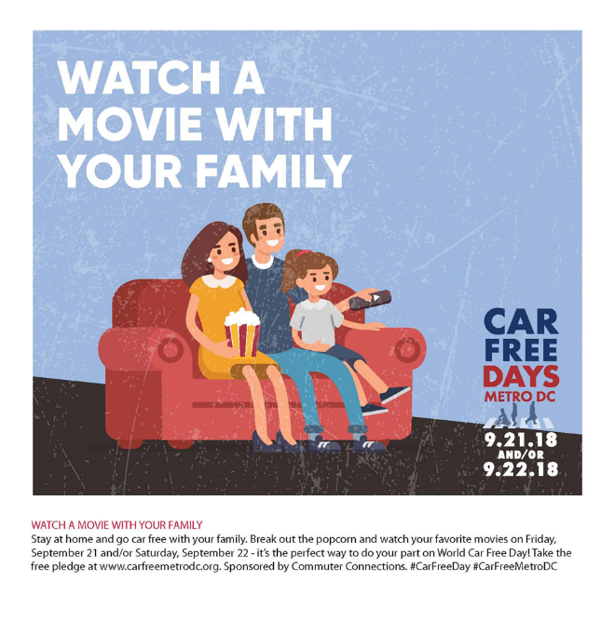
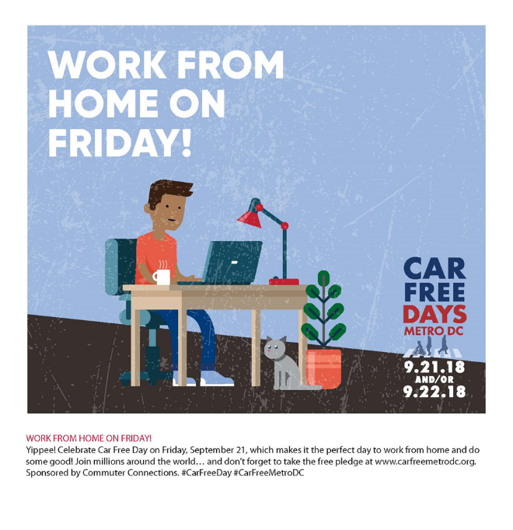
Pandora
An estimated 3,500,000 impressions were delivered using Pandora’s unique geo-targeting and effective advertisement delivery system. For Car Free Days, a :30 radio spot ran concurrently with display advertisements.

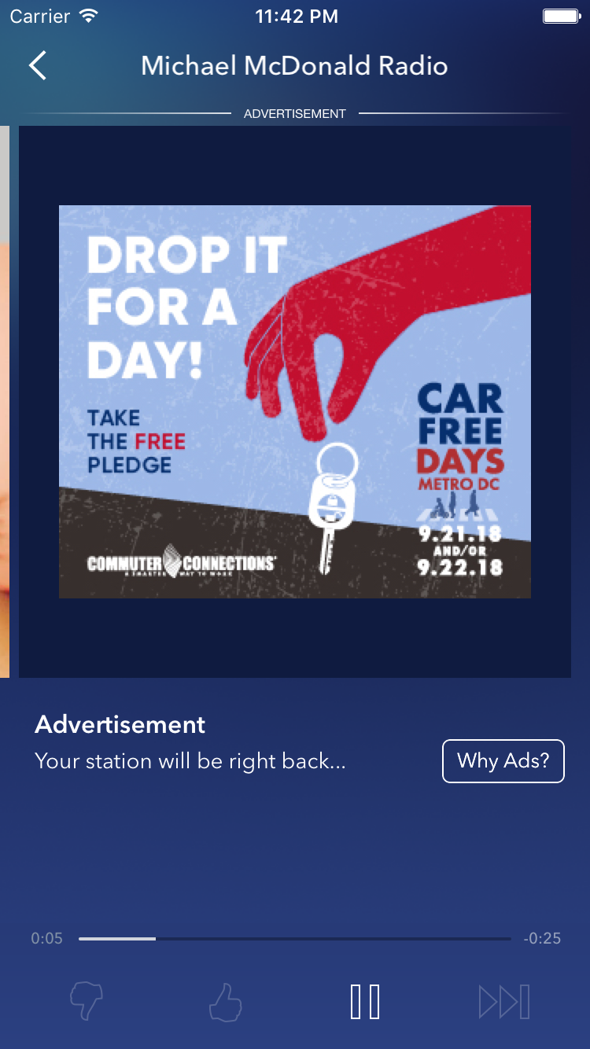

YouTube
A :30 video was placed on YouTube encouraging viewers to Choose a favorite way to go car free.

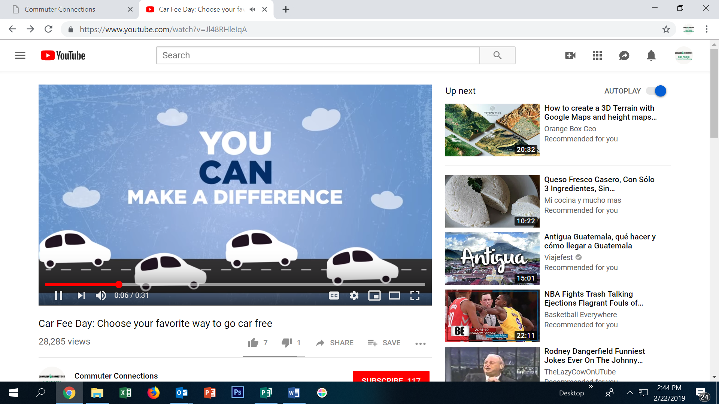

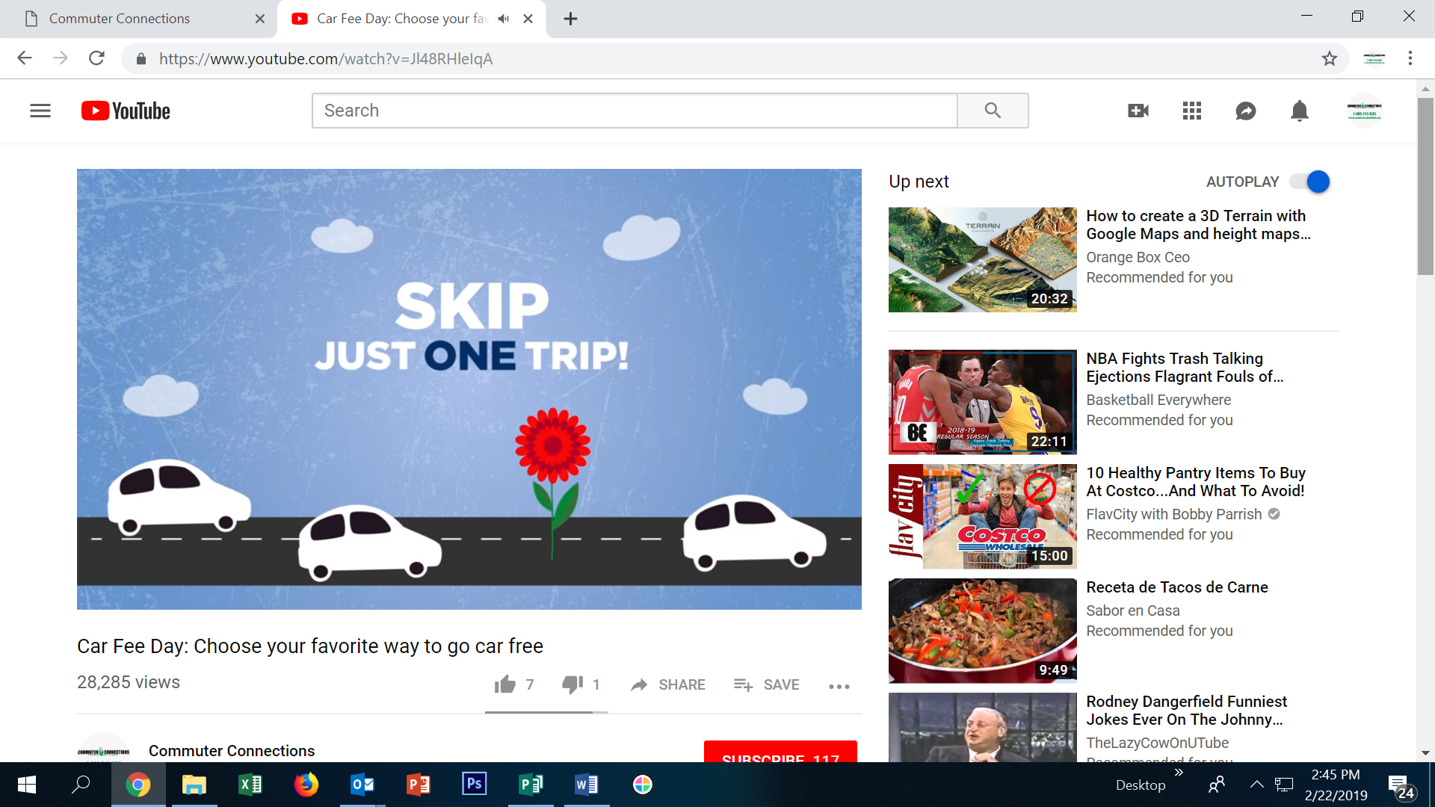

Key Influencer Blogs
Paid endorsements with popular local bloggers Meg Biram and Courtney Dredden helped reach unique audiences. These influential lifestyle blog writers spread the word about Car Free Day in a grass-roots style fashion to generate conversation and awareness of getting around without driving alone by car. Both wrote comprehensive articles from a personal perspective. In the blog they discussed various forms of transportation that readers could use on Car Free Day. Articles contained caveats regarding sponsor transparency.

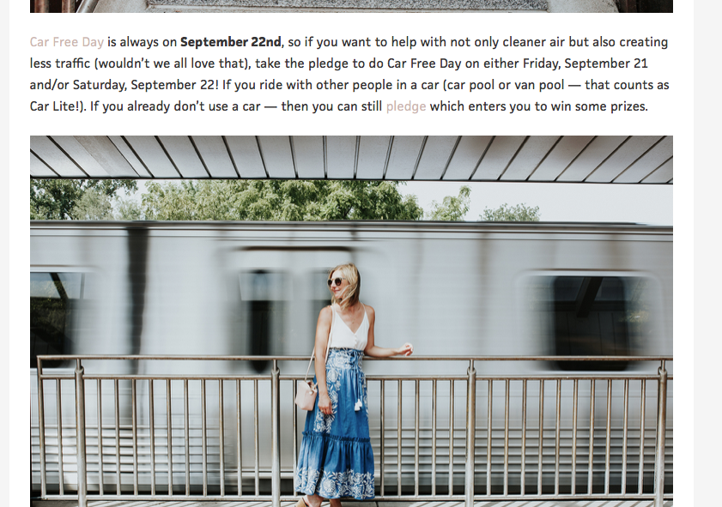

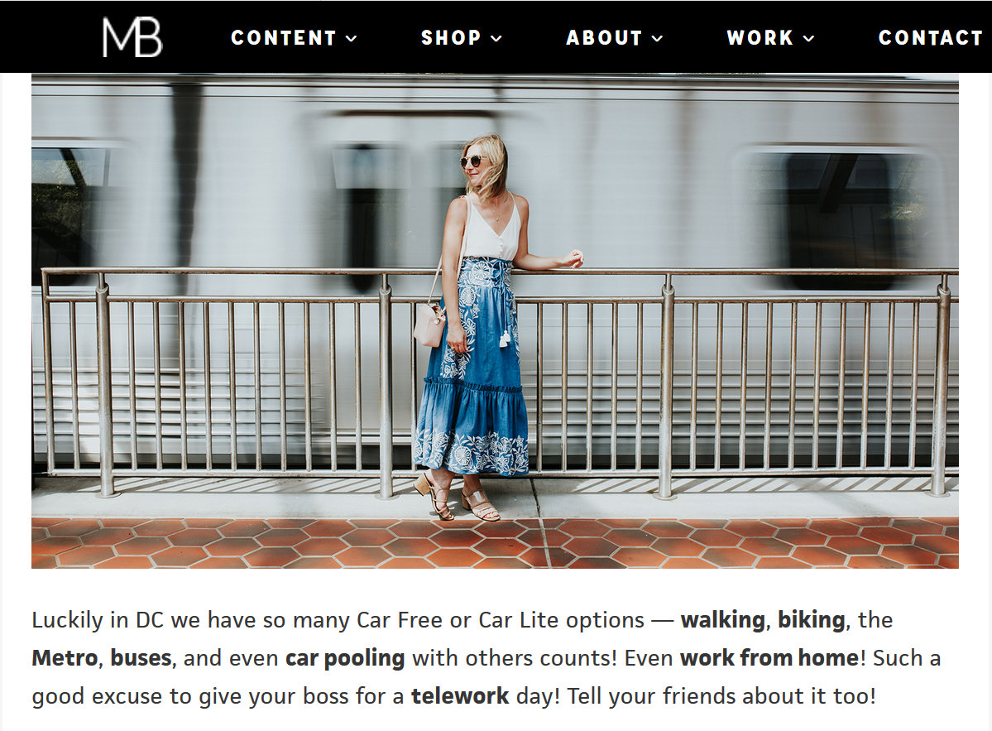

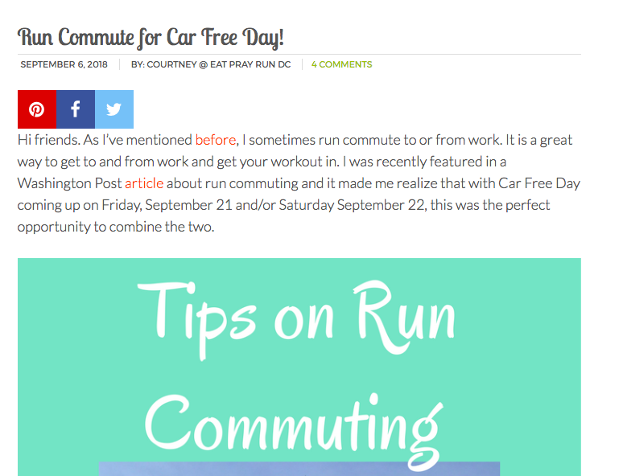

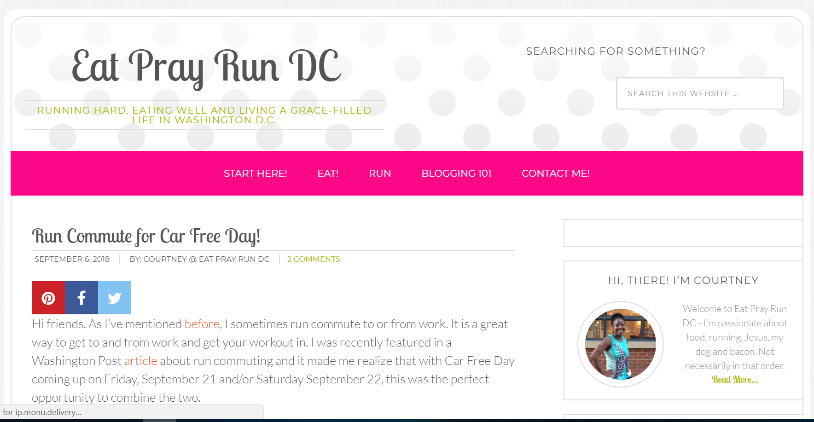

Text Messages
When event registrants took the Car Free Day pledge at www.carfreemetrodc.org they were provided with the opportunity to opt-in and enter their mobile number to receive text messages about the upcoming event. The message asked recipients to encourage friends, family, and co-workers to take the pledge as well.

Thanks for dropping your keys for a day! Ask your co-workers, family & friends to take the Car Free Day pledge at www.carfreemetrodc.org

Transit Signage
Complimentary transit ad space was donated by the following transit partners:
- Arlington Interior Bus Cards
- Fairfax County Connector Bus Tails
- Prince George’s County Bus Shelters
- Montgomery County Bus Queens
- Metrobus Interior Bus Cards

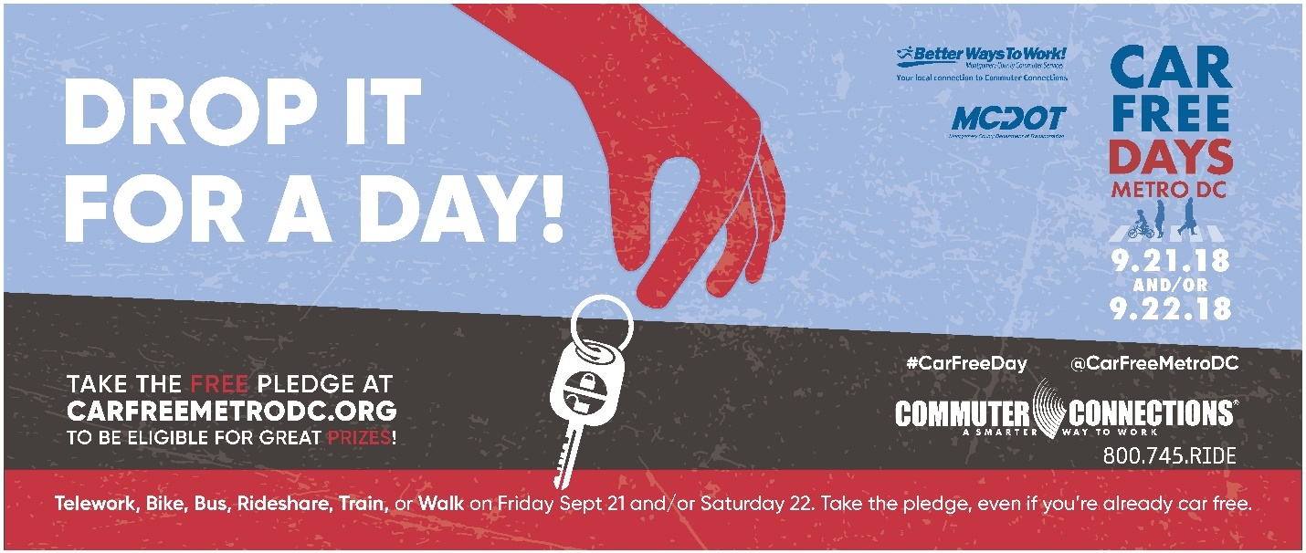

Earned Media
Outreach was conducted that included targeted press releases to raise awareness of the health benefits of going car free and the prize raffle.

Press Releases:
- Don’t miss out on great Car Free Day prizes
- Commute to a healthier lifestyle on Car Free Days, September 21 and 22
- Drop Your Keys for a Day or Two! Take the Pledge to Go Car Free on September 21 and 22

For the second consecutive year, Commuter Connections partnered with the American Lung Association to support the Car Free Day initiative of improving the region’s air quality and health. The American Lung Association provided a quote for the Car Free Day press release and shared Car Free Day promotional posts and articles on their social media pages.

A new partnership was established with the American Heart Association to amplify the Car Free Day message about health and air quality. In addition to providing a quote for the Car Free Day press release, the American Heart Association distributed the release and information about Car Free Day to its media list and stakeholders; posted a blog post about Car Free Day; and promoted the event and its materials through its social media accounts.

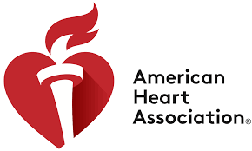
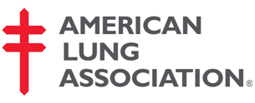

Capital Area Car Free College Campus Challenge

The Capital Area Car Free College Campus Challenge was

created as a friendly competition to generate awareness

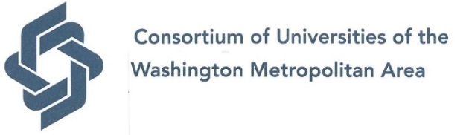
of and participation in Car Free Day on college campuses throughout the region. A promotional kit was distributed to higher learning institutions in partnership with the Consortium of Universities of the Washington Metropolitan Area. Over 250 pledges, 9 percent of all Car Free Day pledges were

made through .edu email domains.

Top Universities
Georgetown University | 120
American University | 42
University of Maryland | 24
George Mason University | 11
Gallaudet University | 10

Website

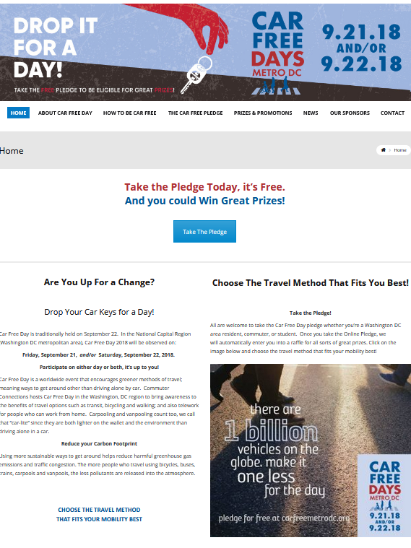

Leaderboard
A daily leaderboard was displayed on the Car Free Day web site’s home page. The chart showed each travel mode in alphabetical order and the number of pledges.

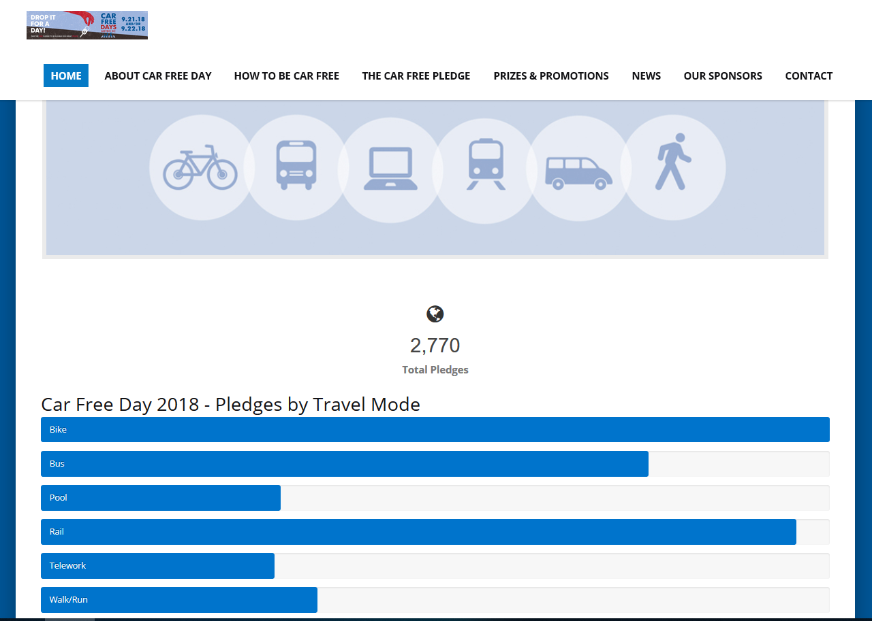
Jurisdiction Activities
Commuter Connections’ network members hosted numerous promotions to celebrate Car Free Day.

- Arlington– Enjoy Car Free Day 2018 by attending Clarendon Day, one of Arlington’s best loved and most diverse street festivals on Saturday, September 22, 2018 from 11 a.m. to 6 p.m.
- District of Columbia NoMa – Turn spaces meant for cars (curbside parking spots) into spaces meant for people. Come up with a design that brings the community together in a unique way. E-mail your best idea to lseremetis@nomabid.org by COB Monday, August 6, and we’ll pick a few favorites, each of which will receive a $500 stipend to make the vision a reality on September 21!
- City of Fairfax – A CUE Swag Bag, including a $50 SmarTrip card will be awarded at random to a resident of the City of Fairfax who takes the 2018 Car Free Day pledge.
- TransIT Services of Frederick County – Friday, September 21, 2018: FREE RIDES on TransIT Connectors and Shuttles for the day.
- Manassas City – Stop by the Farmer’s Market (Prince William Commuter Lot across from Baldwin Elementary) on Saturday – September 22, 2018 from 8:30 am to 12:00 pm to enjoy giveaways and learn more about transportation alternatives and healthy lifestyles. Come enjoy our pop-up park, join a bike tour at 9:00 a.m., and join a walking tour at 10:00 a.m. Residents of the City of Manassas also have a chance to win HMI memberships, Manassas-Opoly games, and Manassas History books. Also at the Farmer’s Market, Omniride will showcase their I-66 Express Lanes wrapped bus to promote half price bus fares through 2020 on bus routes from Gainesville and Manassas.
- Montgomery County Commuter Services – Shop & Play the Easy Way! – Enjoy a Car Free Family Adventure on Saturday, September 22, 2018 with Free Ride On ExtRa Bus Service from Shady Grove Metro to Black Hill Regional Park, with stops at Germantown Transit Center and Clarksburg Premium Outlets. Shop the outlets, enjoy the great outdoors, or both!
- Southern Maryland – Farmer’s Market on the North Beach Boardwalk in Calvert County. Friday, September 21, 2018 from 4:00 p.m. to 9:00 p.m. Enjoy free giveaways from Tri-County Council for Southern Maryland.

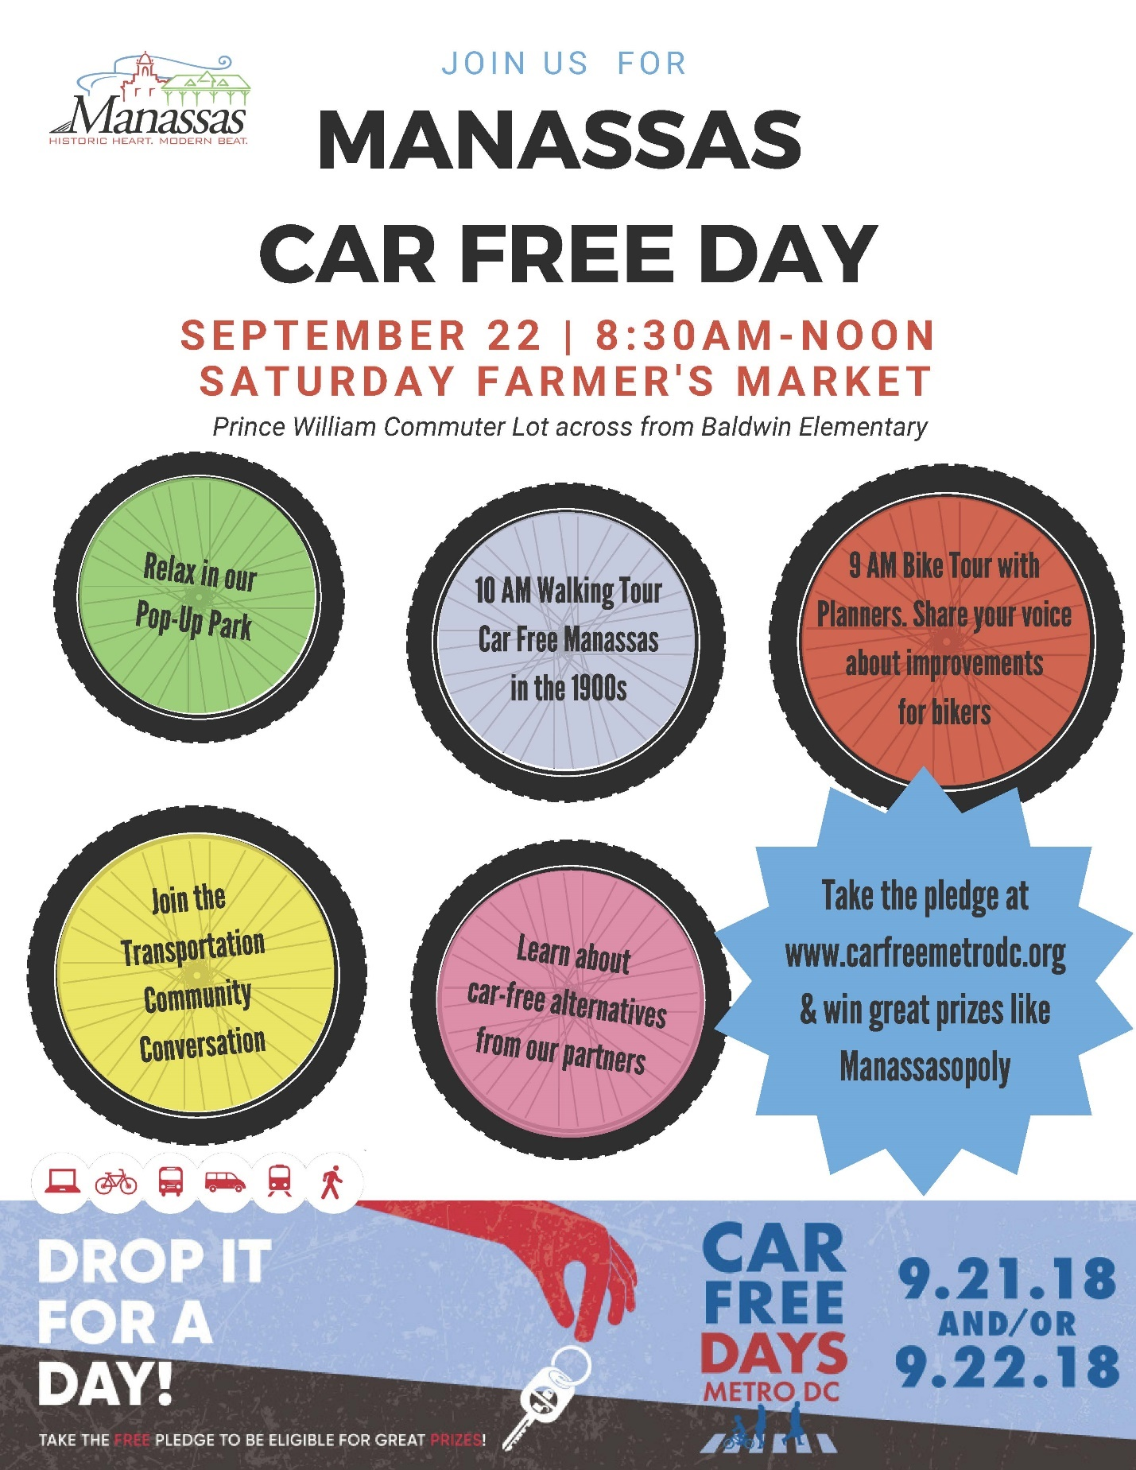
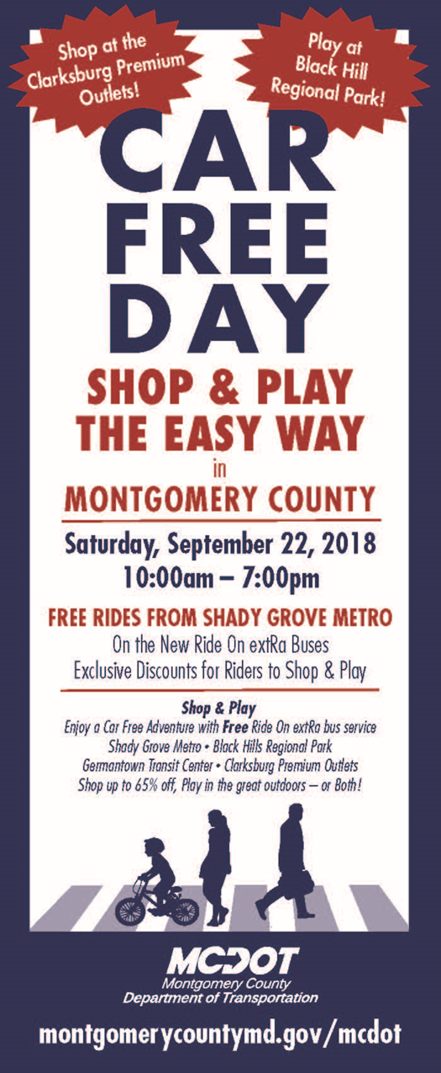
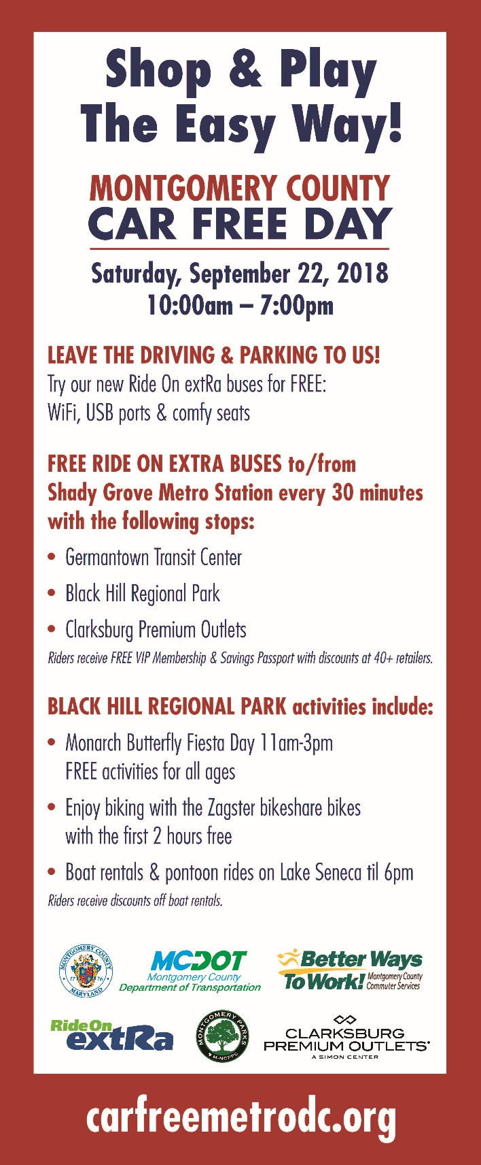

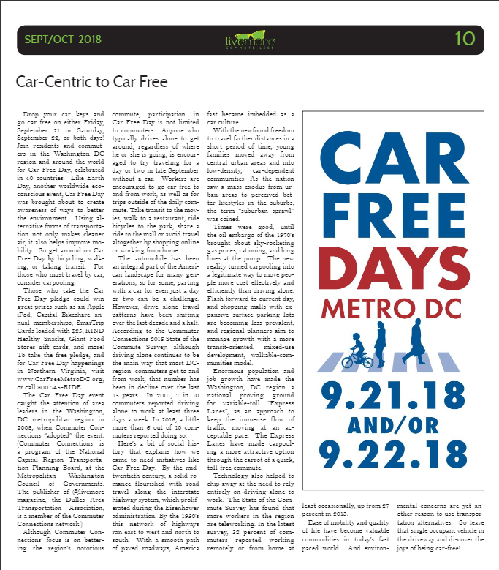
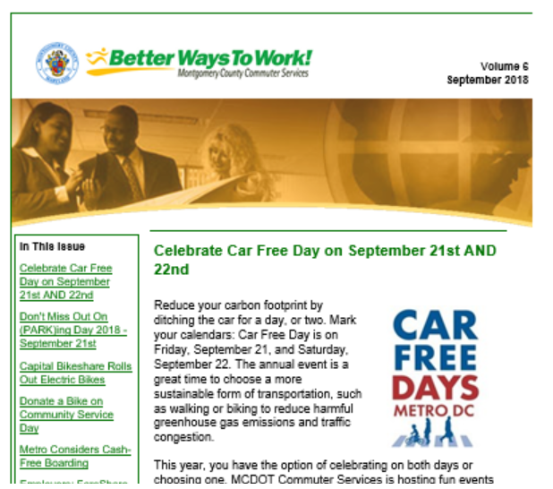

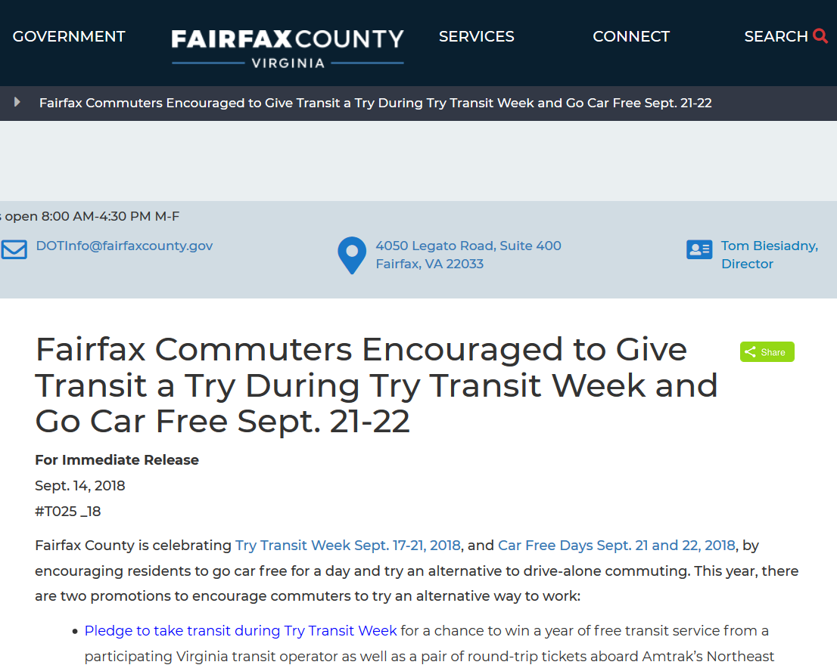
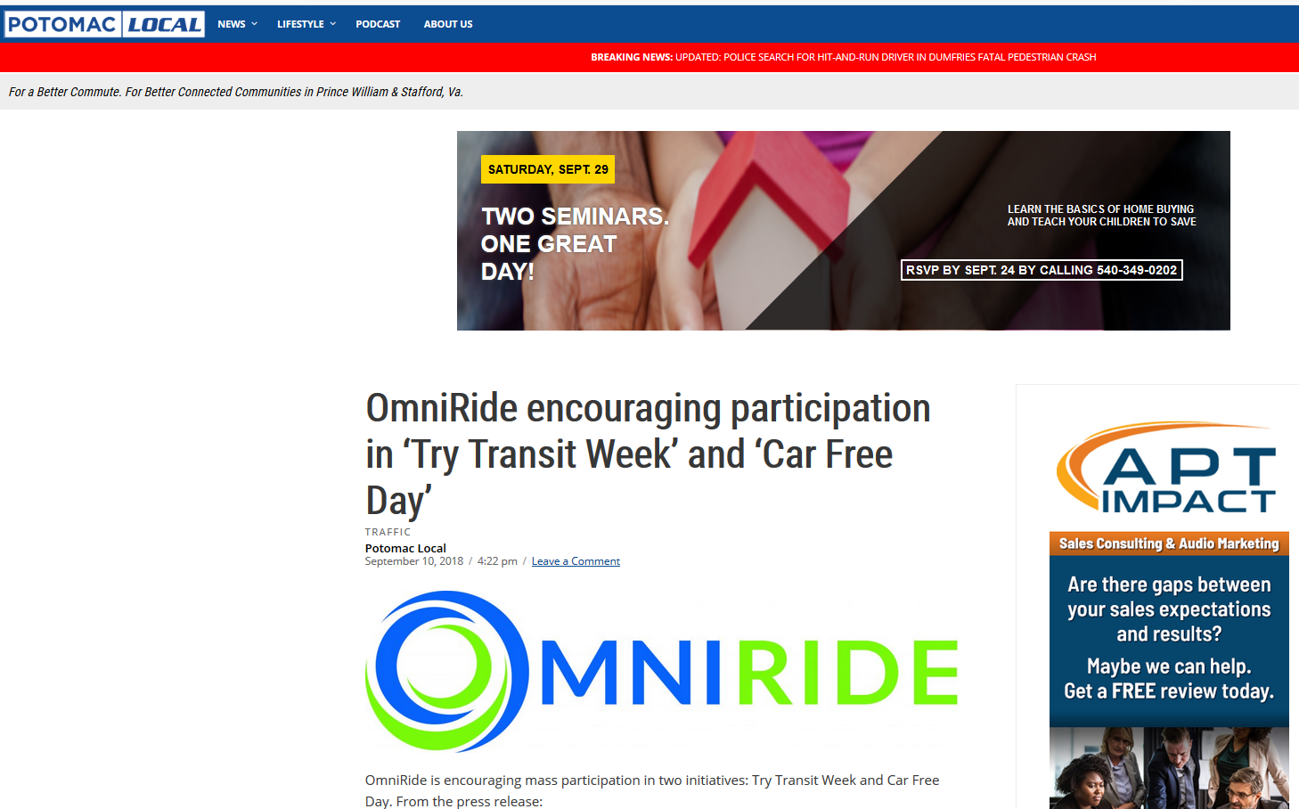

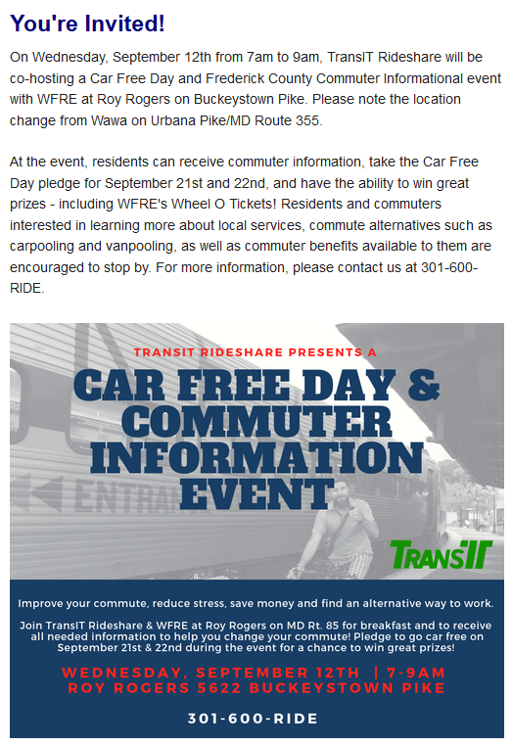

Clean Air Partners
Clean Air Partners promoted Car Free Day through an emoji vote on Facebook. Users were asked to react via emoji to the corresponding alternate method of transportation they would use on Car Free Day. Bus/Metro was the most popular travel mode. The post received 1,441 engagements including 1,270 reactions, 70 comments, and 101 shares.

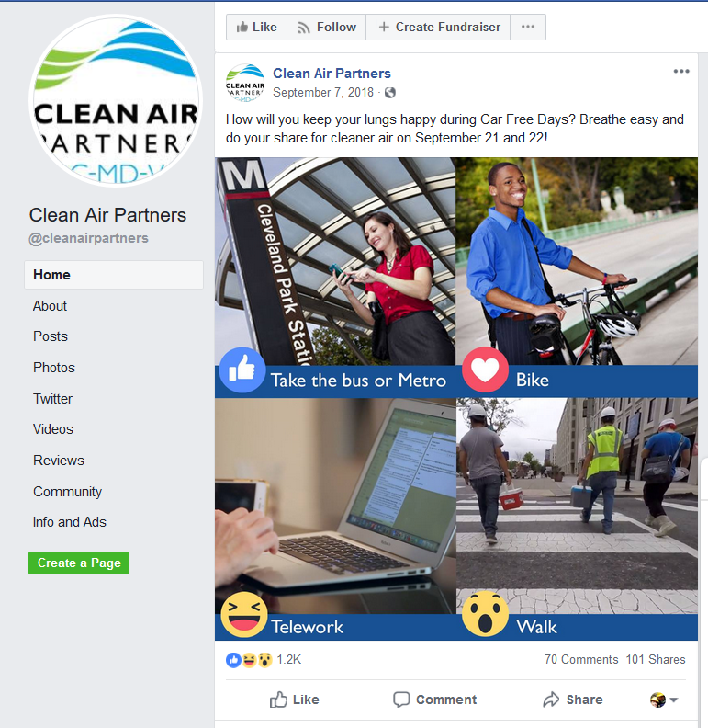

Paid Social Media
Unique promotional visuals were posted onto Facebook during the month of September and boosted for a more expansive audience. A different “ad” was placed every few days. Collectively, the posts received 36,356 user engagements defined as clicks, comments, reactions, and/or shares.

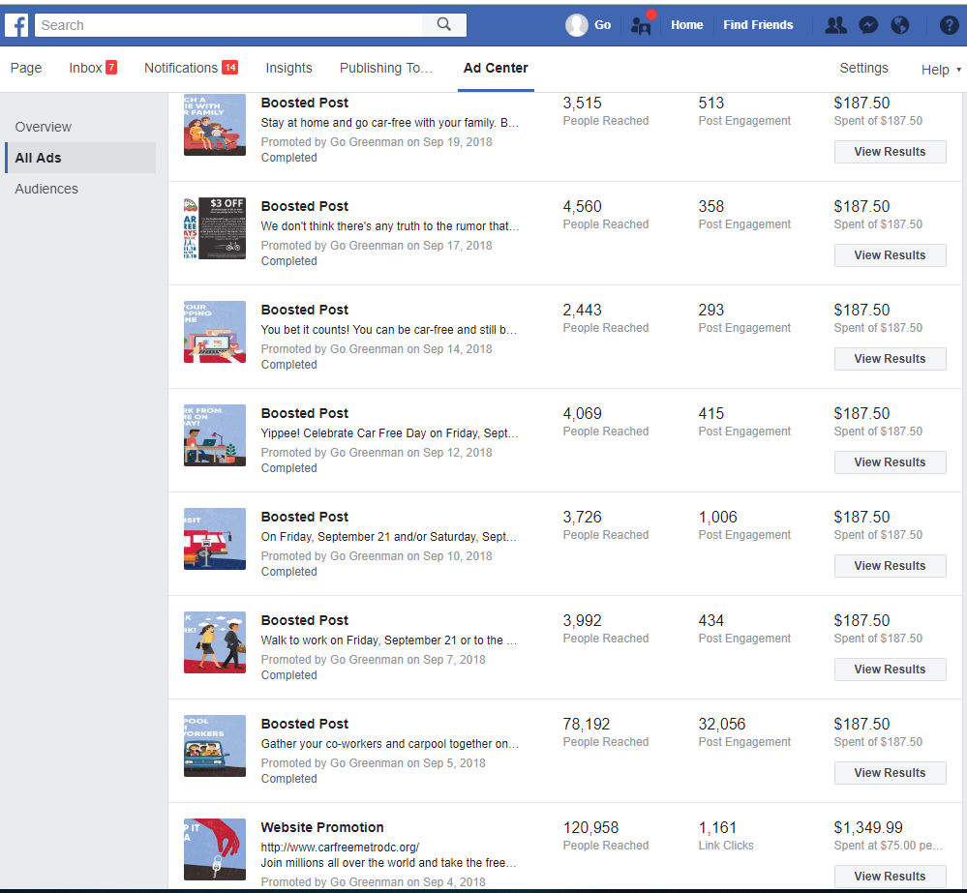
Pledge Data Performance Results

By Travel Mode
A total of 2,770 people took the Car Free Day pledge in 2018. Participants were asked to select the mode they used for the greatest distance of travel during Car Free Days. The breakdown by mode was as follows: Bike 27 percent, Rail 26 percent, Bus 21 percent, Walk 10 percent, Telework and Pool 8 percent.

The previous year’s travel mode usage fell in the same order from largest to smallest, however changes in percentage by mode shifted by varying degrees. Compared to 2017, rail and bus both increased by 4 percent, walk/run mode share decreased by 6 percent, and bike decreased by 2 percent. Pool and Telework percentage share remained unchanged from year to year.

Transportation Mode | # Pledges | % Pledges
Bike (bicycles) | 753 | 27%
Rail (Metrorail, MARC, VRE) | 721 | 26%
Bus (Metro, local bus, and commuter) | 580 | 21%
Walk/Run | 264 | 10%
Telework | 223 | 8%
Pool (carpools and vanpools) | 229 | 8%
 | 2,770 | 100%

By Alt Mode/SOV
To segment those already in alternative modes from regular SOV travelers, the question was asked “If you didn’t take this pledge, would you travel entirely alone by car on Car Free Day?” In addition, those who pledged were asked to estimate the total miles they will travel on Car Free Day (other than any drive alone distance, i.e. to the park and ride lot). The total mileage saved or reduced on Car Free Day was 87,947 miles. Those who self-identified as normally SOV drivers made up 43 percent of the pledges, and 45,734 of the vehicle miles reduced.

Usual Travel Status | # of Pledges | % of Pledges | Miles Saved on CFD | % of Miles
Normally Car Free | 1,587 | 57% | 42,213 | 48%
Normally SOV | 1,183 | 43% | 45,734 | 52%
 | 2,770 | 100% | 87,947 | 100%

By State
Each state generated at least 650 total pledges in 2018. The highest bike mode share for any state was the District, with bikes making up 39% of its total pledges. The District also had the highest mode share for walk/run, at 15% of its total. The highest mode share for rail by state was Maryland, with rail representing 28% of its total. Maryland also had the highest mode share for Telework, making up 11%. The highest mode share for bus by state was Virginia with 24%. The Commonwealth also had the highest mode share for Carpools/Vanpools, making up 12% of its total.

Mode | DC Pledge Count | DC % | MD Pledge Count | MD % | VA Pledge Count | VA % | Other Pledge Count | Other % | Total Pledge Count | Total Pledge %
Bike | 258 | 39% | 235 | 24% | 251 | 23% | 9 | 21% | 753 | 27%
Bus | 100 | 15% | 217 | 22% | 257 | 24% | 6 | 14% | 580 | 21%
Pool | 25 | 4% | 73 | 7% | 126 | 12% | 5 | 12% | 229 | 8%
Rail | 178 | 27% | 281 | 28% | 252 | 24% | 10 | 23% | 721 | 26%
Telework | 10 | 1% | 110 | 11% | 96 | 9% | 7 | 16% | 223 | 8%
Walk/Run | 99 | 15% | 70 | 7% | 89 | 8% | 6 | 14% | 264 | 10%
 | 670 | 100% | 986 | 100% | 1,071 | 100% | 43 | 100% | 2,770 | 100%

By Jurisdiction
With 24.2 percent of the total pledges, DC was the #1 jurisdiction, followed by Montgomery County, and Arlington, both with double digits as well. Ranked forth was Fairfax with a strong 9 percent.

Jurisdiction | # Pledges | % Pledges
DC District of Columbia | 670 | 24.2%
MD Montgomery County | 589 | 21.3%
VA Arlington County | 290 | 10.5%
VA Fairfax County | 257 | 9.3%
VA Prince William County | 159 | 5.7%
MD Prince George's County | 142 | 5.1%
VA Loudoun County | 123 | 4.4%
VA Alexandria City | 91 | 3.3%
MD Frederick County | 77 | 2.8%
MD Howard County | 41 | 1.5%
MD Anne Arundel County | 39 | 1.4%
VA Stafford County | 37 | 1.3%
VA Fairfax City | 33 | 1.2%
MD Baltimore City | 23 | 0.8%
VA Falls Church City | 20 | 0.7%
VA Spotsylvania County | 19 | 0.7%
MD Baltimore County | 17 | 0.6%
MD Calvert County | 17 | 0.6%
MD Charles | 17 | 0.6%
WV Jefferson County | 10 | 0.4%
VA Fauquier County | 8 | 0.3%
MD St. Mary's County | 7 | 0.3%
MD Washington County | 6 | 0.2%
WV Berkeley County | 5 | 0.2%
Other | 73 | 2.6%
Total | 2770 | 100.0%

Emissions Impacts
COG/TBP staff provided Car Free Day emissions impacts (in tons). NOx or nitrogen oxides are the chemical in automotive exhaust; VOC or volatile organic compounds are ground-water contaminants; GHG or greenhouse gases are released into the atmosphere and absorb and emit radiation; and Particulate Matter are microscopic matter suspended in the earth's atmosphere.

Emissions rates for VOC, NOx, PM2.5 (previously calculated for TERMs analysis) and GHG (calculated for this analysis) are calculated for the respective planning areas using output from the MOVES model, as described below:

Emission Rate = [Emissions] / [VMT of passenger cars and passenger trucks]
Emissions savings are calculated as below:
Emissions Savings = [Emission rate] X [Pledged VMT]

Car Free Days Earned Media Placements
Car Free Days 2018 media placements, across print, internet, radio, and television outlets, along with a selection of social media placements.

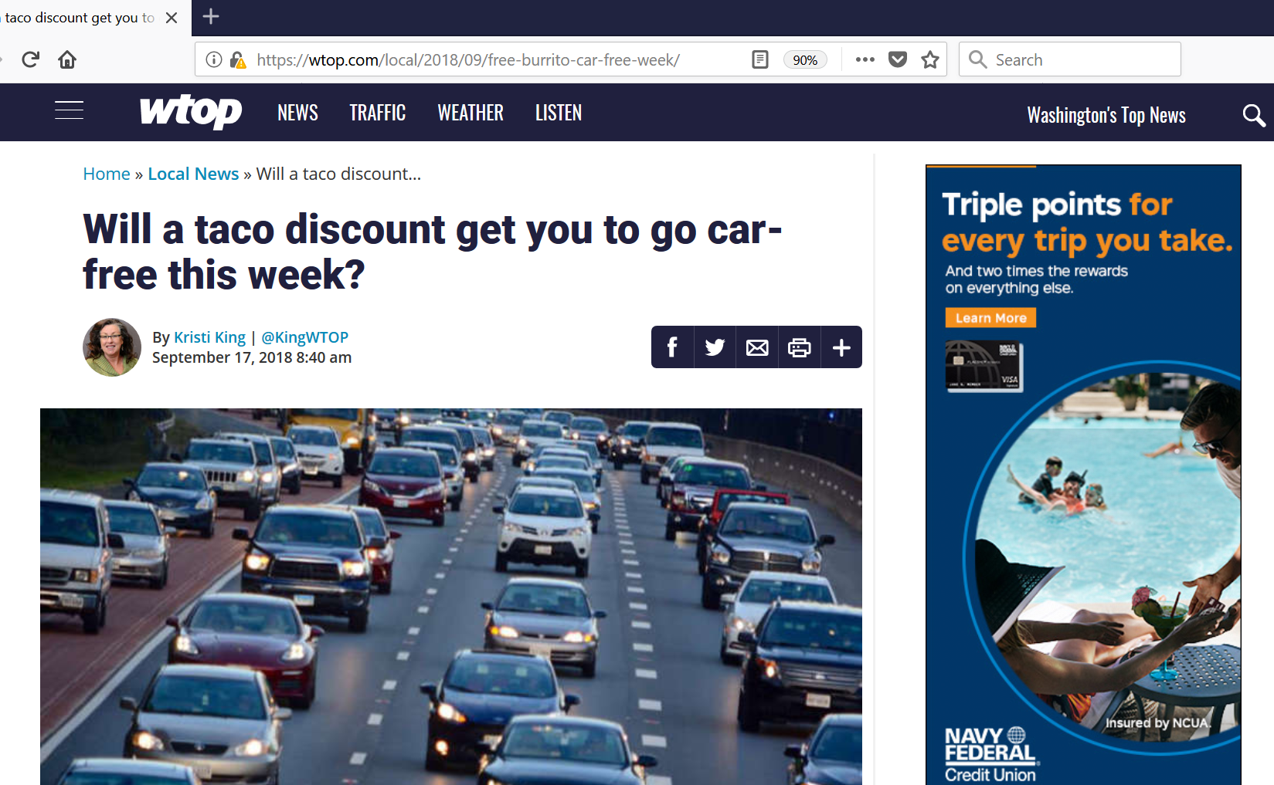

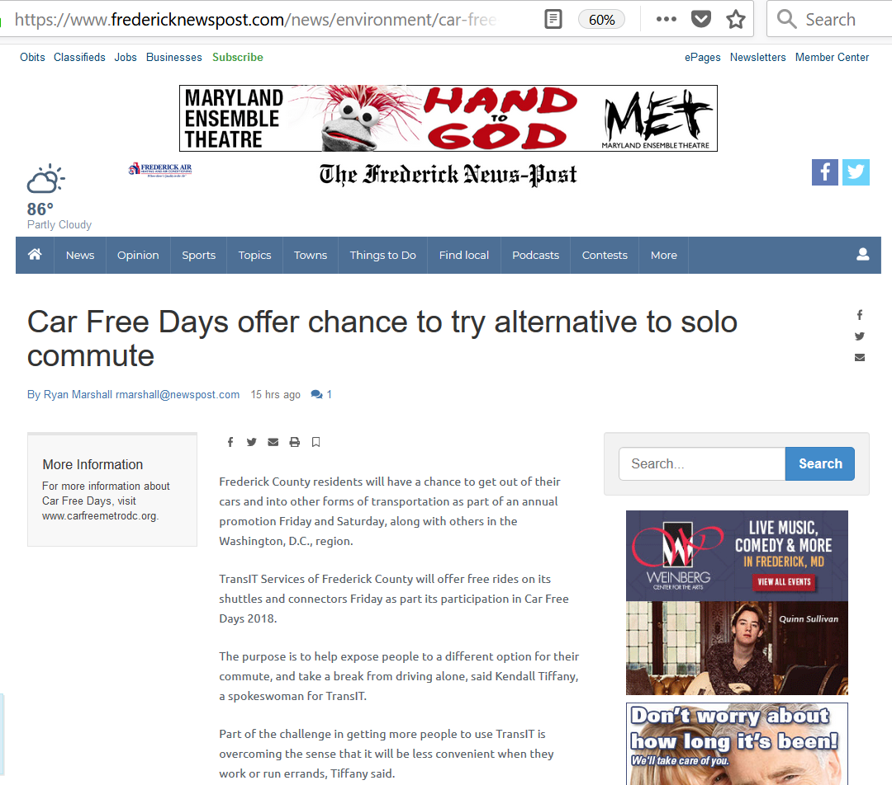

Media Placements

CFD 2018 Print /Online Coverage
Date | Outlet | Topic linked to URL
7/18/18 | Washington Times | D.C. officials to stretch 'Car Free Day' into two days
8/29/18 | issuu | Car-Centric to Car Free
9/01/18 | CityScene | Celebrate Try Transit  Week and Car-Free Day
9/05/18 | Montgomery County | Shop & Play the Easy Way
9/07/18 | Gallaudet University | "Car Free Day" to take place Friday, September 21, 2018
9/07/18 | Arlington Transit | Free ART Bus Rides on September 20
9/10/18 | Potomac Local | OmniRide encouraging participation in ‘Try Transit Week’ and ‘Car Free Day’
9/11/18 | Bristow Beat | ‘Try Transit Week,’ ‘Car Free Day’ Encourages Driving Alternatives
9/12/18 | Montgomery County MD | MCDOT to Sponsor Special Car Free Day “Shop and Play” Celebration
9/14/18 | Prince William County Virginia | Consider Going Car Free for a Day
9/14/18 | Fairfax County | Fairfax Commuters Encouraged to Give Transit a Try During Try Transit Week and Go Car Free Sept. 21-22
9/16/18 | NIH | Car Free Day
9/17/18 | WTOP | Will a taco discount get you to go car-free this week?
9/17/18 | WTOP | How to get a free bus ride in Arlington this week
9/17/18 | Potomac Local | Leave the car at home on Car Free Day
9/17/18 | WFMD | Car Free Days Taking Place Later This Week
9/17/18 | City of Frederick | Car-Free Days, Free Ride on TransIT
9/17/18 | Greater Greater Washington | Be carefree by being car-free
9/18/18 | American Heart Association | American Heart Association Supports Car Free Day to Create Heart Healthy Habits in DC
9/18/18 | The Frederick News Post | Car Free Days offer chance to try alternative to solo commute
9/19/18 | Potomac Almanac | Car Free Days 2018
9/19/18 | Prince William Times | Can you go car-free for a day?
9/19/18 | Urban Places and Spaces | World Car Free Day: Saturday September 22nd
9/19/18 | Herald Mail Media | TransIT encourages greener modes of travel Friday and Saturday
9/20/18 | Mass Transit Magazine | MD: Car Free Days Offer Chance to Try Alternative to Solo Commute
9/20/18 | Cultural Tourism DC | Pledge to Go Car Free and  Join Us for Walking Town DC
9/20/18 | 94.7 Fresh FM | Watch Jen Try Scooters, Bikeshare & More Modes of Transport for Car Free Day
9/23/18 | Greater Greater Washington | On Car-Free Day, residents yearn for the Purple Line
CFD 2018 Television Coverage
9/18/17 | Prince George’s Community Television | Car Free Day
CFD 2018 Radio Coverage
9/21/17 | CFD WTOP | Car Free Day
9/21/17 | Fresh FM | Car Free Day
CFD 2018 Paid Influencer Blog
9/14/18 | Eat Pray Run DC | Top Ten Big Birdcamp Memories
9/13/18 | Meg Biram | Change It Up
CFD 2018 Calendar Listing
Outlet | Listing
Maryland
The Baltimore Sun | Car Free Days 2018
Bethesda Transportation Solutions | Car Free Day
Frederick News Post | Car Free Days 2018
Evensi | Car Free Day 2018
Bethesda Magazine | Car Free Days 2018
Carroll County Times | Car Free Days 2018
WMAR-TV (ABC – Baltimore) Channel 13 | Car Free Days 2018
Across Maryland | Car Free Days 2018
Annapolis | Car Free Days 2018
Baltimore | Car Free Days 2018
Bowie | Car Free Days 2018
College Park | Car Free Days 2018
Edgewater | Car Free Days 2018
Laurel | Car Free Days 2018
Severna Park | Car Free Days 2018
Virginia
Fairfax County | Try Transit Week and Go Car Free September 17 - 22
Arlington Transit | Car Free Day
Arlington Transportation Partners | Car Free Day
Try Transit Week | Virginia's 2018 Try Transit Week September 17 - 21
Bike Arlington | Car Free Day 2018
Alexandria Times | Car Free Days 2018
Neck Ride | Car Free Days
Across Virginia | Car Free Days 2018
Arlington | Car Free Days 2018
Clarendon | Car Free Days 2018
Norfolk | Car Free Days 2018
Richmond | Car Free Days 2018
Roanoke | Car Free Days 2018
Tysons Corner | Car Free Days 2018
Washington, D.C.
Washington, D.C. | Car Free Day
Mix 107.3 | Car Free Day
WMAL | Car Free Day

