potomac river water quality in the washington region - Draft

November 2018

potomac river water quality in the washington region
Prepared by the Water Resources Technical Committee
Adopted on Month Date, Year (if not officially adopted, just include a publish date)

About COG
The Metropolitan Washington Council of Governments (COG) is an independent, nonprofit association that brings area leaders together to address major regional issues in the District of Columbia, suburban Maryland, and Northern Virginia. COG’s membership is comprised of 300 elected officials from 24 local governments, the Maryland and Virginia state legislatures, and U.S. Congress.

Credits
Editor:
Contributing Editors:
Design:
Photo Credit: (for reports with cover photos)

Acknowledgements (Optional)
Funding or external support described here.

Accommodations Policy
Alternative formats of this document are available upon request. Visit www.mwcog.org/accommodations or call (202) 962-3300 or (202) 962-3213 (TDD).

TITLE VI NONDISCRIMINATION POLICY
The Metropolitan Washington Council of Governments (COG) fully complies with Title VI of the Civil Rights Act of 1964 and related statutes and regulations prohibiting discrimination in all programs and activities. For more information, to file a Title VI related complaint, or to obtain information in another language, visit www.mwcog.org/nondiscrimination or call (202) 962-3300.

Copyright © 2017 by the Metropolitan Washington Council of Governments

TABLE OF CONTENTS
Progress, But More to be Done 3
Report Focus 3
Section 1. Inputs to the Estuary - Regional Wastewater Treatment 5
Section 2. Inputs to the Estuary - Monitoring Pollutant Loads at Chain Bridge 7
Section 3. Inputs to the Estuary - Nonpoint Source Loads from below the Fall Line 9
Section 4. Estuarine Water Quality 12
Section 5. Success Stories – Submerged Aquatic Vegetation (SAV) 17
Section 6. Local Water Quality – Case Study 19
Summary 22

Figure 1: Land Use Map of the Potomac Watershed
Figure 2: Total Nitrogen Loads from Regional WWTPs
Figure 3: Total Phosphorus Loads from Regional WWTPs
Figure 4: Potomac River at Chain Bridge – Total Nitrogen Load Trend
Figure 5: Potomac River at Chain Bridge – Total Phosphorus Load Trend
Figure 6: Potomac River at Chain Bridge – Total Sediment Load Trend
Figure 7: USGS Nontidal Monitoring Station – Change in Total Load 2007-2016
Figure 8: USGS Nontidal Monitoring Station – Change in Total Load 2007-2016
Figure 9: Map of Water Quality Monitoring Stations in the Potomac Watershed
Figure 10: Attainment Deficit for the Potomac Deep Channel Stations in MD
and VA
Figure 11: Attainment Deficit for the Potomac Deep Channel Stations in MD
and VA
Figure 12: Potomac River Annual Trends for Surface Total Nitrogen
Figure 13: Potomac River Annual Trends for Surface Total Phosphorus
Figure 14: Summer Trends for Bottom Dissolved Oxygen
Figure 15: Bottom Dissolved Oxygen: Summer for station RET2.4
Figure 16: Annual Trends for Secchi Disk Depth
Figure 17: Long and Short Term Annual Trends for Chlorophyll-a
Figure 18: Potomac Estuary SAV (Upper Portion) and Flow

overview

Progress, But More to be Done

The assessment of water quality in the Potomac River shows that the hundreds of millions of dollars that the Washington region’s local governments and utilities have invested in improving wastewater treatment have yielded significant improvements. Among the success stories: the amount of nitrogen and phosphorus discharged by wastewater plants in the Washington metropolitan region has declined dramatically since the 1980s and is on track for further reductions. As a result, the potential for harmful algal blooms in the upper Potomac estuary has declined significantly. And the populations of at least some of the plants and animals that live in this portion of the river, such as submerged aquatic vegetation and American shad, have rebounded.

But these improvements do not mean that either the river itself has fully recovered from the poor conditions of previous decades or that further efforts are unnecessary. In this, the river’s situation mirrors that of the larger Chesapeake Bay watershed, of which it is an integral part.
Report Focus

This report presents data collected by various entities and compiled by COG to provide a broad overview of water quality conditions in the Potomac River, particularly the portion that flows through the Washington region. It focuses on both the key water quality parameters – dissolved oxygen, water clarity and chlorophyll-a -- and the major pollutants -- nitrogen, phosphorus and sediment -- that are targeted by the Chesapeake Bay Total Maximum Daily Load (TMDL). Other COG fact sheets will explore particular aspects of the region’s water quality management efforts in more detail.

In broad terms, water quality in the Potomac estuary is determined by three major inputs:

- WWTPs - discharge from wastewater plants directly to the estuary
- Across the Fall Line - the quality of the water flowing across the main Potomac River fall line at Chain Bridge
- Below the Fall Line - the quality of the water that drains to the river below Chain Bridge. A much larger percentage of the land draining to the river below Chain Bridge compared to above Chain Bridge is urbanized; here the quality of stormwater runoff is a critical factor.

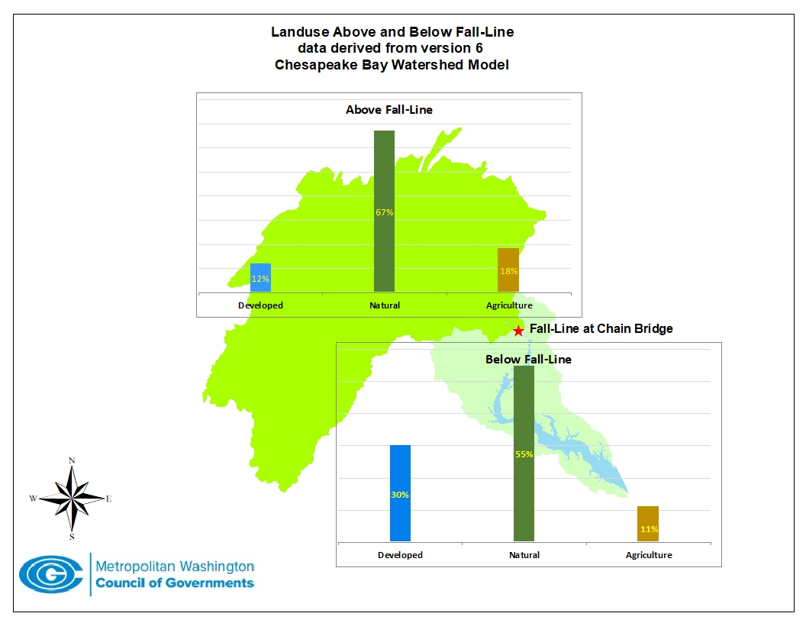
Figure 1: Land Use Map of the Potomac Watershed
POTOMAC RIVER WATERSHED AT A GLANCE

LENGTH: 383 miles from origins in West Virginia to confluence with the Chesapeake Bay
AREA: At 14,670 miles, the watershed comprises about 23 percent of the overall Bay watershed
NATURE: Free-flowing to the fall line at Chain Bridge, a tidally-influenced estuary for the rest of its length
POPULATION: About 6 million, 80 percent of whom live in the COG region
LAND USE: Primarily forested in the portion that drains above Chain Bridge, somewhat urban in the portion that drains below Chain Bridge

Determining how much pollution arises from the watershed’s different land uses is key to understanding what management actions are necessary to further improve water quality.

Section 1. Inputs to the Estuary - Regional Wastewater Treatment

Starting in the early 1960s and continuing through today, the area’s wastewater treatment plants have made many upgrades to increase the efficiency at which they capture nutrients and other sources of pollution from their effluent.
The reduction in nutrient discharges from wastewater treatment plants is all the more impressive because it has been achieved despite increases in wastewater flow (depicted by blue lines in the accompanying charts) to the plants as a result of population and job growth in the region. The improvement in nutrient reduction efforts has given the region a cushion to accommodate future growth without exceeding the Bay TMDL’s nutrient caps.
Phosphorus was the first major nutrient concern because of its role in stimulating harmful levels of algal bloom in the freshwater portion of the Potomac estuary. Starting in the 1980s, phosphorus controls at area treatment plants reduced the amount discharged by about 96 percent and these controls remain at limit-of-technology levels today.

Beginning in the 1990s, the plants began to focus on reducing discharges of nitrogen. The first round of such reduction efforts, known as biological nutrient removal, reduced wastewater loadings 40 - 50 percent from previous levels. Since 2010, the plants have been installing another round of nitrogen removal technology that is producing significant further reductions.

Reductions in wastewater nutrient loadings account for the most significant progress, by far, in the 35-year history of the Chesapeake Bay restoration effort. According to Chesapeake Bay Program (CBP) calculations, the wastewater sector accounts for about 75 percent of total reductions of nitrogen and phosphorus since 1985.

The success is derived from a funding partnership among all levels of government. Federal grants helped local governments pay for the original round of phosphorus controls; state and federal funds are helping to pay now for the further nitrogen controls.

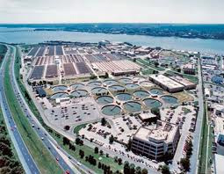
Although the indicators of water quality remain mixed, it is possible to document the impact of the reductions in wastewater pollutants on improving water quality in the river, particularly in the upper Potomac estuary into which almost all of the Washington region’s plants discharge their effluent. Monitoring efforts here have shown improvements in dissolved oxygen levels, a reduced incidence and severity of harmful algal blooms, and rebounding populations of several critical living resources, including submerged aquatic vegetation.
Source: Blue Plains WWTP

Figure 2: Total Nitrogen Loads from Regional WWTPs
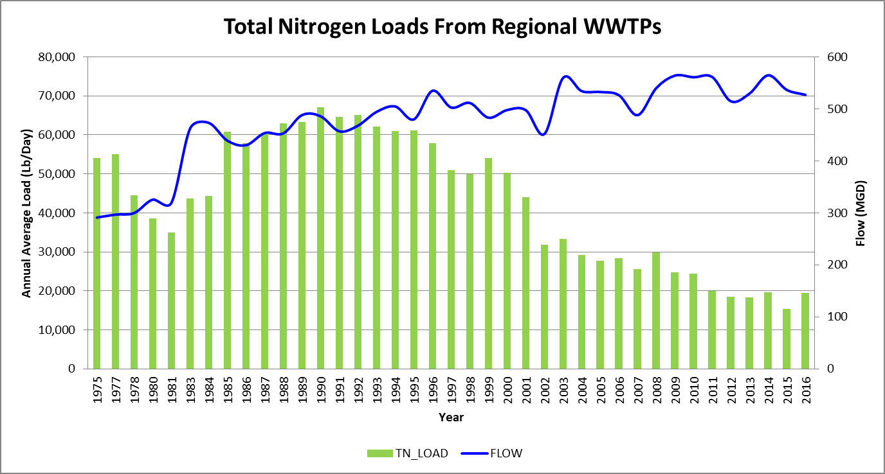

Figure 3: Total Phosphorus Loads from Regional WWTPs
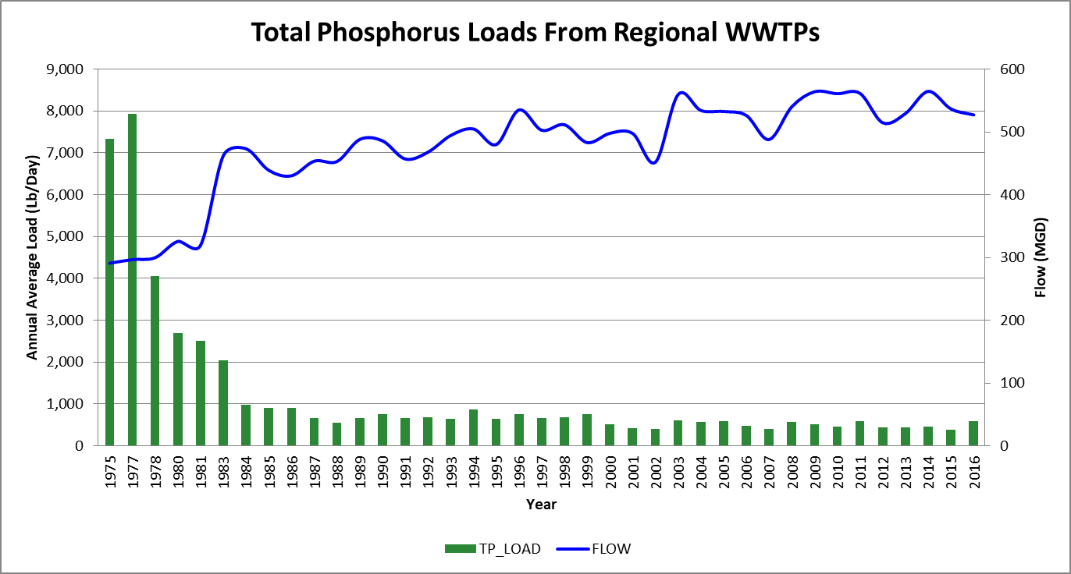

Section 2. Inputs to the Estuary - Monitoring Pollutant Loads at Chain Bridge

The U.S. Geological Survey has maintained a Potomac River fall line monitoring station at Chain Bridge since 1985, one of a series of river input monitoring stations that analyze water quality flowing into the Bay from its major tributaries. Data in this section is drawn from the USGS Chain Bridge station and addresses the three major pollutants regulated by the Bay TMDL: total nitrogen, total phosphorus and total sediment.

We would like to know from this data if the Bay Program’s pollution reduction efforts are working, that is, whether the trend for these parameters is increasing or decreasing. (It’s important to note that almost all of the wastewater effluent from plants in the COG region is discharged into the river below Chain Bridge; water quality at Chain Bridge reflects some impacts from upstream wastewater plants, but it is more affected by nonpoint sources, particularly agriculture.)

However, this task is complicated by several factors. Foremost of these is the variability created by changing weather patterns. On a year-to-year basis, the total amount, or load, of these pollutants will fluctuate with the flows resulting from differing patterns of precipitation. To discern water quality trends impacted only by human activities, the USGS has developed a method for estimating flow-normalized trends. This method (known by its acronym, as WRTDS) produced the data shown in this section; it also provides some of the data used to establish loads for the Bay TMDL and to calibrate the CBP watershed model.

These charts show the total annual amounts of the major Bay pollutants measured at the Potomac fall line at Chain Bridge by USGS. Total nitrogen and total phosphorus are shown in millions of pounds/year; total sediment; in billions of pounds/year.

Figure 4: Potomac River at Chain Bridge – Total Nitrogen Load Trend
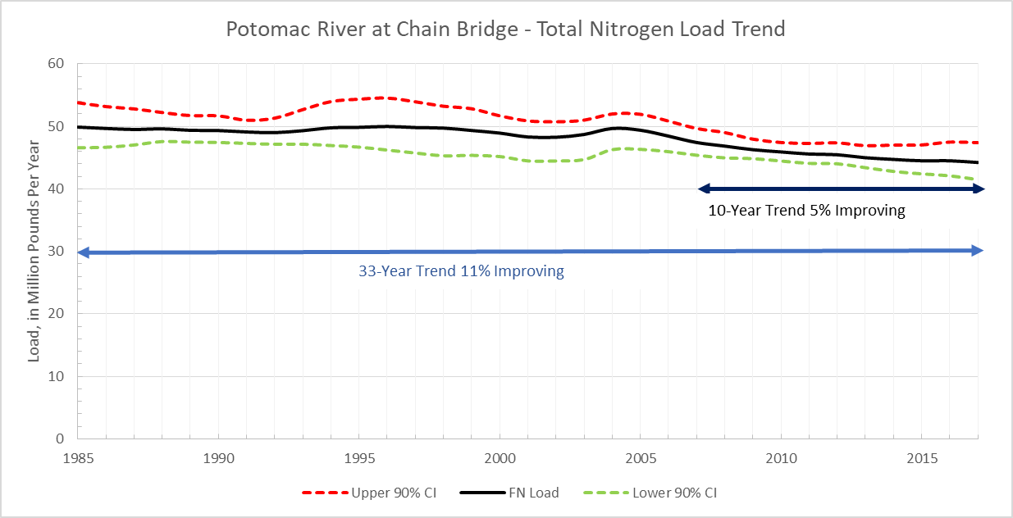

USGS uses statistical techniques to remove most of the variability in actual loads introduced by fluctuating hydrology. The resulting flow-normalized loads provide an illustration of how nutrient and sediment loads have altered because of man-made changes.

Figure 5: Potomac River at Chain Bridge – Total Phosphorus Load Trend
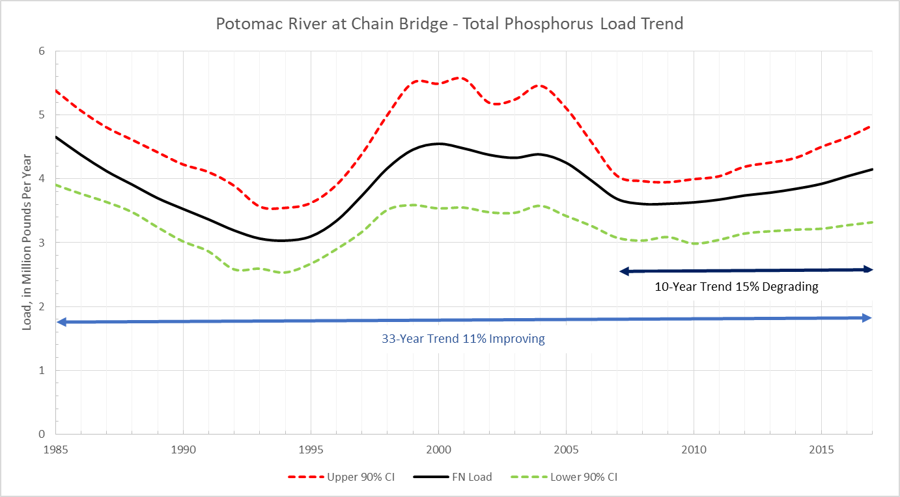

Figure 6: Potomac River at Chain Bridge – Total Sediment Load Trend
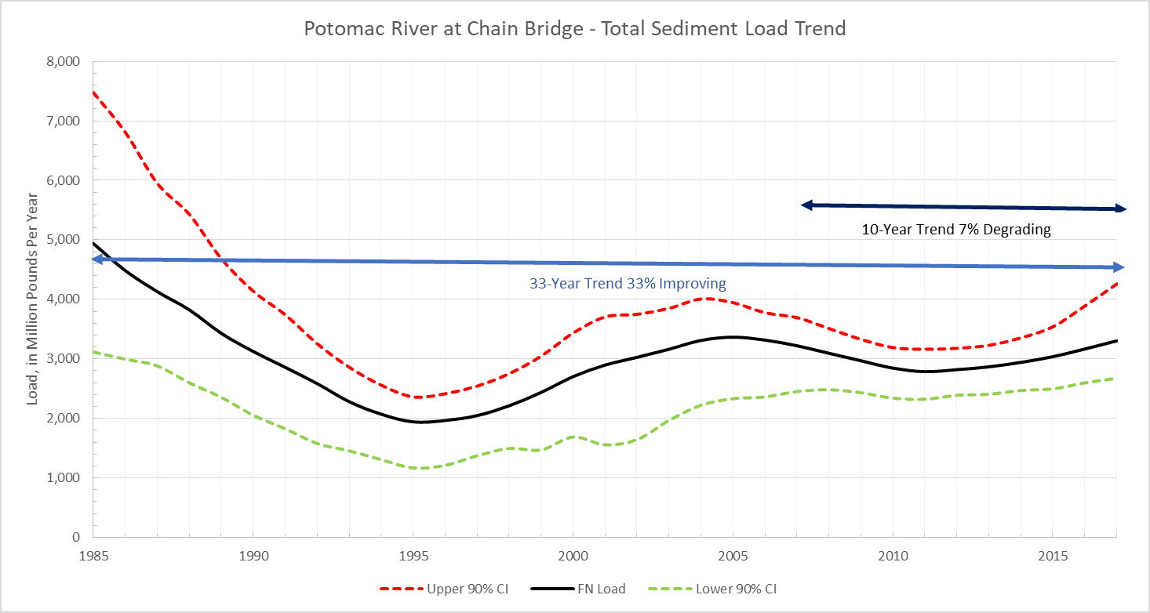

The USGS data shows that nutrient reduction efforts above the Potomac fall line have led to decreasing trends since 1985 for all three of the major pollutants. However, the patterns differ between nitrogen (TN) on the one hand and both phosphorus (TP) and sediment (TS) on the other. The TN load trend has been flat to steadily declining over the 33-year span of the USGS monitoring data. TP and TS load trends have gone up and down and in both cases show increases (i.e. degrading trends) in the most recent 10 years. There is not a definitive explanation for the drivers of these trends. Reductions in nutrients from wastewater plants and from agriculture probably account for most of the progress. In the case of the recent increases in flow-normalized TP and TS loads, it is thought that increases in animal numbers and the resulting manure in certain portions of the watershed and increases in the amount of developed land above the Chain Bridge fall line have contributed to these degrading trends.
Section 3. Inputs to the Estuary - Nonpoint Source Loads from below the Fall Line
Efforts to reduce nutrient and sediment loads from urban landscapes are still in their infancy compared to wastewater nutrient reduction efforts. COG member jurisdictions with MS4 permits for their stormwater conveyance systems only began to focus on pollutant reductions from BMPs in permit cycles that began between 2005 and 2010. Moreover, because ramping up program resources, both financial and otherwise, to implement the latest generation of nutrient-reducing BMPs has been a major challenge, the pace of implementation has been slower than in other sectors.

Nevertheless, some signs have emerged of progress in reducing nutrient loads in portions of the COG region. The following charts show TN and TP trend data from all of the USGS nontidal monitoring stations in the Potomac and Patuxent watersheds in the 10 years from 2007 - 2016. (See Figure 9 for a map of where these stations are located.) Improving load trends (shown as green circles) indicate reduction progress; brown circles indicate degrading load trends. The stations at Northwest Anacostia, Patuxent Bowie, Accotink Creek, and Western Branch Upper Marlboro (all of which drain primarily urban areas, although not all of the watersheds are in the Potomac basin) all show improving trends for TN and Patuxent Bowie and Northwest Anacostia also show improving trends for TP. However, these trends are not definitive and there are other COG stations that drain urban watersheds that still show degrading trends.

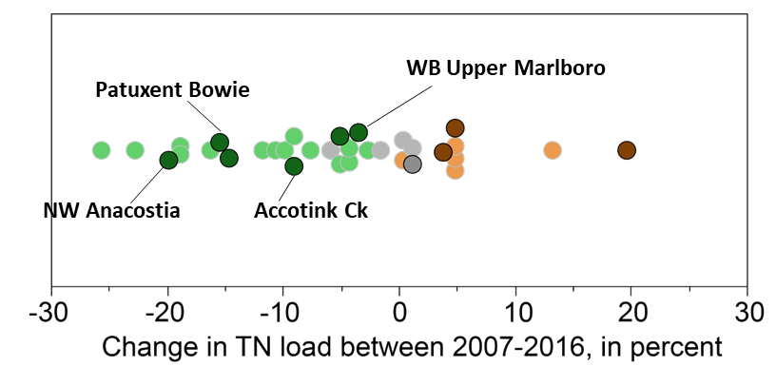
Figure 7: USGS Nontidal Monitoring Station – Change in Total Load 2007-2016

Figure 8: USGS Nontidal Monitoring Station – Change in Total Load 2007-2016
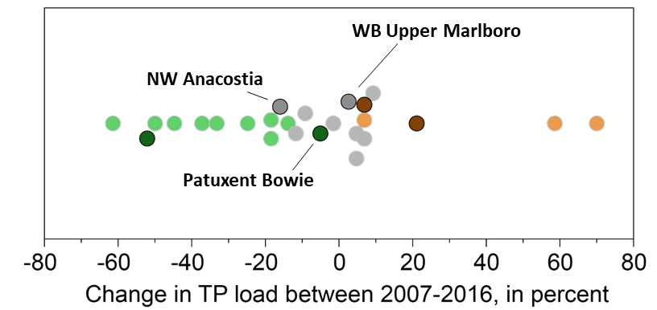
Section 4. Estuarine Water Quality

Figure 9: Map of Water Quality Monitoring Stations in the Potomac Watershed
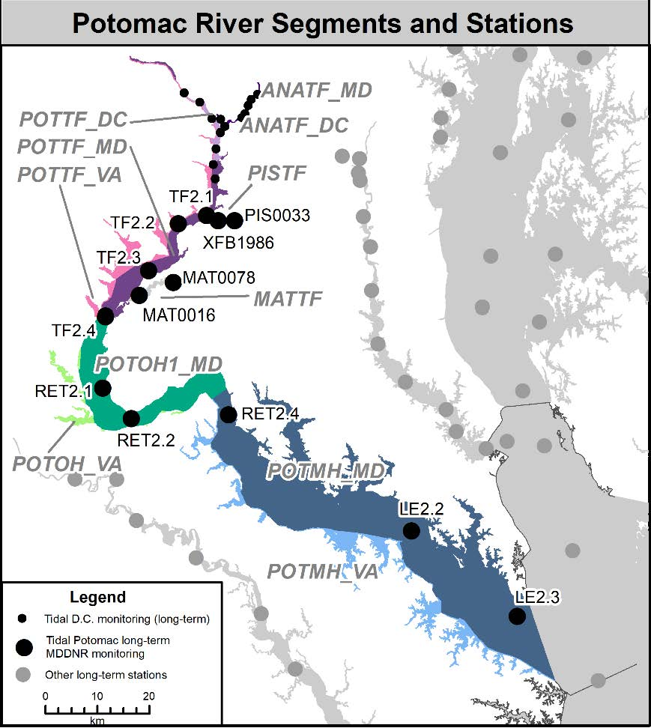
Water quality data gathered in the Potomac River estuary and the Chesapeake Bay since 1985 provides a mixed picture of progress, with certain parameters showing signs of improvement while others have degraded. The data in the following charts is derived from the Chesapeake Bay Program’s (CBP) tidal monitoring program, under which MDDNR and VADEQ in collaboration with the CBP collect water quality samples from the Bay and its tidal tributaries (Most of these charts are a subset of the larger CBP 2016 tidal trends release provided courtesy of R. Murphy, UMCES-CBP {CBP 2017}.) At most stations, samples are collected twice a month in the warmer months, when living resources are most active and environmental stresses are most acute, and monthly in the winter. The data is analyzed and presented in the same way across all the stations, allowing for uniform assessments of the degree to which the water is meeting water quality standards.

There are three official water quality parameters for assessing attainment: dissolved oxygen, water clarity and chlorophyll-a (a measure of algal abundance). The Bay Program provided guidance to the states in selecting threshold values or criteria for each of these based on different habitat zones within the Bay. The different segments into which the Bay and its tidal tributaries have been divided are designated as in or out of attainment based on a criteria assessment procedure that uses the monitoring data (USEPA 2003; USEPA 2010 ). Just as in the mainstem of the Bay, the deeper waters toward the mouth of the Potomac estuary have not met their dissolved oxygen attainment criteria throughout the data record and are the drivers for the level of nutrient reductions necessary to return the river to full health.

Because a simple in- or out-of-attainment metric does not convey the extent of non-attainment nor lend itself to an assessment of progress, Bay Program analysts have developed other ways of evaluating the data. One of these is “attainment deficit,” which incorporates estimates of the volume of water and the amount of time that a particular tidal water segment is determined to be out of attainment for a particular parameter (Zhang et al. 2018).

The following charts are all based on attainment deficits for dissolved oxygen, a key water quality endpoint for which the Bay TMDL was designed. They are calculated for rolling three-year periods. Values at “0” in these charts means the segment is in attainment.

The two charts show attainment deficit for the deep channel and the adjacent deeper waters in the lower portion, or mesohaline section, of the Potomac estuary. POTMH-MD represents the Maryland portion of these waters, which comprise the bulk of the mainstem; POTMH-VA comprises Virginia’s portion, which includes a number of embayments on its side of the river. There is much less data for these Virginia waters and its water quality does not necessarily correspond to conditions in the main part of the estuary.
Figure 10: Attainment Deficit for the Potomac Deep Channel Stations in MD
and VA

Although the charts show deficits in the range of 5 – 15 percent on a time- and volume-weighted basis for these segments, it does appear that water quality degradation bottomed out in the 2007-2009 period and has been improving since then. And there is other data that provides evidence of recent improvement in water quality in the Potomac estuary.

Figure 11: Attainment Deficit for the Potomac Deep Channel Stations in MD
and VA

Assessing Trends

Working in concert with analysts for the Maryland Department of Natural Resources, Bay Program staff has begun using a new implementation of a statistical technique known as Generalized Additive Models (or GAMs) to discern trends and other patterns in the data over time (Murphy et al. in review). In the following charts, GAM-based trend results are shown for both the long-term and short-term data records for multiple parameters.

From “Tidal Trends in Water Quality: Potomac River 2016 Tributary Summary.”
Figure 12: Potomac River Annual Trends for Surface Total Nitrogen
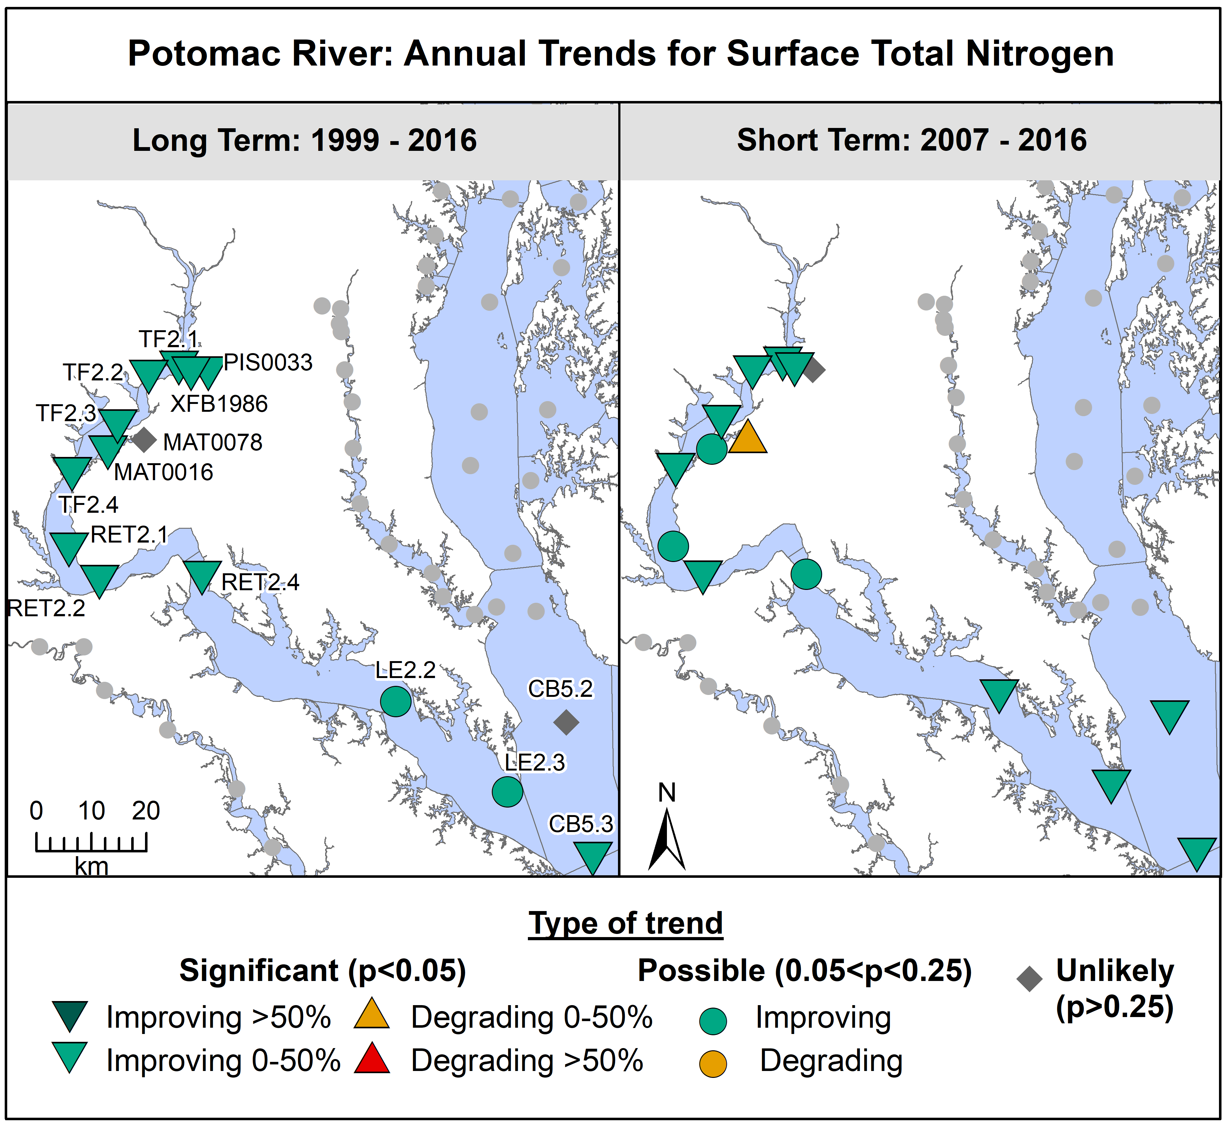

The charts show trends for a variety of water quality parameters measured by the tidal water monitoring program. They all employ the same visual symbols, indicating whether the trends are improving (in green arrows or circles), degrading (in either red or yellow arrows or circles) or neutral (grey diamonds). The color and shape also denote the degree to which the trend is statistically significant.

Figure 13: Potomac River Annual Trends for Surface Total Phosphorus

From “Tidal Trends in Water Quality: Potomac River 2016 Tributary Summary.”
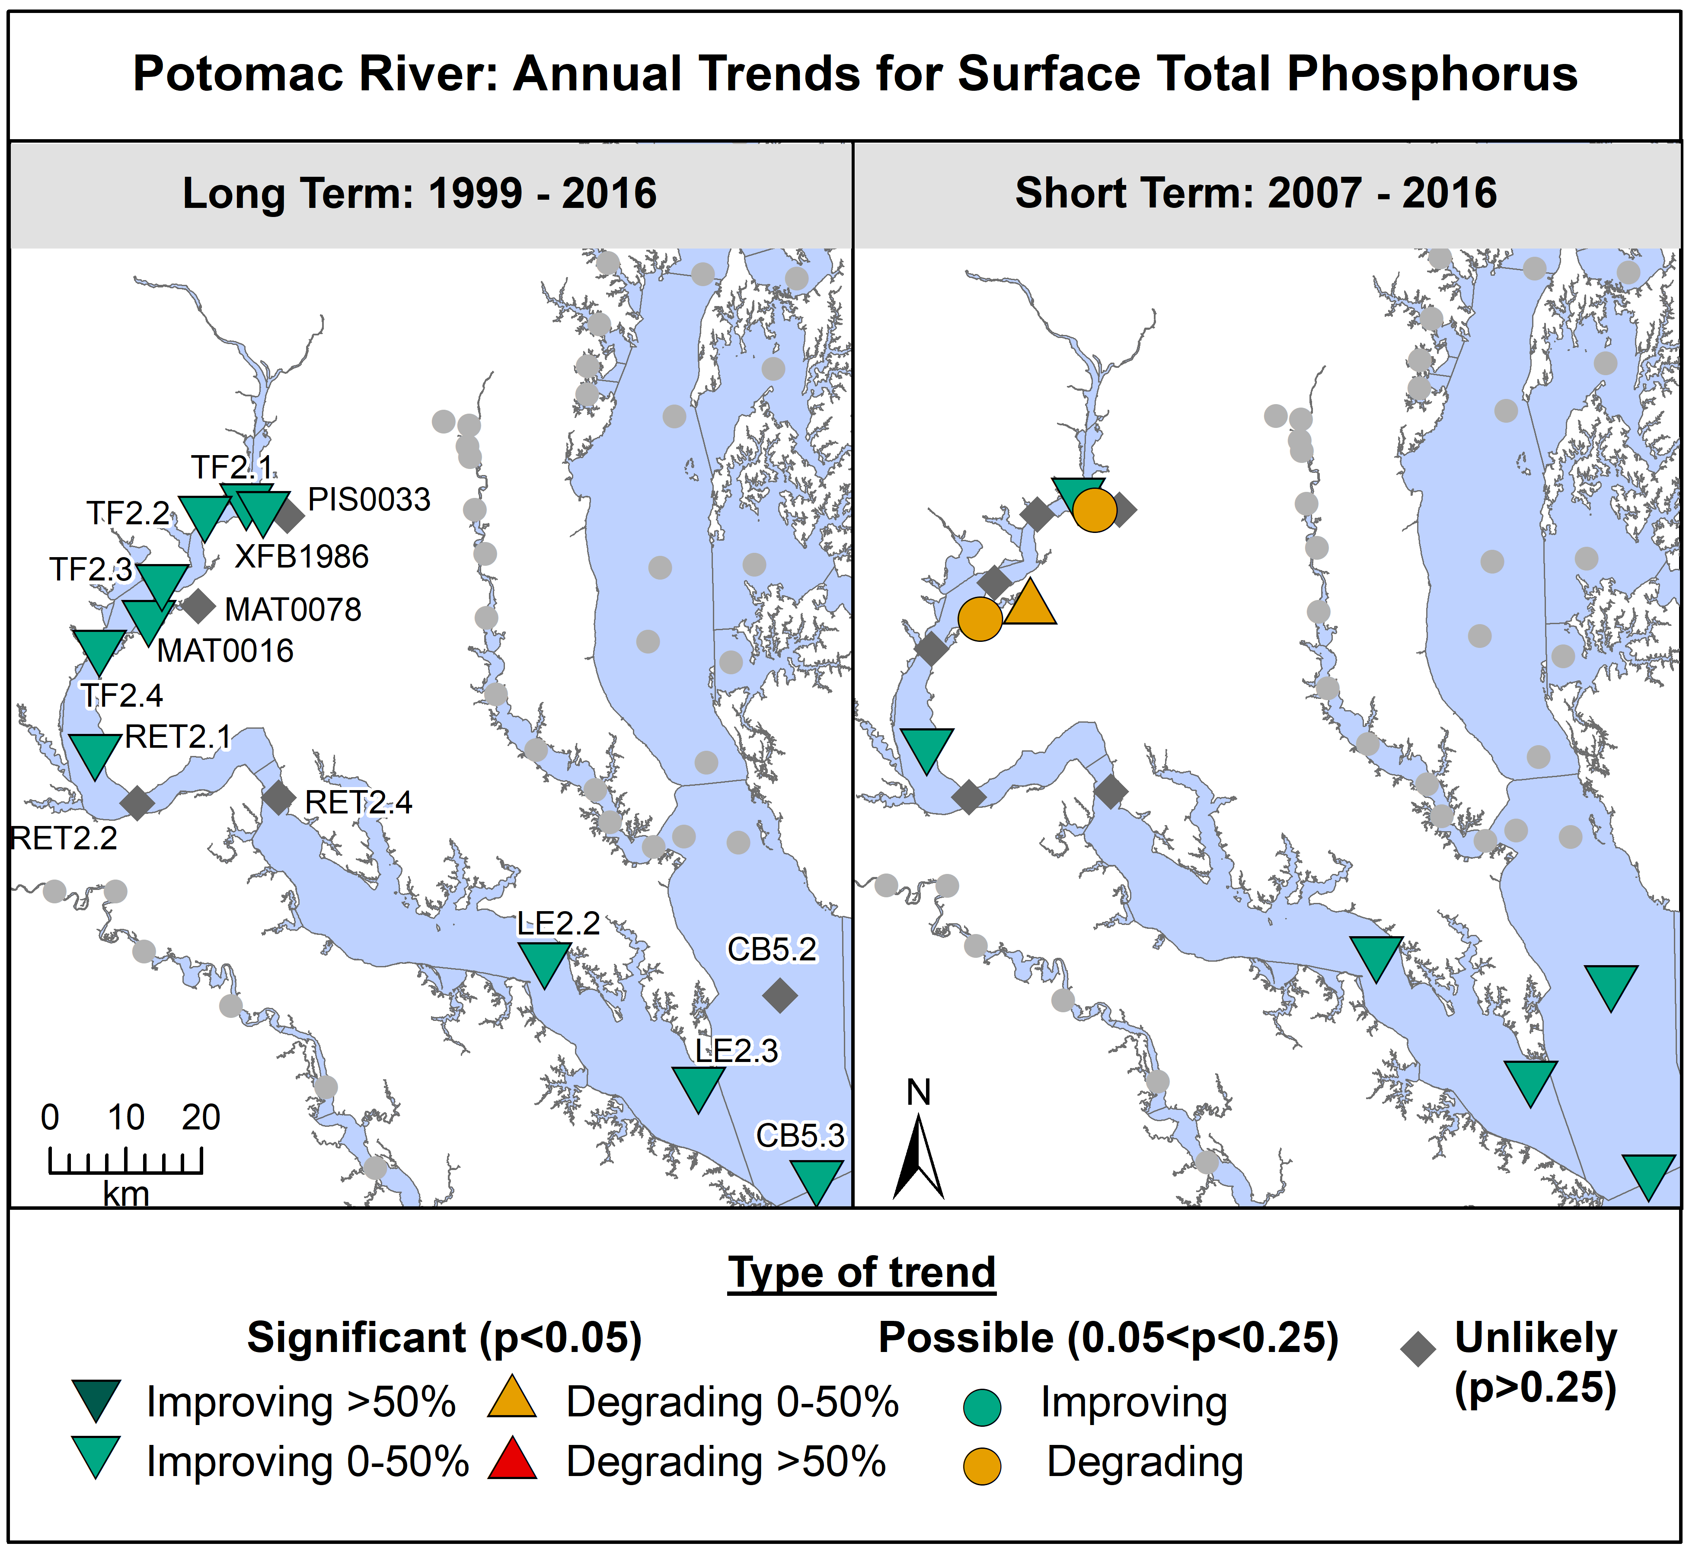

Most of the trends in both surface nitrogen and surface phosphorus concentrations in all portions of the estuary show significant improvement (i.e. reductions) in both the short- (10 years) and long-term (20 years). Reductions in the nutrients discharged from wastewater plants are likely the major cause for this improvement, although reductions from other sources also contributed to the trends.

However, improvements in other water quality parameters are harder to discern, both because such improvements tend to lag behind reductions in the pollutants that are the root cause of degradation and because other factors come into play in the complex estuarine environments.

For example, dissolved oxygen has shown a significant long-term improving trend at almost all of the upstream stations since 1985 and at ones in the uppermost tidal fresh portion of the estuary since 2007. However, the lowermost stations – LE2.2 and LE2.3 – have mostly shown no trends or degrading trends during these same periods. However, these stations represent the deepest waters in the Potomac estuary, typically where low oxygen conditions are hardest to overcome, and also are more influenced by water quality in the mainstem of the Bay than the other Potomac stations.

Figure 14: Summer Trends for Bottom Dissolved Oxygen

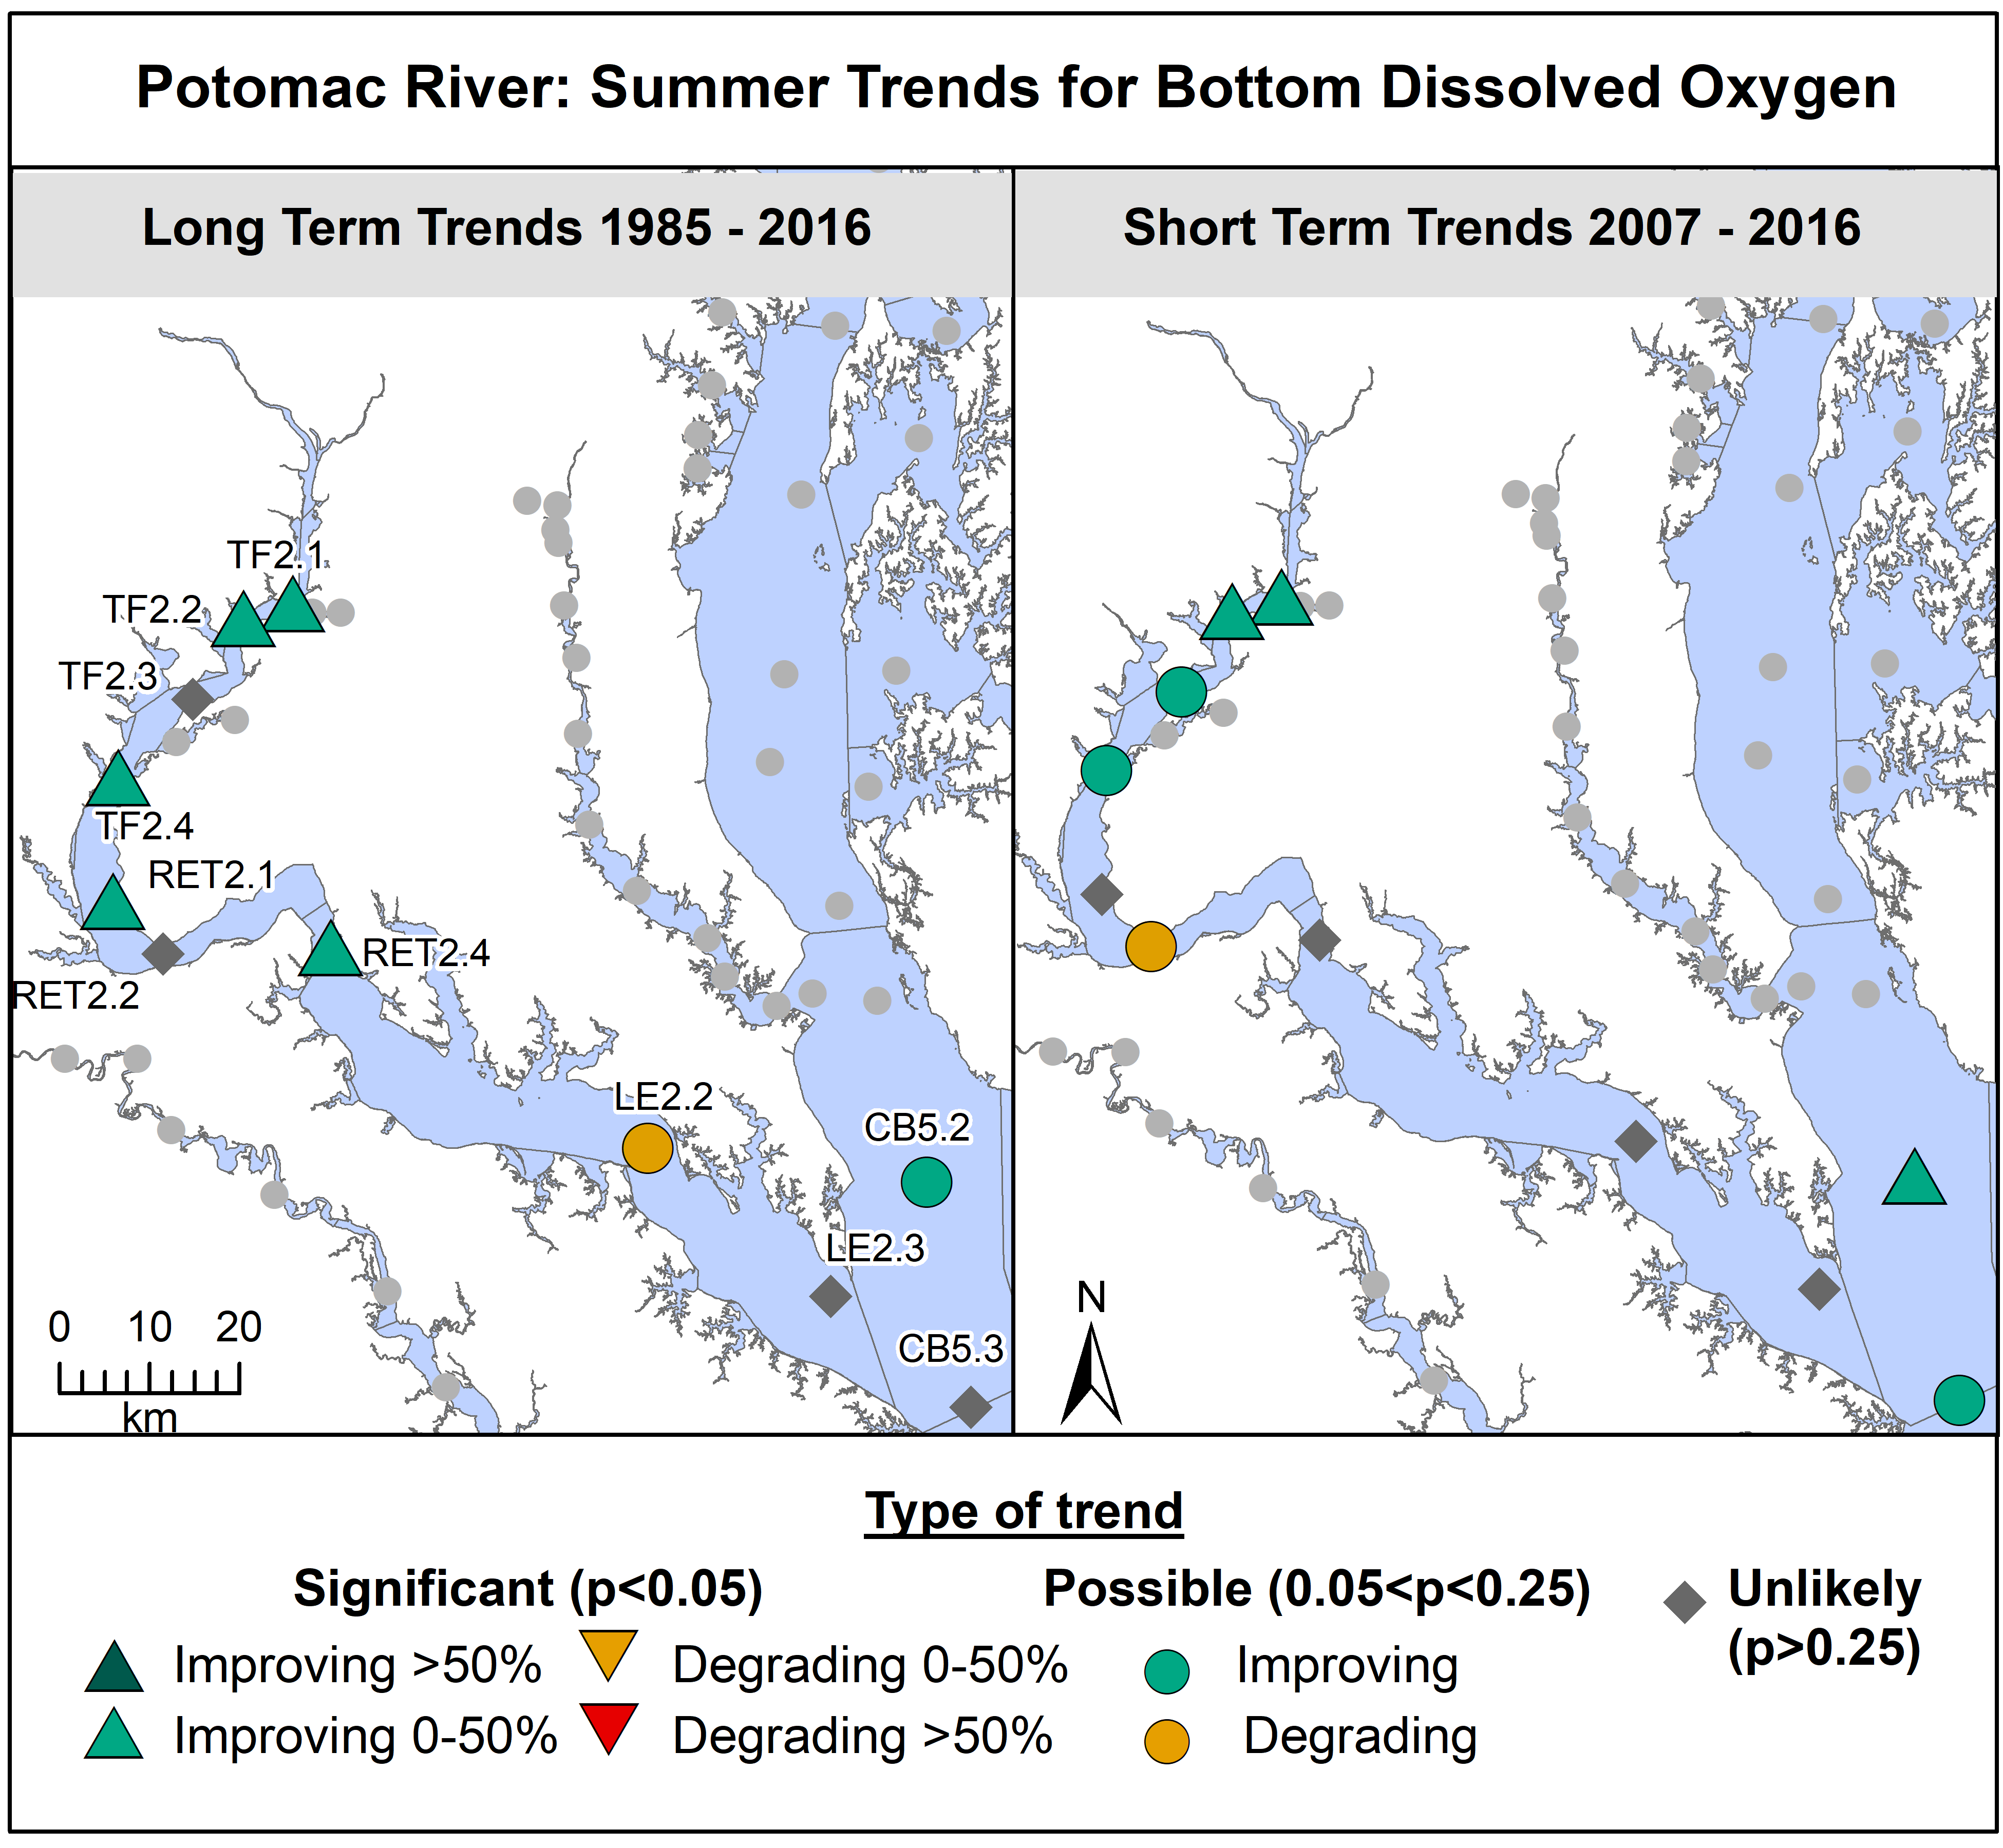
Even where overall statistical analysis shows no signs of improvement, analysts believe they can pick out smaller signs that progress is being made. At the RET 2.4 station near the Route 301 Bridge, for example, the monitoring data from recent years has only 1 value below the deep channel instantaneous criterion of of 1 milligram/liter.

From “Tidal Trends in Water Quality: Potomac River 2016 Tributary Summary.”

Figure 15: Bottom Dissolved Oxygen: Summer for station RET2.4

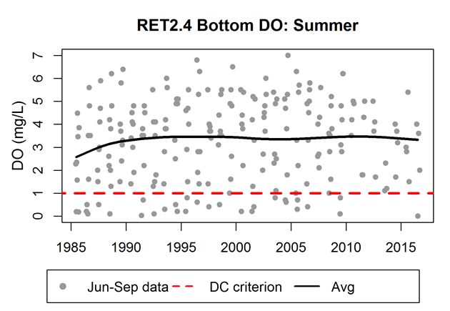

The trends for Secchi disk depth (a measure of water clarity) and chlorophyll-a (a measure of algal amounts) also are mostly degrading, especially in the upper portion of the estuary where the impact of wastewater nutrient reduction should be the greatest. Researchers are currently examining the reasons for these seemingly contradictory trends. One theory is that other factors, such as changes in climatic factors and in the populations of freshwater clam species, have tended to obscure the positive impacts of nutrient reduction.
Figure 16: Annual Trends for Secchi Disk Depth
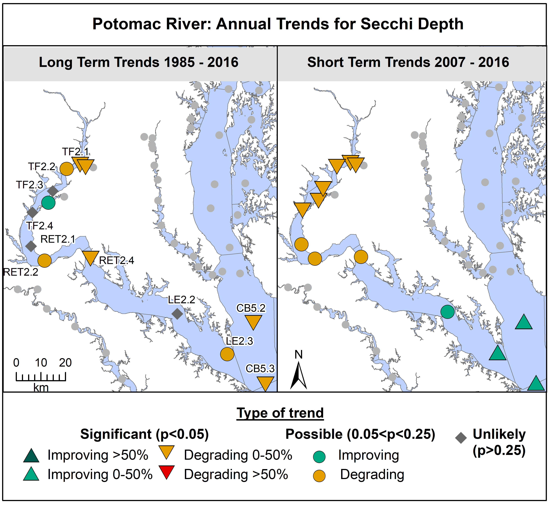
From “Tidal Trends in Water Quality: Potomac River 2016 Tributary Summary.”
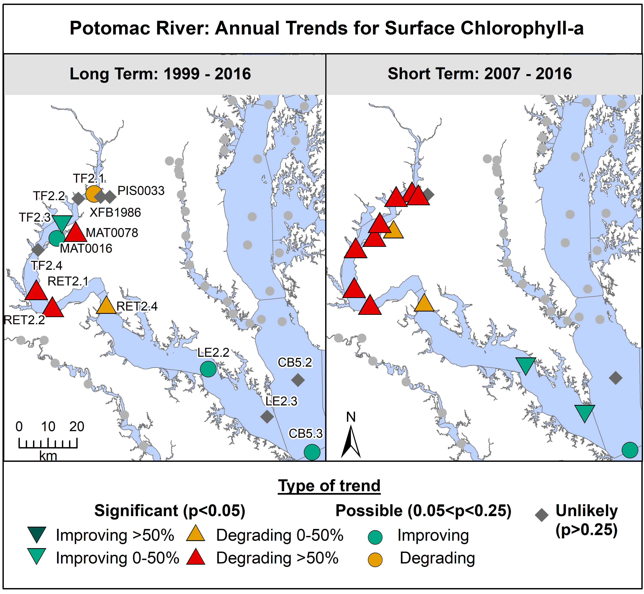
From “Tidal Trends in Water Quality: Potomac River 2016 Tributary Summary.”
Figure 17: Long and Short Term Annual Trends for Chlorophyll-a

Section 5. Success Stories – Submerged Aquatic Vegetation (SAV)

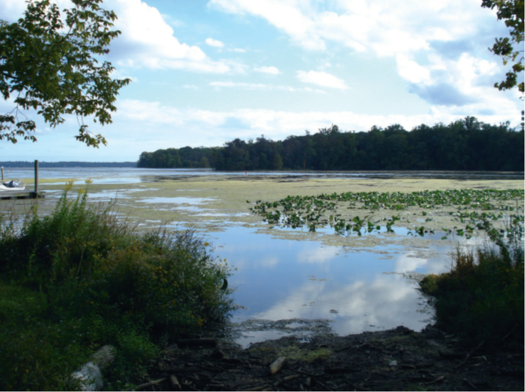
Although water quality in the river does not fully meet the water quality goals established under the Clean Water Act, there are success stories where concerted action has led to significant improvements in some conditions and where in recent years the populations of certain species of plants or animals have rebounded from previously low levels. Most of the Potomac’s successes, which include submerged aquatic vegetation (SAV) and a number of fish species, derive largely from the reductions of nutrients from wastewater plants in the Washington region. It show up most clearly in the freshwater portion of the Potomac estuary, which stretches from the river’s fall line at Chain Bridge in Washington, D.C., downriver to the mouth of Mattawoman Creek.
Source: Flickr Creative Commons
The amount of SAV growing in the upper estuary fluctuates annually because of changes in weather conditions and other factors, but overall it has increased significantly in recent years as nutrient levels in the water have decreased. Fewer nutrients leads to less algal growth, which in turn increases the amount of light that reaches underwater grasses. In addition to greater overall SAV growth, the upper estuary also has seen the diversity of underwater grasses increase in recent years. Hydrilla, an invasive exotic species that was the first type of SAV to recolonize shallow water habitat in the estuary, now comprises less than 10 percent of total SAV abundance in most years.

The SAV success story is still somewhat limited, however. The Chesapeake Bay Program has established initial targets for the extent of SAV acreage in different parts of the Bay and the tidal waters of its tributaries, including the Potomac. SAV growth in the tidal freshwater portion of the Potomac estuary mostly met this target in recent years, but did not do so in 2011 and 2012. The underwater grass populations in the river remain sensitive to environmental disturbance. Weather conditions that favored greater algal growth in 2011 and 2012 also saw fewer acres of underwater grasses in the upper estuary. Moreover, SAV growth tends to drop off in the lower, saltier portions of the estuary, where the amount of SAV acreage has not yet met any of the initial Bay Program targets. And even where SAV growth has met the initial restoration targets, it remains far short of the ultimate goal: underwater grasses growing in all of the shallow water habitat of the Bay and the tidal waters of its tributaries.

Figure 18: Potomac Estuary SAV (Upper Portion) and Flow at Chain Bridge

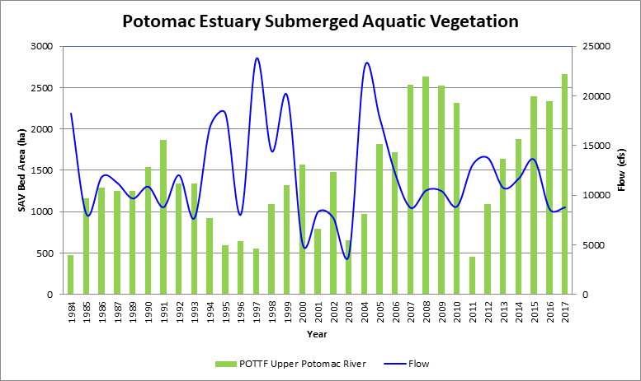

Local Water Quality in Gunston Cove – A Case Study
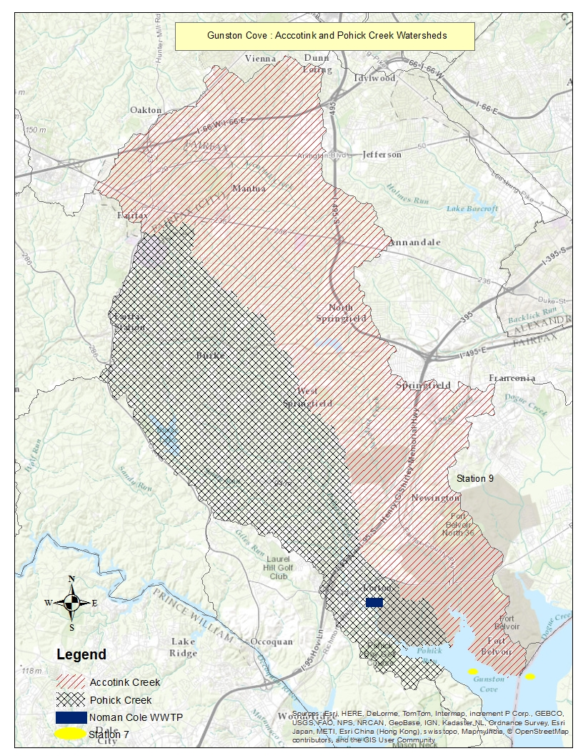
Figure 19. Watershed Draining to Gunston Cove
Although restoration of the Chesapeake Bay has been the main driver behind many of the water quality improvement efforts undertaken in the region, the improvement of water quality in smaller, localized water bodies is also an important reason for action. Local streams, many of which have been degraded by decades of urbanization, are targeted for a variety of restoration measures by local government stormwater management programs. And where wastewater discharges occur into local rivers or Potomac River embayments, reductions in the discharge of nutrients and other pollutants can have a major impact on improving local water quality conditions.

Information in Section 3,”Nonpoint Source Loads from below the Fall Line,” indicated that smaller tributary watersheds throughout the COG region present a mixed set of trends for nutrient and sediment reduction, with some improving and some degrading. Despite some improvements in some local streams, almost all of the smaller watersheds in the region are at most only partly restored and will require decades of further work to return to fully fishable and swimmable conditions.

Perhaps the most encouraging case study of how restoration efforts can improve local waters is provided by Gunston Cove, a Potomac River embayment on the edge of Fairfax County, into which the county’s Noman M. Cole Jr Wastewater Plant discharges its effluent. Water quality in the cove has been extensively studied for decades by a research team from George Mason University led by Dr. Chris Jones. Data in this section is derived from this research.

Historically, water quality and living resources in Gunston Cove experienced the same overall response pattern as have tidal waters throughout the Bay. As water quality continued to decline in response to increasing pollution, the living resources were increasingly stressed, and in some cases, disappeared. By the mid-20th Century, summer conditions in the embayments came to be dominated by rapidly expanding populations of algae, known as blooms, stimulated by an excess of nutrients. The surface-growing algae cut off light to the underwater grasses (known as submerged aquatic vegetation or SAV), which disappeared entirely from the embayments by the 1960s and 1970s. When algal cells die off, they sink to the bottom and their decomposition uses up most of the dissolved oxygen. These and other stresses from pollution reduce both the diversity and population numbers of fish species and other forms of aquatic life.
Figure 20. Flow and Loads at Noman Cole Plant
The road to recovery began with a ban on phosphates in detergents in the late 1970s and the implementation of phosphorus controls at all of the major wastewater plants discharging to the estuary in the late 1970s and early 1980s, including the Noman Cole plant in Fairfax County. These were followed by controls on nitrogen discharges in successive periods from 2000-2005 and again since 2015. (See Figure 20.)

Noman M. Cole Jr. WWTP
Between 1980 and 1985, the amount of phosphorus discharged into the lower Pohick Creek by the Noman Cole plant decreased by about 85 percent and the amount of phosphorus leaving the plant has remained at the same low level despite increases in the flow of wastewater to the plant. The discharge of nitrogen continued to increase until 2000-2005, when Noman Cole implemented its first round of biological nitrogen removal, achieving reductions of about 85 percent. Noman Cole implemented its second round of nitrogen reductions in 2013.

The water quality response can be seen in figures 21, 22 and 23 - a small amount of SAV growth was seen in the wake of the initial reductions in wastewater phosphorus. However, summertime levels of chlorophyll-A, a measure of the amount of algal growth, remained elevated and, correspondingly, water clarity, as measured by Secchi disk depth, remained relatively poor through 2000. Then, at various points between 2001 and 2005, chlorophyll-A levels declined dramatically – indicating a major reduction in algal populations – and water clarity improved. These are believed to be the major factors in the significant expansion of SAV acreage subsequently seen in this embayment.

Although the general pattern of nutrient reductions leading to water quality improvements seems clear and has been observed in other parts of the Bay, water quality scientists are not certain of all the details and there are individual differences at play as well. Jones believes that the chlorophyll-A, water clarity and SAV acreage changes in Gunston Cove were triggered by the phosphorus reductions at Noman Cole, even though several decades elapsed between these two sets of events. He attributes this response lag to the persistence of phosphorus in bottom sediments in the cove; it is only when this phosphorus reservoir was depleted that the algal populations declined and the SAV rebounded.

Figure 22. SAV Extent in Gunston Cove in 2015
Figure 21. SAV Extent in Gunston Cove in 2005

Figure 23. Various Water Quality Parameters in Gunston Cove

Summary

Although local governments and utilities in the COG region have made great progress in reducing the amount of nutrients discharged from wastewater plants in the region and there has been some progress, albeit smaller, in achieving reductions from other nutrient sources in the Potomac watershed, overall nutrient loads are still relatively high. Researchers are investigating if concentrations are simply still too high to see large-scale progress towards meeting water quality criteria in the river. Water quality data from the Potomac River estuary paints a mixed picture of progress, with both improving and degrading trends.

This can be seen in the following charts, which show the level of dissolved nutrients in the tidal fresh portion of the estuary compared to the theoretical algae “saturation limits” for dissolved inorganic nitrogen (DIN) and phosphorus (PO4). Above these limits, there is enough fuel so that algal populations can essentially grow unimpeded by nutrients, although light availability can limit growth. Because more progress has been made to date in reducing phosphorus, there are times in recent years where algal growth has been limited by P concentrations. For the same reason, the region has not experienced especially harmful levels of algal blooms since the early 1980s.

Because wastewater has essentially already achieved state-of-the art levels of nutrient reduction, further progress in improving water quality conditions depends on further efforts to reduce nutrients and sediment from so-called nonpoint sources, such as agriculture and urban runoff. Here too the data is somewhat uncertain, with many improving trends but some degrading ones as well. Scientists are still interpreting the effects of time lags, for instance, in the flow of nitrate-enhanced groundwater that gradually feed surface waters and in the ability of BMPs to reduce extensive phosphorus reservoirs in certain soils. What is certain is that additional efforts to reduce nutrients and sediment from these nonpoint sources will be needed to achieve the river’s long-term water quality goals.
Dissolved Inorganic Nitrogen (DIN) in Spring

Approximate “saturation limit” for dissolved nitrogen: Above this limit, there is so much DIN that algae can’t grow any faster. To see a DO response, the DIN level will need to be below the saturation limit on a continuing basis.

For More Information
^{viii}Courtesy Rebecca Murphy, UMCES-CBPO
Dissolved Phosphorus (Orthophosphate) in Spring
Approximate “saturation limit” for dissolved phosphorus: Only in recent years, and in the lower Potomac estuary, do we see concentrations consistently below the limit. More improvements are needed to achieve water quality standards.
Dissolved Inorganic Nitrogen (DIN) in Spring

More in-depth information is available from the following sources:

(need to add web references)

Endnotes

Moyer, D.L., Chanat, J.G., Yang, Guoxiang, Blomquist, J.D., and Langland, M.J., 2017, Nitrogen, phosphorus, and suspended-sediment loads and trends measured at the Chesapeake Bay Nontidal Network stations: Water years 1985-2014: U.S. Geological Survey data release, https://doi.org/10.5066/F7XK8D2R.
CBP. 2017. Maps of 2016 Tidal Trends. https://www.chesapeakebay.net/who/group/integrated_trends_analysis_team
U.S. Environmental Protection Agency (2003a). Ambient water quality criteria for dissolved oxygen, water clarity and chlorophyll-a for the Chesapeake Bay and its tidal tributaries. USEPA Region III Chesapeake Bay Program Office EPA 903-R-03-002. Annapolis, Maryland. https://www.chesapeakebay.net/content/publications/cbp_13142.pdf
U.S. Environmental Protection Agency (2010a). Ambient water quality criteria for dissolved oxygen, water clarity and chlorophyll a for the Chesapeake Bay and its tidal tributaries: 2010 technical support for criteria assessment protocols addendum. USEPA Region III Chesapeake Bay Program Office EPA 903-R-10-002. Annapolis, Maryland. https://www.chesapeakebay.net/content/publications/cbp_51366.pdf.
Zhang, Q, P.J. Tango, R.R. Murphy, M.K. Forsyth, R. Tian, J. Keisman, and E.M. Trentacoste. 2018. Chesapeake Bay Dissolved Oxygen Criterion Attainment Deficit: Three Decades of Temporal and Spatial Patterns. Frontiers in Marine Science. doi: 10.3389/fmars.2018.00422
Murphy, R.R., E. Perry, J. Harcum, and J. Keisman. A Generalized Additive Model approach to evaluating water quality in Chesapeake Bay. In Review at Environmental Modelling and Software.
(need citation for Jones’ work) ^{viii}Courtesy Rebecca Murphy, UMCES-CBPO

