Prince George’s County Maryland
Pedestrian Safety Measures for the New Carrollton Metrorail Station

Project Summary
The New Carrollton Metrorail Station is currently Prince George’s County’s only full-service intermodal transportation center, which provides the region with an excellent opportunity to transform it into a premier, high-intensity and livable urban center and regional transit-oriented destination featuring a walkable and transit friendly environment. This grant request calls for implementation of 12 of the initial TLC study proposals for implementation.

Project Cost
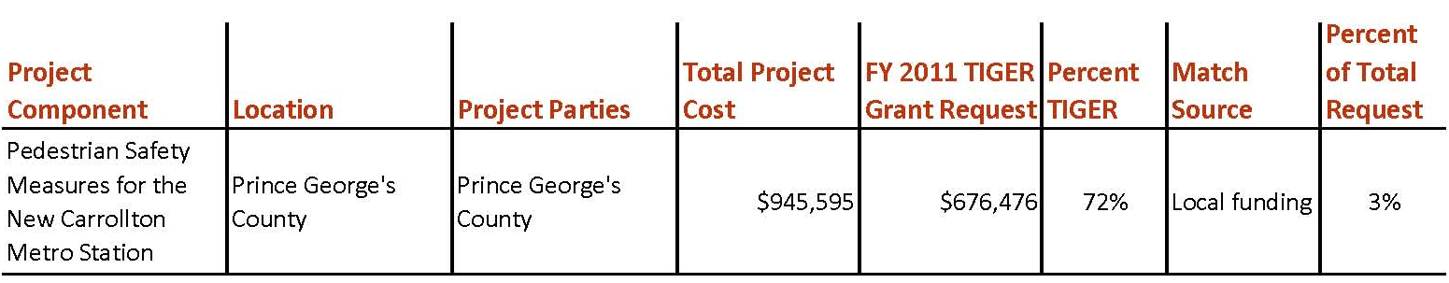

Project Location
This project is located in Prince George’s County, Maryland, around the New Carrollton Metrorail Station, the terminus station on the eastern portion of Metro’s orange line. The location also includes the New Carrollton Amtrak and MARC commuter rail stations. The

Project Planning
The 2010 New Carrollton Approved Transit District Development Plan (TDDP) and Transit District Overlay Zoning Map Amendment include planning concepts, recommendations, and implementation steps that came from the recommendations of the 2004 New Carrollton Transit-Oriented Development Strategy Planning Study, proposed public infrastructure investment recommendations provided by the Urban Land Institute Technical Assistance Panel convened in July 2007, as well as an extensive public outreach program that includes intensive hands-on workshops. Subsequent to the approval of the Plan, Prince George’s County’s Maryland National Capital Park and Planning Commission (M-NCPPC), through the Washington Metropolitan Council of Governments Transportation Planning Board (MWCOG-TPB), recently approved the 2010 Transportation Land-Use Connection (TLC) Study for the New Carrollton Station Area that provided a tool box of 29 recommended capital improvements.

Project Details
This grant request calls for construction of 12 of the initial TLC study recommendations for implementation. Included is the implementation of sidewalk and crossing improvements and signal timing changes, as identified in the TLC Study, and the pedestrian and bicycle recommendations of the 2010 TDDP around the New Carrollton Metro Station, which will assist the County in attracting future economic development to this area. Further, New Carrollton is the Number 1 identified Transit Oriented Development (TOD) in the County and ensuring that it is a safe pedestrian and bicycle friendly environment is critical to enhancing existing transit infrastructure and compounding its value as a TOD.

Project Schedule
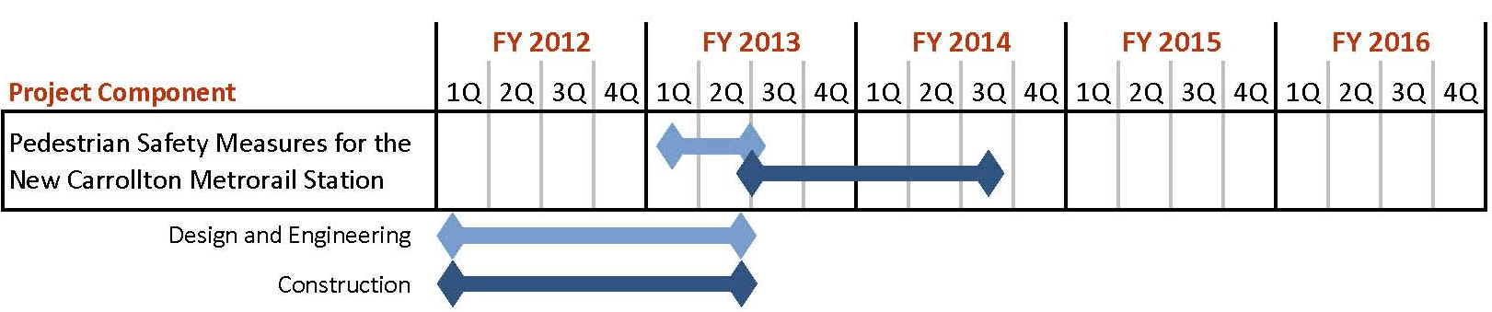

Additional Documentation
The components of this project were compiled from the 2010 TLC Program Study: New Carrollton Interim Pedestrian Safety Improvements. This study is located on the MWCOG website: http://www.mwcog.org/transportation/activities/tlc/pdf/NewCarrolltonPedSafety.pdf

