Item #6


National Capital Region
Transportation Planning Board
COMMUTER CONNECTIONS PROGRAM

Bike To Work Day 2024
Report
Prepared for:

Metropolitan Washington Council of Governments
777 North Capitol Street, NE, Suite 300
Washington, DC 20002-4290

Prepared by:

Mark Hersey, COG/TPB staff

November 13, 2024

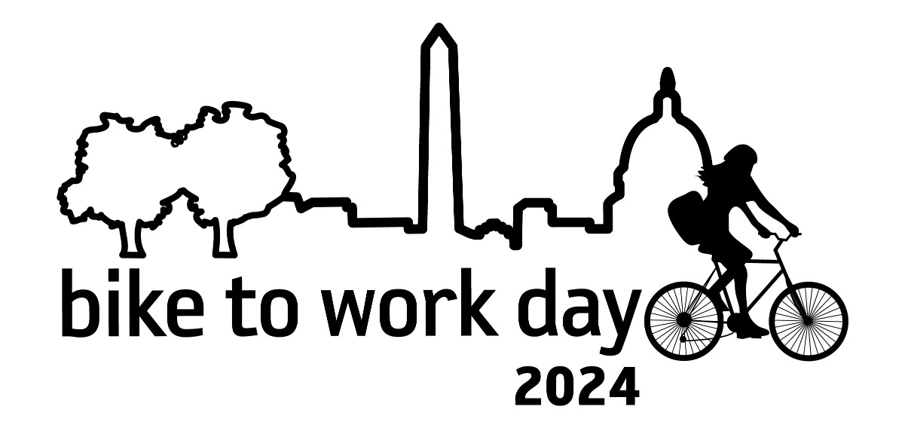

Table of Contents

Acknowledgements, Registration, Pit Stops – Page 3

Background/Executive Summary – Page 9

BTWD Registration by Year – Page 11

Sponsorship – Page 12

Highlights from Area Pit Stops - Page 14

Employer Participation – Page 38

Media Coverage– Page 49

Proclamation – Page 79

Marketing Materials – Page 81

Press Release – Page 85

Photos and Other Promotional Items – Page 88

ACKNOWLEDGEMENTS - PIT STOPS - REGISTRANT TOTALS

The 2024 Metropolitan Washington Bike to Work Day (BTWD) Pit Stop Managers consisted of the following individuals representing their respective organizations and the number of registrants for each pit stop:
Pit Stop Name 2024 | Pit Stop Manager | Company/Organization Name | # of Registrants
DC NE Anacostia Riverwalk Trail - River Terrace Park | Julie Kutruff | National Park Service | 97
DC NE Brookland Turkey Thicket | Lauren Marcinkowski | Mundo Verde Bike Bus/ Ward 5 Family Biking | 150
DC NE Edgewood Metrobar | Jesse B Rauch | metrobar | 130
DC NE Ivy City at BicycleSPACE | Philip Koopman | BicycleSPACE | 36
DC NE NoMa at Wunder Garten | Delonte' Kitt | NoMa Business Improvement District | 401
DC NE Old City Market and Oven | Curt Hansen | Old City Market and Oven | 105
DC NW Adams Morgan at Unity Park | Brian Barrie | Adams Morgan Partnership BID | 293
DC NW Cathedral Heights at Conte's Bike Shop | Jeff Roberts | Conte's Bike Shop | 127
DC NW Columbia Heights Plaza | Daniel Hayes | Retired Volunteer | 257
DC NW Dupont Circle at American Geophysical Union | Margaret Moerchen | American Geophysical Union | 176
DC NW Franklin Park | Latasha Stiger | DowntownDC Business Improvement District | 267
DC NW Georgetown Waterfront Park | Debbie Young | Georgetown Business Improvement District | 428
DC NW Golden Triangle - Farragut Square | Alex Benson | Golden Triangle BID | 133
DC NW Golden Triangle - L Street | Tia Carson | Tower Companies | 78
DC NW Logan Circle Main Street | Michele Molotsky | Logan Circle Main Street/District Bridges | 66
DC NW Mt. Vernon Triangle at VIDA Fitness | Nancy Burnham | VIDA Fitness | 102
DC NW National Geographic Society | Susan Kolodziejczyk | National Geographic Society | 148
DC NW Shaw | Tory Gibler | Fehr & Peers | 121
DC NW West End at American College of Cardiology | Lara Gold | American College of Cardiology | 62
DC SE Anacostia | Ryen Washington | Anacostia BID | 61
DC SE Capitol Hill at Eastern Market | McKenna Boyland | Capitol Hill BID | 315
DC SE Capitol Riverfront at Canal Park | Alexandra Smith | Capitol Riverfront Business Improvement District | 151
DC SE U.S. Coast Guard HQ | Kimber Heida | USCG | 39
DC SW Capitol Hill at House Office Buildings | Diane Gutierrez | Architect of the Capitol | 88
DC SW Southwest Business Improvement District | Lexie Albe | SWBID | 69
DC SW The Wharf | Jennifer Currie | The Wharf | 132
MD Charles Co Indian Head at Village Green Pavilion | George Clark | Tri County Council for Southern Maryland | 72
MD Frederick Co Brunswick Train Station (MARC) | Carmen Hilton | Brunswick Main Street | 41
MD Frederick Co Frederick Downtown at Transit Center | Jaime McKay | Transit Services of Frederick County | 203
MD Montgomery Co Bethesda - Downtown | Kristen Blackmon | Betheda Transportation Solutions | 420
MD Montgomery Co FDA White Oak | David Manchas | Food and Drug Administration | 96
MD Montgomery Co Friendship Heights | James Carlson | Montgomery County DOT Commuter Services | 172
MD Montgomery Co Gaithersburg Kentlands | Brian Fields | City of Gaithersburg | 155
MD Montgomery Co Gaithersburg Olde Towne Plaza (afternoon) | Brian Fields | City of Gaithersburg | 55
MD Montgomery Co Germantown at BlackRock Center | Paul Gatons | MCDOT - Commuter Services | 79
MD Montgomery Co National Institutes of Health Bldg 1 | Sean Cullinane | National Institutes of Health | 268
MD Montgomery Co North Bethesda at Pike and Rose | Traci McPhail | North Bethesda Transportation Center | 288
MD Montgomery Co Rockville - Fallsgrove Thomas Farm Community Ctr | Jennifer Bolick | FOVNDRY on behalf of MCDOT Commuter Services | 221
MD Montgomery Co Rockville - Town Square | Michelle Golden | MCDOT | 189
MD Montgomery Co Rockville - Twinbrook | Michelle Hughes | JBG SMITH/GI Property Management | 86
MD Montgomery Co Silver Spring - Downtown at Veterans Plaza | Ruthann Eiser | MCDOT-Commuter Services | 314
MD Montgomery Co Takoma Park - Downtown/Old Town | Kaysi-Ann Webley | City of Takoma Park | 123
MD Montgomery Co Takoma Park - Langley Crossroads | Kaysi-Ann Webley | City of Takoma Park | 5
MD Montgomery Co Takoma Park - Sligo Creek Trail | Kaysi-Ann Webley | City of Takoma Park | 56
MD Montgomery Co Wheaton - Downtown at Marian Fryer Town Plaza | Maritza De La Vega | MCDOT | 84
MD Prince George's Co Bladensburg Waterfront Park | Robert Walker | Bladensburg Waterfront Park/ M-NCPPC | 53
MD Prince George's Co Bowie City Hall | Ridwan Coker | City of Bowie | 41
MD Prince George's Co College Park at City Hall Plaza | Erik Valentine | City of College Park | 121
MD Prince George's Co Greenbelt Aquatic & Fitness Center | Di Quynn Reno | Greenbelt Recreation | 141
MD Prince George's Co Hyattsville at Driskell Community Park | Chris Militello | Arrow Bicycle / Hyattsville CDC | 133
MD Prince George's Co Largo/Kettering/Perrywood Community Center | Tiffany Jennings | Prince George's County Department of Public Works & Transportation | 94
MD Prince George's Co Mount Rainier Bike Co-op | Sarah Lifsey | Mt. Rainier Green Team | 33
MD Prince George's Co Oxon Hill/National Harbor | Michael Jackson | M-NCPPC | 41
MD Prince George's Co Port Towns at Edmonston | Rod Barnes | Town of Edmonston | 27
MD Prince George's Co Riverdale Park Station | Lydia Chandlee | Cushman & Wakefield | 42
MD Prince George's Co University of Maryland | Maddy Cirineo | University of Maryland | 73
VA Arlington Co Arlington Mill Community Center | Donald Herndon | Phoenix Bikes | 132
VA Arlington Co Ballston | Lauren Hassel | BikeArlington | 579
VA Arlington Co East Falls Church Metro | Antonio Rossi | WMATA | 219
VA Arlington Co Langston Blvd (afternoon) | Ginger Brown | Langston Boulevard Alliance | 77
VA Arlington Co National Landing Water Park | matthew jones | National Landing BID | 361
VA Arlington Co Rosslyn at Gateway Park | Lauren Hassel | BikeArlington | 579
VA Shirlington | Lauren Hassel | BikeArlington/Arlington County | 212
VA City of Alexandria Del Ray at Colasanto Park | Joseph Davison | Velocity Bicycle Cooperative | 175
VA City of Alexandria Eisenhower Square | Kimberly Turner | Panco Mgt | 43
VA City of Alexandria Fairlington Centre | Megan Hurst | Great Harvest Bread | 48
VA City of Alexandria John Carlyle Square Park | Morgan Babcock | Carlyle Council | 469
VA City of Alexandria Mark Center | Hugh McGloin | Department of Defense / Washington Headquarters Services | 55
VA City of Alexandria National Landing at APTA | Candace Lambert | APTA | 68
VA City of Alexandria Old Town at City Hall | Hamzat Sani | City of Alexandria - GO Alex | 327
VA City of Fairfax Old Town Square | Chloe Ritter | City of Fairfax | 124
VA City of Falls Church | Jeffrey Sikes | City of Falls Church Virginia | 174
VA City of Manassas Park VRE Station | Alanna Mensing | City of Manassas Park | 14
VA City of Manassas VRE Station | Barrett, Bryce | Prince William County Department of Transportation | 69
VA Fairfax Co Alexandria - Mt Vernon/Hybla Valley/Ft Hunt | Nicole Wynands | Fairfax County Department of Transportation | 44
VA Fairfax Co Annandale at George Mason Regional Library | Kevin Romance | Fairfax Alliance for Better Bicycling | 22
VA Fairfax Co Annandale Wakefield Park at Audrey Moore RECenter | Sands Smith | Fairfax County Park Authority - Audrey Moore Rec Center | 50
VA Fairfax Co Burke Centre VRE Station | Joy Faunce | FABB | 38
VA Fairfax Co Centreville/Clifton | Nicole Wynands | Fairfax County Department of Transportation | 15
VA Fairfax Co Chantilly - Stringfellow | Nicole Wynands | Fairfax County Department of Transportation | 40
VA Fairfax Co Chantilly - Sully Government Center | Michael Coyle | Fairfax County Government - Sully District Supervisor's Office | 22
VA Fairfax Co Fair Lakes Center | Liz French | The Peterson Companies | 55
VA Fairfax Co Fairfax County Government Center | Nicole Wynands | Fairfax County Department of Transportation | 72
VA Fairfax Co Falls Church - Culmore | Nicole Wynands | Fairfax County Department of Transportation | 29
VA Fairfax Co Fort Belvoir | Charice Smith | Installation Safety Office | 37
VA Fairfax Co Herndon Innovation Center | Nicole Wynands | Fairfax County Department of Transportation | 44
VA Fairfax Co Herndon Town Hall Green | Julie Kagler | Town of Herndon - Parks and Recreation | 320
VA Fairfax Co Jim Scott Community Center | joanna fitzpatrick | Fairfax County Board of Supervisors | 30
VA Fairfax Co Lorton at Workhouse Arts Center | Jennifer Deutschendorf | Workhouse Arts Center | 17
VA Fairfax Co McLean MITRE Corporation | Linsey Burch | MITRE | 122
VA Fairfax Co Mosaic at Strawberry Park (afternoon) | Marie Cox | Wells + Associates | 102
VA Fairfax Co Newington - Saratoga Park & Ride | Nicole Wynands | Fairfax County Department of Transportation | 24
VA Fairfax Co Oakton at Oakmont RECenter | Megan Baker | Fairfax County Park Authority | 24
VA Fairfax Co Reston at The Bike Lane | Anne Mader | The Bike Lane | 303
VA Fairfax Co Springfield at South Run RECenter | DAVID FALLERT | Fairfax County Park Authority | 42
VA Fairfax Co Springfield Metro Park at Walker Lane | CARLA Eades | TRANSWESTERN-Metro Park | 54
VA Fairfax Co Town of Vienna | Charlie Strunk | Town of Vienna Bicycle Advisory Committee | 273
VA Fairfax Co Tysons Corner Center | Alyssa Brooks | Macerich/Tysons Corner Center | 51
VA Fairfax Co West Springfield Government Center | Peyton Onks | Springfield District Supervisor Pat Herrity, Fairfax County Board of Supervisors | 33
VA Loudoun Co Leesburg at Raflo Park | Judy Galen | Loudoun County Transit and Commuter Services | 263
VA Loudoun Co Purcellville at Full Distance | Sydney Patterson | Full Distance | 12
VA Loudoun Co Sterling | Judy Galen | Loudoun County Transit and Commuter Services | 203
VA Prince William Co Dumfries at Simpson Community Center | Yvette Ragland | Town of Dumfries | 12
VA Prince William Co Kelly Leadership Center | George Phillips | Prince William County Department of Transportation | 21
VA Prince William Co Manassas GMU at Freedom Center | Margaret Smith | Active Prince William | 38
VA Prince William Co Rippon Landing VRE Station | Holly Morello | OmniRide | 18
VA Prince William Co Woodbridge - Chinn Center | Dan Pittman | Chinn Aquatics & Fitness Center | 37
VA Prince William Co Woodbridge - Tackett's Mill | Paolo Belita | Prince William County DOT | 9
VA Prince William Co Woodbridge - VRE Station | Bertha Johnson | Prince William County- Board of County Supervisors Woodbridge District | 13
 |  | Pit stop registrant total | 13,972

Metropolitan Washington Council of Governments (COG) staff included:

James Davenport Douglas Franklin Mark Hersey Dan Sheehan

Washington Area Bicyclist Association (WABA) staff included:

Colin Browne Jeslyn Zakes

District, Maryland, Virginia, and U.S. Departments of Transportation

For their continued funding support of the Commuter Connections work programs.

Both COG and WABA thank all individuals and organizations that helped make the Washington, DC metropolitan region Bike to Work Day 2024 a success.

BACKGROUND and EXECUTIVE SUMMARY

Bike to Work Day has been held annually in the Washington metropolitan region for over two decades and was originally started by the Washington Area Bicyclist Association (WABA) with a rallying point or “pit stop: in downtown DC. In September 2000, The National Capital Region Transportation Board’s (TPB’s) Commuter Connections program, housed at the Metropolitan Washington Council of Governments, partnered with WABA to form a regional Bike to Work Day Steering Committee to examine the feasibility of adding additional Bike to Work Day pit stops throughout the region. In 2001, the expanded event created a greater awareness of using cycling to work as a viable commuting alternative. Since the first regional Bike to Work Day in 2001, annual registrations have grown exponentially over the years. In 2020, Bike to Work Day was canceled due to the COVID pandemic, reinstated in 2021, and is gradually looking to rebound to pre-COVID levels. The 2024 Bike to Work Day event had a total of 13,972 registrants.

Several bicycles were raffled off and participants enjoyed free T-shirts, snacks, prize drawings, and engaged with elected officials.
The marketing campaign relied upon targeting of employer and commuter audiences, identification of cost-effective media, crafting key messages, and procuring t-shirts designed to attract commuters to try bicycling to work.

The Steering Committee’s resources for Bike to Work Day 2024, included:

- Web site designed and maintained by Commuter Connections.
- Posters and rack cards developed and printed by Commuter Connections.
- Promoting the event through WABA’s membership.
- A comprehensive marketing campaign produced and placed by Commuter Connections.
- Outreach to employers through a direct mail and email marketing campaign by Commuter Connections.
- An article in the Commuter Connections employer newsletter.
- Local marketing efforts by the various pit stop managers.
- An e-mail to previous year’s participants by Commuter Connections.
- Banners designed and artwork provided by Commuter Connections.
- A public affairs outreach effort through the Metropolitan Washington Council of Governments Office of Communications and WABA.
- The design and distribution of free t-shirts by Commuter Connections.
- Donated bicycles for the regional raffle from Al’s Bike Shop, BicycleSPACE, and Bikes@Vienna, Handy Bikes, and Terrapin Bicycles.

In addition, 9 confirmed bicycling convoys with route leaders assisted novice and experienced cyclists . Each route traveled to a pit stop where cyclists received free refreshments, T-shirts and other giveaways. Many pit stops had additional activities for bicyclists and are described later in this report.

Since 2000, the COG/TPB’s Commuter Connections program has worked to increase awareness of bicycling to work as a viable commute option by joining with WABA in their efforts to promote and coordinate the region’s annual Bike to Work Day event. Commuter Connections created and maintained a regional marketing effort that helped to increase the number of cyclists participating in the yearly event from 1,100 in 2001 to a peak of more than 18,000 in 2017. Although biking to work accounts for a small percentage of the overall regional commute mode split, bicycling helps reduce traffic congestion, improves air quality, and provides a healthy commute alternative for those commuters who choose to use it as a sustainable means of transportation to and from work.

Registration by Year

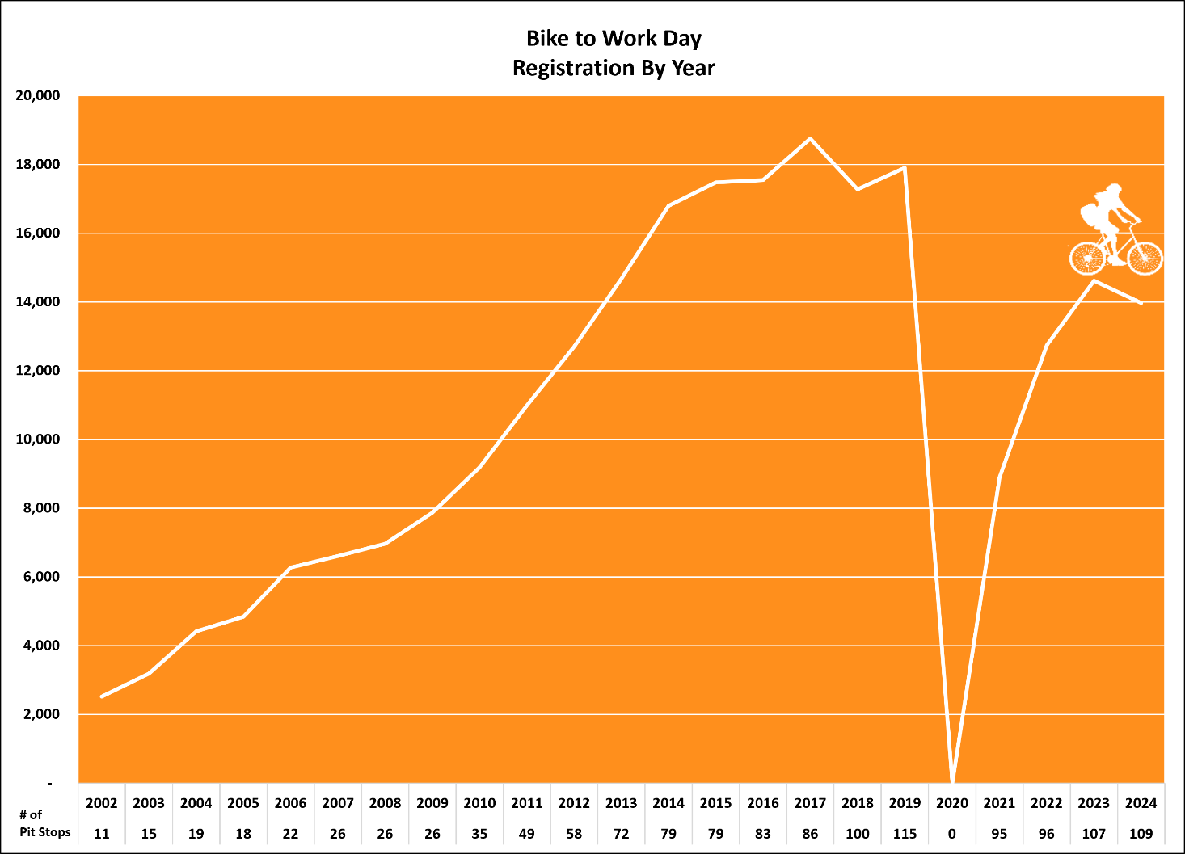

Sponsor Declaration Form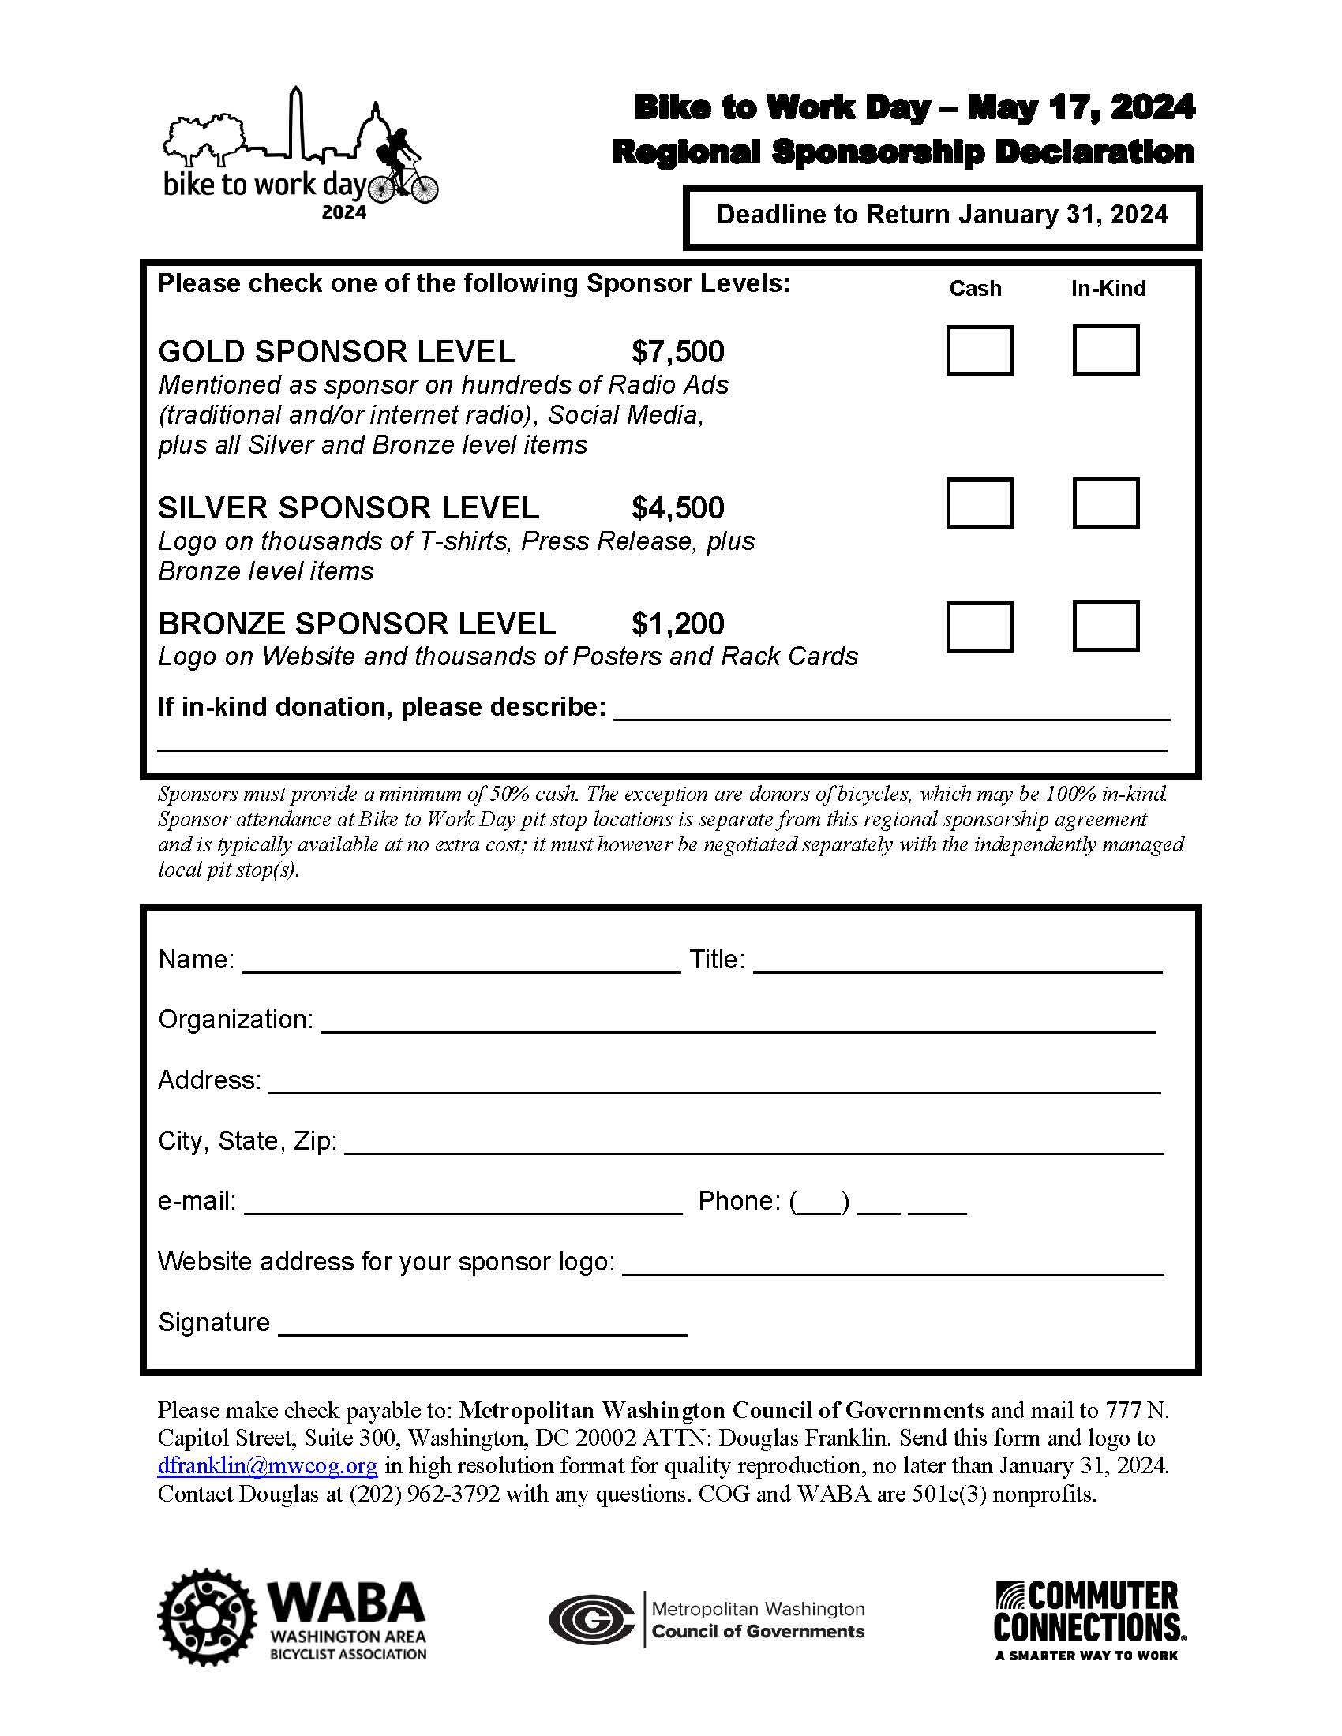

Sponsor Drive

Commuter Connections gained both monetary and in-kind sponsorships from a variety of organizations in the Washington metropolitan region. A total of $37,550 in cash was donated for the regional event. The following is a list of cash and in-kind bike raffle sponsors who generously donated to the Bike to Work Day 2024 event:

HIGHLIGHTS FROM AREA PIT STOPS

Adams Morgan: The Adams Morgan Partnership BID hosted its annual Bike to Work Day Pit Stop in Unity Park from 7:30 - 9:30 am, with fresh bagels and coffee from Tryst waiting for over 200 registrants upon arrival. The Line Hotel also passed out breakfast bites and water to participants.
Joined by neighborhood businesses, the BID raffled items every 15 minutes from Lunar Massage, Venture X, The Line Hotel, Center Pointe and Washington Area Bicyclist Association. To extend the fun, Johnny Pistolas Restaurant hosted their first Bike to Work Day Happy Hour in the evening with complimentary drinks provided by The Rounds.
We were joined by CM Brianne Nadeau from Ward 1 who helped choose a few of the raffle winners.

Alexandria Carlyle: Bike to Work Day 2024 was a wonderful success for our 14th year as the Carlyle Pit Stop! Our turnout was great, the weather was nice, and it was so great to have so many supportive sponsors on site and/ or those who donated to our raffle. We are so thankful that everyone took the time to register and come out to support our pit stop! We had our live raffle every 15 minutes with four winners each time! Our breakfast bar from District Biscuit was a huge success for our first year trying this new small business from Del Ray. Our Mayor, Justin Wilson, Councilman John Chapman, Councilman Canek Aguirre, and Councilwomen Sarah Bagley stopped by to support and helped us with our raffle drawings! NBC 4 was also onsite to do live coverage from our Pit Stop!
We cannot thank our wonderful sponsors below enough! They donated generous gift cards and gifts for the raffle! We are so thankful for all our wonderful businesses and group organizations for their support and time.

ALX Dog Walk
Alexandria Families for Safe Streets
Alexandria Renew
Alexandria Spokeswomen
Bicycle and Pedestrian Advisory Council
Boundary Companies
Burke & Herbert Bank
Carlyle Gateway
Club Pilates Alexandria
Covanta
Cowo & Creche
District Cryo
Eisenhower Partnership
Handy Bikes
JM Zell
Lost Boy Cider
Nando’s Peri Peri
MAA
Panera Bread
Paradigm
Post Carlyle
Pure Barre Alexandria
Simpson Properties
Sweet Fire Donna’s
Tequlia & Taco
Virginia Railway Express
VPRA
Washington Area Bicyclist Association
Wegman’s
Whiskey & Oyster
The Westin Alexandria
Yoga Six

Alexandria: Staff from the City of Alexandria’s Office of Mobility Services greeted more than 200 cyclists at Old City Hall on Bike to Work Day on May 17, 2024 between 7am-10am. The weather was cool and overcast. The pit stop was a party-like atmosphere, with twelve staff and volunteers managing the event logistics. After checking in, receiving swag bags, and selecting their T-shirts, participants were offered:
- Bottled water, coffee, tea, bananas, oranges, and an assortment of pre-packaged grab and go snacks,
- Ten tents representing area businesses and City services,
- Bike tune-ups,
- Music with a DJ,
- 25 raffle prizes, and
- DASH bike loading demonstrations.
The event had the support of the local community with two bike shops participating by offering bike checks, coffee, tea, and snacks donated by local businesses. The Alexandria Economic Development Partnership (AEDP) generously agreed to MC the event, community organizations such as Alexandria BPAC and WABA shared biking information, and local businesses donated more than $1200 in raffle prizes and donations.
Staff secured special guest speakers including Justin Wilson, Mayor, City of Alexandria, MWCOG Executive Director, Clark Mercer, and MWCOG Transportation Operations Program Director, Dan Sheehan and BPAC representative, Ken Notis.
To encourage participation, Bike to Work Day was publicized in variety of ways: news releases, social media posts, a website article, communication with employers, and street team distribution of posters, flyers, rack cards. Bike to Work Day registration was promoted at in-person events in late April and early May. The event was also publicized through the Visit Alexandria and Economic Development Partnership newsletters.
During the event, staff captured still photos for use in social media and other communications materials.

Alexandria Del Ray: The event was held at Colasanto Park from 6am to 9am. There were 175 registrants for the pit stop.

Alexandria Eisenhower Square: Eisenhower Square Pit Stop Recap- This year was our 1st year for Bike to Work Day. We had about 45 people register for our pit stop. We had giveaways and snacks for our participants that stopped by. We did the pit stop without any sponsors this year as we are still learning and got a late start. We didn’t run out of T-shirts but did have requests for more mediums than we had. Our event was from 7am-9am.

Alexandria Fairlington: There were 55 registrants for the event’s pit stop.

Alexandria Mark Center: There were 77 registrants for the event’s pit stop.

Alexandria National Landing at APTA: At least 50 Bike to Workday participants at APTA Pit Stop and 4 additional staff volunteers: MET – 96 participants registered for 2024 APTA pit stop and successfully secured 4 staff volunteers.

Anacostia: The event was held by the Arts Center from 7am to 9 am. There were 61 registrants for the pit stop.

Anacostia Riverwalk Trail: The event was held from 7am to 9am. There were 97 registrants. It was a great morning as always! We saw a lot of familiar faces and bike traffic going into DC and folks headed out to Greenbelt and NASA. Some were neighbors from River Terrace and around the Benning Road corridor with local community participation. We were ambassadors for Bike to Work Day by encouraging people biking and walking to stop. Many of our non-registered visitors were unaware of Bike to Work day and were happy to learn about the event and to get resources like bike maps. The weather may have deterred a few participants this year as it looked like it was going to rain a good bit of the time, but we didn't have any rain.

Annandale: The event was held at Wakefield Park/Audrey Moore RECenter from 6:30am to 9am. There were 50 registrants for the pit stop.

Annandale George Mason Library: The event was held from 6:30am to 9am. There were 22 registrants.

Arlington Mill: The Arlington Mill pit stop was held on the plaza of the Arlington Mill Community Center from 7-9am. The stop had 132 registrants.

Arlington Ballston: Hosted in the parking lot of Trek Bicycle Arlington Ballston from 7:00-9:00 a.m., BikeArlington’s Ballston Pit Stop broke all previous records for this location with 579 registered riders, tying BikeArlington’s Rosslyn Pit Stop for #1 in the region. With in-kind donations of doughnuts and coffee from Ballston’s own Good Company Doughnuts & Café, a dozen tabling partners, volunteers from the local community, wake-up music from our DJ, and visits from Arlington County Board member Maureen Coffey and the Escuela Key Elementary School Bicibus (bike train), the Ballston Pit Stop delivered a festive atmosphere from start to finish.
SPONSORS:
Piedmont Office Realty Trust
Riveron
Good Company Doughnuts & Café
CO-HOST:
Trek Bicycle Arlington Ballston
TABLING PARTNERS:
Arlington Families for Safe Streets
Arlington Public Library/Central Library
Arlington’s Car-Free Diet Ballston Business Improvement District
Friends of the W&OD Trail
Gold’s Gym Ballston
National Multiple Sclerosis Society/Bike MS
Onelife Fitness - Ballston
PR Run + Walk
Sustainable Mobility for Arlington County
The Nature Conservancy
Washington Area Bicyclist Association
GUESTS:
Maureen Coffey, Arlington County Board Member
Susan Cunningham, Arlington County Board Member
Arlington County Police Department Community Engagement Team

Arlington Langston Blvd: There were 77 registrants for the event’s pit stop.

Arlington National Landing: There were 361 registrants for the event’s pit stop.

Arlington Rosslyn: Conveniently located at the crossroads of the Mount Vernon Trail and Custis Trail, Rosslyn’s Gateway Park Pit Stop never fails to attract legions of bike commuters, from first-timers to veterans who’ve amassed T-shirts from every Bike to Work Day to date! This year was no exception, with 579 registered riders tying BikeArlington’s other Orange Line corridor Pit Stop at Ballston for highest number in the region. Thanks to support from the Rosslyn Business Improvement District, Gateway Park was transformed into a bike commuter’s oasis from 7:00-9:00 a.m. on May 17, with an array of refreshments including McDonald’s/McD Mateo’s bountiful breakfast burritos and coffee, Good Company’s decadent doughnuts, and HealthPub’s fresh juices. The Rosslyn Pit Stop also featured bike checks from Trek Bicycle Arlington Clarendon and tabling partners offering information and services to all comers. With enthusiastic support from volunteers, County partners and Arlington County Police’s Community Engagement Team and appearances by Arlington County Board members Maureen Coffey and Susan Cunningham, the Rosslyn Pit Stop was operating at “full-service” all morning!
SPONSORS: Piedmont Office Realty Trust Riveron McD Mateo’s / McDonald’s Good Company Doughnuts & Café
CO-HOST: Rosslyn Business Improvement District
TABLING PARTNERS: Arlington County Department of Parks and Recreation Arlington Trails Arlington’s Car-Free Diet BASH Boxing Bellringer Friends of the Mount Vernon Trail HealthPub Kasper’s Cargos-Bicycle Copilots Program Mom’s Organic Market National Multiple Sclerosis Society/Bike MS Northern Virginia Transportation Authority Orange Theory Fitness Rosslyn Potomac Pedalers Bike Club Riveron Sustainable Mobility for Arlington County The Bikelawyer.com Trek Bicycle Arlington Clarendon
Washington Area Bicyclist Association
GUESTS: Maureen Coffey, Arlington County Board Member Susan Cunningham, Arlington County Board Member Arlington County Police Department Community Engagement Team

Arlington Shirlington: After setting up on the north side of Arlington Mill Drive and the Four Mile Run Trail and operating in the afternoon for the past few years, the Shirlington Pit Stop returned to the Village at Shirlington and morning operations in 2024. The move was well-received, with more than 200 riders registered for this BikeArlington Pit Stop, tucked away in the friendly confines of Shirlington Plaza. From 7:00-9:00 a.m., riders visited tabling partners, including the Shirlington Branch of Arlington Public Library and multiple Arlington-based non-profit organizations, availed themselves of courtesy bike checks from Conte’s Bike Shop, enjoyed Astro’s signature doughnuts and hot coffee, and lingered to mingle with fellow riders before pedaling off to start their day.
SPONSORS:
Piedmont Office Realty Trust
Riveron
Astro Doughnuts
CO-HOST
Astro Doughnuts / The Village at Shirlington
TABLING PARTNERS:
Animal Welfare League of Arlington
Arlington Food Assistance Center
Arlington Public Library/Shirlington Branch
Arlington’s Car-Free Diet
Conte’s Bike Shop
EcoAction Arlington

Bethesda: There were 426 registrants in downtown Bethesda. Officials from Montgomery County presented a proclamation from County Executive Marc Elrich. Maryland State Delegate Marc Korman served as pit stop Emcee. Montgomery County Councilman Andrew Friedson spoke at the pit stop.
Maryland Department of Transportation Chief of Environment and Sustainable Transportation Deron Lovaas also attended the event. Bethesda Transportation Management District Advisory Committee Members volunteered at the event.
There were many breakfast and beverage options, including bagels donated by Bethesda Bagels, gluten-free pastries from The Red Bandana Bakery, parfaits and coffee courtesy of Silver restaurant, Just Tea from Eat The Change and water from Drink More Water. Bethesda Transportation Solutions purchased bananas, apples, fruit snacks, bars and cookies for the cyclists.
Bethesda Transportation Solutions gave the Bethesda Bicycle Commuter Spirit “Golden Pedal” Award to bicycle commuter and Bethesda employee Alex Duarte. A custom-made trophy was presented to Mr. Duarte, who just started bike commuting a few months ago and has encouraged all of his coworkers at ASHP to try bicycling for their commutes.
There was a free raffle during the event with prizes purchased and donated by local businesses. Bethesda’s Griffin Cycle donated a bike that was raffled off at the end of the Bethesda pit stop event. Bethesda’s Terrapin Bicycles also donated a bike for the regional bike raffle, selected from all Bike to Work Day registrants.
Bethesda had 21 sponsors, who donated great prizes, food and beverages, or had a table at the downtown Bethesda pit stop, including (listed alphabetically):
Barre3 Bethesda
BellRinger
Bethesda Bagels
Bethesda Bike and Ski
Cheltenham Interiors
Drink More Water
Eat the Change – Just Tea
Fully Promoted
Griffin Cycle
Montgomery County Department of Transportation – Ride On
Montgomery Planning
Pedego Electric Bikes
Pitango Gelato
Potomac Pedalers
Silver - New American Brasserie
Terrapin Bicycles
The Barrett - Chevy Chase Lake
The Coalition for the Capital Crescent Trail
The Red Bandana Bakery
The St. James
WABA

Bladensburg Waterfront Park: The event was held at the Waterfront Park from 7am to 9am. There were 53 registrants for the pit stop.

Bowie City Hall: There were 41 registrants for the event’s pit stop.

Briggs Chaney Park & Ride Mobile Commuter Store: There were 20 registrants for the pit stop.

Brookland Turkey Thicket: There were 150 registrants for the event’s pit stop.

Brunswick MARC Station: Brunswick's BTWD '24 was fun and full of relationship building! We had a gentleman that wants to open a bike shop in Brunswick attend and he was able to get a lot of support through the bikers that stopped by the tent.

Our sign-up had 40 people! This is a new record for Brunswick. However, only 17 showed up but we were very happy they did. 17 is approximately what we had the first year we were a pit stop.

Since we didn't have a bike shop to help us with out goody bags, the Main Street Program Manager and the City provided bike key chains that are also bottle openers, a Brunswick wallet for the back of a cell phone, Brunswick chapstick, and a Nutri grain bar along with their t-shirt.

Burke: There were 38 registrants for the event’s pit stop.

Capitol Hill Eastern Market: The event was held at the Eastern Market Metro Plaza from 7am to 9am. There were 315 registrants for the pit stop.

Capitol Hill at House Office Buildings: The event was held at First Street SW and Maryland Ave SW from 7 – 10 am. There were more than 100 cyclists who stopped by to enjoy volunteer-provided snacks and water. Many of the cyclists worked on Capitol Hill and others stopped by on their way to other federal agencies and workplaces nearby.

Capitol Riverfront: This year's Bike to Work Day pit stop at Canal Park (200 M St SE) saw over 100 bikers joining in. They kicked off their morning with a blend of fun and fitness, enjoying free health and wellness resources from local DC fitness providers, giveaways, bike tune-ups courtesy of Conte's Bike Shop, and breakfast snacks and drinks provided by Silver Diner and Courtyard Capitol Hill/Navy Yard.

Cathedral Heights: The event was held from 7am to 9am. There were 127 registrants.

Centreville/Clifton: The event was held from 6:30am to 9am. There were 15 registrants for the pit stop.

Chantilly Library: The event was held at the Chantilly Regional Library from 6:30am to 9am. There were 40 registrants for the pit stop.

Chantilly Sully: The event was held from 6:30 am to 9:30am. There were 22 registrants for the pit stop.

Coast Guard Headquarters: The event was held at US Coast Guard Headquarters from 6am to 9am. There were 39 registrants for the pit stop.

College Park City Hall: The City of College Park hosted its morning pit stop at City Hall Plaza from 6:30 to 8:30 am. There were 121 registrants.

Columbia Heights Plaza: The gray, cloudy, cool day did not deter cyclists from attending the festivities in Columbia Heights Plaza, but the sprinkles of rain after 5pm scattered the many participants who had gathered during the rest of the event.

104 (including 19 previously signed up at other Pit-stops) intrepid riders visited, obtained their T-shirts and snacks and water, patronized the DC Libraries Bike Book-mobile, schmoozed with WABA staff Matthew and Sarah and DC Councilwoman Brianne Nadeau and ANC reps Jeremy and Steven, and represented the DC Bicycling Community! 232 had signed up prior to the event, which grew to 260 in total from electronic on-site new sign-ups.

Thanks to our indefatigable volunteers: Jennifer, Joshlin, Katie, Lori, Nicole, Shandy, and John; Jo Percell of DC Public Libraries; and John Groth and Joey from Lou’s City Bar, who sponsored the Happy Hour during and subsequent to the event! We appreciated Giant Food, who supplied the bananas, oranges, and apples, and the Mount Pleasant Library (Bobbie Dougherty) who provided tables! Once again, The Adams Morgan Pit-stop dropped by their extra T-shirts, which assisted our distribution in depleted sizes.

Crystal City/National Landing: With over 300 registrants, the Bike to Work Day Pit Stop in Crystal City/National Landing was filled with energy. Conte's Bike Shop offered bike safety checks, a raffle for National Landing branded bike jerseys and backpacks, and a smoothie food truck, all with a DJ providing the tunes for a festive vibe. Looking forward to surpassing to building on this success for 2024!

Dumfries: The event was held at the Dumfries Town Hall from 7:30am to 9:30am. There were 12 registrants for the pit stop.
Dupont Circle: Dupont Circle's pit stop at the American Geophysical Union (AGU) enjoyed its 4th year at this location! We had a great turnout, including 160 registered participants and a number of ride-by stop-ins. Staff and visitors at the stop included volunteers from AGU, DC ANC Commissioner Zach Adams (Dupont Circle 2B08), WABA Trail Ranger Operations Manager Ezra Hollander, and two pros from local bike shop and community hub Conte's Bike Shop. Once again, we feasted on delicious bagels courtesy of Call Your Mother Deli (from the Logan Circle and Connecticut Avenue locations). This year we had some exciting door prizes to raffle off: assorted totes and zipper bags made out of last year's BIke to Work Day banner from this pit stop, made by Mile High Workshop in Denver, Colorado (https://www.milehighworkshop.org), which offers an employment and job training program for those facing barriers to work.
Edgewood at Metrobar: The event was held from 4pm to 8pm. There were 130 registrants for the pit stop.
Fairfax City Old Town Square: There were 124 registrants for the event’s pit stop.
Fairfax Government Center: The event was held at the Fairfax County Government Center from 6:30am to 9am. There were 72 registrants for the pit stop.
Fair Lakes: The event was held Fair Lakes Center from 6am to 9am. There were 55 registrants for the pit stop

Fairlington Center: The event was held at Fairlington Center in front of Great Harvest Bread from 6:30am to 9:00am. There were 52 registrants.

Falls Church: The event was held from 6:30am to 9am. There were 174 registrants.

Falls Church Culmore: There were 29 registrants for the event’s pit stop.

Fort Belvoir: There were 37 registrants for the event’s pit stop.

Franklin Park: The event was held from 7am to 9am. There were 267 registrants.

Frederick: The pit stop at the Transit Center in Downtown Frederick with 203 participants registered for the event.

- Over 200 participants registered
- Local elected officials participated, including City of Frederick Mayor Michael O’Connor, County Executive Jessica Fitzwater, and Alderman Kelly Russell.
- There were 25+ participants from the City of Frederick and Frederick County Government Divisions.
- Group participation of 7+ participants from: Frederick Health, Fort Detrick, and Thermo Fisher.
- Vendors included: Frederick County Office of Communications and Public Engagement, Frederick County Government Divisions: Energy & Environment, Volunteer Fire & Rescue, Parks & Recreation, and the Sheriffs Office, Charm City Run Frederick, Frederick Health, Visit Frederick, Key 103, Bike Doctor Frederick, The Bicycle Escape, The City of Frederick Departments: Housing and Human Services and Sustainability, and The Common Market.

Friendship Heights: The 2024 Friendship Heights pit stop was again hosted by The Shops at Wisconsin Place, at the corner of Wisconsin Ave. & Western Ave. in Chevy Chase and ran from 6:30 – 9:00 AM. There were 189 riders at final registration. A total of 88 of the pre-registered attended plus 25 walk-ups.
As in previous years, there were two new bike winners. This year, the bikes were from Griffin Cycle, Inc. in Bethesda. One winner had to be present to win, the other was selected in a second drawing from assigned numbers listed on the registration.
VIP guests included Montgomery Council President Andrew Friedson, Town of Somerset Mayor Jeffrey Slavin, and MCDOT Deputy Director Haley Peckett.
Pit stop exhibitors and raffle donors included:
· All-In-One Entertainment – DJ and music
· Amazon Fresh
· The Avalon Theater
· Craft Beer & Wine
· Crunch Fitness
· Drink More Water
· Friendship Heights Alliance
· Happy Go Bikes – Bike station tune ups
· GEICO
· Junction Café
· LRM
· Montgomery County Ride On
· Potbelly Sandwich Shop
· Pure Barre
· Roti
· Starbucks
· Washington Eye Physicians & Surgeons
· Wisconsin Place Recreation and Community Center

Gaithersburg Kentlands: The event was held on the corner of Great Seneca Highway and Orchard Ridge Drive from 7am to 9am. There were 155 registrants for the pit stop.

Gaithersburg Old Towne: The event was held in Old Towne, Gaithersburg from 4pm to 6pm. There were 55 registrants for the pit stop.

Georgetown – Meigs Park and Waterfront Park (DC): The Georgetown Business Improvement District hosted the pit stop again this year in the Georgetown Waterfront Park with 430 participants registered. This is about 100 registrants lower than usual. We’re not certain if this is due to more folks working from home or our later than usual start in promoting due to delay in receiving permit for the event (we’re not able to promote until we get greenlight from permitting office). Nonetheless, it was a great and steady turnout of cyclists who showed up and supported our pit stop! Our stop was sponsored by donations from area businesses and partnering organizations, including:
• Unwind – chair massage station
• Bellringer – BTWD-themed giveaways and info about their bike ride to end cancer
• South Block – wellness juice shots
• Grace Street Roasters - coffee
• Coalition for Capital Crescent Trail – giveaways and information
• Georgetown Cupcake – 250 cupcakes
• Embassy of Switzerland – small giveaways, apple strudel and Nespresso coffee
• WABA – info and membership
• DC Water – water and their mascot
• Gold’s Gym – raffle, energy snacks, recovery area with mats for stretching and massage gun
• Trek – bike tune ups

Germantown at Blackrock: There were 79 registrants for the event’s pit stop.

Golden Triangle – Farragut Square: The event was held at Farragut Square from 7am to 9am. There were 133 registrants for the pit stop.

Golden Triangle – L Street (DC): The event was held on the corner of 19th and L Streets NW from 7:30am to 9am. There were 78 registrants for the pit stop.

Greenbelt: Bike to Work Day 2024 was Greenbelt’s 12th year. A committee of three City of Greenbelt employees organized the event in the Aquatic & Fitness Center parking lot.
There were 139 bikers registered with 100 passing through.
Laurie Lemieux led 9 bikers on a convoy to downtown Washington DC and Jeff Lemieux led 18 bikers on a convoy to NASA in Greenbelt.
Greenbelt Mayor and four Council Members were present along with the Greenbelt Police bike patrol.
Our sponsors:
o Anacostia Trails Heritage Area provided funding for breakfast snacks.
o Greenbelt COOP Supermarket & Pharmacy provided Kind Bars and free coffee coupons.
o McCarl Dental Group provided toothbrushes and coupons.
o Proteus Bicycle mechanics conducted maintenance and safety checks.
o Greenbelt Sunoco sponsored coffee to bikers stopping at their shop.
o Greenbelt Cinema provided coupons and stickers, and a raffle prize.
o Jersey Mike’s Subs provided free sub coupons.
o CCI Health provided key chains and were at the event with giveaways and resources.
o Cirkul was present at the event and distributed water bottles with flavor infused filters.
o Amy Rappole led Stretching with Your Bicycle just prior to the DC convoy departure.
o M-NCPPC Disability Services Prince George’s County was present with their Therapeutic Recreation in Motion (TRIM) trailer with kick bikes to promote inclusivity.
o WABA was present with advocacy and membership information.

Herndon Innovation Center: The event was held from 6:30am to 9am. There were 44 registrants for the pit stop.

Herndon Town Hall Green: Herndon Parks and Recreation Department staff planned and executed this year’s pitstop Riders gratefully grabbed water, fruits, and a variety of snacks provided by Wegmans. Riders also got to indulge in freshly made bread from Great Harvest Bread Co. All riders were very excited to get their T-shirts this year! We opened at our new time at 6:00am but it picked up mostly between 8am – 9am. We also had coffee and bike tech provided by Green Lizard Cycling. Other vendors who came out were NOVA Parks, Reston Bike Club, and Dulles Area Transportation Association. We had over 300 riders who were grateful to be a part of Bike to Work Day 2024!

Hyattsville Driskell Park: The event was held at Driskell Park from 6:30am to 8:30am. There were 133 registrants for the pit stop.

Indian Head:
We had over 100 attend the event with freebies and give aways, also we had Trek of Waldorf bike shop set up a free tune up station, the Tri-County Councils mobile career center came and help those who needed resume updates or job placement. We had badminton and corn hole games available for all. Received a Proclamation from the Charles County Commissioners and an Official Citation from the Maryland General Assembly.

Ivy City/Bicycle Space: There were 36 registrants for the event’s pit stop.

Kelly Leadership Center: The event was held from 6am to 9:30am. There were 21 registrants.

Largo: The Prince George’s County Department of Public Works & Transportation in partnership with the M-NCPPC Department of Parks and Recreation, Prince George’s County and the Prince George’s County Bike and Pedestrian Safety Community Advisory Group co-hosted a Bike to Work Day Pit Stop at the Largo/Kettering/Perrywood Community Center in Upper Marlboro, MD on May 17, 2024. Capital Bikeshare, DPW&T, Vision Zero Prince George’s and the Be Seen, Be Alert, Be Safe Campaign were proud Bronze Sponsors of Bike to Work Day 2024!

The event was a great success! There were 97 cyclists that registered in advance for the Bike to Work Day pit stop and 56 that signed up onsite. Additionally, students, teachers and the guidance counselor from the adjacent Perrywood Elementary School stopped by to support Bike to Work Day; obtain pedestrian and bicycle safety information and giveaways from vendors; and to tour Prince George’s County’s Zero Emissions TheBus.

DPW&T’s Bicycle and Pedestrian Program Manager, Tiffany Jennings, who served as Bike to Work Day Pit Stop Manager along with Tedd Russell, Co-Pit Stop Manager from M-NCPPC welcomed the cyclists and all in attendance to Bike to Work Day. Greetings and Remarks were provided to the cyclists, partners and supporters from across Prince George’s County, Maryland and around the Region by Oluseyi Olugbenle and Stacey Smalls, Deputy Directors of DPW&T; Bill Tyler, Director of M-NCPPC Department of Parks and Recreation; Joe McAndrew, Assistant Secretary, Maryland Department of Transportation; Wala Blegay, Prince George’s County Councilmember, District 6; Kenniss Henry, Founder of the Ride for Natasha and Bicycle Safety Advocate; and Benjamin Gate, Professional Cellist and Pedestrian Safety Advocate who provided remarks and performed two outstanding musical selections on his cello.

During the Bike to Work Day event, cyclists took part in demonstrations on how to load and unload their bicycles on the bike rack located on the front of TheBus. Cyclists participated in free rides using Capital Bikeshare eBikes. Additionally, cyclists were provided information and giveaways from representatives of agencies, organizations, and clubs who attended and supported the 2024 Bike to Work Day.

Bike to Work Day at the Largo/Kettering/Perrywood Community Center Pit Stop was Outstanding and we look forward to hosting Bike to Work Day again in 2025!!

2024 Bike to Work Day Partners and Supporters
- Prince George’s County Department of Public Works & Transportation
- M-NCPPC Department of Parks and Recreation, Prince George’s County
- Prince George’s County Bicycle and Pedestrian Safety Community Advisory Group
- Largo/Kettering/Perrywood Community Center, M-NCPPC
- Prince George’s County Executive’s Office
- Prince George’s County Council
- Prince George’s County Department of Public Works & Transportation
- Prince George’s County Police Department
- Prince George’s County Fire Department
- Prince George’s County Department of the Environment
- Prince George’s County Office of Community Relations
- Prince George’s County Office of Central Services
- Prince George’s County Department of Permitting, Inspection and Enforcement
- TheBus
- RideSmart
- Maryland National Capital Park and Planning Commission
- MNCPPC Park Police
- M-NCPPC Park Rangers
- Perrywood Elementary School
- WABA
- MWCOG
- Commuter Connections
- Maryland Highway Safety Office
- Maryland Department of Transportation
- Kenniss Henry, Founder of the Ride for Natasha and Bicycle Safety Advocate
- Benjamin Gate, Professional Cellist and Pedestrian Safety Advocate
- The Capital Market 20743
- Bowie Metro Alumni Chapter’s Bowie Bike Tour Organizer, Bowie State University National Alumni Association
- Black Nurses of Southern Maryland
- Jafe Cycling
- PGCTV
Cycling Clubs
- M-NCPPC Senior Cycling Club
- DMV Cycling Alliance
- Artemis
- Push’N Pedals Cycling Club
- Caribbean Riders
- Getting It In Cycling
- Diva Cycling Inc.
- Phase Cycling
- Each One, Reach One

Leesburg: After several rainy days in Leesburg, the weather was pleasant and clear for Bike to Work Day 2024. A team from Loudoun County Transit and Commuter Services distributed orange T-shirts and giveaways to 149 Bike to Work Day participants between 6:30 and 9:00 a.m. at Raflo Park.

Refreshments provided by Loudoun County included bananas, pre-packaged snacks, and cold beverages. Local sponsor Leesburg Diner added to the spread with bags of granola, fresh blueberry muffins and coffee.

A Loudoun County Transit bus was staged at the pit stop to demonstrate how to load a bicycle onto a bus bike rack. Maverick Bikes of Leesburg supported participants with simple repairs and bike adjustments. Representatives from the Loudoun County Combined Fire and Rescue System hosted an information table. Staff from VDOT dropped by and added to the assortment of available swag.

Bike to Work Day was publicized to employers, the Loudoun Chamber and community at large with a banner, posters, rack cards, a news release, and social media posts. Registration information was shared with local bike shops and distributed during outreach events in late April and early May. The event was also publicized through the employer outreach newsletter. Staff from Loudoun County Public Affairs and Communication captured still photos and video footage which will help promote the 2025 event.

Logan Circle: There were 66 registrants for the event’s pit stop.

Lorton: The event was held 3pm - 7pm at the Workhouse Arts Center in Lorton, VA. There were 17 registered and 20 attended.

Manassas VRE: There were 69 registrants for the event’s pit stop.

Manassas Park VRE: The Manassas Park pitstop had 21 visitors at the VRE station where we were set up. VRE and the Prince William Department of Transportation sent out people and swag to give out. We had School Board Member Stacy Seiberling stop by on her bike. It was a great event!

Manassas GMU: There were 38 registrants for the event’s pit stop.

McLean – MITRE: The event was held from 6:30am to 9am. There were 122 registrants.

Merrifield - Mosaic: The Mosaic Bike to Work Day Pit Stop featured 16 partners who provided activities, food and drinks, giveaways, and raffle items. We engaged with more than 350 people at Strawberry Park, with the goal of celebrating new and current bicyclists and informing more people in the community about bicycling and active transportation. We leveraged 2024’s Bike to Work Day color to create an 80s/90s retro theme for the pit stop with themed photo ops, candy, giveaways, and more. Caboose Commons kept the party going with an exclusive Bike to Work Day happy hour for participants until 9:00 PM. Overall, we saw increases across the board in marketing metrics, registration, first-time registration, attendance, and partner engagement.
Stats:
Final Registration: 102 – note this is total but likely includes a couple of duplicate registrations (12% increase from 2023)
First Time Registrants: 38 (22.6% increase from 2023)
Final Attendance: Engaged a whopping 364 individuals despite the rain! (106.8% increase from 2023)
Final Partner List: 16
DJ Lady B
Alta Strada
Jinya
SweatHouz
Inova
Bash
Just Ice Tea
Lather
NOVA Cycleworks
Tiny Dancers
Mom and Pops
OVME
Lather
Pupatella
Bartaco
Caboose Brewing

Mt. Rainier: The Mount Rainier Green Team and Mt. Rainier Bicycle Co-op hosted a BtWD pit stop for the fourth year in a row. The pit stop is located at the Mt. Rainier Bicycle Co-op at 36th St. and Bunker Hill Rd. and is staffed by volunteers from the Co-op, the Green Team, and the community. In 2024, we had approximately 30 people stop by to pick up their shirts and enjoy snacks.

Mt. Vernon – Belle View (VA): The event was held at Mount Vernon Rec Center from 6:30am to 9:00am. There were 44 registrants for the pit stop.
Mt. Vernon: The event was held at VIDA Fitness from 6:30am to 9:00am. There were 102 registrants for the pit stop.
Naval Support Activity: The event was held from 6am to 9am. There were 101 registrants for the pit stop.

National Geographic Society: The event was held from 8am to 10am. There were 148 registrants.

Newington: The event was held at South and C Streets SE from 6:30am to 9am. There were 24 registrants for the pit stop.

NIH: The event was held from 7am to 9:30am. There were 268 registrants.

NOMA: The event was held at Wunder Garten from 7:30am to 9:30am. There were 401 registrants for the pit stop.

North Bethesda: On Bike to Work Day, the North Bethesda Pit Stop and the North Bethesda TMD staff eagerly welcomed cyclists and participants at our location at Pike & Rose. The pit stop was located in the parking lot next to Bark Social and behind Pinstripes. Each registered participant received a Bike to Work Day t-shirt, towel, bike maps, and other goodies. They were treated to a variety of breakfast foods, giveaways, and information provided by our great sponsors who attended – Bender JCC of Greater Washington, Bethesda Green, Call Your Mother Deli, Montgomery County Ride On, Office of Home Energy Programs, Onelife Fitness, Pike District, Pike District Partnership, REI, Strathmore/AMP by Strathmore, and WABA. Additional giveaways were generously donated by Central Farm Markets and Just Ice Tea. A very special thank you to our host, Pike & Rose, for all the support!
Prizes, drawings, and “sponsor spotlights” were made every 15 minutes and music was provided throughout the event. Cyclists participated in various fun contests as well. Techs from REI performed checks on participants’ bicycles.
Montgomery County Council Vice President Kate Stewart brought greetings from the Montgomery County council. She also spoke about the importance of bicycling in Montgomery County.
The grand prize was a bicycle, from REI. Council Vice President Stewart and REI staff helped with the drawing and congratulated the lucky winner. A second bicycle, also from REI, was awarded to another lucky winner after the event. Another successful year was enjoyed at the North Bethesda at Pike & Rose pit stop!

Oakton: The event was held at the Oak Mar RECenter from 6:30am to 9:00am. There were 24 registrants for the pit stop.

Old City Market and Oven: The event was held on the corner of 6th and K Streets NE from 7am to 9am. There were 105 registrants for the pit stop.

Oxon Hill: The pit stop was operated by the Prince George’s County Planning Department of the Maryland-National Capital Park and Planning Commission. Michael Jackson, the pit stop manager was assisted by Leah Daniels, Evan Tenenbaum, Scott Rowe, and Thomas Burke. Deborah Topcik, Director of Marketing at National Harbor, provided promotional assistance prior to the event and was present to provide giveaways and information about National Harbor. Twenty-nine (29) people registered for our pit stop. Snacks, water, giveaways, and information were provided along with tee shirts.
We asked bicyclists to complete a survey regarding their bike commutes. Eighteen (18) surveys were completed and combined with the information received in the registration excel sheets we were able to glean interesting information about the participants and their bike rides.
There were 12 men and 6 women. Except for one person, all others were at least 50 years old or better. All except two attendees were biking to work. Seven (7) commutes were within Prince George’s County, five (5) commutes were between the county and DC, and five (5) were between the county and Virginia. Two (2) commutes were from Charles County to DC and one (1) was from Charles County to Virginia. One (1) commute was from Alexandria to National Harbor. One commute was from Fairfax County to DC, another was from Alexandria to Falls Church and one from NE DC to Arlington. Possibly the last three registrants went out of their way when registering for the Oxon Hill/National Harbor pit stop.
The shortest one-way commute was 3.5 miles and took 12 minutes. Two 20-mile one-way commutes and one 41-mile commute were reported, all with 3-hour travel times. Where bikes were parked at worked varied as 7 bikes parked at bike racks, 1 bike in a bike locker, 7 bikes brought into offices, and 1 bike parked in a building stairwell. Most survey respondents had no problems to report.

Penn Quarter: The event was held from 7am to 9am. There were 74 registrants.

Port Towns at Edmonston: The Town of Edmonston sponsored the Port Towns Bike Stop at Veteran’s Park on Bike to Work Day. We operated the stop from 6 to 8 a.m. and 4 to 6 p.m. We had 26 participants registered for the site. Our Police Department bike unit participated from 4 to 6 p.m.

Providence Community Center: The event was held from 7am to 9am. There were 31 registrants for the pit stop.

Purcellville: There were 12 registrants for the event’s pit stop.

Reston: The event was held at the Plaza from 6:30am to 9:30am. There were 303 registrants for the pit stop.

Riverdale Park Station: There were 42 registrants for the event’s pit stop.

Rockville: The Bike To Work Day event at Rockville Town Center on May 17th, 2024, was a resounding success, filled with energy, enthusiasm, and community spirit. Participants arrived bright and early, ready to kick off the day with a sense of camaraderie. Upon arrival, they were greeted with official Bike To Work Day shirts, hand sanitizers, rain ponchos, and an array of other goodies as tokens of appreciation for their participation.
This year, we were thrilled to welcome several first-time vendors to the event, including Gold's Gym and the Best Western Hotel. Their presence added fresh excitement to the festivities. Returning vendors, such as Onelife Fitness, Montgomery County Transit, and Care Some Sustainability, also made their mark, contributing to a diverse and engaging experience for all attendees.
The event was further elevated by the attendance of several dignitaries, including Councilmember Sydney Katz, City of Rockville Mayor Monique Ashton, and Phil McLaughlin, General Manager, Division of Transit Services. Their presence underscored the importance of the event and added a special touch to the day.
Exciting raffles were held, with participants winning a variety of bike-related prizes like locks and pumps. The highlight of the raffle was the giveaway of two Trek bikes which were won by two lucky participants.
Dawson's Market played a crucial role in keeping everyone refreshed, generously providing coffee and water for all attendees. The atmosphere was further enlivened by the DJ, whose music provided the perfect backdrop for conversations and interactions among participants.
Overall, the Rockville Town Center pit stop was a memorable event, offering participants the opportunity to engage with each other, explore the offerings of our vendors, and celebrate the joy of biking to work.

Rockville Fallsgrove: The Rockville-Fallsgrove 2024 Bike to Work Day pit stop enjoyed our second year at our new location at Thomas Farm Community Center, located in Fallsgrove Park and right on the Carl Henn Millennium Trail, in the heart of the Life Sciences Corridor. We got lucky with the weather for our early morning festivities and welcomed participants to join in the fun from 6:30-9:00 a.m. Many residents of the surrounding communities started their day with a short ride and stopped by on their way to work, or back home to start their day of teleworking. They came in waves throughout the morning, and included employees commuting to area businesses from as far away as Dupont Circle and Silver Spring. There were 222 registered and 136 in attendance. Casual bikers and cyclists, first-timers, and seasoned commuters --all gathered to celebrate one of their favorite activities and means of commuting, general travel, and exercise.

MCDOT Commuter Services and the City of Rockville co-sponsored the pit stop, as in years past and the MCDOT Greater Shady Grove TMD outreach team managed the event, with the help of great volunteers. Our DJ rocked the morning, while participants enjoyed yummy snacks and coffee from local businesses, picked up their Bike to Work Day t-shirts, towels, bicycle swag, and checked out the exhibitors with information, resources, and fun giveaways to share. Bike Center LTD performed bike safety checks and simple maintenance repairs, while County and City agencies hosted information tables, and OneLife Fitness trainers led multiple mini stretching sessions to get everyone in motion. Our emcees, including Gary Erenrich with MCDOT, engaged the crowd, introduced speakers, like State Delegate Lily Qi, and offered updates and information.

Our free raffle ran throughout the morning, and everyone had a chance to win really cool items from area businesses, while two lucky winners were selected in our random drawings for the beautiful Trek bikes, provided by MCDOT. There were big cheers all around and special thanks to our location host the City of Rockville’s Thomas Farm Community Center --and for our volunteers, raffle donors, food sponsors and information exhibitors who contributed to making the event a great success. They included: MOM’s Organic Market, Starbucks, Krispy Kreme, Bethesda Bagels, Dunkin’ Doughnuts, Safeway, Harris Teeter, Costco, Drink More Water, Chick-fil-A, Nando’s Per-Peri, Panera, Jersey Mike’s, Verizon, Mama Lucia, Copper Canyon Grill, Yard House, Dick’s Sporting Goods, MyEyeDr, Trader Joe’s, Potomac Pizza, Restore Hyper Wellness, Dave & Buster’s, All-In-One Entertainment, Sandy Spring Bank, Target, Bike Center LTD, BIRD Scooters, WABA, Rockville Bicycle Advocacy Committee, Visit Montgomery, MCDOT-Commuter Services, Capital Bikeshare, MCDOT-Division of Transit Services, Ride On, Montgomery County Department of Environmental Protection: Waste Reduction and Recycling Section, Police Department Community Engagement Division, and the City of Rockville Traffic and Transportation Division.

Rockville Twinbrook: The team setup in front of 5625 Fishers Lane with a DJ as well as photo booth with props. Coffee was provided along with juice, and water as well as bagels, granola bars and fruit. Tables were setup to distribute t-shirts and maps as well. It was a lovely day and the JBG SMITH team enjoyed partnering with GI Property Management once again to host the event.

Shaw: The event was held from 7 – 9 AM and had 123 registered Bike to Work Day participants. Snacks were provided by Fehr & Peers and two amazing volunteers helped pass out t-shirts and goodies to attendees. The highlight was an elementary school group meeting at our pit stop and then riding into school together.

Silver Spring: The 2024 Bike to Work Day Silver Spring pit stop was held at Veterans Plaza, and 360 individuals registered online. 235 individuals attended the event to enjoy music, raffles, a BTWD t-shirt, and other giveaways.

MCDOT staff managed the Veterans Plaza pit stop. Fovndry provided contractor support, securing donors, sponsors, and exhibitors. Two additional volunteers helped at the giveaway tables. The Silver Spring Urban District(SSUD) Program Manager helped with the event layout while the indispensable SSUD Clean and Safe Team was on hand bright and early to assist with set up and with break down at the end of the event.
Raffles, Exhibitors and Grand Prize Winners: Commuter Services purchased two bicycles from Silver Cycles for the raffle. This year’s winners were Jordan Gerth and Akilah Futch .

Strong Business Participation and Support: We had a lot of donated raffle items and refreshments that provided prizes for multiple raffles throughout the morning. Breakfast treats include bagels, fruit, muffins, and coffee. Downtown Silver Spring businesses, merchants, and non-profits who supported the event included The Blairs, Chik-fil-A, Einstein Bagels, Giant, Nando’s Peri-Peri, Nike, Lime, WABA, CCI Health, Dave and Busters, Silver Cycles, Whole Foods, and others. All in One Entertainment was the DJ again this year for the event. In addition, other County and City agencies hosted information tables, along with other exhibitors.

Southwest Business Improvement District: The event was held at the BID from 8am to 10am. There were 69 registrants for the pit stop.

Springfield Metro: The event was held at the Springfield Metro Park from 6:30am to 8:30am. There were 54 registrants for the pit stop.

Springfield – South Run: The event was held at the South Run RECenter from 6:30am to 9:00am. There were 42 registrants for the pit stop.

Sterling: More than 100 cyclists visited the Sterling Pit Stop between 6:30 and 9:00 a.m. on Bike to Work Day. The event was held outside of the Sterling Ruritan Club, adjacent to the W&OD Railroad Regional Park.
Tents were hosted by Loudoun County Transit and Commuter Services, Trek Bikes Leesburg, Bike Loudoun, and Loudoun Water. A representative of Virginia National Guard hosted a table and visited with participants. A Loudoun County Transit bus was staged nearby to demonstrate the ease of placing a bike on a bus.

Participants picked up orange T-shirts and chose from a variety of giveaways. Loudoun County provided coffee, sports beverages, bananas, and a selection of pre-packaged snacks.
The Loudoun County Board of Supervisors was represented by Vice Chair Juli Briskman (Algonkian District) who read and presented a Proclamation for Bike to Work Day. One participant experienced a flat tire just steps away from the pit stop. She referred to the Trek team as “her heroes.” After a quick repair she was on her way to work. Loudoun County publicized Bike to Work Day through a news release and social media posts (with video). A banner near the pit stop site helped alert the community prior to the event. Additionally, posters and rack cards were shared with employers and bike shops. A highlight video and photos captured during the event will help promote Bike to Work Day 2025.

Takoma Park – Downtown/Old Takoma: The event was held at Takoma Urban Park from 6:30am to 9am. Participants received bike safety swag, bicycle maps, T-Shirts and resources, and breakfast snacks. There were 122 registrants for the event and at least 73 registered riders stopped by the pit stop, an additional 17 unregistered ride-ups stopped by. We were also visited by 7 riders who registered at a different pit stop.

Takoma Park – Sligo Creek Trail: The Sligo Creek Pit stop held the event from 7:00am to 9:30am. Participants received bike safety swag, bicycle maps, T-Shirts and resources, and breakfast snacks. There were 57 registrants for the event and at least 62 riders stopped by the pit stop, approximately half were ride-ups.

Takoma Park – Langley Crossroads: The Takoma Langley Pit Spot held the event from 6:30am to 9am. Participants received bike safety swag, bicycle maps, T-Shirts and resources, and breakfast snacks. There were 5 registrants for the event, 2 riders stopped by the pit stop including 1 ride-up.

The Wharf/Southwest Waterfront: The event was a massive success—between 7am-9am, 110 cyclists visited our pit stop on the patio of our neighborhood Starbucks. During our morning pit stop we offered granola bars, bananas, bottled water, and Starbucks coffee. We also posted on social platforms including X (1, 2) and Instagram stories.
We were thrilled to once again host the Amidon-Bowen Elementary School “bike bus”—a growing collection of nearly 20 kids cycling together through SW on the way to school (photo attached). The VPRA also gave out granola bars with a QR code to the Long Bridge Project website that educates cyclists on the bicycle-pedestrian bridge project between Arlington, VA and Washington, DC.

Tysons Corner: There were 51 registrants for the event’s pit stop.

University of Maryland: The University of Maryland pit stop had a great turnout this year, with 74 registrants! BTWD 2024 fell on the last day of finals for the university, so the majority of participants were faculty/staff, but students who remained on campus visited our pit stop and had a great time! A big thank you to Jersey Mike's, the UMD Beekeeping Club, and Redshift sports for providing time, energy, and raffle items to help make our pit stop possible! Can't wait to see everyone next year!

Vienna – Metro/Jim Scott Community Center: The second Bike-to-Work Day at the Jim Scott Community Center near the Vienna Metro Station was a huge success with 31 registrants and more than 45 cyclists who showed up!
Several walkers came by, too! Supervisor Dalia Palchik and her daughter, Sivan welcomed cyclists to our tents where officers from the Fairfax County Police Department and staff from the transportation departments of Fairfax County and Virginia answered questions and provided tips on safer cycling. We were grateful for their presence. We replenished water bottles participants brought and had t-shirts, bike lights, maps, fruit, snacks, bags, handouts, blinkers for bikes and many other goodies provided by our lovely partners to give riders to make this memorable day even better! We thank Sun and Surf Bike Shop who brought equipment and a stand to repair bikes and REI who also brought some fun goodies to provide our attendees. Also, a big thank you to Seva Food Truck who provided some snacks for us to hand out. Lastly, thanks for Fairfax for Safe Streets for coming and sharing information with our community. As our location becomes better known in the biking community, we are certain the number of participants will grow next year! Looking forward to hosting our 3rd Bike to Work Day pitstop in 2025!

Vienna: The Town of Vienna's pit stop is located on the Town Green, adjacent to the W&OD Trail and Maple Avenue in the heart of Vienna. This year, we had a record breaking number of cyclists (227) stop by, pick up their T-shirt, and enjoy some coffee and snacks. Mayor Colbert and several Council members stopped by to say hello. This year's sponsors included: Caffe" Amouri, Friends of the W&OD, Contes Bikes, Trek Bikes Vienna, Bikes@Vienna, Caboose Tavern, and the Town of Vienna Bicycle Advisory Committee. It's a lot of fun, especially when the weather cooperates.

West End at ACoC: There were 62 registrants for the event’s pit stop.

West Springfield: There were roughly 40 people who attended. This included students, employees, police officers, and the fire department. Everyone had a great time. Looking forward to the next one and sponsors are as well.

Wheaton: The 2024 Wheaton Marian Fryer Plaza pit stop was second year hosted at 2425 Reedie Dr. Wheaton, MD from 7:00 – 9:00 AM. There were 93 riders at final registration. A total of 85 of the pre-registered attended plus 17 walk-ups and Pre-register who did not show up 9.
As last year years, there were one new bike winner. This year, the bike was from Linda Mac, Silver Cycles. in Silver Spring. The winner was selected in a second drawing from assigned numbers listed on the registration.
VIP guests included Montgomery Council Member Fanni Gonzalez and Michael Paylor, Division Chief, Traffic Engineering & Operations.

Bike to Work Day Vendors:
1.- Dunking Donuts, General Manager Ken Shank
2.- Lourdes Bakery, Owner Lourdes
3.- Ana Arriaza, Planning Division
4.- Eli Glazier, Country Wide Planning & Policy Division (We Provide the table)
5.- Tyniah McDuffie, Green Bank (We provide the table)
6.- Duwan Morris, Planning Division Traffic Engineering Studies
7.- Althea Grey-McKenzie, Chair, NCAHM Steering Committee (We provide the table)
8.- Sidney Cooper, Marketing & Events Manager Wheaton Urban District
9.- Wendy Howard, Executive Director One Montgomery gree.org (We provide the table

White Oak/FDA: The Office of Facilities Engineering and Mission Support Services’ (OFEMS) Logistics and Transportation Management Branch (LTMB) sponsored a Pit Stop from 7:30 a.m. to 9:30 a.m. for any bicyclist commuting that day. This was held in front of the historic FDA Building 1. LTMB had 6 volunteers that provided refreshments to include water, coffee, juice, doughnuts, muffins, fruit, and each bicyclist registered for our pit stop received a 2024 BTWD T-Shirt. The first bicyclist arrived around 7:14 a.m. and eventually had 47 bicyclists used the pit stop. The final number of registered bicyclists for the White Oak/FDA pit stop was 96. The day started off overcast and warm and a great time was had by all.

Woodbridge Chinn Center: The event was held at the Chinn Aquatics & Fitness Center from 6am to 9am. There were 37 registrants for the pit stop.

Woodbridge - Rippon VRE Station: There were 18 registrants for the event’s pit stop.

Woodbridge – Tackett’s Mill: The event was held from 6am to 9am. There were 9 registrants for the pit stop.

Woodbridge VRE Station: The event was held at the Woodbridge VRE station from 6:00am to 9:00am. There were 13 registrants for the pit stop.

EMPLOYER PARTICIPATION

There were over 300 Employers that had 5 or more employees registered for the Bike to Work Day 2024 event:

The winner of the Employer Challenge for the free luncheon was the Food and Drug Administration (FDA).
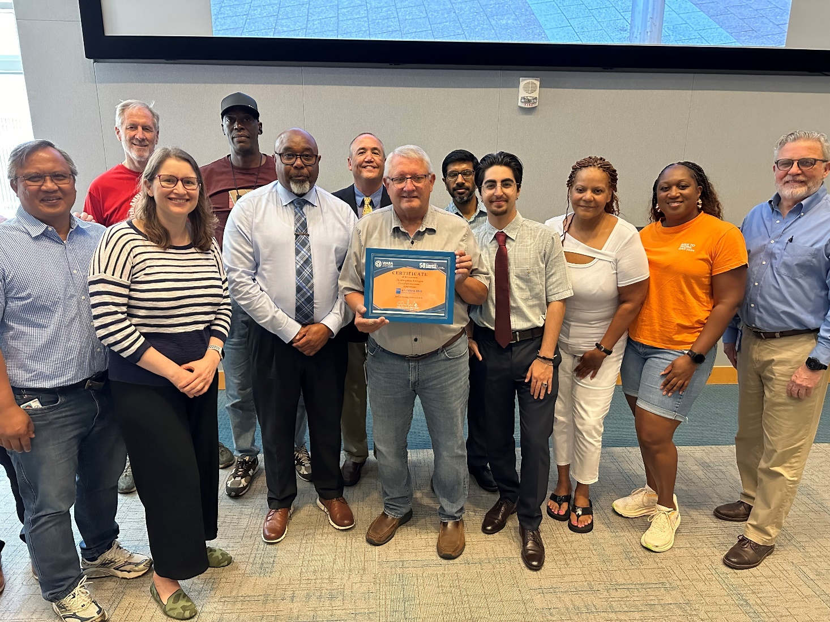

Bike to Work Day 2024 Employer | # of Registrants
National Institutes of Health (NIH) | 398
U.S. Department of State | 206
Fairfax County | 176
U.S. Department of Defense | 176
University of Maryland | 155
U.S. Environmental Protection Agency | 148
Arlington County | 142
U.S. Food and Drug Administration | 141
District of Columbia Government | 116
Montgomery County Government | 113
U.S. Department of Justice | 107
The World Bank | 104
United States Army | 103
U.S. Navy | 102
City of Alexandria | 89
The MITRE Corporation | 88
Amazon | 93
George Washington University | 76
U.S. Department of Agriculture | 74
Georgetown University | 70
U.S. Patent and Trademark Office | 67
U.S. Department of Energy | 61
N/A | 59
U.S. Coast Guard | 57
U.S. Agency for International Development | 53
Booz Allen Hamilton | 49
DDOT | 43
Capital One | 42
National Oceanic and Atmospheric Administration | 42
George Mason University | 41
Library of Congress | 41
Deloitte | 40
Northrop Grumman | 40
US Government | 38
NA | 37
DC Public Schools | 32
FCPS | 32
Government | 30
Leidos | 30
American University | 27
DCPS | 27
Freddie Mac | 27
USG | 27
ICF | 26
Architect Of The Capitol | 25
Google | 25
inova | 25
Microsoft | 25
AstraZeneca | 24
NASA | 24
None | 24
Federal Reserve Board | 23
USPS | 23
DHS | 22
WMATA | 22
SAIC | 21
Accenture | 31
Fannie Mae | 20
Lockheed Martin | 20
City of Greenbelt | 19
IMF | 19
International Monetary Fund | 19
Loudoun County Government | 19
National Science Foundation | 19
REI | 19
US Senate | 19
AARP | 18
Student | 18
Bloomberg Industry Group | 17
National Institute of Health | 17
CACI | 16
Mastercard | 16
National Institute of Standards and Technology | 16
Peraton | 16
Smithsonian Institution | 16
Westat | 16
Fort Detrick | 15
GDIT | 15
AECOM | 14
Department of Homeland Security | 14
Department of Veterans Affairs | 14
FAA | 14
HHS | 14
Kaiser Permanente | 14
Nist | 14
Town of Herndon | 14
US House of Representatives | 14
Verizon | 14
National Cancer Institute | 13
National Park Service | 13
Palantir | 13
PTO | 13
Smithsonian | 13
U.S. Department of Education | 13
U.S. Geological Survey | 13
Unemployed | 13
US Department of Transportation | 13
USAF | 13
Washington Area Bicyclist Association | 13
City of Rockville | 12
COMCAST | 12
Department of Commerce | 12
Department of transportation | 12
Frederick County Government | 12
General services administration | 12
Inter-American Development Bank | 12
Loudoun County | 12
Loudoun County Public Schools | 12
Washington Metropolitan Area Transit Authority | 12
Department of the Treasury | 11
Federal Energy Regulatory Commission | 11
Foursquare ITP | 11
Gallaudet University | 11
Gonzaga College High School | 11
Idb | 11
Marriott International | 11
Navy Federal Credit Union | 11
PGCPS | 11
RAND Corporation | 11
The Washington Post | 11
US Air Force | 11
USDOT | 11
Verisign | 11
Whiskey and Oyster | 11
American College of Cardiology | 10
City of Frederick | 10
City of Gaithersburg | 10
Cornerstone Research | 10
FEDERAL EMERGENCY MANAGEMENT AGENCY | 10
Federal trade commission | 10
Gsk | 10
IBM | 10
Institute for Defense Analyses | 10
Irs | 10
Marriott | 10
M-NCPPC | 10
Montgomery College | 10
National Geographic Society | 10
NPR | 10
Oracle | 10
Pan American Health Organization | 10
Paradigm Companies | 10
T-Mobile | 10
US FDA | 10
US Govt | 10
World Resources Institute | 10
WSP | 10
Air Force | 9
Arnold & Porter | 9
Boeing | 9
Department of Labor | 9
Federal Communications Commission | 9
Frederick Health | 9
General Dynamics | 9
Guidehouse | 9
Medstar | 9
Morgan Stanley | 9
National Gallery of Art | 9
NAVSEA | 9
Peace Corps | 9
Prince William County Schools | 9
US Department of Labor | 9
Us dot | 9
VDOT | 9
Walter P Moore | 9
Aurora Flight Sciences | 8
British Embassy | 8
CGI Federal | 8
CVS | 8
DC Public Library | 8
EY | 8
Ferc | 8
Fibertek, Inc. | 8
HOK | 8
IFC | 8
Jacobs | 8
Kimley-Horn | 8
Mathematica | 8
PAHO | 8
Prince William County | 8
RTI International | 8
SEC | 8
The Catholic University of America | 8
The Nature Conservancy | 8
Thermo Fisher Scientific | 8
US Department of the Treasury | 8
US DOJ | 8
Arlington County Public Schools | 7
Amtrak | 7
Burke and Herbert Bank | 7
CareFirst | 7
Charles County Government | 7
chemonics | 7
Chemonics International | 7
City of College Park | 7
City of Falls Church | 7
Dc gov | 7
Department of Health and Human Services | 7
Department of the Interior | 7
Department of Treasury | 7
FCC | 7
FDIC | 7
Federal Aviation Administration | 7
Georgetown Day School | 7
IADB | 7
Inova Health System | 7
Metropolitan Washington Council of Governments | 7
MPR Associates | 7
National Endowment for Democracy | 7
National Geographic | 7
National League of Cities | 7
NCI | 7
NGA | 7
office of management and budget | 7
The Pew Charitable Trusts | 7
Thermofisher Scientific | 7
TSA | 7
U.S. Department of Commerce | 7
United States Air Force | 7
United States Senate | 7
US Department of Commerce | 7
US Department of Education | 7
Utility Systems | 7
Wegmans | 7
Williams & Connolly LLP | 7
American Chemical Society | 6
APS | 6
Arlington free clinic | 6
BAE Systems | 6
Carlyle Council | 6
Children’s National Hospital | 6
CNA | 6
Consultant | 6
DC Council | 6
DC Office of Planning | 6
Defense Health Agency | 6
EAB | 6
Elite Documents | 6
Federal Deposit Insurance Corporation | 6
Federal Reserve Board of Governors | 6
Federal Reserve | 6
FEMA | 6
FINRA | 6
GAO | 6
General Dynamics Information Technology | 6
Gorove Slade | 6
Gsa | 6
Health and Human Services | 6
HNTB | 6
House of Representatives | 6
Howard University | 6
HUD | 6
Indonesian Embassy | 6
International Republican Institute | 6
KPMG | 6
Lcps | 6
Loudoun County Public Library | 6
Management Sciences for Health | 6
Mantech | 6
Medstar Washington Hospital Center | 6
Meta | 6
National Guard Bureau | 6
National Public Radio | 6
Noblis | 6
Organization of American States | 6
Panera Bread | 6
Pentagon | 6
Phoenix Bikes | 6
shrm | 6
Strathmore | 6
STUDIOS Architecture | 6
Surface transportation board | 6
Target | 6
Tri-County Council for Southern Maryland | 6
U.S. House of Representatives | 6
Urban Institute | 6
Washington Post | 6
Water Environment Federation | 6
American Geophysical Union | 5
American Society of Clinical Oncology | 5
Apple | 5
APTA | 5
Association of American Medical Colleges | 5
CBP | 5
City of Takoma Park | 5
Collins Aerospace | 5
Congressional Budget Office | 5
Consumer Financial Protection Bureau | 5
Custom Ink | 5
Daysi | 5
DC Water | 5
Department of Education | 5
DHCD | 5
DHHS | 5
DLS | 5
DOS | 5
DuckRabbit Strategy | 5
Embassy of Malaysia | 5
Federal Highway Administration | 5
Gold’s Gym | 5
Government Accountability Office | 5
HJF | 5
International Finance Corporation | 5
JBG Smith | 5
Johns Hopkins University | 5
KCCT | 5
LandDesign | 5
MacroGenics | 5
MedStar Health | 5
Metropolitan Washington Airports Authority | 5
MNCPPC | 5
NASA GSFC | 5
National Academies of Sciences | 5
National Academy of Sciences | 5
National Association of Broadcasters | 5
National Democratic Institute | 5
National Geospatial-Intelligence Agency | 5
Naval research lab | 5
naval sea systems command | 5
NeighborWorks America | 5
NeoNiche | 5
Nuclear Regulatory Commission | 5
Oceana | 5
Office of Personnel Management | 5
OSSE | 5
Palantir Technologies | 5
PBS | 5
Prince George's County Public Schools | 5
Prince William County Government | 5
Radio Free Asia | 5
Rapid7 | 5
RMI | 5
Rocky Mountain Institute | 5
School | 5
School Without Walls | 5
Securities and Exchange Commission | 5
Sensis Agency | 5
Stirling Findley | 5
The Brattle Group | 5
Town of Edmonston | 5
Town of Leesburg | 5
Transportation Security Administration | 5
Two Six Technologies | 5
U.S. Department of Labor | 5
U.S. Government | 5
U.S. Nuclear Regulatory Commission | 5
U.S. Treasury | 5
United States Postal Service | 5
UPS | 5
US Dept of Transportation | 5
USIP | 5
VA | 5
Vangard | 5
Virginia Hospital Center | 5
Virginia Spine Institute | 5
Walmart | 5
WBG | 5
Wells + Associates | 5
Whiskey and Taco | 5
World Wildlife Fund | 5
WSP USA | 5

Earned and Social Media

Bike to Work Day 2024 Earned Media Placements

Bike to Work Day 2024 Earned Media Report
Organization | URL
News Articles
Washington Post | https://www.washingtonpost.com/dc-md-va/2024/05/16/best-things-to-do-dc/
Patch (Loudon) | https://patch.com/virginia/reston/bike-work-day-include-reston-herndon-pit-stops
Patch (Vienna) | https://patch.com/virginia/vienna/bike-work-day-2024-include-stops-around-vienna
Patch (Arlington) | https://patch.com/virginia/arlington-va/bike-work-day-includes-arlington-pit-stops
Patch (Fairfax) | https://patch.com/virginia/fairfaxcity/bike-work-day-includes-fairfax-city-area-pit-stops
Patch (McLean, Tysons) | https://patch.com/virginia/mclean/bike-work-day-include-mclean-tysons-pit-stops
Gazette Leader | https://www.gazetteleader.com/arlington/news/regions-annual-bike-to-work-day-on-the-horizon-8709921
Thrillist | https://www.thrillist.com/events/washington-dc/things-to-do-in-washington-dc-this-weekend
TysonsToday | https://tysonstoday.com/event/bike-to-work-day-2024/
Tysons Reporter | https://www.tysonsreporter.com/2024/04/25/wod-trails-50th-anniversary-celebration-kicks-off-this-weekend-with-cleanup/
Prince William living article 1 | https://princewilliamliving.com/get-ready-to-ride-bike-to-work-day-registration-is-now-open/
Prince William Living article 2 | https://princewilliamliving.com/bike-to-work-day-2024/#google_vignette
Patch | https://patch.com/virginia/oldtownalexandria/bike-work-day-2024-include-alexandria-stops
ALXNow | https://www.alxnow.com/2024/05/09/pit-stops-and-free-giveaways-planned-for-bike-to-work-day-next-week-in-alexandria/
FFX Now | https://www.ffxnow.com/2024/05/03/bike-to-work-day-returns-to-d-c-area-this-month-promising-a-workout-and-swag/
Hillrag | https://www.hillrag.com/events/register-for-bike-to-work-day/
The Georgetown Dish | https://www.thegeorgetowndish.com/articles/bike-work-day
Georgetown DC | https://www.georgetowndc.com/news/registration-open-for-bike-to-work-day/
DC News Now | https://www.dcnewsnow.com/news/local-news/washington-dc/bike-to-work-day-2024-how-to-register-more/
Rappahannock News | https://www.rappnews.com/local-events/?_evDiscoveryPath=/event%2F2346436-bike-to-work-day-2024
Inside NoVa | https://www.insidenova.com/calendar/?_evDiscoveryPath=/event/2346436-bike-to-work-day-2024
Yahoo News | https://www.yahoo.com/lifestyle/bike-day-2024-register-more-181235644.html
Northern Virginia Magazine | https://northernvirginiamag.com/things-to-do/things-to-do-features/2024/05/16/change-up-your-commute-with-bike-to-work-day/
MoCo Show | https://mocoshow.com/2024/05/11/annual-bike-to-work-day-takes-place-friday-may-17/
Georgetown BID | https://www.georgetowndc.com/news/join-us-may-17-for-bike-to-work-day/
Arlington County | https://www.arlingtonva.us/Government/Programs/Office-of-Sustainability-and-Environment/Earth-Day-Events
DMV Climate Partners | https://climatepartners.org/events/get-ready-to-roll-bike-to-work-day-2024-registration-is-now-open/
Bethesda Transit Solutions | https://www.bethesdatransit.org/bethesda/bike-work-day
Prince William County | https://www.pwcva.gov/news/get-ready-ride-bike-work-day-registration-now-open
City of Alexandria | https://www.alexandriava.gov/news-tes/2024-05-13/participate-in-bike-to-work-day-friday-may-17
Visit Washington DC | https://washington.org/event/bike-work-day
Downtown DC | https://www.downtowndc.org/event/bike-to-work-day-2024/
Dulles Moms | https://dullesmoms.com/event/bike-to-work-day/
Fairfax County | https://www.fairfaxcounty.gov/transportation/bike-work-day-2024
Greater Greater Washington | https://ggwash.org/search/4953cf3f412dec9754231bf2c8a304a0
Loudoun County Transit and Commuter Services | https://www.loudoun.gov/biketowork
MidCity DC | https://midcitydcnews.com/2024/05/01/register-for-bike-to-work-day-2/
WinCalendar | https://www.wincalendar.com/Bike-To-Work-Day
My MCM (1) | https://www.mymcmedia.org/hundreds-pedal-away-friday-on-bike-to-work-day/
My MCM (2) | https://www.mymcmedia.org/5-things-to-know-today-may-17-in-montgomery-county-3/
National Landing | https://nationallanding.org/do/bike-to-work-day
Visit Montgomery | https://events.visitmontgomery.com/event/brca-bike-to-work-day-pit-stop
City of Falls Church | https://www.fallschurchva.gov/CivicAlerts.aspx?AID=1399
Montgomery County Blog | https://montgomerycomd.blogspot.com/2024/05/washington-regions-annual-bike-to-work.html
City of Rockville | https://www.rockvillemd.gov/calendar.aspx?EID=11793
Popville (1) | https://www.popville.com/events/bike-to-work-day-9013/
Popville (2) | https://www.popville.com/2024/04/bike-to-work-day-is-may-17-here-are-the-dc-pit-stops/
Potomac Local News (1) | https://www.potomaclocal.com/tag/bike-to-work-day/
Potomac local news (2) | https://www.potomaclocal.com/events/bike-to-work-day-2024-8488/
Prince George's County | https://www.princegeorgescountymd.gov/departments-offices/news-events/news/bike-work-day
The Hill is Home | https://thehillishome.com/2024/05/the-to-do-list-week-of-may-10-2024/
Town of Herndon | https://www.herndon-va.gov/departments/recreation/special-events/bike-to-work-day
Potomac Local News | https://www.potomaclocal.com/author/laneranger/
The Zebra | https://thezebra.org/2024/05/08/alx-commuters-gear-up-for-bike-to-work-day-on-may-17/
Virginia Tech | https://news.vt.edu/articles/2024/05/national-bike-to-work-day-2024.html
ARLNow Community Post 1 | https://www.arlnow.com/announcements/roll-out-for-arlingtons-bike-to-work-day-celebration-on-friday-may-17-494/
ARLNow Community Post 2 | https://www.arlnow.com/events/bike-to-work-day-2024-8501/
Source of the Spring | https://www.sourceofthespring.com/silver-spring-news/2823602/pedal-power-mcdot-sponsors-pit-stops-for-annual-bike-to-work-day/
ALXNow (2nd article) | https://www.alxnow.com/2024/05/13/poll-how-often-do-you-bike-to-work/
University of Maryland | https://calendar.umd.edu/bike-to-work-day-rides-pit-stops
Prince William County (2) | https://www.pwcva.gov/news/things-do-may-0
WTOP | https://wtop.com/things-to-do-in-dc/2024/05/cirque-du-soleil-corteo/
WUSA | https://www.wusa9.com/article/news/local/bike-lanes-connecticut-avenue-bowser-ddot-dc-council/65-26bfc5b1-1bc6-4226-8254-6c4b661f8ed5
ARL Now | https://www.google.com/url?sa=t&source=web&rct=j&opi=89978449&url=https://www.arlnow.com/2024/05/17/morning-notes-3406/&ved=2ahUKEwjitunwkZWGAxXbFlkFHWJTDqU4FBDF9AEoAHoECAkQAQ&usg=AOvVaw3IvFl1TXw_O-3GaC-CwQLX
Virginia Tech | https://news.vt.edu/notices/adm-evergreens/ops-biketoworkday.html
WDBJ | https://www.wdbj7.com/video/2024/05/08/may-is-national-bike-month-next-week-is-bike-work-week/
Fairfax County (2) | https://www.fairfaxcounty.gov/news/guide-to-cycling
Meetup | https://www.google.com/url?sa=t&source=web&rct=j&opi=89978449&url=https://www.meetup.com/bike-rockville/events/299646426/&ved=2ahUKEwj4-tfnppyGAxUoF1kFHSAhCB4QxfQBKAB6BAgQEAE&usg=AOvVaw332m81wqh61PIl5UouDERR
DC News Now (2) | https://www.dcnewsnow.com/video/bike-to-work-day-over-100-pit-stops-in-the-dmv/9705955/
DC News Now (3) | https://www.dcnewsnow.com/video/bike-to-work-day-over-100-pit-stops-in-the-dmv/9703868/
Yahoo (2) | https://www.yahoo.com/lifestyle/bike-day-over-100-pit-105820469.html
TysonsToday (2) | https://tysonstoday.com/2024/mclean-community-center-calendar-of-events-for-may-2024/
City of College Park | https://www.collegeparkmd.gov/CivicAlerts.aspx?AID=600&ARC=1518
Velocity Bicycle Cooperative | https://velocitycoop.org/bike-to-work-day-2024-del-ray-pit-stop/
Montgomery Village News | https://www.montgomeryvillage.com/press-room/village-news/bike-to-work-day-is-coming-to-the-dmv-may-17
ARLNow (3) | https://www.arlnow.com/2024/05/16/debrief-5162024/
Herald Dispatch | https://www.herald-dispatch.com/news/huntington-celebrates-national-bike-to-work-day-at-local-bike-shop/article_b2f63dd9-430f-5b50-91a6-59e60bd24080.html
Around Mason | https://www.gmu.edu/news/2024-05/around-mason-week-may-7-2024
Northern Virginia Magazine (2) | https://northernvirginiamag.com/things-to-do/things-to-do-features/2024/05/16/change-up-your-commute-with-bike-to-work-day/
City of Arlington | https://www.youtube.com/watch?v=QEG3Kjlyw4I
Swiss Impact USA | https://swissimpactusa.com/bike-to-work-day-with-the-swiss-embassy/
Carlyle Council | https://www.thecarlylecommunity.com/featured/2024/2/2/bike-to-work-day-2024
BikeArlington | https://www.bikearlington.com/biketoworkday/
Chesapeake Family | https://www.chesapeakefamily.com/events-calendar/?_escaped_fragment_=/show/?start=2023-07-19#!/details/bike-to-work-day/13348697/2024-05-17T08
Capital Roverfront | https://www.capitolriverfront.org/do/bike-to-work-day-3
Diplomatic Watch | https://diplomaticwatch.com/26984/diplomacy/citizen-diplomacy/major-u-s-cities-shift-gears-for-bike-to-work-day/
Bikeride | https://www.bikeride.com/events/bike-to-work-day-2024/
Arlington Transportation Partners | https://blog.arlingtontransportationpartners.com/arlington-county-bike-to-work-day-2024
MNCPPC | https://www.mncppc.org/Calendar.aspx?EID=23011&month=5&year=2024&day=17&calType=0
National Institute of health | https://nihrecord.nih.gov/2024/05/10/register-bike-work-day-may-17
Experience Prince Georges | https://www.experienceprincegeorges.com/event/bike-to-work-day/28538/
Ward 5 Family Biking | https://www.ward5familybiking.org/events/biketoworkday
Tysons Central Connect | https://tysonscentralconnect.com/2024/04/your-guide-to-bike-to-work-day-2024/
The Point at Dunn Loring Connect | https://thepointatdunnloringconnect.com/2024/04/your-guide-to-bike-to-work-day-2024/
MoCo Show (2) | https://mocoshow.com/2024/04/04/montgomery-county-to-sponsor-eight-pit-stops-during-national-bike-to-work-day/
Loudoun County | https://www.loudoun.gov/CivicAlerts.aspx?AID=9049
Greenbelt MD | https://www.greenbeltmd.gov/Home/Components/Calendar/Event/7879/18
Arbor Row Connect | https://arborrowconnect.com/2024/04/your-guide-to-bike-to-work-day-2024/
District Bridges | https://www.districtbridges.org/events/bike-to-work-day-2024/
Capitol Hill Bid | https://capitolhillbid.org/post/register-for-bike-to-work-day-2024
US Senate Federal Credit Union | https://www.ussfcu.org/media-center/ussfcu-corner/ussfcu-corner-blog-detail.html?cId=86350&title=bike-to-work-day-2024#
William Yurasko's Blog | https://www.yurasko.net/wfy/2024/05/bike-to-work-day-2024-is-may-17.html
NOMA BID | https://nomabid.org/event/bike-to-work-day-2024/
7:30 DC | https://us7.campaign-archive.com/?u=576dfd24a3c9e732d2920f811&id=f1e58a8031
Alexandria Gazette Packet | https://m.alexandriagazette.com/news/2024/may/15/participate-in-bike-to-work-day-friday-may-17/
City of Fairfax | https://www.fairfaxva.gov/government/public-works/transportation-division/cycling-in-the-city/bike-to-work-day
Fairfax Times | https://www.fairfaxtimes.com/articles/people_and_places/people-and-places---week-of-march-22-2024/article_34a2f8ee-e791-11ee-8c5e-bb1c00549345.html
FABB (1) | https://fabb-bikes.org/bike-to-work-day-2024-join-us-on-may-17th/
FABB (2) | https://fabb-bikes.org/register-now-for-btwd-2024/
Gazette Leader (2) | https://www.gazetteleader.com/fairfax/news/fairfax-dept-of-transportation-lauded-by-national-bicycle-group-8470376
GoDCGo | https://godcgo.com/calendar/
Action Net | https://www.actionet.com/about-us/community/bike-to-work-day-2024/
Zebra (2) | https://thezebra.org/2024/05/21/over-a-thousand-alexandria-bicyclists-turn-out-for-bike-to-work-day-city-pit-stops-friday-may-17/
DC Public Service Commission | https://dcpsc.org/Calendar/Bike-to-Work-Day-2024.aspx
Connection | http://connectionarchives.com/PDF/2024/052224/Arlington.pdf
Calendar listings
Adams Morgan BID | https://admodc.org/event/bike-to-work-day-2/
Afro American Newspaper | https://afro.com/event-listings/#/details/BIKE-TO-WORK-DAY/13348697/2024-05-17T08
All Events | https://allevents.in/washington/bike-to-work-day-2024/80002091972706?ref=smdl
Anacostia BID | https://anacostiabid.org/news/may-17-bike-to-work-day-ys5wn-6l84g-tewlx
ARL Now | https://www.arlnow.com/events/bike-to-work-day-2024-8486/
Arlington Transportation Partners | https://arlingtontransportationpartners.com/initiatives/bike-to-work-day/
Baltimore Child | https://www.baltimoreschild.com/fullcalendar/#/details/BIKE-TO-WORK-DAY/13362608/2024-05-17T07
Baltimore Sun | https://www.baltimoresun.com/events/#!/details/BIKE-TO-WORK-DAY/13362608/2024-05-17T07
Bike Arlington | https://www.bikearlington.com
Capital Gazette | https://www.capitalgazette.com/events/#!/details/BIKE-TO-WORK-DAY/13348697/2024-05-17T08
Capitol Hill BID | https://capitolhillbid.org/do/bike-to-work-day-2024
Capitol Riverfront | https://www.capitolriverfront.org/do/bike-to-work-day-3
Car-Free Diet | https://www.carfreediet.com/news-stories/event-details/?eventID=3958
Central Fairfax Chamber of Commerce | https://www.cfcc.org/events/#!event/2024/5/17/bike-to-work-day-2024
City of College Park | https://www.collegeparkmd.gov/calendar.aspx?eid=7716
City of Fairfax, VA | https://www.fairfaxva.gov/government/public-works/transportation-division/cycling-in-the-city/bike-to-work-day
City of Hyattsville | https://www.hyattsville.org/Calendar.aspx?EID=6981&month=5&year=2024&day=17&calType=0
DC Social Guide | https://www.dcsocialguide.com/?_evDiscoveryPath=%2Fevent%2F2350654-bike-to-work-day&touch=1712611369
DC News Now | https://www.dcnewsnow.com/community/calendar/#/details/BIKE-TO-WORK-DAY/13348697/2024-05-17T08
DC Inno | https://www.americaninno.com/dc/our-events/
District Wharf | https://www.wharfdc.com/upcoming-events/2024-05-17-bike-to-work-day/
Downtown DC | https://www.downtowndc.org/event/bike-to-work-day-2024/
Dulles Moms | https://dullesmoms.com/event/bike-to-work-day/
Dupont Circle | https://dupontcirclebid.org/do/bike-to-work-day-1
Evvnt | https://evvnt.com/events/?_evDiscoveryPath=/event/2350688-bike-to-work-day
Fairfax City EDA | https://www.fairfaxva.gov/Home/Components/Calendar/Event/20567/20?backlist=%2F
Fairfax County Times
Fairfax Alliance for Better Bicycling ￼ | https://fabb-bikes.org/events/
Free in DC Blog | https://twitter.com/FreeinDCBlog/status/1783613165068034242
Gaithersburg-Germantown Chamber of Commerce | https://cca.ggchamber.org/EvtListing.aspx?dbid2=MDGAI&evtid=447785&class=E
Georgetown DC BID | https://www.georgetowndc.com/event/2024-05-17/
Georgetown Dish | https://www.thegeorgetowndish.com/articles/bike-work-day
Golden Triangle DC | https://goldentriangledc.com/event/bike-to-work-day/
Greater Greater Washington | https://ggwash.org/calendar/event/93198/bike-to-work-day-2024-661017367d3555.93850418
Greenbelt MD | https://www.greenbeltmd.gov/Home/Components/Calendar/Event/7879/
InsideNova | https://www.insidenova.com/calendar/?_evDiscoveryPath=%2Fevent%2F2346436-bike-to-work-day-2024&touch=1712334609
Keep Prince William Beautiful | https://kpwb.org/events/
Loudoun Chamber of Commerce | https://www.loudounchamber.org/events/bike-to-work-day-2024/
Loudoun County | https://www.loudoun.gov/biketowork
Maryland Cycling Events | https://www.bikeride.com/events/bike-to-work-day-2024/
Maryland Department of Transportation Active Transportation News | https://www.mdot.maryland.gov/tso/pages/Index.aspx?PageId=194
Mommy Poppins | https://mommypoppins.com/washington-dc-kids/event/events/bike-to-work-day
Montgomery Magazine | https://www.montgomerymag.com/events/#/details/brca-bike-to-work-day-pit-stop-/13382839/2024-05-17T07
National Landing | https://nationallanding.org/do/bike-to-work-day
NoMA BID | https://nomabid.org/community-events-calendar/page/5/
Patch - Arlington | https://patch.com/district-columbia/washingtondc/calendar/event/20240517/22fb663d-8906-4090-af12-bdd8511dbd20/bike-to-work-day
Petworth News | https://www.petworthnews.org/calendar
Potomac Local | https://www.potomaclocal.com/events/bike-to-work-day-2024-8488/
Prince George County, MD | https://www.princegeorgescountymd.gov/departments-offices/news-events/news/bike-work-day
Prince William Chamber of Commerce | https://princewilliamchamberofcommerce.growthzoneapp.com/community-calendar/Details/bike-to-work-day-2024-1114364?sourceTypeId=Website
Prince William Living Magazine | https://princewilliamliving.com/bike-to-work-day-2024/
Prince William, VA | https://www.pwcva.gov/events/bike-work-day-2024
Public Service Commission District of Columbia | https://dcpsc.org/Calendar/Bike-to-Work-Day-2024.aspx
Rosslyn BID | https://www.rosslynva.org/do/bike-to-work-day-2024
SWBID | https://swbid.org/event/bike-to-work-day/
The Bay Net | https://thebaynet.com/events-calendar/#/details/bike-to-work-day/13315040/2024-05-17T00
The Georgetowner | https://georgetowner.com/event/bike-to-work-day-2024/
Town of Herndon, VA | https://www.herndon-va.gov/departments/recreation/special-events/bike-to-work-day
Town of Leesburg | https://www.leesburgva.gov/Home/Components/Calendar/Event/36146/5634?sortn=EName&npage=21&sortd=asc&toggle=allupcoming
Tysons Today | https://tysonstoday.com/calendar/action~agenda/page_offset~2/request_format~json/
Visit Fairfax, VA | https://www.fxva.com/event/bike-to-work-day/34572/
Visit Frederick, MD | https://www.visitfrederick.org/event/bike-to-work-day-2024/11535/
Washington Family, Reston | https://www.washingtonfamily.com/calendar/#/details/bike-to-work-day/13371233/2024-05-17T00
Washington Informer | https://www.washingtoninformer.com/calendar/#/details/bike-to-work-day/13348697/2024-05-17T08
Washington Jewish Week | https://www.washingtonjewishweek.com/calendar/#/details/bike-to-work-day/13362608/2024-05-17T07
Washington Local DMV | https://www.dcnewsnow.com/community/calendar/#/details/national-bike-to-work-day/13337305/2024-05-17T00
Washington Parent | https://washingtonparent.com/events/#!/details/bike-to-work-day/13362608/2024-05-17T07
Social Posts
LinkedIn - Frank Van Der Vleuten | https://www.linkedin.com/posts/fvleuten_today-is-global-bike-to-work-day-i-very-activity-7197212376750800896-akPN/
LinkedIn Pablo Bachelet | https://www.linkedin.com/posts/pablo-bachelet_today-was-bike-to-work-day-while-there-were-activity-7197394620501164032-oWbQ/
LinkedIn - Dana Rodriguez | https://www.linkedin.com/posts/dana-rodriguez-66577a113_bike-to-work-day-2024-in-georgetown-park-activity-7191471369434374144-7mup/
LinkedIn - Chirjeez Sawhney | https://www.linkedin.com/posts/chirjeev-sawhney-2342792b_bike-to-work-day-2024-in-georgetown-park-activity-7191475358192279554-OGHD/
LinkedIn - Golds Gym (1) | https://www.linkedin.com/posts/goldsgymdcmetro_partnership-community-engagement-activity-7197240403299868672-k6z6?utm_source=share&utm_medium=member_desktop
LinkedIn - Douglas Kerr | https://www.linkedin.com/posts/douglas-kerr-826a6b12_btwd2023-biketowork-washingtondc-activity-7065335450659385344-HzPw/
LinkedIn - Arch Street Communications | https://www.linkedin.com/posts/archstreetcommunications_biketoworkday-archstreetcommunications-ecofriendly-activity-7197279729241010176-oyVb?utm_source=share&utm_medium=member_desktop
LinkedIn - Arch Street Communications | https://www.linkedin.com/posts/archstreetcommunications_biketoworkday-archstreetcommunications-ecofriendly-activity-7197279729241010176-oyVb?utm_source=share&utm_medium=member_desktop
Twitter - The Daily Rider | https://x.com/TheDailyRiderDC/status/1791424044970979337
Twitter - Fairfax County Government | https://x.com/fairfaxcounty/status/1790367769621340671
Twitter - Delegate Julie Palakovich Carr | https://x.com/palakovichcarr/status/1790029556696363475
Twitter - Dieta Cero Auto | https://x.com/DietaCeroAuto/status/1787568746799804801
Twitter - Sarah Loftus | https://x.com/BikeToWorkDay/status/1787563761261252831/retweets
Twitter - WHS Transportation | https://x.com/BikeToWorkDay/status/1787563761261252831/retweets
Twitter - Fairfax Alliance for Better bicycling | https://x.com/BikeToWorkDay/status/1787563761261252831/retweets
Twitter - City of Greenbelt | https://x.com/BikeToWorkDay/status/1787563761261252831/retweets
Twitter - Vice Chair Juli E. Bricksman | https://x.com/BikeToWorkDay/status/1787563761261252831/retweets
Twitter - @zwirnm | https://x.com/zwirnm/status/1788921269175366109
Twitter - Fairfax County Government | https://x.com/fairfaxcounty/status/1788661540578578451
Twitter - Fort Belvoir, VA | https://x.com/Fort_Belvoir/status/1786425492683337819
Twitter - Virginia Bicycling Federation | https://x.com/vabike/status/1793135898420297830
Twitter - Alexandria Sherriff | https://x.com/AlexVASheriff/status/1792607262537822282
Twitter - John Taylor Chapman | https://x.com/j_chapman99/status/1791539542970736867
Twitter - Bike Arlington | https://x.com/BikeArlington/status/1791502255738233095
Twitter - National Capital Region Transportation Planning Board | https://x.com/MWCOG/status/1791464643610767666/retweets
Twitter - Sarah for Alexandria | https://x.com/SarahforALX/status/1791106376766283971
Twitter - Alexandria Transportation & Environmental Services | https://x.com/search?q=Bike%20to%20work%20day%20Alexandria&src=typed_query&f=live
Twitter - Alexandria Transportation & Environmental Services (2) | https://x.com/AlexandriaVATES/status/1790109842599809326
Twitter - Alexandria Transportation & Environmental Services (3) | https://x.com/AlexandriaVATES/status/1788905600358727828
Twitter - WHS Transportation | https://x.com/WHS_Transport/status/1788616938676949170
Twitter - ALXNow | https://x.com/AlexandriaNow/status/1788584122123727356
Twitter - WHS Transportation (2) | https://x.com/WHS_Transport/status/1778762352952754381
Twitter - City of Fairfax | https://x.com/CityofFairfaxVA/status/1791562292267495568
Twitter - Ride66Express | https://x.com/ride66express/status/1791483530423173556
Twitter - City of Fairfax CUE | https://x.com/CityofFFXCUE/status/1791421252189466695
Twitter - Fairfax Alliance for Better bicycling | https://x.com/search?q=Bike%20to%20work%20day%20Fairfax&src=typed_query&f=live
Twitter - City of Fairfax | https://x.com/CityofFairfaxVA/status/1791248567081853095
Twitter - City of Fairfax | https://x.com/CityofFairfaxVA/status/1791238515369365672
Twitter - City of Fairfax | https://x.com/CityofFairfaxVA/status/1791170570949656901
Twitter - City of Fairfax | https://x.com/CityofFairfaxVA/status/1791163019180879917
Twitter - City of Fairfax Police | https://x.com/search?q=Bike%20to%20work%20day%20Fairfax&src=typed_query&f=live
Twitter - Fairfax Alliance for Better bicycling | https://x.com/BikeFairfax/status/1791103559234359340
Twitter - City of Fairfax | https://x.com/CityofFairfaxVA/status/1791076661833736303
Twitter - City of Fairfax | https://x.com/CityofFairfaxVA/status/1790883671269949450
Twitter - City of Fairfax | https://x.com/CityofFairfaxVA/status/1790879989769936941
Twitter - City of Fairfax | https://x.com/CityofFairfaxVA/status/1790847186835579307
Twitter - City of Fairfax | https://x.com/CityofFairfaxVA/status/1790796875697684941
Twitter - City of Fairfax | https://x.com/CityofFairfaxVA/status/1790770445039403041
Twitter - City of Fairfax | https://x.com/CityofFairfaxVA/status/1790687377574203607
Twitter - City of Fairfax | https://x.com/CityofFairfaxVA/status/1770827807804834034
Twitter - Fairfax Alliance for Better bicycling | https://x.com/BikeFairfax/status/1764786398652146118
Twitter - Wyatt Gordon | https://x.com/BikeFairfax/status/1764786398652146118/retweets
Twitter - Alexandria Biker | https://x.com/BikeFairfax/status/1764786398652146118/retweets
Twitter - FOSSILS | https://x.com/BikeFairfax/status/1764786398652146118/retweets
Twitter - Bike Arlington | https://x.com/BikeArlington/status/1793711136895893711
Twitter - Nancy Duley | https://x.com/nduley/status/1791881168553390590
Twitter - Elizabeth B. Boyd | https://x.com/ElizabethBBoyd1/status/1791455233677128180
Twitter - Natali Fani-Gonzalez | https://x.com/NataliFGonzalez/status/1791453131642974556
Twitter - Montgomery County DEP | https://x.com/NataliFGonzalez/status/1791453131642974556/retweets
Twitter - D.A. Osorio | https://x.com/NataliFGonzalez/status/1791453131642974556/retweets
Twitter - DC Circulator | https://x.com/DCCirculator/status/1791442149721923757
Twitter - DDOT | https://x.com/DCCirculator/status/1791442149721923757/retweets
Twitter - Council of DC | https://x.com/councilofdc/status/1791440184610898360
Twitter - Purcellville Police department | https://x.com/PurcellvillePD/status/1791433327963972080
Twitter - Natali Fani-Gonzalez | https://x.com/NataliFGonzalez/status/1791204969275588922
Twitter - County executive Angela Alsobrooks | https://x.com/CEXAlsobrooks/status/1791198711210504557
Twitter - PG County DPWT | https://x.com/PGCountyDPWT/status/1791144167986307560
Twitter - MCDOT | https://x.com/MCDOTNow/status/1788902053064200531
Twitter - MCDOT | https://x.com/MCDOTNow/status/1787916558968455649
Twitter - MCDOT | https://x.com/MCDOTNow/status/1782899754084467022
Twitter - MCDOT | https://x.com/MCDOTNow/status/1780734233230950744
Twitter - MCDOT | https://x.com/MCDOTNow/status/1775855850520813601
Twitter -Bike Arlington | https://x.com/BikeArlington/status/1793371727487209740
Twitter -Bike Arlington | https://x.com/BikeArlington/status/1793110182194553014
Twitter - DDOT | https://x.com/DDOTDC/status/1792660213830475980
Twitter - Bike Arlington | https://x.com/search?q=%23BTWD2024&src=typed_query&f=live
Twitter - APTA | https://x.com/APTAtweets/status/1791604690905366533
Twitter - Alexandria Sherriff | https://x.com/AlexVASheriff/status/1791578467802157421
Twitter - Metrobar | https://x.com/metrobardc/status/1791529111321547243
Twitter - DDOT | https://x.com/DDOTDC/status/1791526940043538919
Twitter - Arlington DES | https://x.com/ArlingtonDES/status/1791525352017187274
Twitter - Loudon County Government | https://x.com/LoudounCoGovt/status/1791523716116983989
Twitter - Maureen Coffey | https://x.com/maureencoffeyva/status/1791518864641036326
Twitter- VDOT Northern VA | https://x.com/VaDOTNOVA/status/1791500916803113353
Twitter - Arlington DES | https://x.com/ArlingtonDES/status/1791487862917267776
Twitter - eBike Jillian | https://x.com/BikeGillian/status/1791486979424592161
Twitter - Ell | https://x.com/thedoctorell/status/1791476199224426893
Twitter - Dieta Cero-Auto | https://x.com/DietaCeroAuto/status/1791475172760842246
Twitter - Arlington DES | https://x.com/ArlingtonDES/status/1791469853196616188
Twitter - City of Hyattsville | https://x.com/HyattsvilleMD/status/1791466028892852450
Twitter - AWL Arlington VA | https://x.com/AWLAArlington/status/1791463869417718003
Twitter - LLoyd Doggett | https://x.com/RepLloydDoggett/status/1791462260491055163
Twitter - Arlington DES | https://x.com/ArlingtonDES/status/1791457960033399117
Twitter - Arlington Infrastructure | https://x.com/Arl_Infra/status/1791451044464963834
Instagram - BikeArlington | https://www.instagram.com/p/C7UeibrNIlT/?utm_source=ig_web_copy_link&igsh=MzRlODBiNWFlZA==
Instagram - Council of DC | https://www.instagram.com/p/C7EasLuOvay/?utm_source=ig_web_copy_link&igsh=MzRlODBiNWFlZA==
Instagram - EcocityALX | https://www.instagram.com/p/C7ErHnlRuaa/?utm_source=ig_web_copy_link&igsh=MzRlODBiNWFlZA==
Instagram - Belgian Consulate | https://www.instagram.com/p/C7Ew4XBszUx/?utm_source=ig_web_copy_link&igsh=MzRlODBiNWFlZA==
Instagram - Langston Blvd Alliance | https://www.instagram.com/p/C7XgwXixfe4/?utm_source=ig_web_copy_link&igsh=MzRlODBiNWFlZA==
Instagram - Visit Del Rey | https://www.instagram.com/p/C69JxK_OQSF/?utm_source=ig_web_copy_link&igsh=MzRlODBiNWFlZA==
Instagram - CycleSole | https://www.instagram.com/p/C7FDn_gLnuu/?utm_source=ig_web_copy_link&igsh=MzRlODBiNWFlZA==
Instagram - Hamrkaban.sabz (in Persian) | https://www.instagram.com/p/C7D_6M4Kb4a/?utm_source=ig_web_copy_link&igsh=MzRlODBiNWFlZA==
Instagram - AWLA Arlington VA | https://www.instagram.com/p/C7ElWR0g5GE/?utm_source=ig_web_copy_link&igsh=MzRlODBiNWFlZA==
Instagram - Rumi Matsuyata | https://www.instagram.com/p/C7EVnA8ODj-/?utm_source=ig_web_copy_link&igsh=MzRlODBiNWFlZA==
Instagram - EcoAction Arlington | https://www.instagram.com/p/C6_eQqJODV8/?utm_source=ig_web_copy_link&igsh=MzRlODBiNWFlZA==
Instagram - JKMPhotoWorks | https://www.instagram.com/p/C7LD2ZZrKuR/?utm_source=ig_web_copy_link&igsh=MzRlODBiNWFlZA==
Instagram - JKMPhotoWorks (2) | https://www.instagram.com/p/C7LDgTox8dB/?img_index=1
Instagram - WABA | https://www.instagram.com/p/C7E5tOQu9Rc/?utm_source=ig_web_copy_link&igsh=MzRlODBiNWFlZA==
Instagram - Rosslyn VA | https://www.instagram.com/p/C7CfHjasxd_/?utm_source=ig_web_copy_link&igsh=MzRlODBiNWFlZA==
Instagram - BikeArlington (2) | https://www.instagram.com/p/C7Z5aJrN0Ip/?utm_source=ig_web_copy_link&igsh=MzRlODBiNWFlZA==
Instagram - BikeArlington (28 total posts) | https://www.instagram.com/bikearlington/?g=5
Facebook - exurb Fairfax City | https://www.facebook.com/eXurbFitnessFairfaxCity
Facebook - BlackRock Center for The Arts | https://www.facebook.com/blackrockcenter
Facebook - NIHFCU | https://www.facebook.com/NIHFCU
Facebook - Sheila Olem, Mayor town of Fairfax | https://www.facebook.com/SheilaforHerndon
Facebook - DDOT | https://www.facebook.com/DDOTDC
Facebook - DWECK Properties | https://www.facebook.com/dweckproperties
TikTok - Southwest BID | https://www.tiktok.com/t/ZTLWxdPfL/
TikTok - Georgetown BID | https://www.tiktok.com/t/ZTLWxdbLN/

Social Media Highlights and Earned Media Highlights

Earned Media Clippings

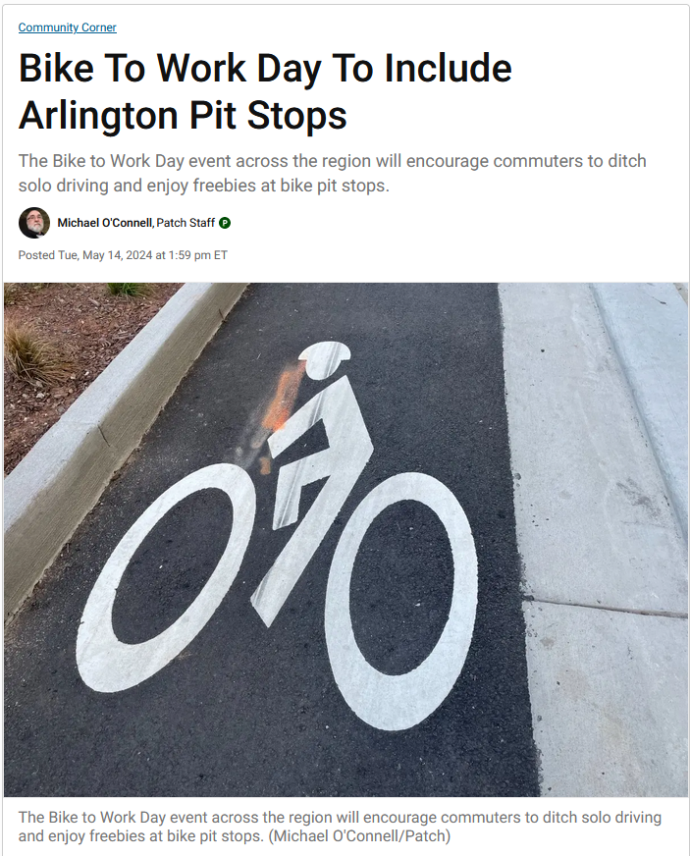
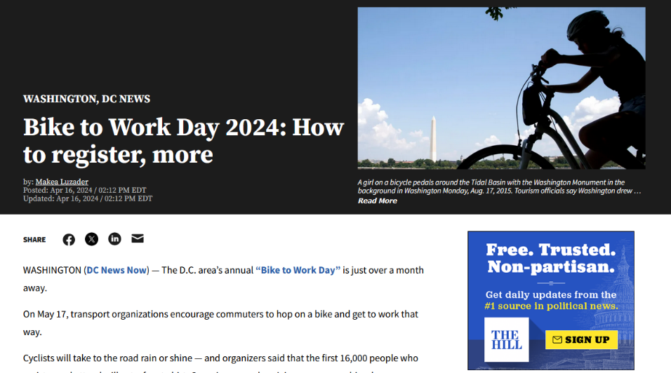
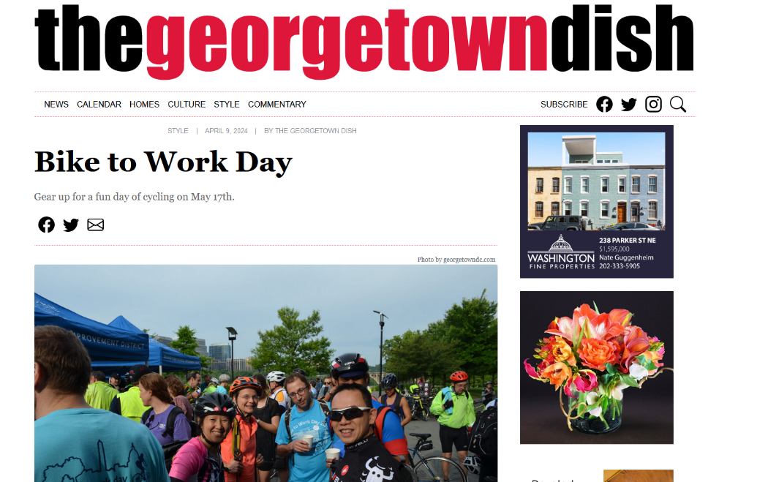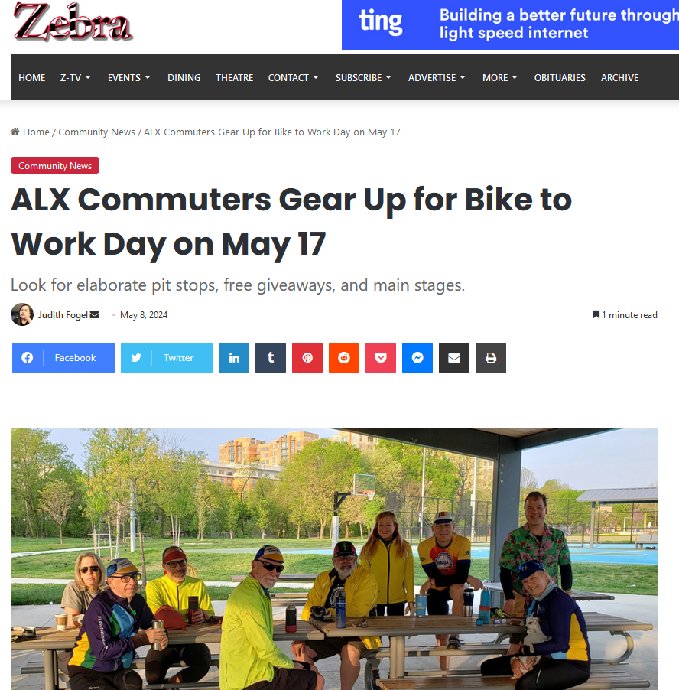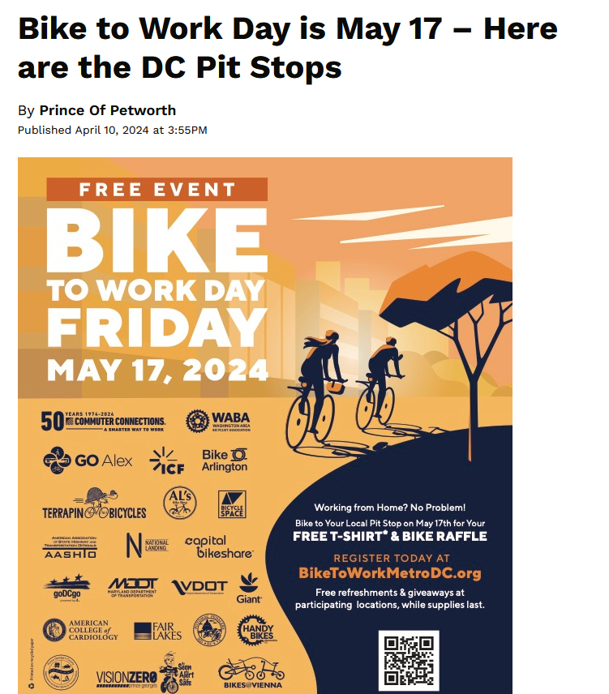
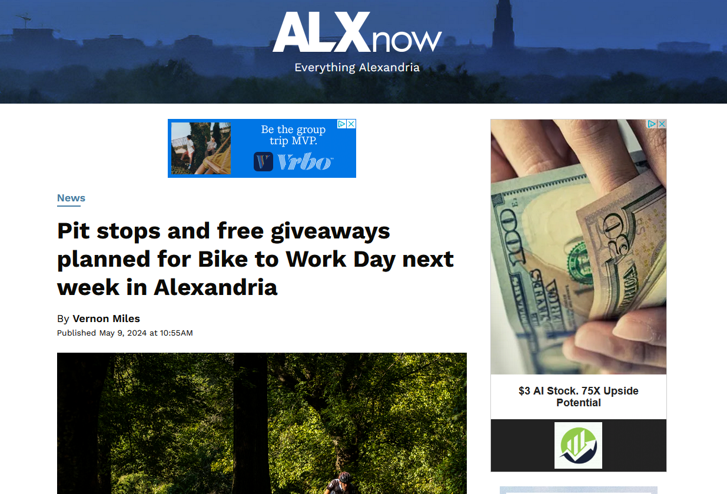
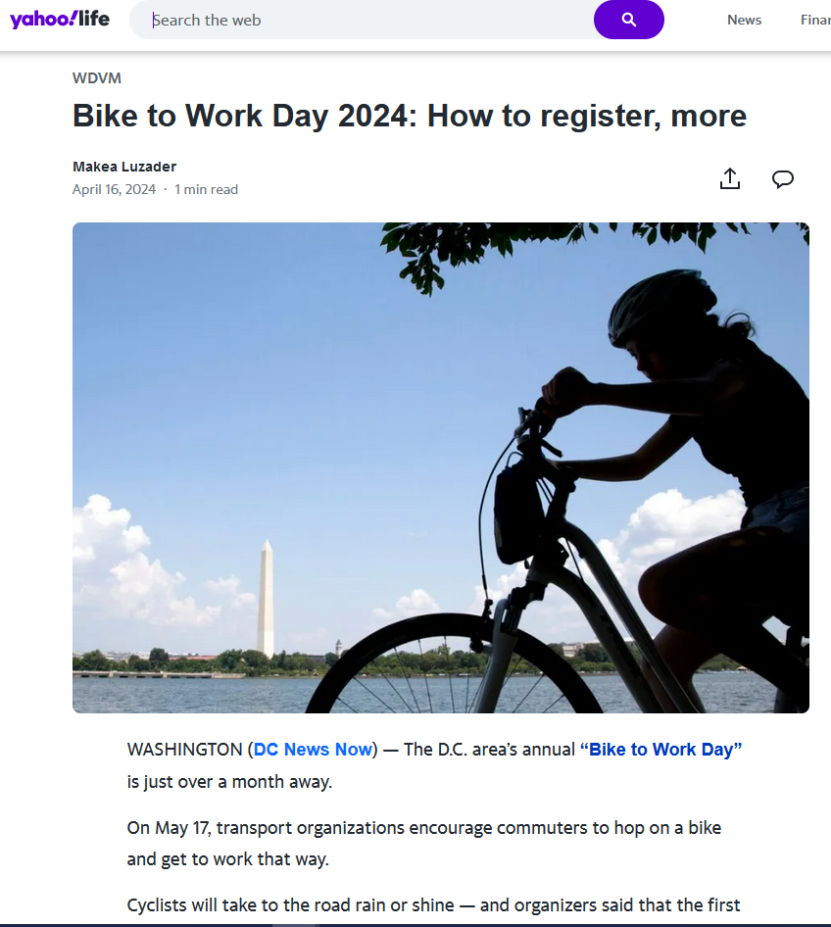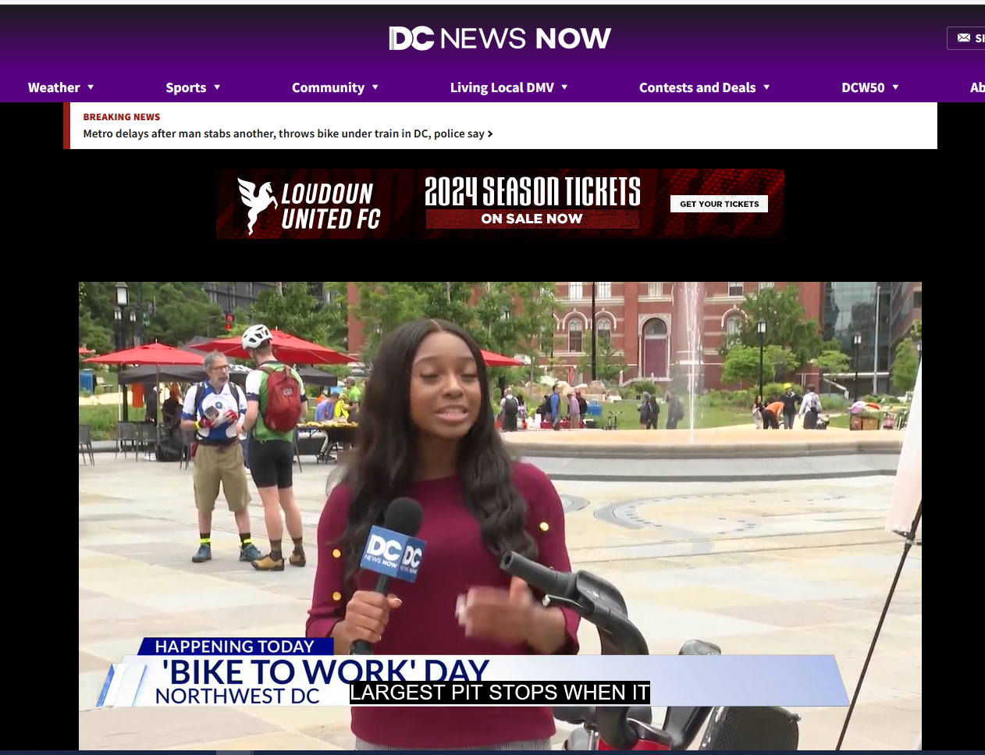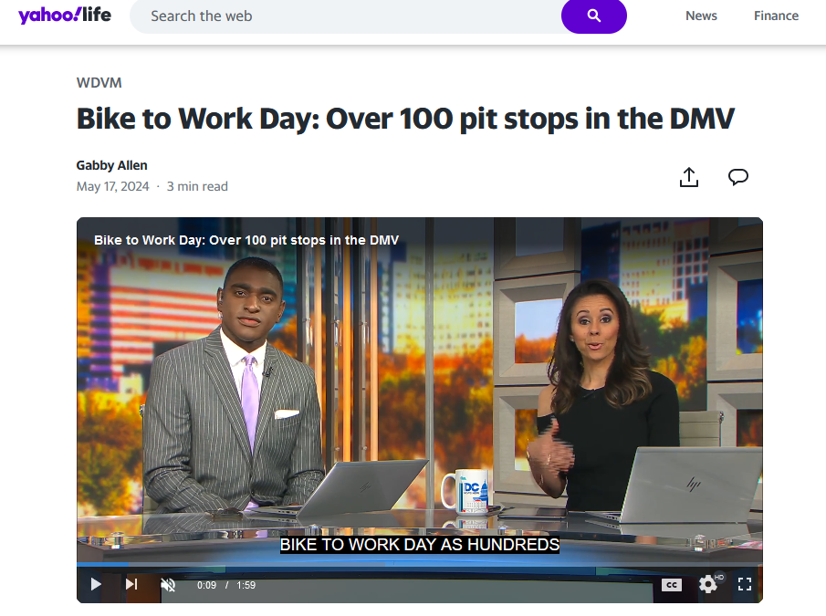
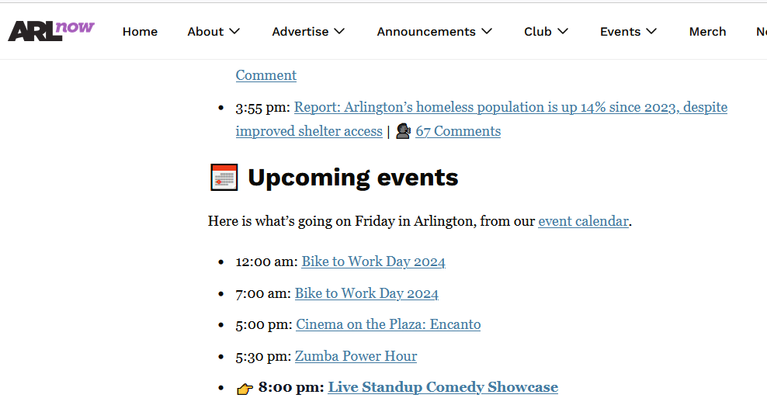
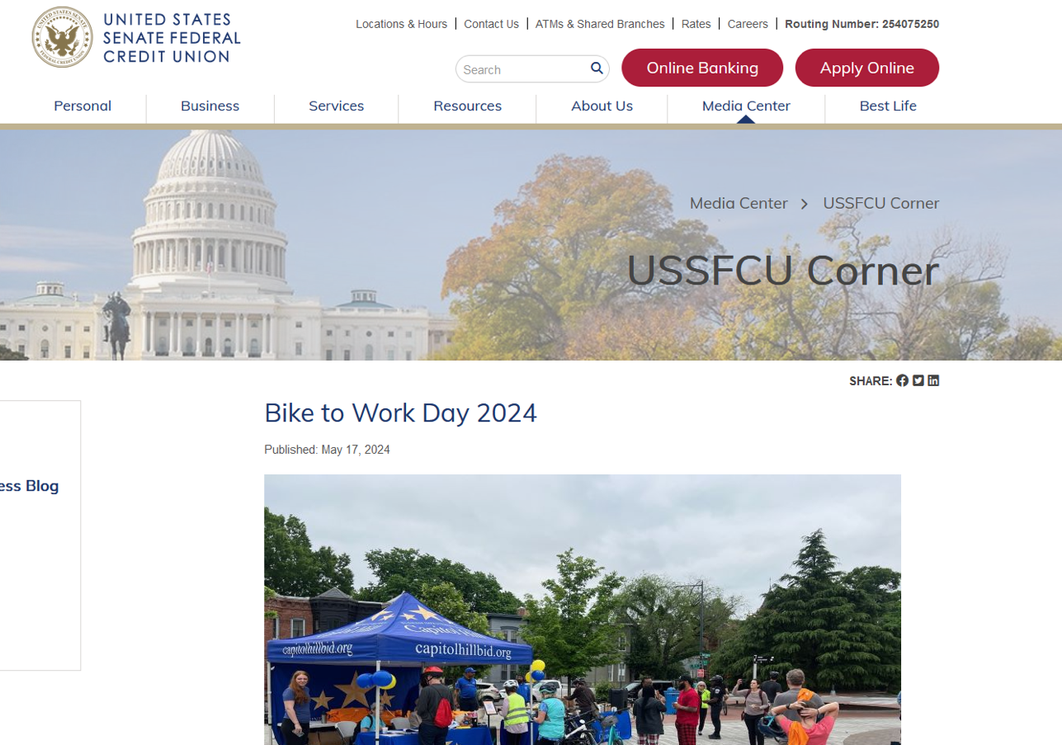
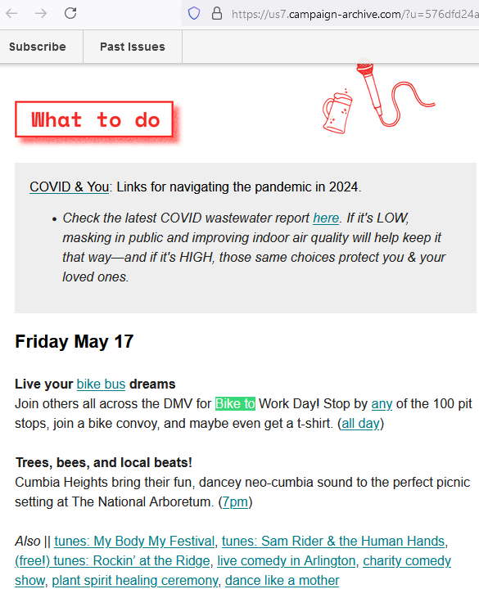
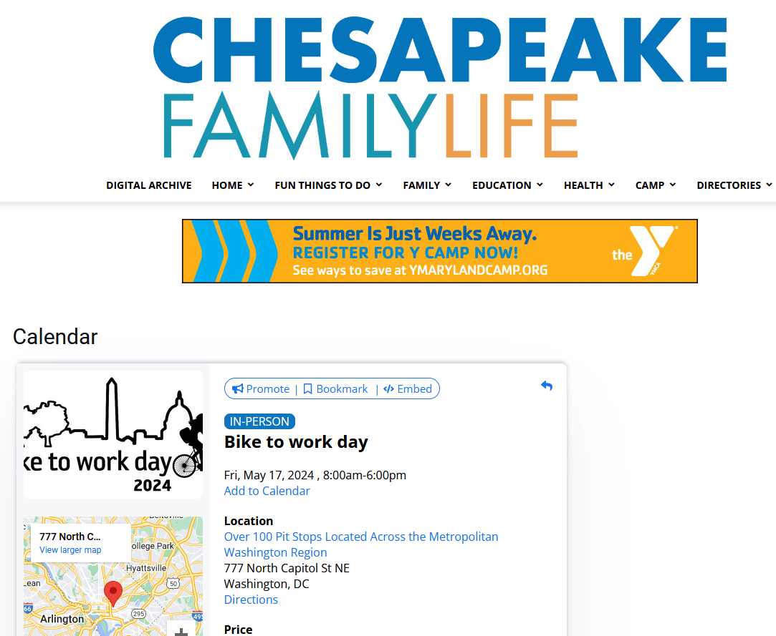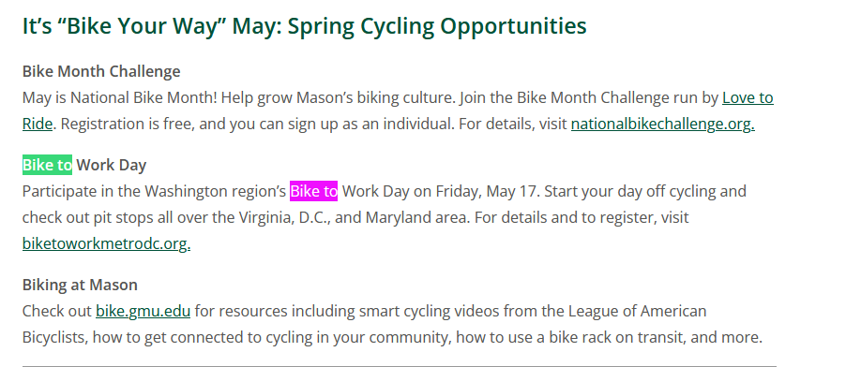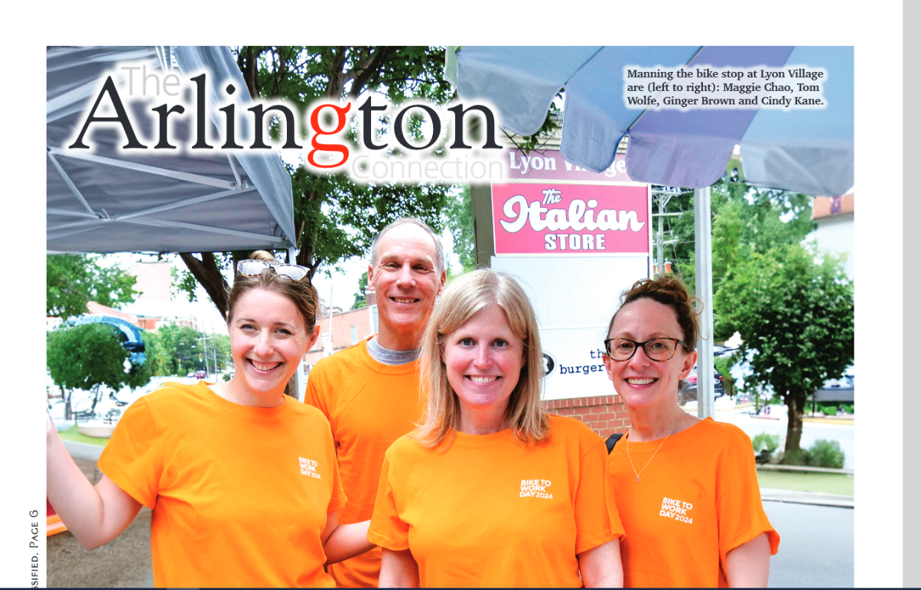
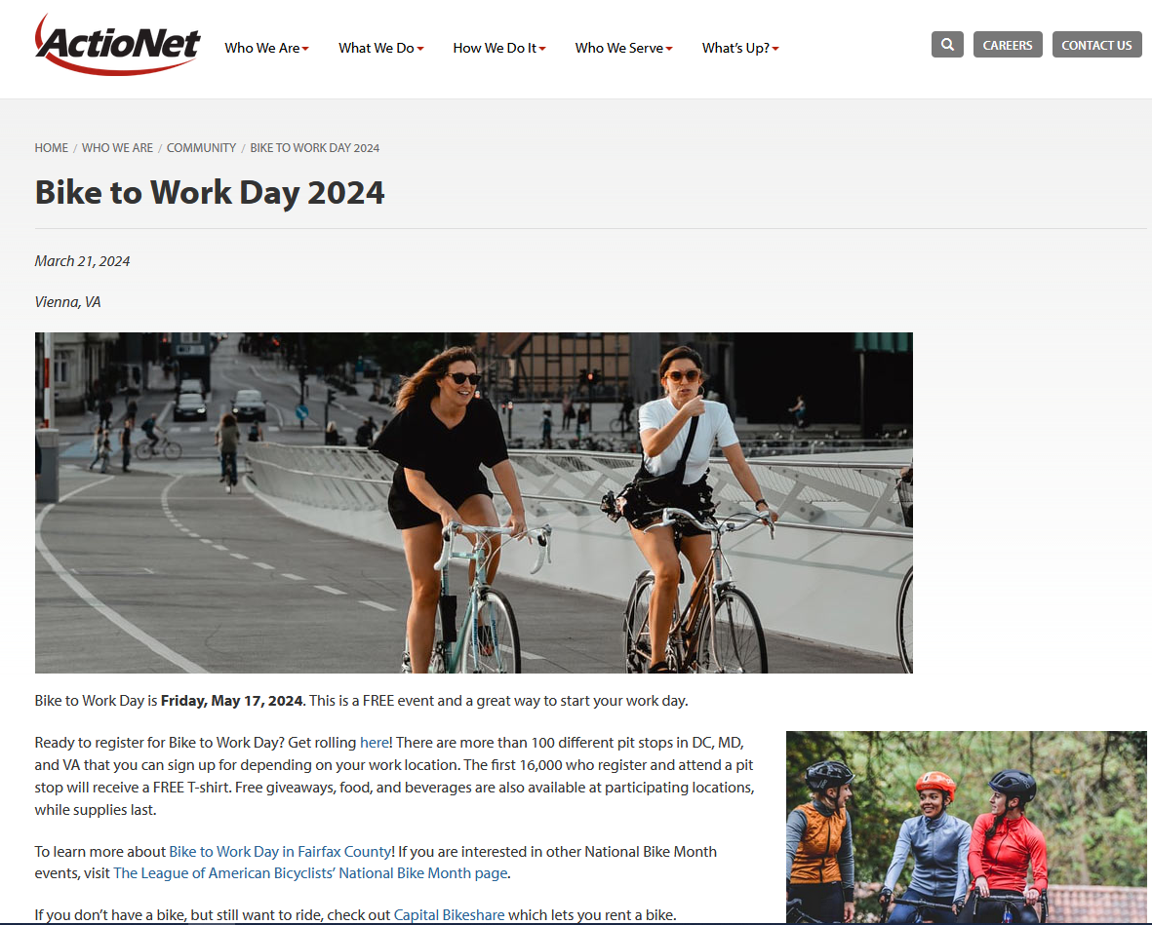
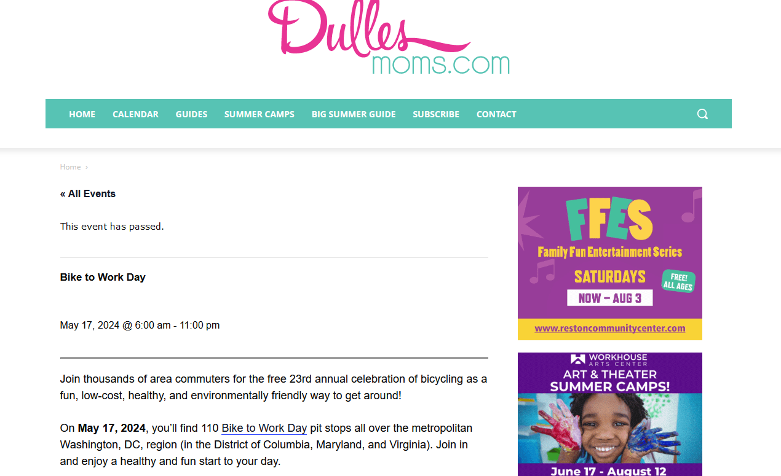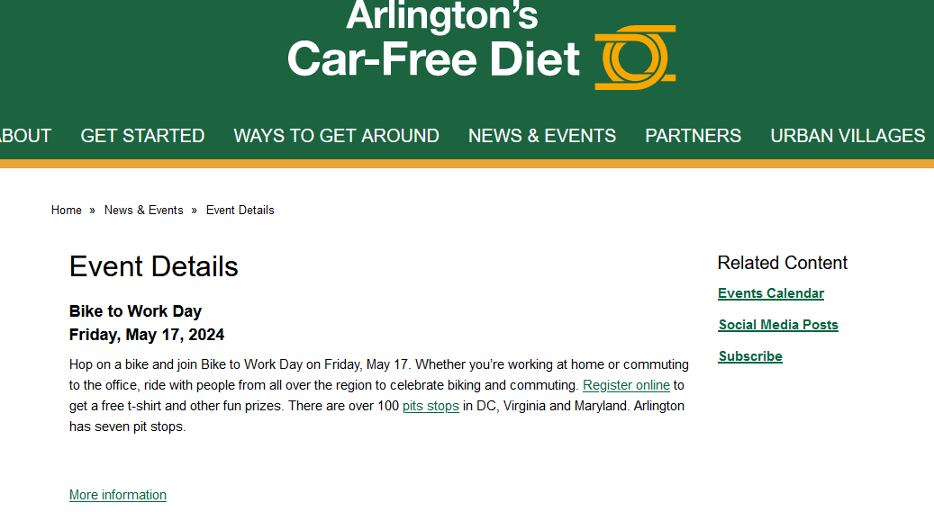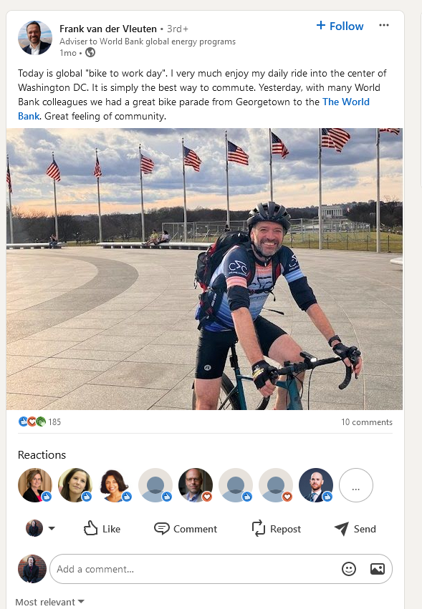
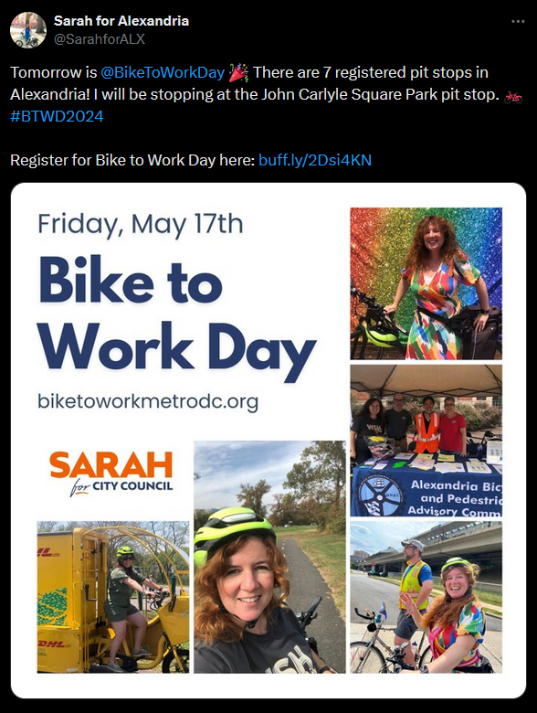

Proclamation
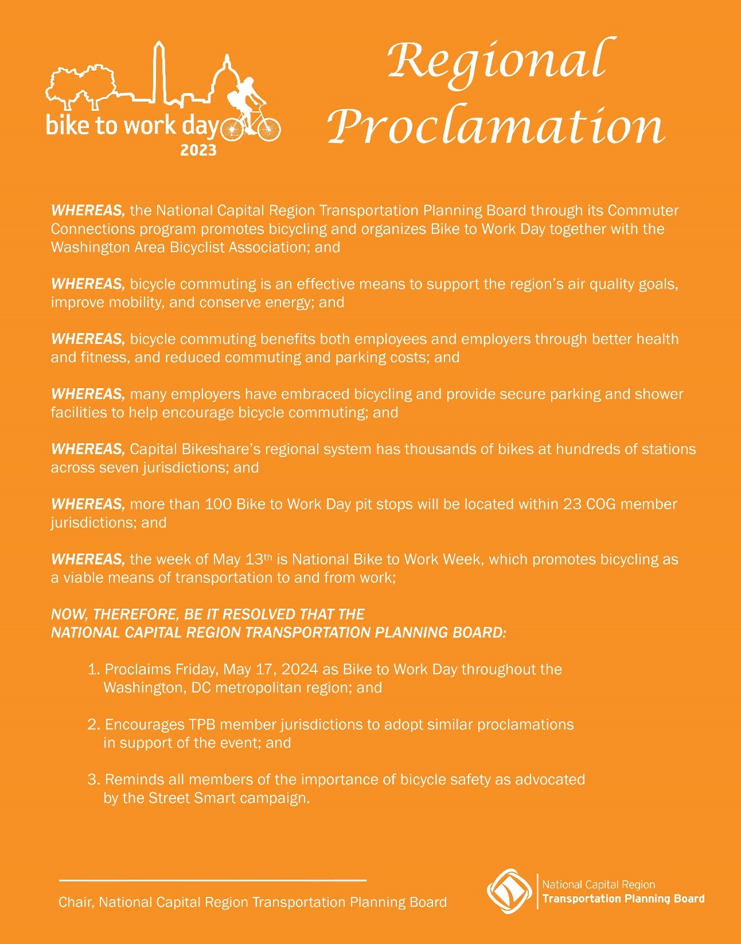

Proclamation Signing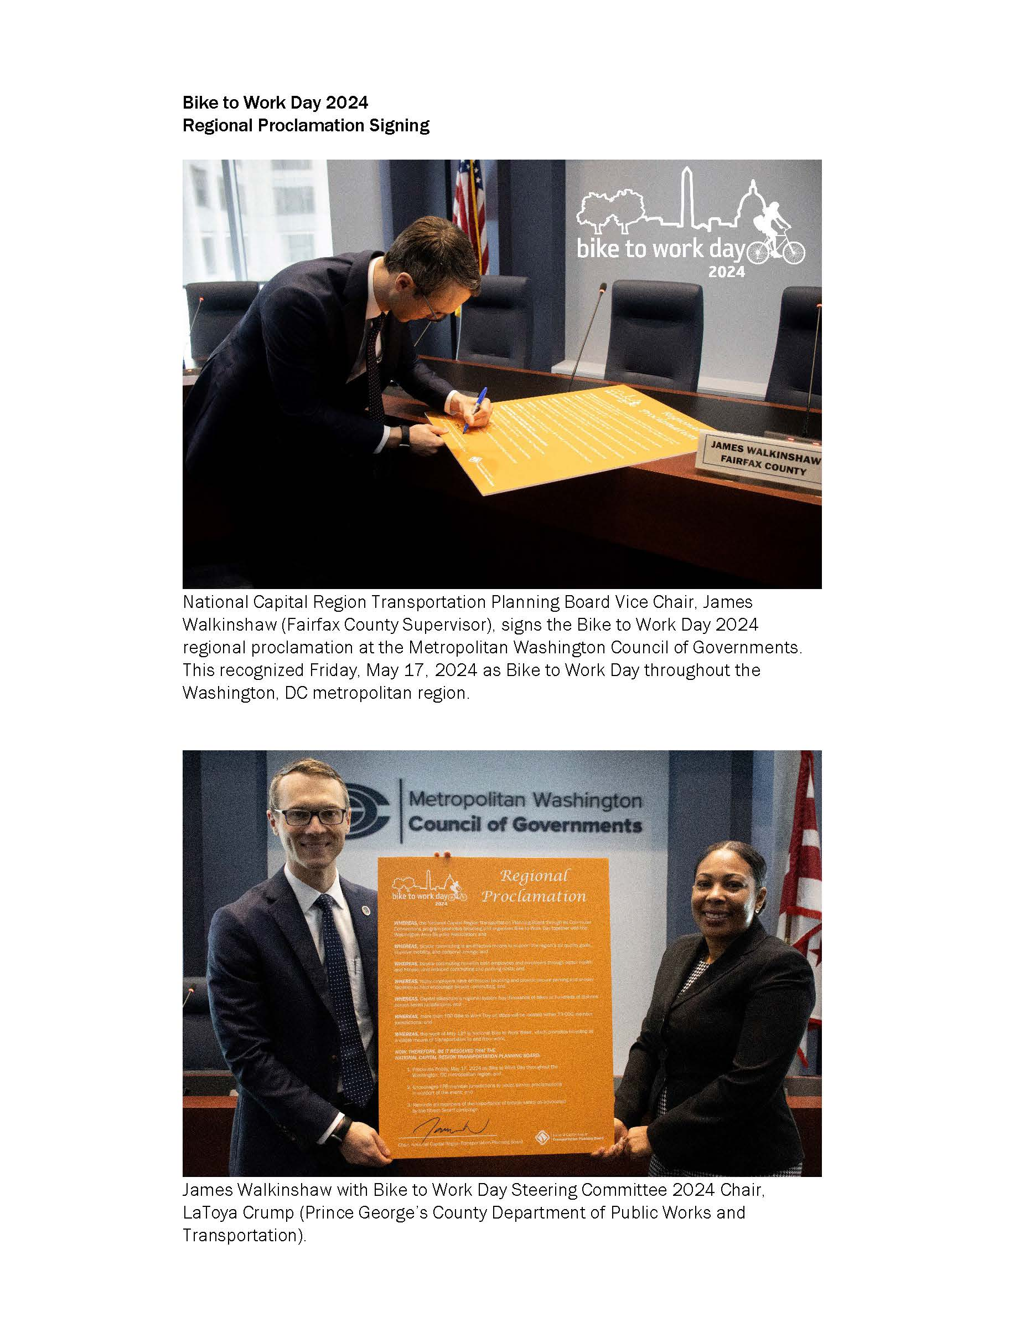

MARKETING MATERIALS

Rack cards 3¾ x 8½” (43,000)
Flyers 8½” x 11” (26,000) plus 1,000 Spanish
Posters 22” x 28” (300)
T-Shirts (16,000)

The marketing materials used for the 2024 BTWD campaign maintained similar look and feel from previous years and were targeted to employers and cyclists throughout the region. The posters were mailed to employers along with a cover letter. Employers were also emailed an html version of the poster with a link to the event web site. An e-mail blast was also sent to the previous year’s registrants.

Flyer English

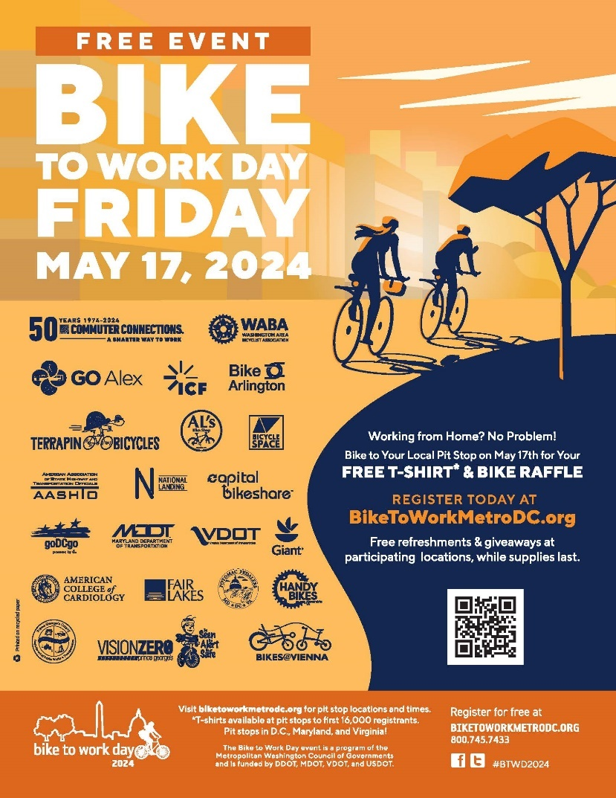

Rack Card
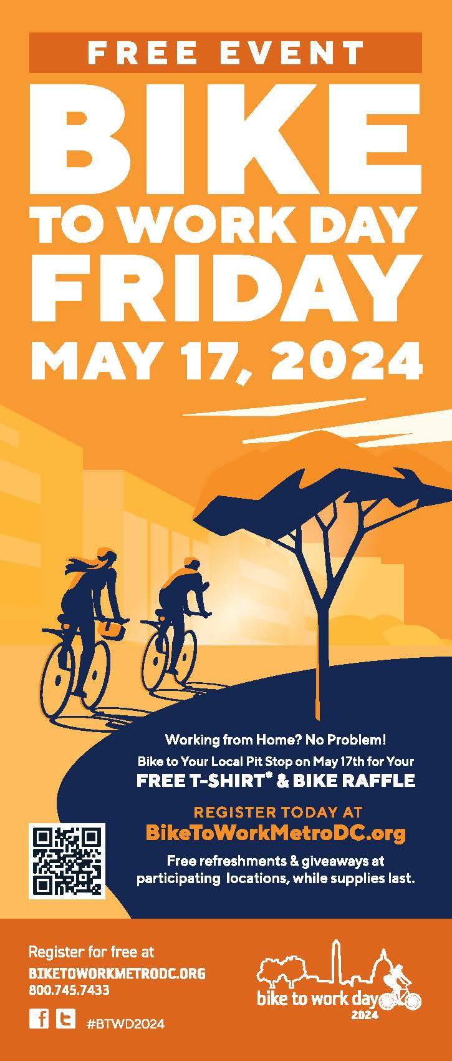
Rack Card Back
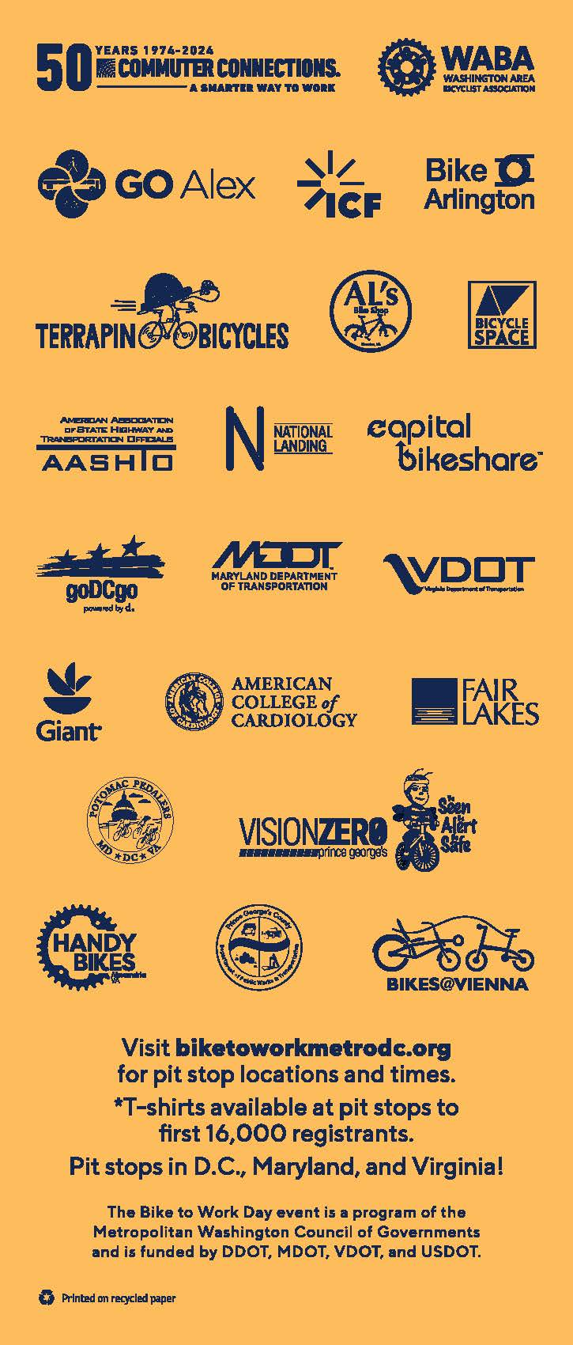

T-Shirt

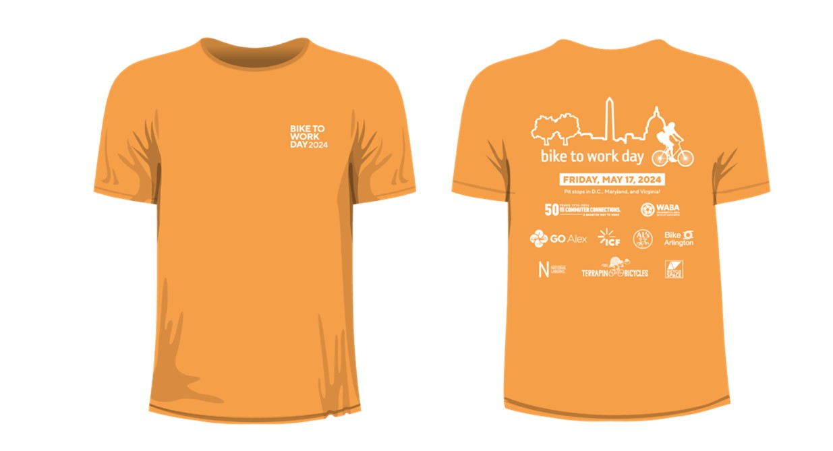

Press Release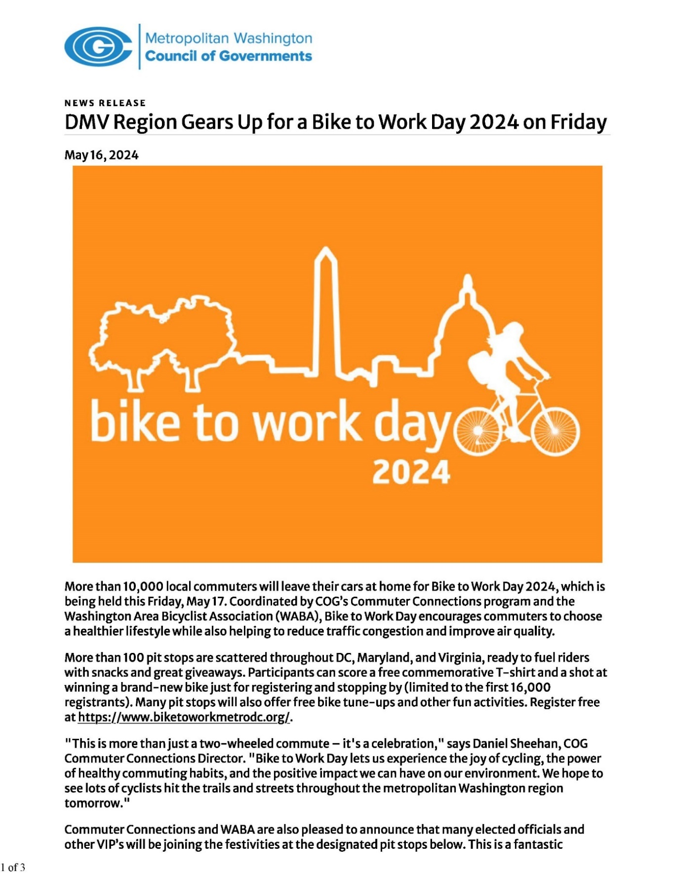
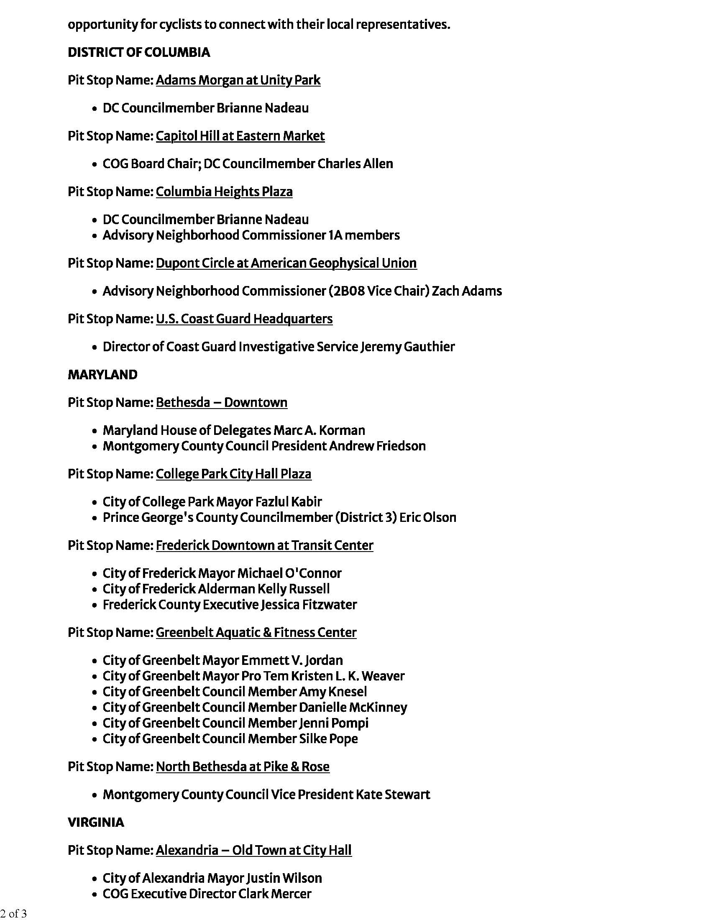
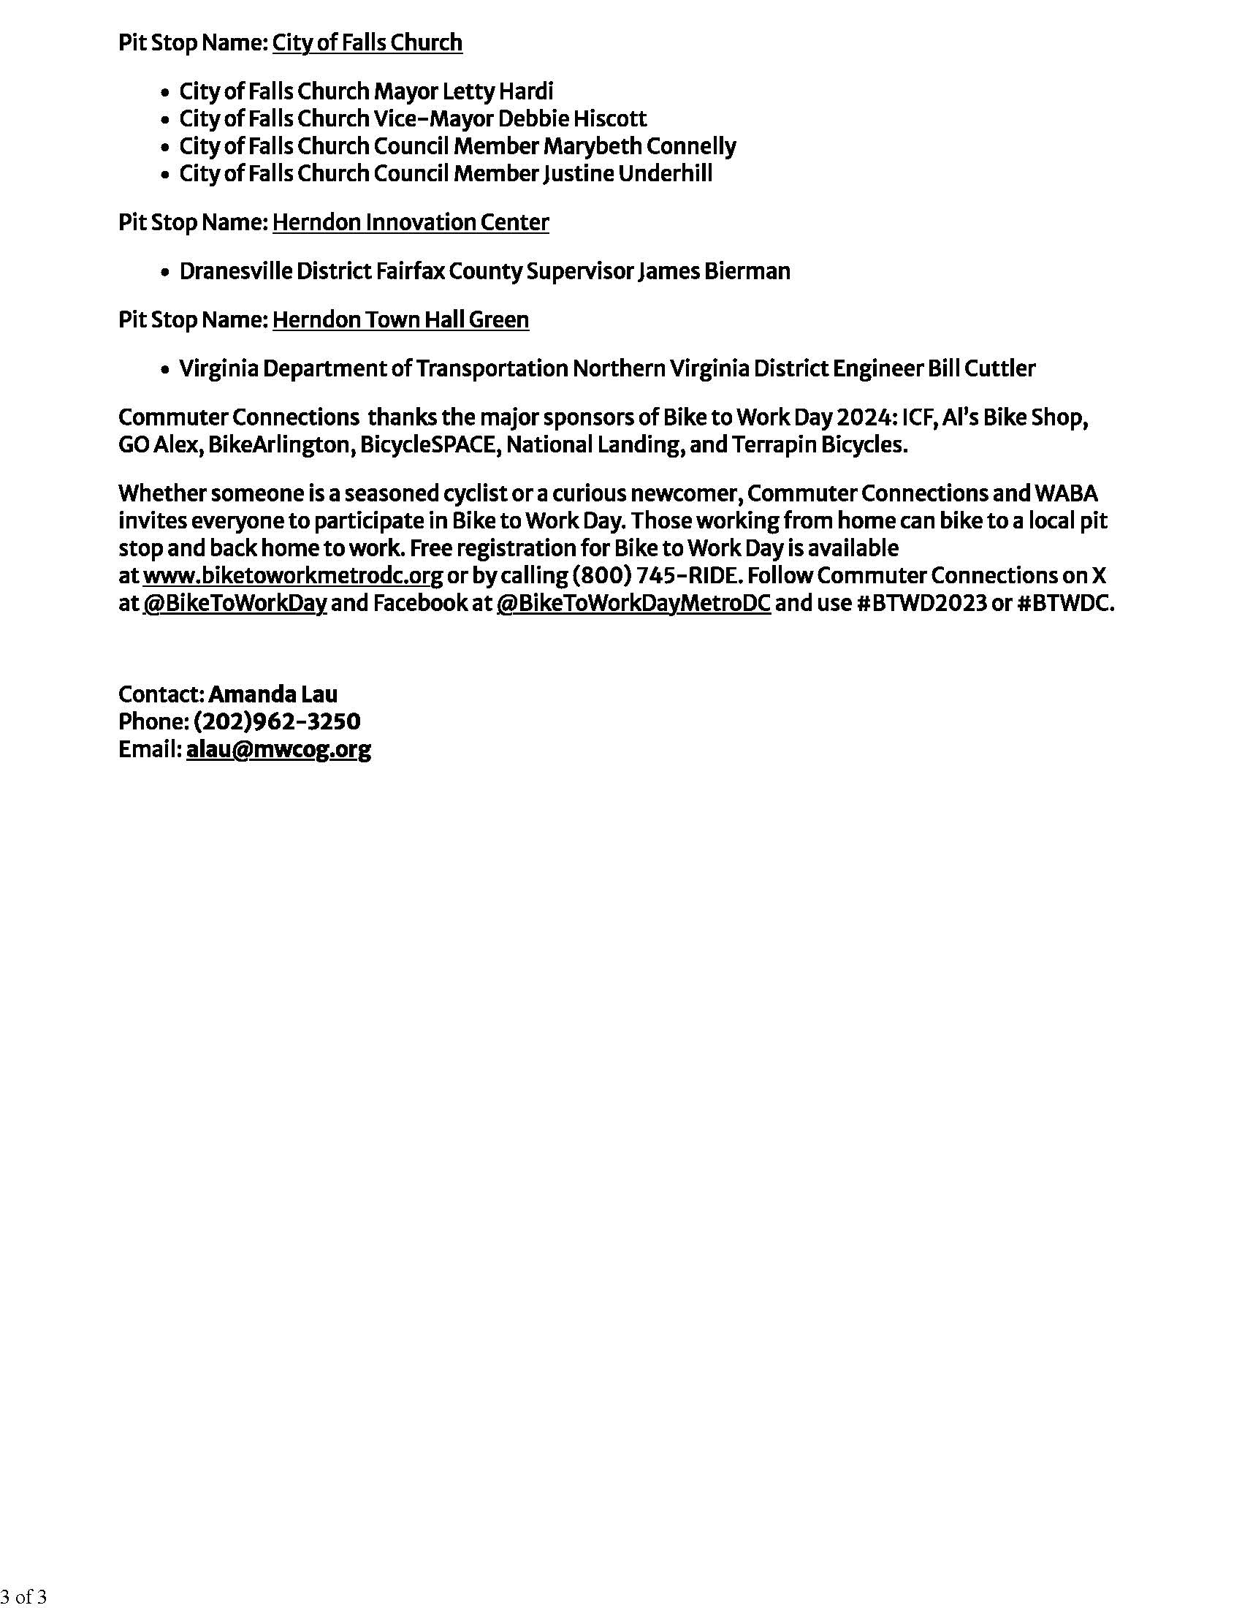
Photos and other promotional items
The T-Shirt Sort
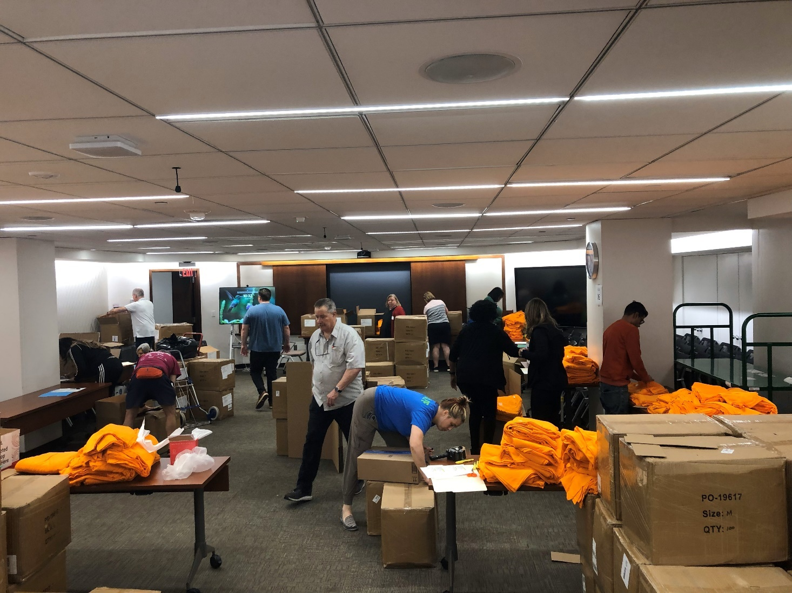

Maryland General Assembly Citation
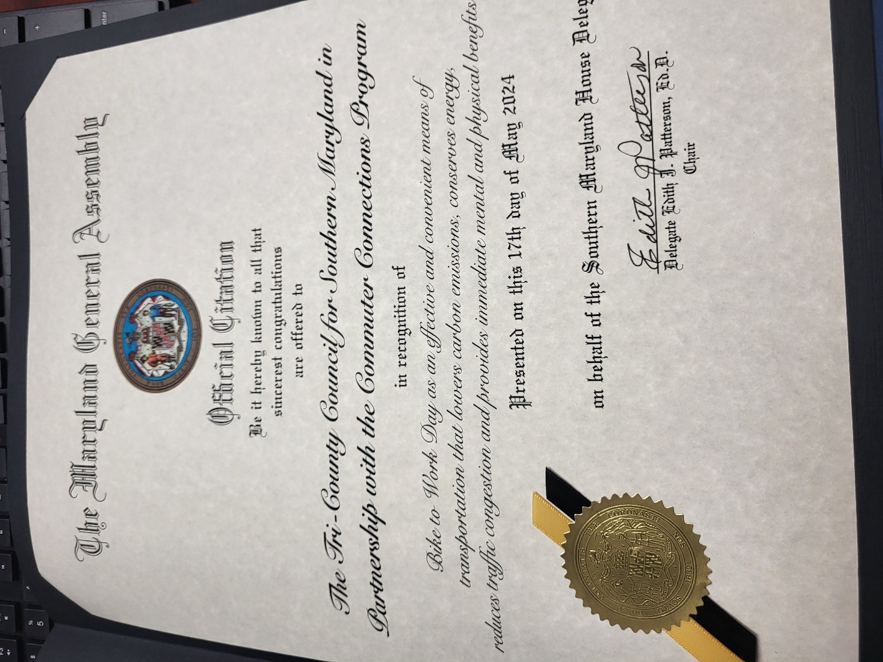

Charles County Proclamation
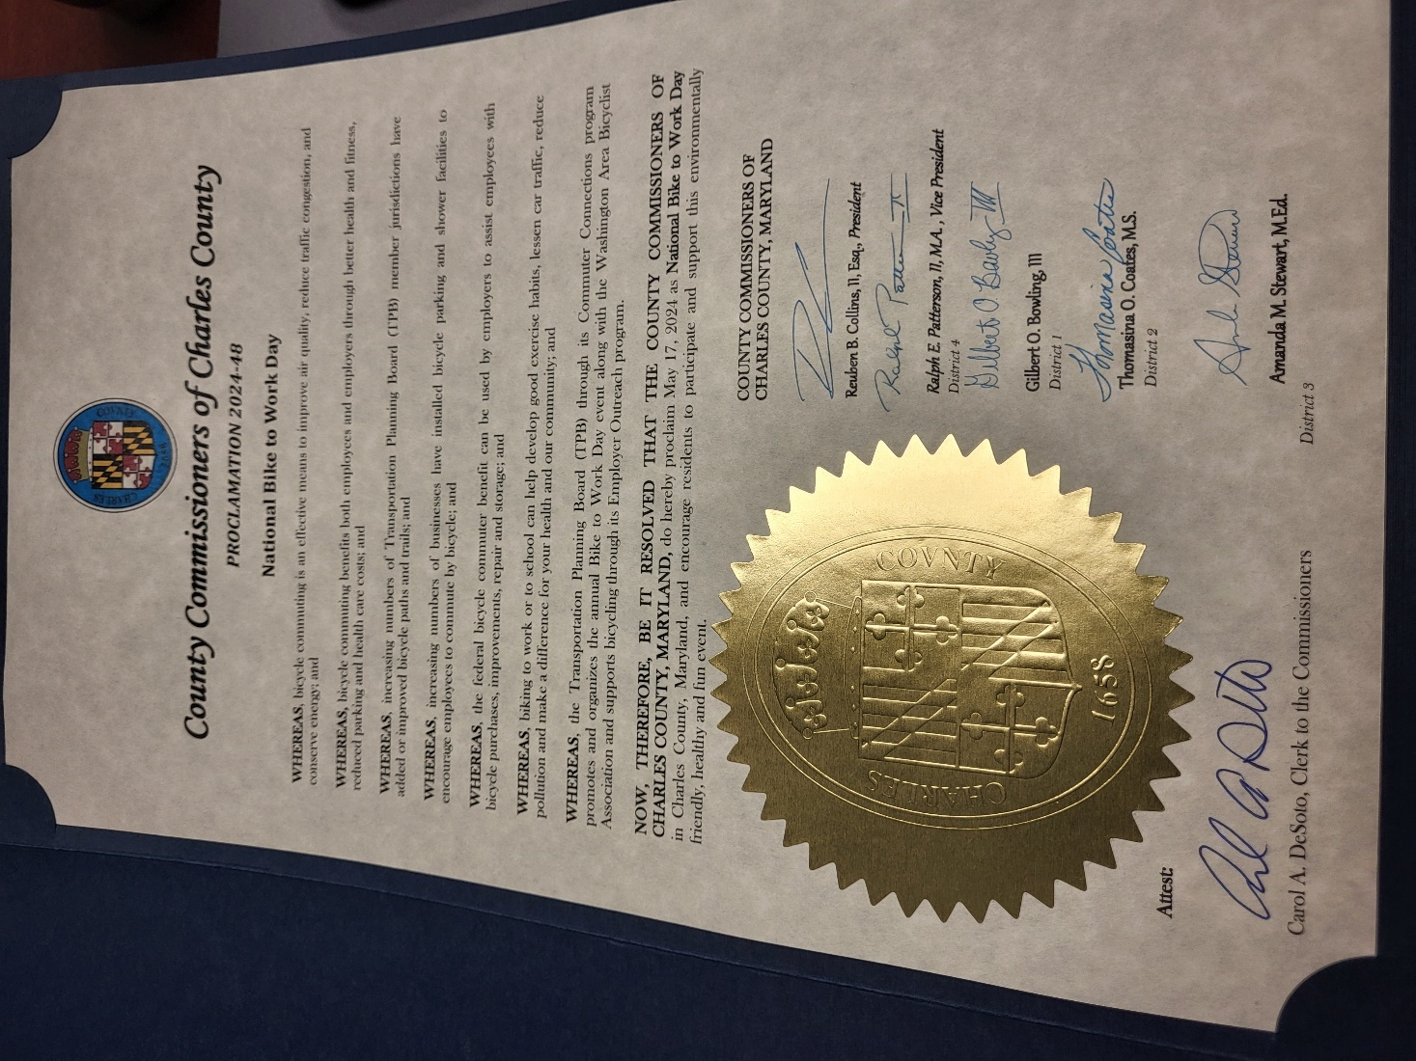

Lorton
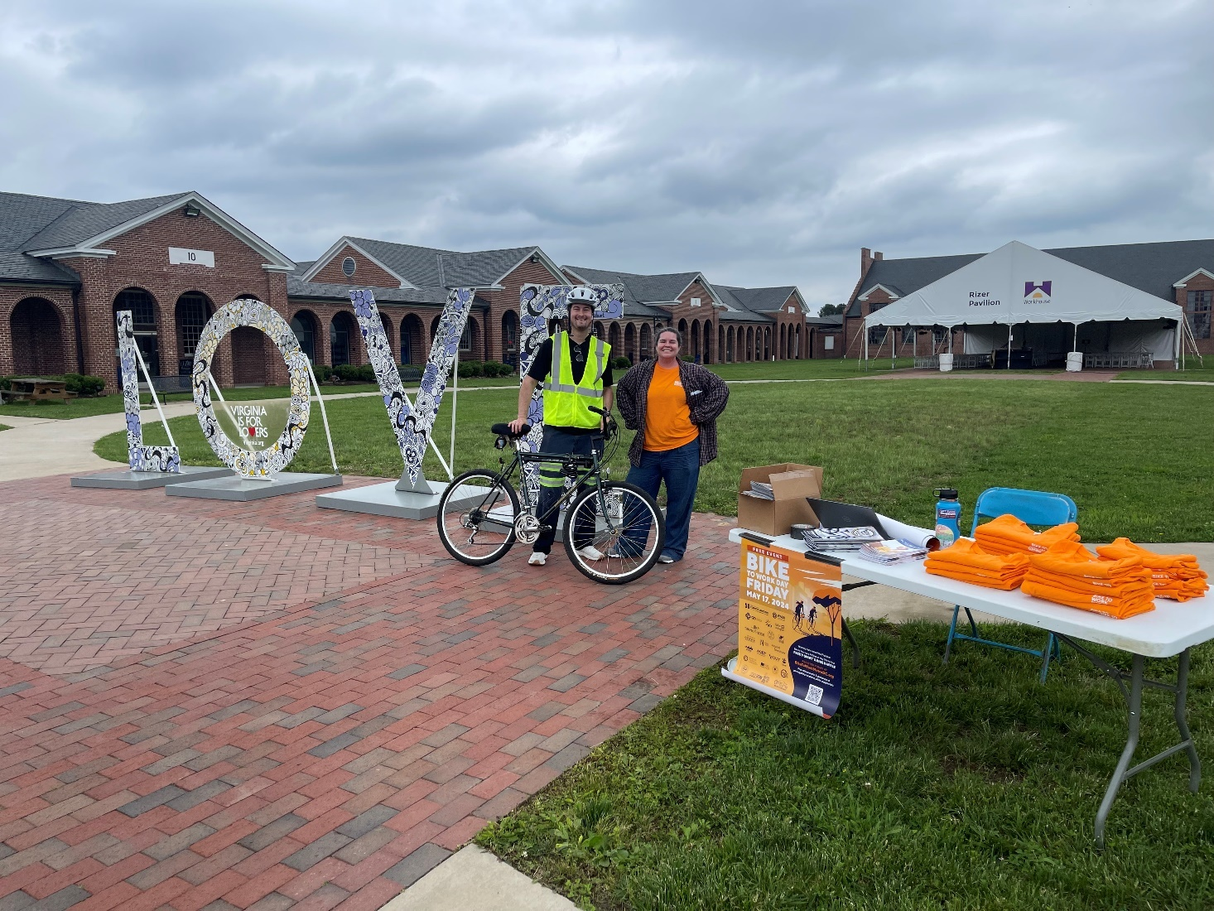

Anacostia River Trail
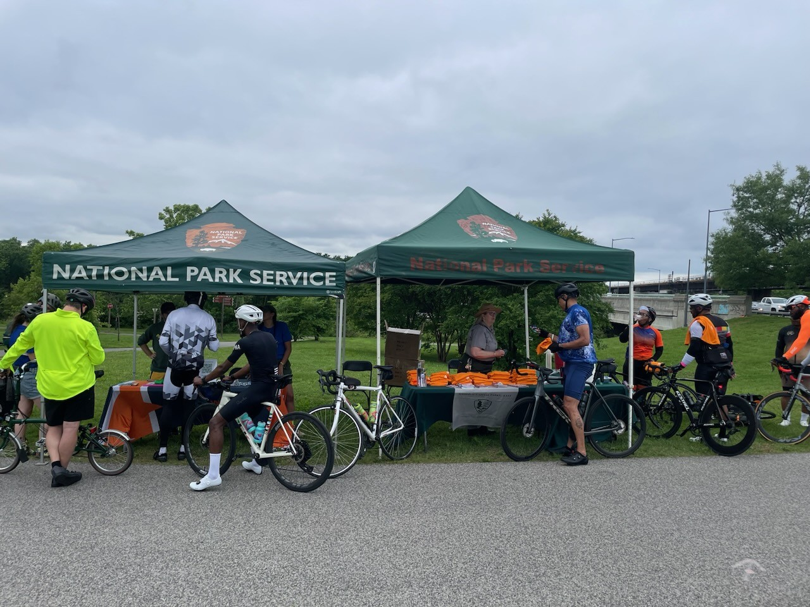

NOMA Wundergarten
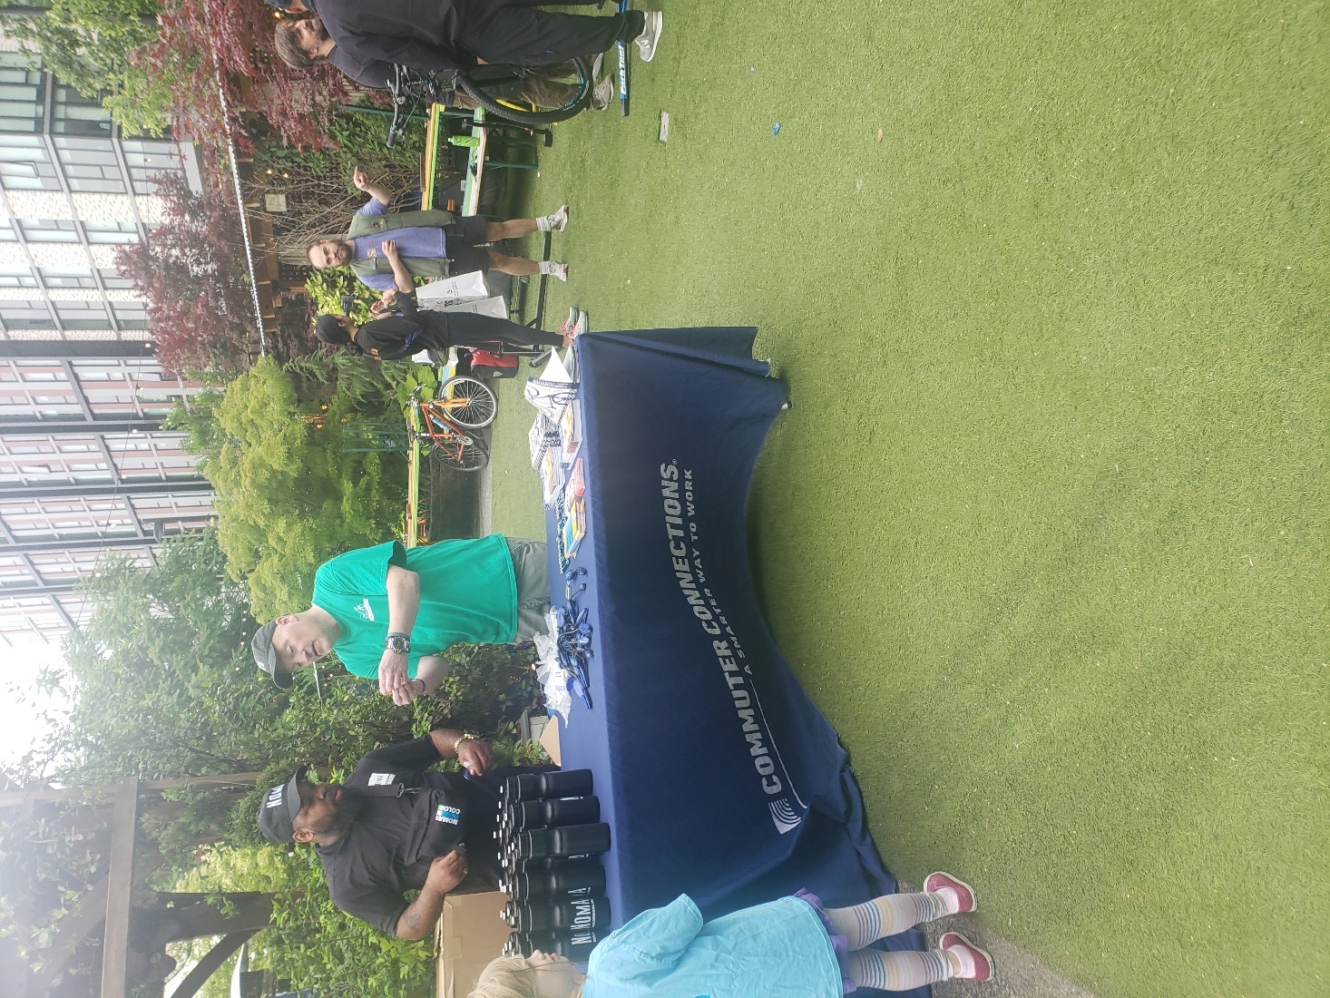

Adams Morgan
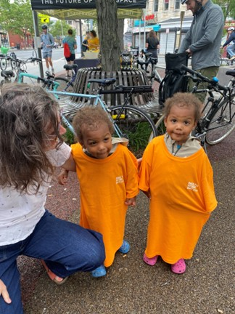
Capitol Heights
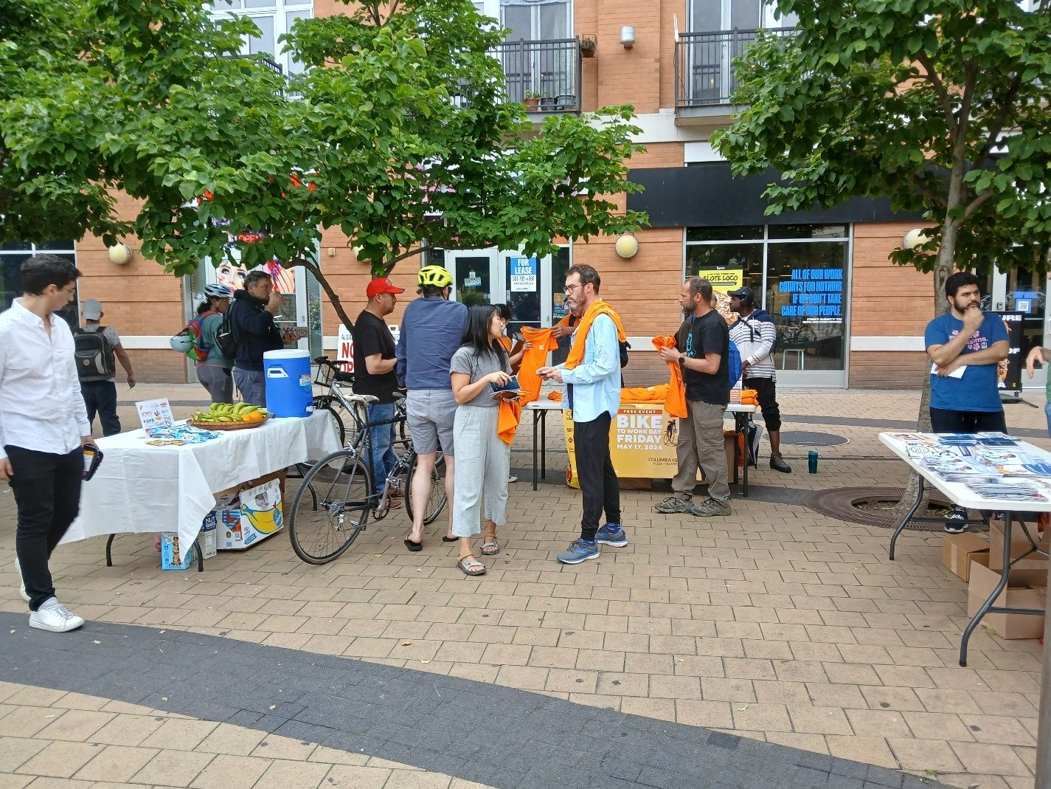

Georgetown
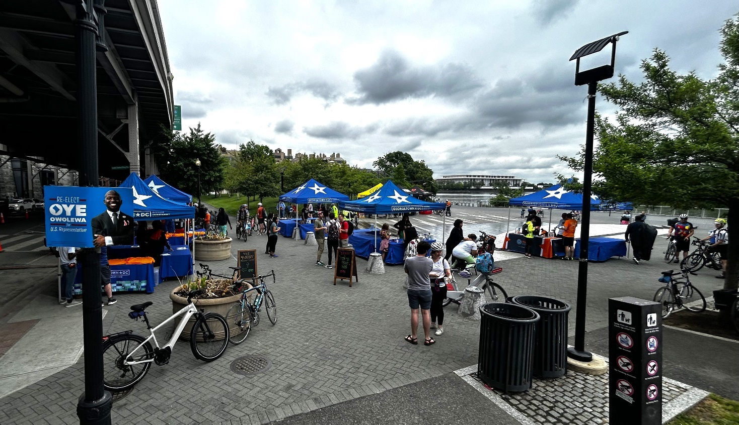
Shaw
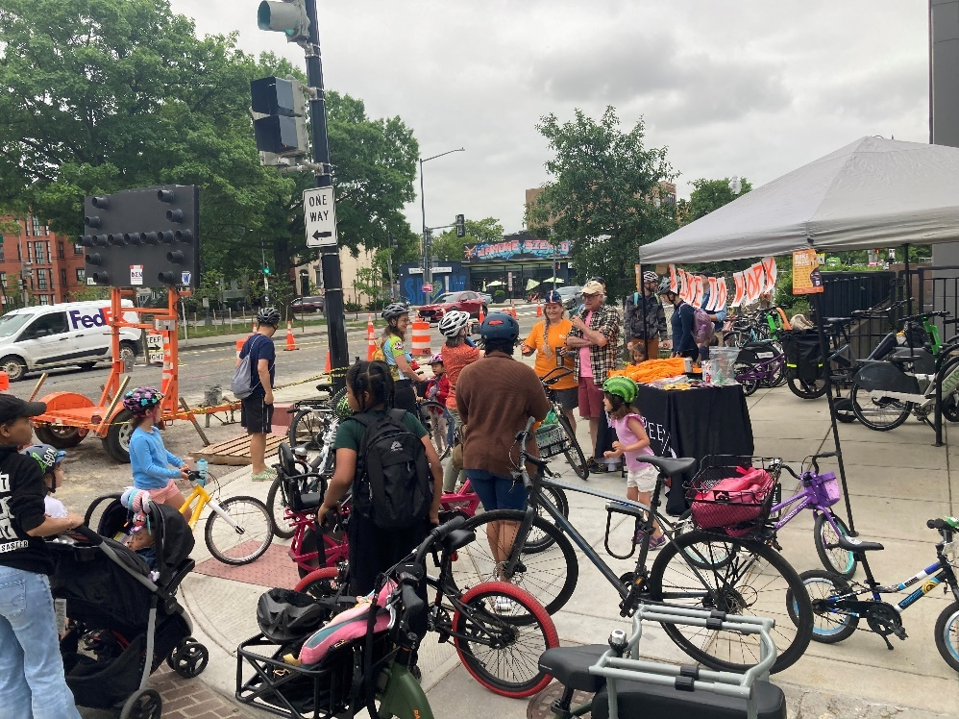

Indian Head
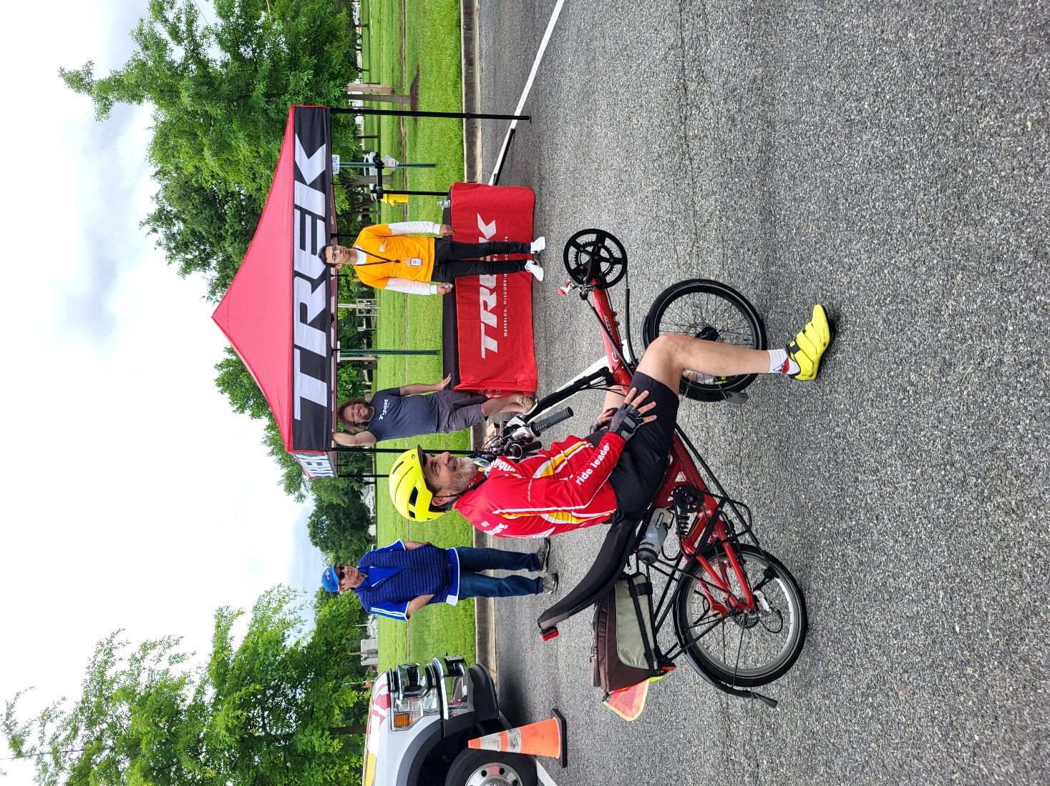

Manassas GMU
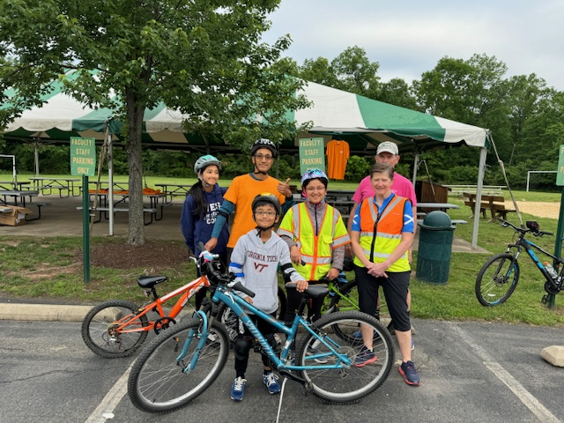
Leesburg 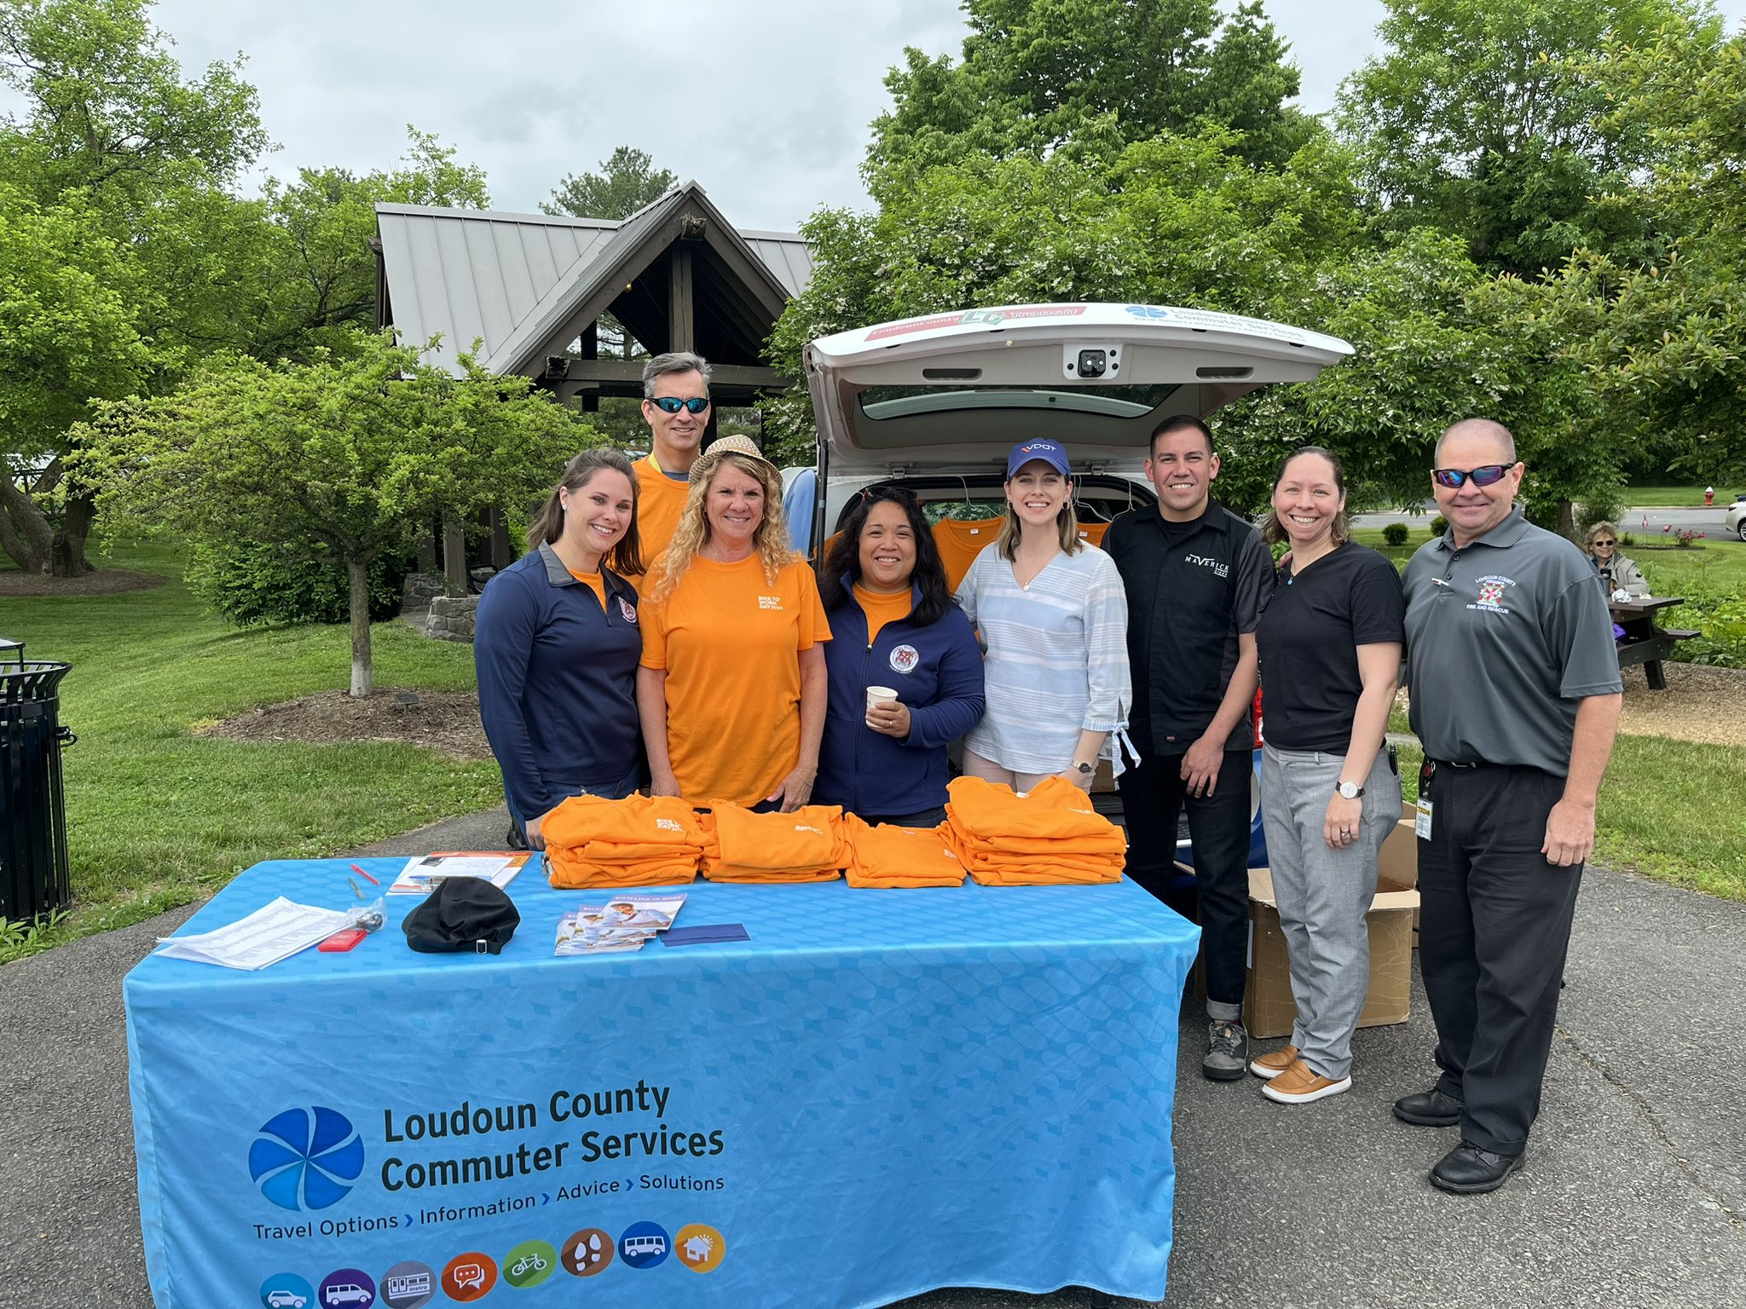

Arlington National Landing
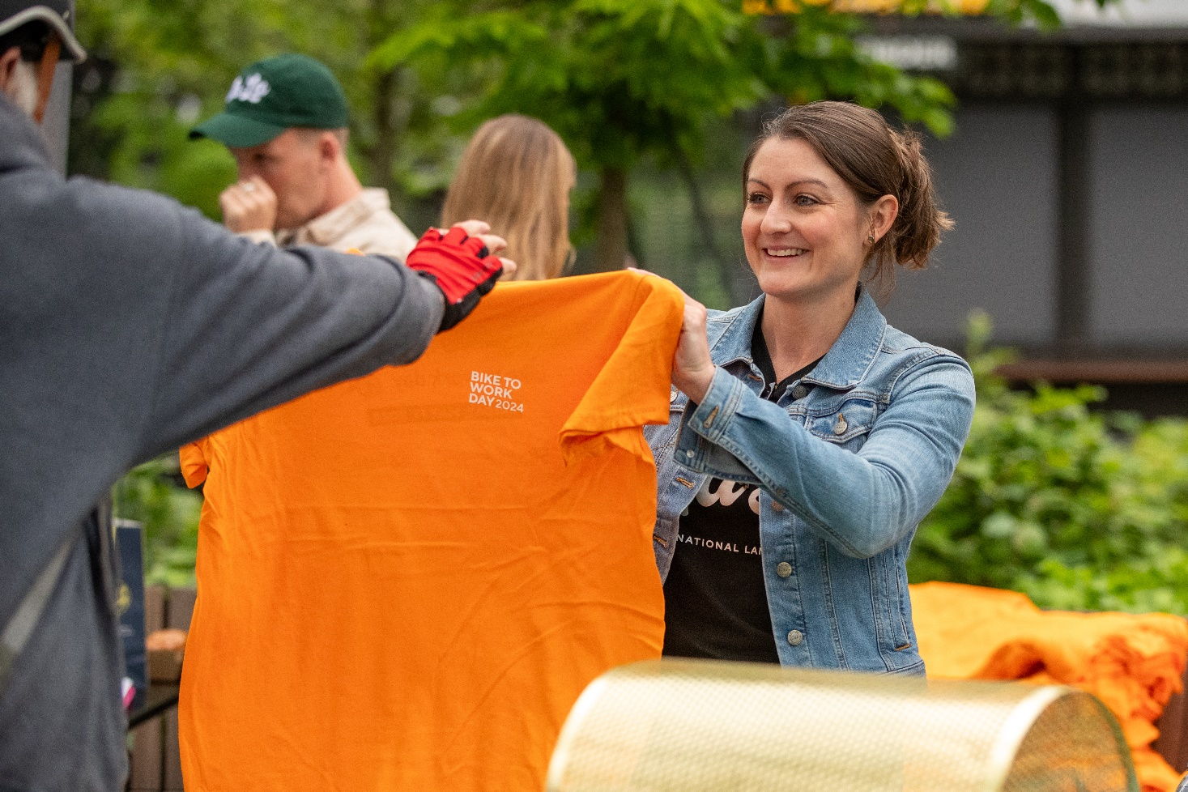
Oxon Hill
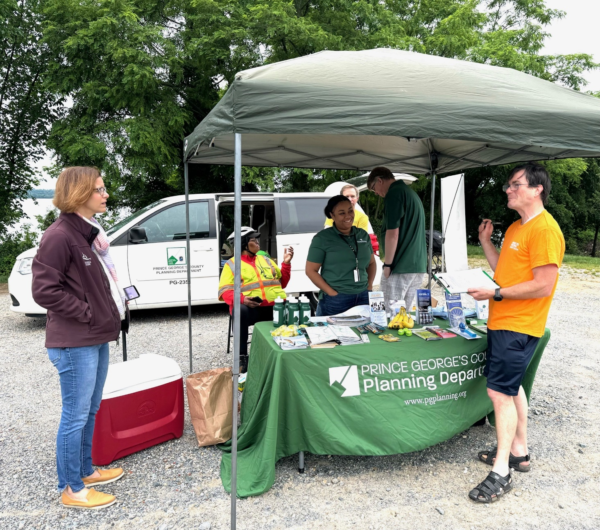

Largo/Kettering/Perrywood
