Montgomery County Maryland
Forest Glen Metro Access Project

Project Summary
The project will construct a grade-separated crossing of Georgia Avenue (MD 97) at Forest Glen Road to provide for safer access to the Forest Glen Metrorail station to several communities and Holy Cross Hospital. The crossing will also streamline access to metro to/from these locations for persons using mobility devices. The project will also add ten Capital Bikeshare station to location around the Metro station and hospital, complementing the regional bikeshare network.

Project Cost
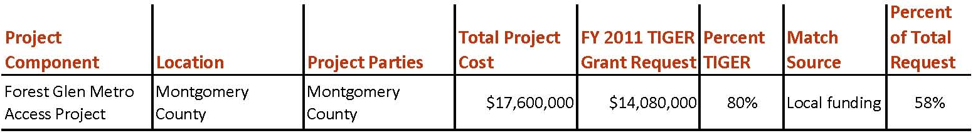

Project Location
This project is located in Montgomery County, Maryland, just north of the Capital Beltway (I-495) at the intersection of Georgia Avenue (MD 97) and Forest Glen Road. Georgia Avenue is eight lanes wide at the Forest Glen Road intersection and there is no island refuge for pedestrians. The current Average Daily Traffic (ADT) volume on Georgia Avenue is approximately 80,000 vehicles per day. There were 84 crashes at this intersection between January 2005 and December 2009.

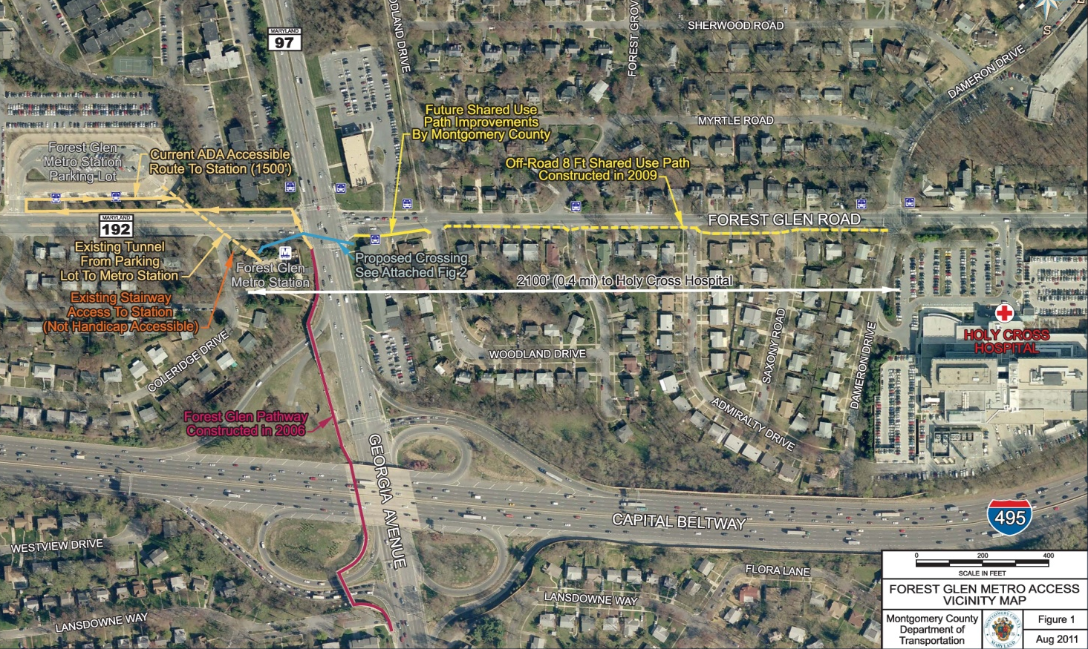

The project area is within Forest Glen Sector Plan and North and West Silver Spring Master Plan. Area is largely already built-out to current proposed land use and includes mostly single-family residential, some multi-family residential near Metro station, Holy Cross Hospital, and some other institutional (churches), medical/office, park, and retail land uses.

Project Planning
Montgomery County Department of Transportation (MCDOT) retained RK&K to perform surveys, identify utilities, complete a traffic study, develop alternatives, and evaluate the feasibility, constructability, impacts, and costs of implementing a new pedestrian passageway underneath or above Georgia Avenue. RK&K performed pedestrian and automobile counts at the intersection to evaluate the potential use of the passageway and impacts to vehicular and pedestrian traffic during construction; daily volumes for the new passageway are estimated to range between 450 and 800 pedestrians. RK&K evaluated initial concept alternatives that were reviewed with MCDOT, Maryland National Capital Park and Planning Commission, Maryland State Highway Administration, and WMATA. The feasibility report, including a recommended alternative will be completed in December 2011. Potential impacts to community, property, and natural, cultural and socio-economic resources are anticipated to be minor. RK&K anticipates that a Categorical Exclusion (CE) will be required to satisfy NEPA. After the Feasibility Report is complete and a preferred alternative is selected, the CE could be completed and approved by the spring of 2012.

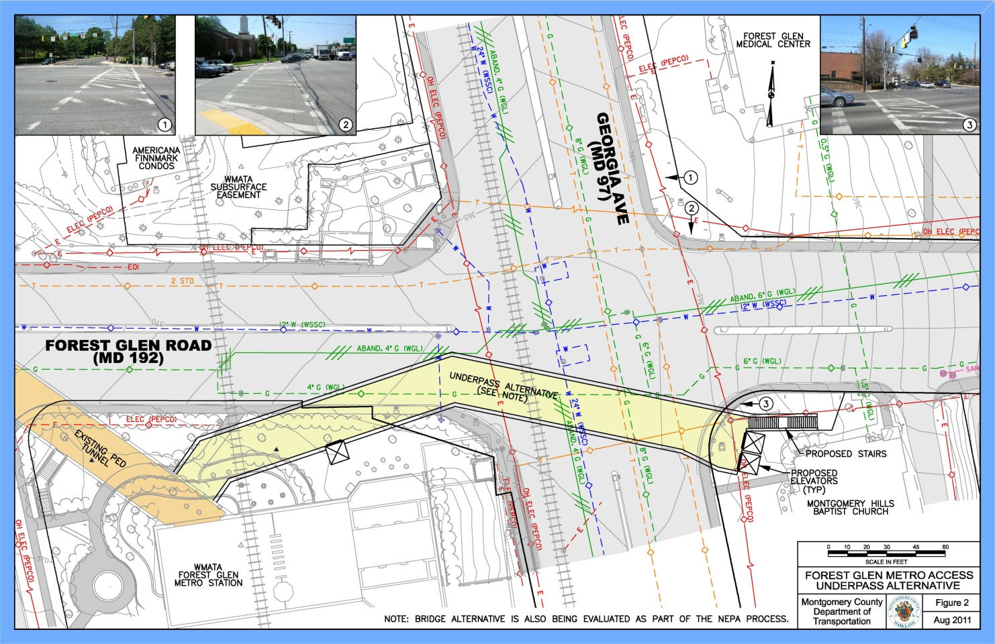

For pedestrians crossing Georgia Avenue, the proposed tunnel would save approximately 119 seconds, on average. For vehicular traffic, pedestrians diverting to the proposed tunnel would reduce the number of calls for the extended pedestrian crossing interval, reducing average delay at the intersection. Based on having 63,603 vehicles entering the intersection during this 13-hour period, the total delay reduction due to the passageway would be 57 hours.

Up to 90 percent of the pedestrian activity at the Georgia Avenue / Forest Glen Road intersection is related to the Forest Glen Metro Station. For pedestrians crossing Georgia Avenue, there were four accidents in the study period of 2005-2009. It is anticipated that 95 percent of pedestrians crossing Georgia Avenue would use the proposed tunnel, eliminating 95 percent of the potential conflicts. This corresponds to a pedestrian accident rate reduction of 0.76 accidents per year.

Project Details
The intersection of Georgia Avenue and Forest Glen Road is one of the most congested intersections located adjacent to a Metrorail station in the Washington region and presents challenges for pedestrians to safely cross MD 97. The community has been lobbying several years for a grade-separated crossing that would eliminate conflicts with automobiles and significantly improve access to the Forest Glen Metro Station. Of the transit users who drive to the Metrorail station, one-third live within one mile of the station and would benefit from a safer connection to rail.

Construction of underpass would be accomplished via cut-and-cover, including construction of a temporary deck-over constructed at night (requiring temporary lane closures at night). Majority of passageway excavation and construction would be accomplished from below-grade, without interrupting traffic on Georgia Avenue during the daytime. Construction of bridge would be accomplished with minimum disruption to Georgia Avenue during peak period. Temporary lane closure would be required to erect the bridge. All work within travel lanes on Georgia Avenue would be limited to overnight hours (11pm-5am). Construction duration would be approximately 2 to 3 years depending on alternative selected.

Project Schedule
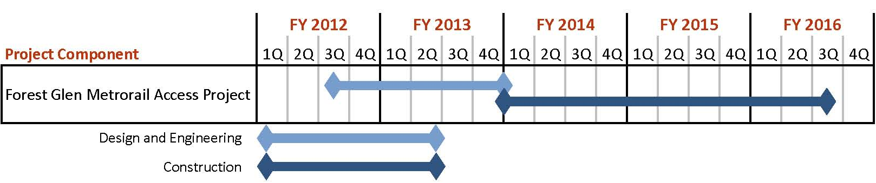

Additional Documentation

