Responses to Questions on the PCN Evaluation Final Draft

WMATA

- For the service only model run, how frequent is the service and how many extra buses does that entail?
- Peak service was coded for 10 minute headways and off-peak for 15 minute headways.
- The fleet required to operate the SOI Alternative is 227 without spares or 250 with 10% spares. The fleet needed for the ELI Alternative is 156 buses without spares and 175 buses with 10% spares.

- Are the trips being reported in table 2 linked or unlinked?
- Unlinked trips are reported as boardings and linked trips are reported as passengers. Table 2 reports boardings (unlinked trips).

Are you using the same measure (linked or unlinked) for Current, No Build, Service Only and Exclusive Lanes (table 2)?
- Yes, boardings (unlinked trips).

- Do the Exclusive Lane ridership numbers include the non-WMATA service (i.e. Ride On, etc.) and the local WMATA bus service that would use each segment?
- Yes.

- Figure 3 (Ratio of Transit Time to Auto Time) does not seem right. How could the service only enhancements ever be less than 100% of the car travel time? Cars should always be faster if there is not an exclusive lane as the buses need to make stops and even between stops they should only be going as fast as the adjacent traffic since they are getting no priority.

- Figure 3 is in error. Upon further investigation, we have determined that it is not appropriate to directly compare auto and bus speeds / times (such as a travel time ratio) using the COG model. Transit and highway speeds are separately modeled and do not directly interact in the modeling. Therefore, while the highway speeds and transit speeds as represented in the model produce results that meet validation tests, they are not equivalent or coordinated. Achieving such a level of integration was beyond the scope of this project. Therefore, we are including corridor-by-corridor travel times for both auto and transit (in separate tables and charts), by direction, for 2008, 2030 NB, 2030 SOIA, and 2030 ELIA The tables and charts are included below:

Highway Travel Times (Table)

Highway Travel Times (mins) |  | Travel | Times
PCN Corridor / Direction | 2008 Existing | 2030 NB | 2030 SOIA | 2030 ELIA
1A. Columbia Pike EB | 41.39 | 40.86 | 39.94 | 40.39
1A. Columbia Pike WB | 19.44 | 20.96 | 20.75 | 20.86
1B. Columbia Pike NB | 34.28 | 44.87 | 45.91 | 57.77
1B. Columbia Pike SB | 18.18 | 21.42 | 21.12 | 26.48
2. REX NB | 31.98 | 31.83 | 31.59 | 31.25
2. REX SB | 19.87 | 20.69 | 20.66 | 20.72
3. Georgia Ave / 7th St SB | 47.87 | 44.72 | 46.21 | 50.72
3. Georgia Ave / 7th St NB | 34.68 | 34.19 | 34.69 | 37.86
4. Crystal City / Potomac Yards NB | 26.35 | 27.21 | 27.41 | 27.74
4. Crystal City / Potomac Yards SB | 15.31 | 15.97 | 16.00 | 16.04
6. Wisconsin / Penn. Avenues EB | 49.41 | 51.62 | 52.80 | 60.17
6. Wisconsin / Penn. Avenues WB | 66.83 | 65.24 | 66.98 | 77.20
7. University Blvd / E-W Hwy EB | 57.64 | 61.52 | 61.41 | 66.07
7. University Blvd / E-W Hwy WB | 64.44 | 66.60 | 66.36 | 71.90
8. 16th St SB | 37.85 | 34.30 | 35.65 | 39.91
8. 16th St NB | 17.58 | 18.55 | 18.58 | 21.04
9. Leesburg Pike EB | 46.56 | 49.81 | 49.71 | 49.97
9. Leesburg Pike WB | 53.92 | 57.09 | 56.08 | 57.20
10. Veirs Mill Rd EB | 48.61 | 47.20 | 47.91 | 49.81
10. Veirs Mill Rd WB | 40.93 | 41.30 | 41.27 | 42.05
11. New Hampshire Ave SB | 31.22 | 27.74 | 27.87 | 32.53
11. New Hampshire Ave NB | 15.78 | 17.62 | 17.47 | 18.95
12. H St / Benning Rd WB | 34.33 | 31.80 | 33.73 | 38.42
12. H St / Benning Rd EB | 12.62 | 14.02 | 14.08 | 14.26

Highway Travel Times |  | Travel | Times
PCN Corridor / Direction | 2008 Existing | 2030 NB | 2030 SOIA | 2030 ELIA
13. Georgia Ave SB | 54.90 | 54.75 | 55.05 | 57.51
13. Georgia Ave NB | 25.80 | 27.23 | 27.15 | 27.98
14A. Greenbelt / Twinbrook EB | 41.72 | 38.87 | 39.03 | 42.57
14A. Greenbelt / Twinbrook WB | 49.42 | 43.16 | 42.83 | 45.80
14B. Greenbelt / Twinbrook EB | 57.16 | 57.78 | 57.66 | 63.77
14B. Greenbelt / Twinbrook WB | 73.03 | 69.39 | 68.95 | 77.54
15. E-W Hwy WB | 42.10 | 44.09 | 44.04 | 47.26
15. E-W Hwy EB | 27.12 | 29.95 | 29.86 | 30.72
16. Anacostia / Congress Hgts NB | 44.31 | 47.18 | 48.18 | 59.12
16. Anacostia / Congress Hgts SB | 14.52 | 16.36 | 16.31 | 16.87
17. Little River Tpk / Duke St EB | 53.56 | 51.25 | 51.19 | 51.32
17. Little River Tpk / Duke St WB | 33.57 | 35.91 | 35.59 | 35.99
18. Rhode Island Ave / Laurel SB | 60.03 | 55.63 | 55.90 | 58.90
18. Rhode Island Ave / Laurel NB | 33.14 | 41.93 | 41.41 | 42.19
19. Mass/U/Fla/8th/MLK NB | 45.20 | 41.93 | 42.66 | 52.84
19. Mass/U/Fla/8th/MLK SB | 24.02 | 24.30 | 24.45 | 26.24
20. Rhode Island Ave EB | 19.50 | 21.07 | 21.09 | 21.33
20. Rhode Island Ave WB | 33.61 | 31.46 | 32.29 | 34.97
21. Eastover / Addison Rd EB | 31.37 | 35.71 | 35.58 | 36.91
21. Eastover / Addison Rd WB | 37.18 | 37.92 | 37.94 | 37.40
22. Colesville / US 29 NB | 21.11 | 24.10 | 23.73 | 26.27
22. Colesville / US 29 SB | 39.59 | 37.96 | 37.47 | 41.17
23. 14th St NB | 21.17 | 21.57 | 21.68 | 22.46
23. 14th St SB | 21.07 | 21.58 | 21.60 | 22.34
24. North Capitol St NB | 19.79 | 22.06 | 22.15 | 22.56
24. North Capitol St SB | 37.89 | 35.33 | 36.56 | 39.47

Highway Travel Times (Chart)

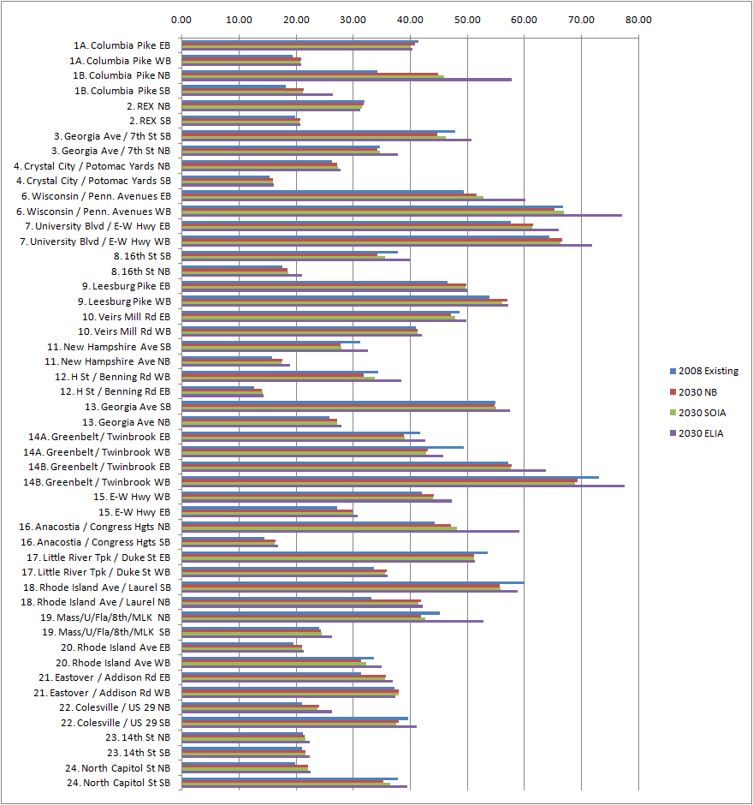
Transit Travel Times (Table)

Transit Travel Times (mins) | Existing | 2030 | 2030 | 2030
PCN Corridor / Direction | (2009) | NB | SOIA | ELIA
1A. Columbia Pike EB | 33.76 | 36.10 | 27.58 | 24.93
1A. Columbia Pike WB | 33.76 | 36.10 | 27.58 | 24.93
1B. Columbia Pike NB | 23.83 | 25.50 | 20.68 | 18.69
1B. Columbia Pike SB | 23.83 | 25.50 | 20.84 | 18.84
2. REX NB | 34.30 | 36.70 | 27.94 | 47.50
2. REX SB | 34.30 | 36.70 | 27.94 | 47.50
3. Georgia Ave / 7th St SB | 56.59 | 60.50 | 48.75 | 31.48
3. Georgia Ave / 7th St NB | 56.59 | 60.50 | 49.38 | 31.89
4. Crystal City / Potomac Yards NB | 24.25 | 25.90 | 20.04 | 20.04
4. Crystal City / Potomac Yards SB | 24.25 | 25.90 | 20.00 | 20.00
6. Wisconsin / Penn. Avenues EB | 76.39 | 81.70 | 64.34 | 43.22
6. Wisconsin / Penn. Avenues WB | 76.39 | 81.70 | 64.80 | 43.53
7. University Blvd / E-W Hwy EB | 65.36 | 69.90 | 60.67 | 55.29
7. University Blvd / E-W Hwy WB | 65.36 | 69.90 | 60.50 | 55.14
8. 16th St SB | 37.98 | 40.60 | 30.34 | 20.78
8. 16th St NB | 37.98 | 40.60 | 30.43 | 20.84
9. Leesburg Pike EB | 58.94 | 63.10 | 52.62 | 52.62
9. Leesburg Pike WB | 58.94 | 63.10 | 52.90 | 52.90
10. Veirs Mill Rd EB | 64.08 | 68.60 | 49.96 | 45.34
10. Veirs Mill Rd WB | 64.08 | 68.60 | 50.00 | 45.38
11. New Hampshire Ave SB | 26.61 | 28.50 | 22.49 | 22.49
11. New Hampshire Ave NB | 26.61 | 28.50 | 22.41 | 22.41
12. H St / Benning Rd WB | 32.12 | 34.40 | 25.95 | 22.31
12. H St / Benning Rd EB | 32.12 | 34.40 | 25.21 | 21.67

Transit Travel Times (mins) | Existing | 2030 | 2030 | 2030
PCN Corridor / Direction | (2009) | NB | SOIA | ELIA
13. Georgia Ave SB | 58.35 | 62.40 | 44.12 | 39.60
13. Georgia Ave NB | 58.35 | 62.40 | 44.12 | 39.60
14A. Greenbelt / Twinbrook EB | 55.01 | 58.86 | 50.86 | 41.16
14A. Greenbelt / Twinbrook WB | 55.01 | 58.86 | 50.86 | 41.16
14B. Greenbelt / Twinbrook EB | 74.65 | 79.88 | 69.33 | 56.12
14B. Greenbelt / Twinbrook WB | 74.65 | 79.88 | 69.33 | 56.12
15. E-W Hwy WB | 38.24 | 40.90 | 32.68 | 32.68
15. E-W Hwy EB | 38.24 | 40.90 | 32.52 | 32.52
16. Anacostia / Congress Hgts NB | 21.88 | 23.40 | 26.26 | 24.27
16. Anacostia / Congress Hgts SB | 21.88 | 23.40 | 26.10 | 24.12
17. Little River Tpk / Duke St EB | 60.10 | 64.30 | 48.57 | 48.57
17. Little River Tpk / Duke St WB | 60.10 | 64.30 | 48.83 | 48.83
18. Rhode Island Ave / Laurel SB | 63.27 | 67.70 | 53.49 | 53.49
18. Rhode Island Ave / Laurel NB | 63.27 | 67.70 | 53.35 | 53.35
19. Mass/U/Fla/8th/MLK NB | 45.87 | 49.10 | 36.03 | 20.13
19. Mass/U/Fla/8th/MLK SB | 45.87 | 49.10 | 36.03 | 20.13
20. Rhode Island Ave EB | 34.39 | 36.80 | 26.52 | 26.52
20. Rhode Island Ave WB | 34.39 | 36.80 | 26.77 | 26.77
21. Eastover / Addison Rd EB | 41.69 | 44.60 | 38.11 | 38.11
21. Eastover / Addison Rd WB | 41.69 | 44.60 | 38.11 | 38.11
22. Colesville / US 29 NB | 33.77 | 36.10 | 28.86 | 25.23
22. Colesville / US 29 SB | 33.77 | 36.10 | 29.20 | 25.53
23. 14th St NB | 44.04 | 47.10 | 33.90 | 19.48
23. 14th St SB | 44.04 | 47.10 | 33.79 | 19.42
24. North Capitol St NB | 37.89 | 40.50 | 36.97 | 36.97
24. North Capitol St SB | 37.89 | 40.50 | 36.62 | 36.62

Transit Travel Times (Chart)

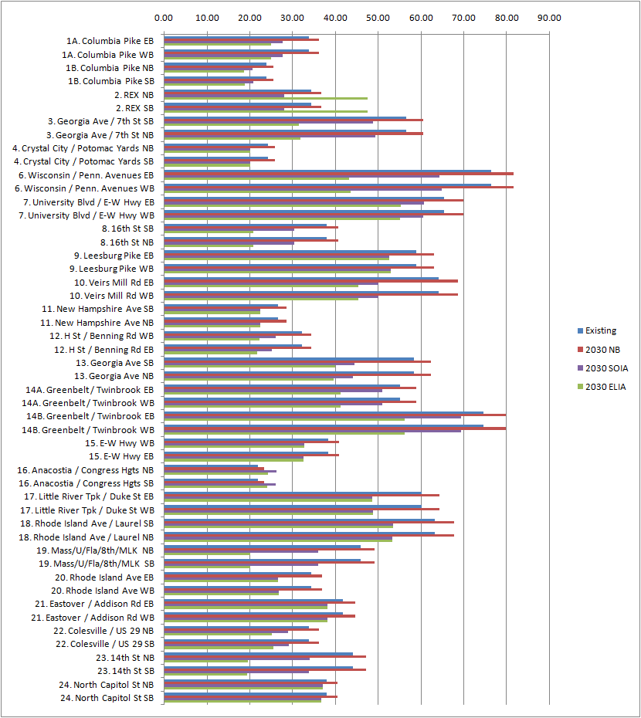

- Do we have any type of number increases for the bus system exclusive of the PCN corridors? We are theorizing that local bus (both WMATA local and jurisdictional local such as Ride On) will have increase in ridership because the PCN is such a strong network: i.e., there should be residual ridership gains attributable to the PCN system.

  - We have the total ridership increase (linked trips) and boardings by system.
  - Table A-3 compares daily transit boardings by mode (local bus, PCN, etc) for the NB and Full-Build PCN.
  - Table A-9 compares daily transit boardings by mode for 2009 NB, 2030 NB, SOIA, and ELIA.
  - Table A-10 compares regional daily linked transit trips by purpose and mode-of-access for 2009 NB, 2030 NB, Full-Build PCN, SOIA, and ELIA.

- Figure 6 (PCN Regional transit mode Share) seems off. Just looking at the 2009 bar, metrorail currently carries around 60% of the regional transit trips (750,000 on metrorail and 600,000 on metrobus and local bus) but your graph shows 48% for metrorail. Do you have the wrong numbers or are you using the total ridership for the entire COG area (not just the WMATA service area) or maybe you are only looking at transit ridership on the PCN corridors? We just want to figure out what this graph is telling us.

- It is ridership for the entire COG area, not just the WMATA service area.

- You have an Average Bus Speed graph that has stuff in miles per hour, could you also translate it into minutes per mile?
  - Original Table (mph) and modified table (minutes per mile computed as 60/[speed in mph]) shown below:

Table A-8 Average Daily Bus Speed (mph) for PCN Alternatives (2030)
 | 2008 CLRP No Build | Service and Operational | % Increase  Over No Build | Exclusive Lane Investment | % Increase  Over No Build
Local Bus | 14.9 | 15.0 | 1% | 15.3 | 3%
PCN Corridors | 12.4 | 12.6 | 2% | 14.3 | 15%

Table A-8’ Average Daily Bus Minutes per Mile for PCN Alternatives (2030)
 | 2008 CLRP No Build | Service and Operational | Exclusive Lane Investment
Local Bus | 4.0 | 4.0 | 3.9
PCN Corridors | 4.8 | 4.8 | 4.2

- The transit trip time chart seems off…the “number of auto trips on Corridors’ seems to be the total auto trips for the entire modeled region. Or is there really 34,496,000 auto trips PER DAY on the 24 PCN corridors alone? Seems like this has to be the regional number as it would equate to roughly 6 auto trips per person. Consequently, the Total Auto Time Change is WAY low (32,258,000 * 1.3 minutes does not equal 1,281,200).

- There were problems with the subject calculations. The following tables correct those problems and replace the tables that were affected.

Table 5: Daily Person Travel Time Savings (Travel in PCN Corridors)
 | 2030 NB | 2030 SOIA | 2030 ELIA
Number of Transit Passengers in PCN Corridors | 480,100 | 592,600 | 600,900
Change in Travel Time (minutes) | n/a | (1.8) | (3.6)
Total Transit Time Change in PCN Corridors (hours) | n/a | (17,800) | (36,100)
Total Auto Time Change in PCN Corridors (hours) | n/a | 5,200 | 21,400
Change in Auto Person Travel Time (occupancy 1.26 persons per vehicle, hours) | n/a | 6,600 | 27,000
Net Change in Total Person Travel Time in PCN Corridors (Transit + Auto, Hours) | n/a | (11,200) | (9,100))

Table A-14 Daily Person Travel Time Change (Travel in PCN Corridors)
 | 2008 CLRP No Build | Service and Operational | Exclusive Lane Improvements
Number of Transit Passengers in PCN Corridors | 480,100 | 592,600 | 600,900
Change in Transit Travel Time (minutes) | n/a | (1.8) | (3.6)
Total Transit Time Change in PCN Corridors (hours) | n/a | (17,800) | (36,100)
Total Auto Time Change in PCN Corridors (hours) | n/a | 5,200 | 21,400
Change in Auto Person Travel Time in PCN Corridors (occupancy 1.26 persons per vehicle, hours) | n/a | 6,600 | 27,000
Net Change in Total Person Travel Time in PCN Corridors (Transit + Auto, Hours) | n/a | (11,200) | (9,100)

M-NCPPC (Montgomery)

- Why does Table A-7 say the two networks strongly support reduction in VMT if pages 60-62 say they increase VMT (for both buses and autos)?

- Table A-7 will be changed to reflect that the networks do not support the objective of reducing VMT.

- If the average bus speed in Table 3 only goes from 12.4 to 12.6 in the SOIA, how can the ratio of transit/auto time in Figure 3 be so low? If the PCN Total is 75% in SOIA, it must also be less than 80% in the no-build, which doesn't make sense if there are transit stops and no bus priority features.

- See previous response to WMATA question with regard to Figure 3.

- Do we have any info on costs for the alternatives? (Study notes it's not done as part of this document, but perhaps there's info from WMATA in other forums?)

- No. This study did not address costs.

- Do we have info on the Full Build scenario as summarized in descriptive bins in Appendix G?

- If we understand the question correctly (Appendix G is the 9-by-9 matrix), the answer is that the level of investment for *ALL* PCN Corridor segments was high for the Full Build.

- On Page 14 the text says that Table A-3 shows regional increase in transit boardings for ELIA and SOIA, but it only shows the increase for ELIA. Instead of the reference, perhaps show this on Figure 6 as total bars.

- The reference should be to Table A-9 and will be corrected.

- Why does a 4 minute average travel time savings for ELIA result in a 75% increase in household accessibility when a 2 minute average travel time savings for SOIA only leads to a 1.5% increase in household accessibility? Seems like 75% is too high.

- We also have concerns about the order of magnitude of accessibility results and the computation process, particularly in light of the follow-up tests conducted by COG/TPB staff on the PCN networks. Our suggestion is to modify the text to generally state that the PCN increases accessibility to jobs and households (within 45 minutes) over the no-build, but not to include specific numbers.

VDOT

- On page 4 in the last paragraph, the document states that the ELIA includes the addition of exclusive bus lanes. As the lanes were sometimes taken from general traffic and were not additional lanes, this statement may confuse the reader if they do not read beyond the executive summary.
- We will add a note to readers indicating that “exclusive lanes” can be created in different ways and include references to the detailed discussions of this issue in the appendices.
- The last paragraph on page 5 talks about the CLRP plans for guideway transit projects, and how the PCN services were overlayed in the corridor. Later in the document the writer states that the PCN services replaced the routes on those corridors (bottom of page 43). Were the PCN services overlayed or did they replace the CLRP bus routes on the Potomac Yard Transitway, the Columbia Pike Transit services or the REX services?
- Page 23 indicates that the PikeRide service was included in the baseline network and then was replaced by PCN service for all subsequently modeled alternatives. Page 24 indicates that the REX service was included in the baseline network and then was replaced by PCN service for all subsequently modeled alternatives. The Crystal City / Potomac Yard transitway was included as a light rail line since that mode was already in the CLRP network, and then the PCN bus service was added in the corridor. Pages 25-6 of the report will be changed to include this clarification.
- Table 5 and later Table A-14 don’t look correct. For the 2030 SOIA there are 34,636,600 auto trips in the corridor, which should be multiplied by 1.26 to get the total auto person trips. This number then gets multiplied by the 1.18 minutes of delay that autos were expected to experience. How does that add up to 310,900 (under Total Auto Time Change)? And how does the time savings for transit make up for that total auto delay? Perhaps we are missing the point of this table. We also looked at the difference between 2030 NB and 2030 SOIA values and still we can not get 310,900 minutes of time savings.
- These tables have been corrected. See response to WMATA question #8.
- The negative values in Figure 4 (Auto Travel Time changes) do not look reasonable. Shouldn’t all the values be positive? Why the values in VA are all negative?
- Negative values in Figure 4 reflect decreases in auto passenger travel time in the PCN corridors (i.e., travel time savings) relative to the no-build, so negative values may be viewed as (positive) benefits for travelers in the VA PCN corridors.
- How does Figure 5 on page 13 relate to Table 2 in depicting the number of daily boardings for the alternatives vs. daily passengers?
- As noted in the response to WMATA question #2, in the report, linked trips are reported as passengers, and unlinked trips reported as boardings. Figure 5 reports the number of daily boardings over the no-build for the PCN routes only. Table 2 reports the number of daily boardings for all express buses that utilize the PCN corridors (including non-PCN routes) and the number of daily transit passengers in the PCN corridors (meaning they use the corridor for some part of their trip).
- On page 28, last paragraph for Route 7- why was the 28X not included in the transit network that was modeled for the PCN network?
- The 28X service was not in the 2008 CLRP transit network provided by COG/TPB, as the service had not yet been initiated when the network was developed. This means the 28X was not included in the 2008 CLRP or 2030 No Build model networks. For the SOIA and ELIA model networks, PCN routes were included for the Leesburg Pike PCN corridor. Our review notes that Table 1 of the report includes the 28X as an existing express route in the Leesburg Pike PCN corridor, and to see that and see later in the report that the 28X was not modeled might be confusing; therefore, we will clarify Table 1.
- On page 50, table A-6- was there any consideration to looking at person throughput at your defined cut lines for the baseline vs. the two scenarios? We would think that would be an important consideration when taking a lane for transit is proposed.
- We did consider this but found that model performance at the cutline level was not satisfactory enough to conduct such an analysis. We did analyze person travel (transit ridership) and vehicle throughput (v/c ratio) by PCN segment when determining level of investment (which in turn helps determine the appropriateness of an exclusive lane). That analysis is discussed in Table A-2 and contained in Appendix G of the report.
- It would be helpful to see some recommendations called out in the Executive Summary. There are some in the text, but it would be helpful to see them more explicit.
- The intent of the PCN Evaluation was to test the validity of the PCN concept, and we have found the concept to have considerable merit and reported our results in the section on Overall Findings and Key Measures of Effectiveness. Corridor-specific recommendations are beyond the scope of this report.

In the ELIA 4.3 miles of additional running-way was added to the REX PCN route to insure that network coverage was retained from the existing REX express routes in the base case. This increased the transit travel time for the corridor in the ELIA.

