Prince George’s County Maryland
West Hyattsville Metrorail Station Access Improvements

Project Summary
The project includes two components: adding approximately 500 linear feet of frontage along the south side of Jamestown road to improve pedestrian access to the West Hyattsville Metrorail station and providing a WMATA secure bike parking facility and related identified improvements that connect into the West Hyattsville station.

Project Cost
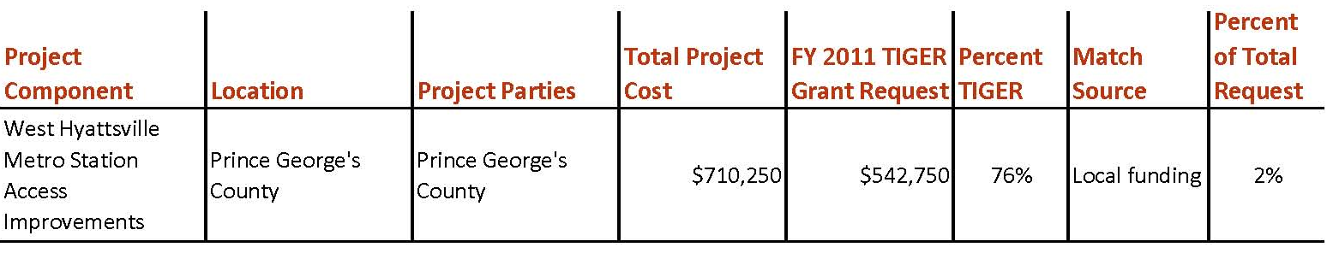

Project Location
This project is located in Prince George’s County, Maryland, at the West Hyattsville Metrorail station, which is on the Metro green line, one station stop outside of the District of Columbia. This project is located in a mixed residential and commercial area and will provide better non-motorized access to the rail station. On a given weekday, 41 percent of the station’s riders walk to the station. This amounts to approximately 1,600 pedestrian trips to the station and another 1,600 trips leaving the station. Many of these trips are along Jamestown Road, as it connects to high density residential uses located to the south and east of the station. An existing trail runs from the apartments to Queens Chapel Road, intersecting Queens Chapel Road near the intersection of Jamestown Road. Pedestrians using Jamestown Road must walk along the shoulder to reach the station.

Project Planning
The approved Prince George’s Countywide Master Plan of Transportation (CMPOT) recommends wide sidewalks and designated bike lanes along Jamestown Road. These facilities are intended to improve pedestrian safety, facilitate non-motorized access to metro, and complement the existing stream valley trail network along Northwest Branch. According to WMATA’s Station Site and Access Planning Manual, the West Hyattsville Metrorail station currently has the highest rate of bicycle and pedestrian access of all the metro stations in Prince George's County. The provision of bike facilities will further encourage and safely accommodate this mode. The road improvements along Jamestown Road will achieve the community vision as expressed in the West Hyattsville Transit District Development Plan (TDDP) by establishing land use/transit linkages that make it easier to use transit (rail and bus) and by creating an attractive pedestrian-friendly environment around the transit station. The TDDP also includes recommendations for various pedestrian safety features and amenities through the transit district that will serve to make a safer and more inviting pedestrian environment immediately around the station. Some of these improvements will occur as part of larger development applications; while others will be implemented by local agencies as funding becomes available.

The station area enhancements, including the secure bicycle parking facility, were derived from WMATA’s Metrorail Bicycle and Pedestrian Access Improvements Study.

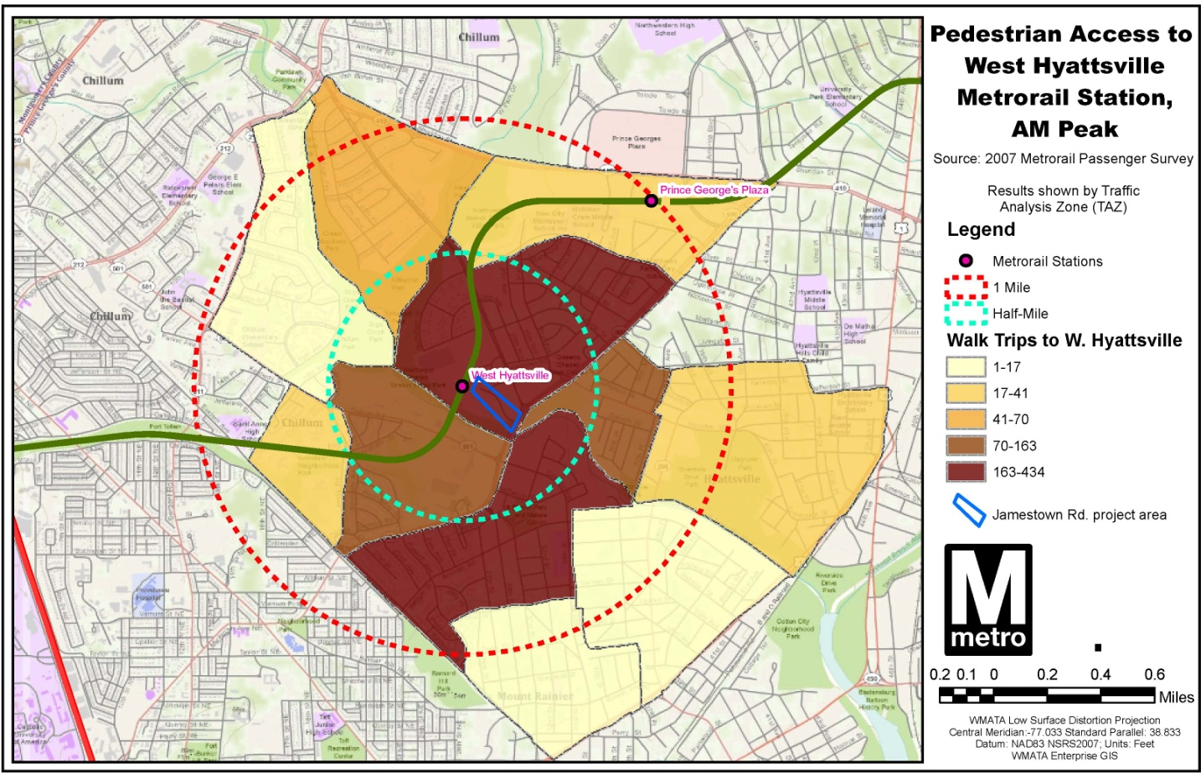

Project Details
The project will add approximately 500 linear feet of sidewalk along the south side of Jamestown road to improve pedestrian access to the West Hyattsville Metrorail station. A WMATA secure bike parking facility and related identified improvements that connect into the WMATA West Hyattsville Station will be provided. This is one of the recommendations out of the WMATA Bicycle Access Study. The bike parking facility will be located adjacent to station entrance and will have access to the local bike network, including the trail system discussed above. It will be weather protected and security will be maintained by limited access entry system and cameras. A similar facility is under construction at the nearby College Park Metrorail Station (http://planitmetro.com/2011/10/06/college-park-bike-ride-under-construction/).

Project Schedule
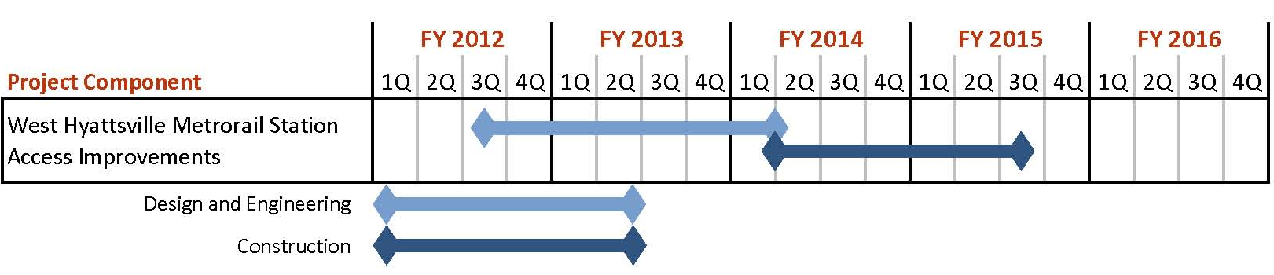

Additional Documentation

References to this project may be found in the following documents:

Washington Metropolitan Area Transit Authority, Station Site and Access Planning Manual, Appendix C, page C-4.

Maryland-National Capital Park and Planning Commission, Approved West Hyattsville Transit District Development Plan, page 1.

Washington Metropolitan Area Transit Authority, Metrorail Bicycle & Pedestrian Access Improvements Study, October 2010:
http://planitmetro.com/wp-content/uploads/2010/12/Metrorail-Bicycle-Pedestrian-Access-Improvements-Study-_Final.pdf

