City of Rockville Maryland
Twinbrook Metro Station: Pedestrian Safety Improvements

Project Summary
The project will construct safety improvements along four specific corridors within one half mile radius of the Twinbrook Metrorail station. The improvements identified in this area include refurbished high-visibility crosswalks, median extensions, curb extensions, and other related enhancements at approximately 26 intersections within the project area. Implementation of this project will improve pedestrian safety in the immediate vicinity of the station.

Project Cost
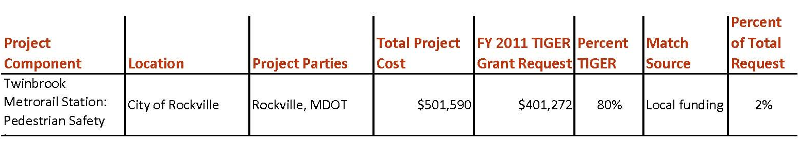

Project Location
This project is located entirely within a one half mile radius around the Twinbrook Metrorail station.
Twinbrook Metrorail station is located on the southeastern edge of the City of Rockville, and surrounded by roads owned and maintained by the City of Rockville, Montgomery County Department of Transportation (MCDOT), and the Maryland State Highway Administration (SHA). This project is located in a State-designated Transit Oriented Development area with existing residential, commercial, and employment uses. There are several other mixed-use developments expected to be constructed in this vicinity within the next few years.

Project Planning
The City of Rockville received a planning grant through the TPB’s Transportation/Land-Use Connections (TLC) technical assistance program in 2011 to study safer walkways to the Twinbrook Metrorail Station. The TLC grant study was the result of a joint partnership between the City of Rockville and National Capital Transportation Planning Board. The community participated during the evaluation phase of this project, as Rockville hosted resident representatives from the City’s Traffic and Transportation Commission as well as agency representatives for each of the jurisdictions described in this report. This project will require City staff to collaborate with Montgomery County Department of Transportation (MCDOT), Maryland State Highway Administration (SHA), and WMATA. Representatives from these agencies participated in a workshop during the concept design phase of the TLC study to discuss the proposed study recommendations.

Nearly every recommendation included in the TLC grant study correlates directly to a safety improvement. Recommendations include, but are not limited to, providing pedestrian refuge islands, curb extensions, additional pedestrian-scale lighting, etc. The TLC study recommends consideration of rectangular rapid flashing beacons (RRFBs) to improve driver awareness of pedestrian activity at mid-block crosswalks. The grant study also recommended the use of innovative public safety campaigns, such as thermoplastic safety messages on the sidewalk, to reach pedestrians.

Project Details
The area immediately surrounding Twinbrook Metrorail station is currently under development as a high density residential community. This project will improve pedestrian and bicyclist accessibility to rapid transit without inhibiting automobile or bus operations. Improvements associated with this project are in four specific corridors within the ½ mile radius of the Twinbrook Metrorail station. These five corridors were identified based on their importance to pedestrian accessibility and potential for improvement to support enhanced accessibility. These corridors are: Halpine Road, Lewis Avenue, Parklawn Dr/ Fishers Lane, and Rockville Pike. The improvements identified in this area include refurbished high-visibility crosswalks, median extensions, curb extensions, and other related enhancements at approximately 26 intersections within the project area.

Private-sector redevelopment around the Twinbrook Metrorail station, a State-designated Transit Oriented Design (TOD) area, is adding more residential, retail, and office units. One such development, Twinbrook Station, is an award-winning, project that will include 1,595 residential units, 220,000 square feet of ground-floor retail, and 325,000 square feet of Class-A commercial space. Twinbrook Station has been designated a Smart Growth project by the Washington Smart Growth Alliance, received the International Charter Award for Excellence from the Congress for the New Urbanism, and was the first project in the Washington, DC, area to be awarded Stage 2 LEED for Neighborhood Development Gold-level certification for its plan. The City is able to match federal TIGER funds via Development Impact taxes collected as part of the Twinbrook Station development.

Project Schedule
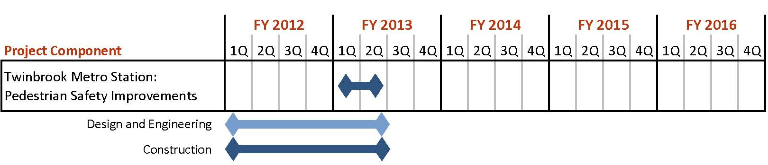

Additional Documentation
This project was developed based on recommendations from a 2011 TLC Study: Safer Walkways to Transit in the City of Rockville, Maryland: http://www.mwcog.org/transportation/activities/tlc/pdf/Rockville-TOD.pdf

