District of Columbia Washington, DC
Fort Totten/1st Place-Galloway Road Access Improvement Project

Project Summary
The primary goal of the project is to improve circulation so all modes can safely access and navigate the station area of the Fort Totten Metrorail station. The project will rehabilitate existing sidewalks and install sidewalks where informal footpaths currently exist along the roadway.

Project Cost
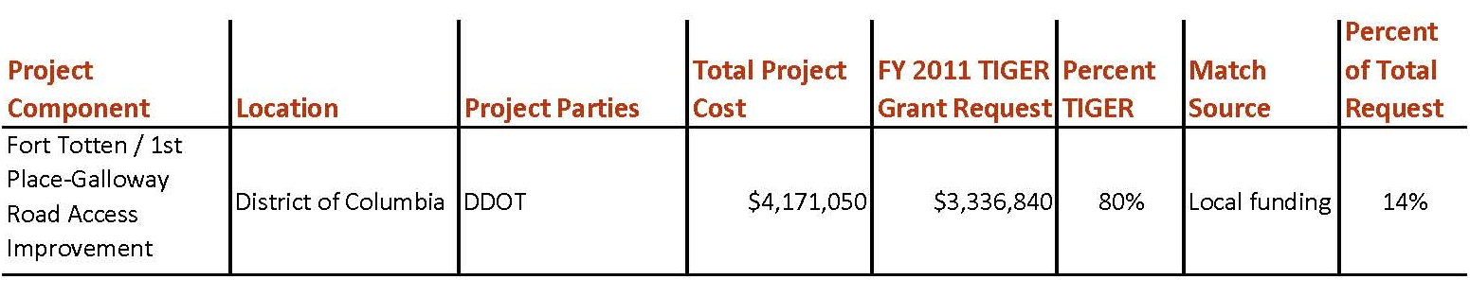

Project Location
This project is located in the District of Columbia around the Fort Totten Metrorail station, a transfer station in northeast Washington, DC. The project area includes roadways and paths within one quarter of a mile of the Metrorail station. The land surrounding the station is currently underutilized and ripe for development. The station currently provides transit access to a diverse customer base. Any improvements to the station area will provide better access to these customers, who include low-income populations. There are several significant changes coming to the area, including a planned reconfiguration of the Riggs Road/South Dakota intersection and several major real estate developments in various stages of planning and construction in the immediate vicinity that will significantly increase residential and commercial densities.

Project Planning
In 2007, the Washington Metropolitan Area Transit Authority (WMATA) prepared the Fort Totten Metrorail Station Area Planning Study, an analysis that reviewed existing conditions at the site. This study identified deficiencies in the infrastructure that complicated pedestrian access to the station.

In August 2011, the District Department of Transportation (DDOT) received the final draft of the 1st Place and Galloway St, NE Transportation Access Study and Improvement Plan, which identified multimodal recommendations for circulation improvements around the station. The project was initiated by the District Department of Transportation to improve access and circulation for the confluence of pedestrians, bicyclists, buses, and vehicles at the Fort Totten Metrorail station. The study area included roadways and paths within 1/4‐mile of the Fort Totten Metrorail station. Three public meetings were held with the community during the planning phase of the study. The process also included many meetings with WMATA, the National Park Service, and the DC Office of Planning.

Project Details
The project calls for Low Impact Development and storm water management features at two newly created pedestrian plazas near the Metro entrance. The project will install pavers, secure bicycle parking, and landscaping in and around the pedestrian plaza.

Improvements along 1st Place, NE include adding a sidewalk and lighting. Along Galloway Street, NE, the improvement will add a sidewalk and retaining wall. On WMATA property, the project includes adding pedestrian infrastructure, lighting and a rain garden.

Project Schedule
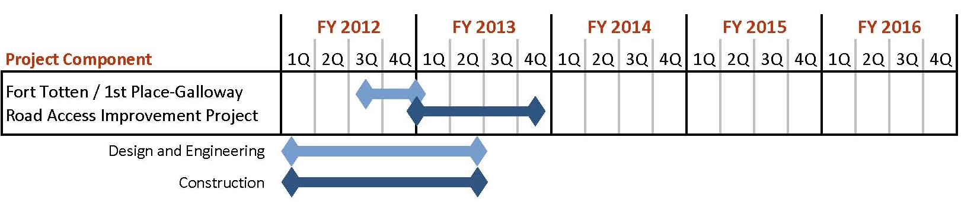

Additional Documentation
The study, the 1st Place and Galloway St, NE Transportation Access Study and Improvement Plan, was completed August 4, 2011. More information may be found on the project website: http://www.tooledesign.com/forttotten.

